Software Architecture Document

Swapnil Srivastava, Alex Thropp, and Jonas Schulz

**Architectural Representation**

The architecture in this document will be described using technical memos and architectural views, and well as plain english for those who are less technical.

**Architectural Factors**

Supplemental Specs

* Bluetooth 5.0
* Latest Gyroscope
* IOS 10 or above (for mobile app connectivity)
* Android Orea or above (for mobile app connectivity)
* User Agreement

Glossary: [Glossary](https://drive.google.com/open?id=1KKEADwntuazLlKKFOMIcxBGJhb43Jxwa)

**Architectural Decisions**

**Logical View (Package, Class, and Domain Diagrams)**

**Domain Model Diagram:** 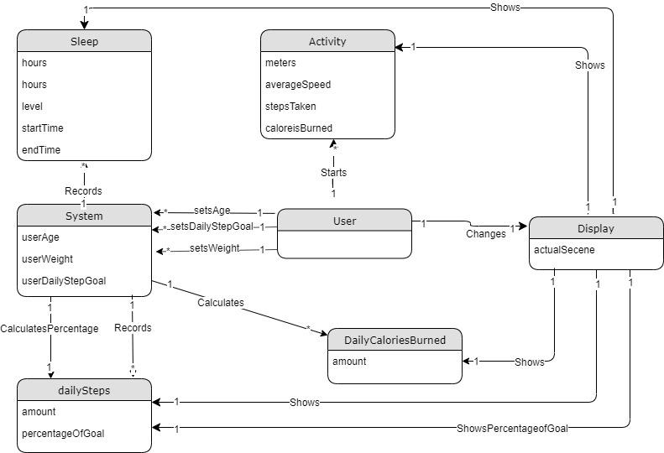

**Deployment View (Deployment Diagrams)**

**Process View (Class and interaction Diagrams)**

**System Sequence Diagrams:**

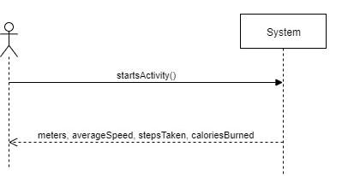

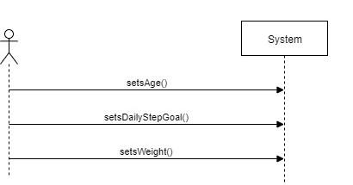

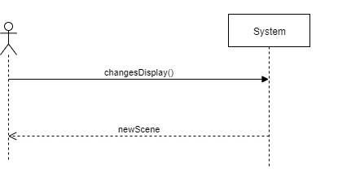

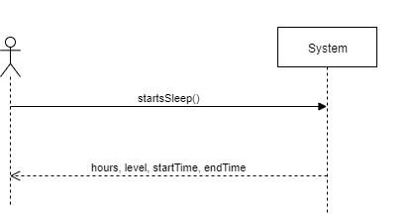

**Sequence Diagram and Operation Contracts:**

* Recording activity

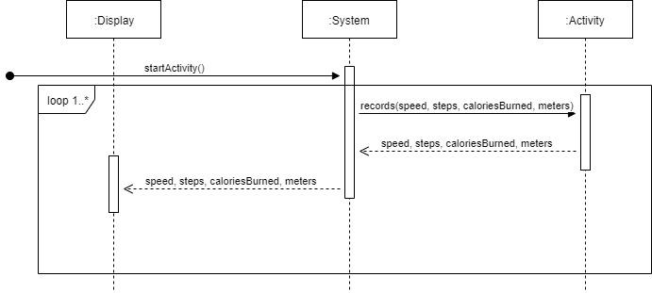

**Contract: recordActivity**

**Operation:** startActivity()

**Cross References:** Use Case 1

**Pre-conditions:**

* System is on
* Pedometer active
* Gyroscope active
* Acitivity was detected

**Post-conditions:**

* An Activity instance activity was created
* activity was associated with day
* activity was associated with userAge
* activity was associated with userWeight
* activity was associated with userDailyStepGoal

**Contract: recordActivity**

**Operation:** record (steps:integer, meter: integer, stepsTaken: integer, caloriesBurned: integer)

**Cross References:** Use Case 1

**Pre-conditions:**

* An Activity instance activity was created

**Post-conditions:**

* activity.meters became meters
* activity.stepsTaken became steps
* activity.averageSpeed became speed
* activity.caloriesBurned became caloriesBurned
* see “DailySteps” Stage

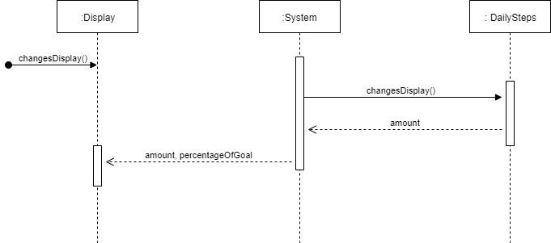

**Contract: dailyStepsScene**

**Operation:** changesDisplay()

**Cross References:** Use Case 3

**Pre-conditions:**

* System is on
* Former Scene was “home”
* User pressed the button

**Post-conditions:**

* Display.scene became “dailySteps”
* See “caloriesBurned” Stage

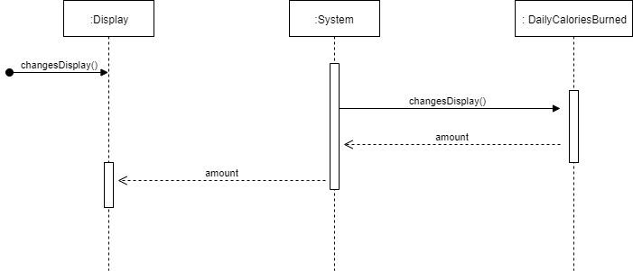

**Contract: caloriesBurnedScene**

**Operation:** changesDisplay()

**Cross References:** N/A

**Pre-conditions:**

* System is on
* Former Scene was “dailySteps”
* User pressed the button

**Post-conditions:**

* display.scene became “caloriesBurned”
* start Sleep

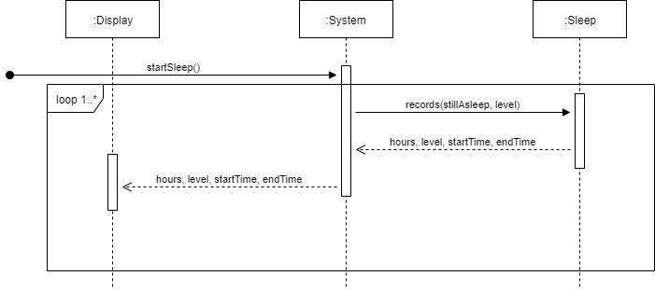

**Contract: recordSleep()**

**Operation:** startSleep()

**Cross References:** Use Case 2

**Pre-conditions:**

* System is on
* Pedometer active
* Gyroscope active
* Sleep was detected

**Post-conditions:**

* An Sleep instance sleep was created
* sleep was associated with day

**Contract: recordSleep()**

**Operation:** record (stillAsleep: boolean, level: integer)

**Cross References:** Use Case 2

**Pre-conditions:**

* An Sleep instance sleep was created
* sleep was associated with day
* stillAsleep == true

**Post-conditions:**

* sleep.hours became 5 minutes more
* sleep.level became level
* sleep.startTime became startTime
* sleep.endTime became current Time
* change Age (same with Weight, and DailyStepGoal)

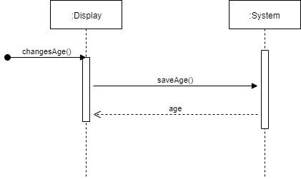

**Contract: setAge**

**Operation:** setAge (age: integer)

**Cross References:** Use Case 6

**Pre-conditions:**

* System is on
* User accesses age through settings

**Post-conditions:**

* system.age became age

**Use Case View**

**Use case 1**

Use Case: Recording activity and health

Scope: Activity tracker

Level: User goal

Primary Actor: User of activity tracker.

Stakeholders and Interests:

* User: Wants to record their activity accurately and with ease.

Preconditions: The activity tracker is paired with a phone.

Success Guarantee: Activity is recorded and saved accurately. Heart Rate is monitored and recorded accurately.

Main Success Scenario:

1. User wears the activity tracker
2. The tracker monitors and reports the heart rate of the user.
3. Tracker records the number of steps that the user takes
4. Tracker estimates the number of calories burned by the user based on the number of steps and heart rate.
5. When user sleeps, tracker monitors the quality of user’s sleep.
6. Tracker saves the day’s recorded activity and reports the activity app on paired phone.

Extensions (Alternative scenarios)

If the watch is not paired before use

1. Watch saves activity and health data for up to 1 week
2. If the phone is paired in that week, the data is shared with the phone
3. If the tracker is not paired for over 1 week, then it only saves data of the past 7 days.

Special Requirements:

* Wearable must have large text and buttons.
* The UI should be clean and easy to interact with
* The activity feedback should be in real time.

Technology and Data Variations: Wearable turned off and on by pressing and holding side button for 3 seconds.

Frequency of Occurrence: Continuous

Miscellaneous Such as open issues: Transferring data from the wearable to the smartphone app.

**Use case 2**

Use Case: Monitors sleep pattern

Scope: Activity tracker

Level: System goal

Primary Actor: System of activity tracker

Stakeholders and Interests:

* User: Wants to record their activity accurately and with ease.

Preconditions: The activity tracker is paired with a phone.

Success Guarantee: Sleep activity is recorded and saved accurately. Heart Rate is monitored and recorded accurately.

Main Success Scenario:

1. The user falls asleep wearing his activity tracker (that is connected to a smartphone).
2. The phone recognizes the position and location of watch using the gyroscope (to know if user is asleep).
3. The system actively monitors heart rate,O2 levels, and movement during sleep.
4. System publishes daily report of sleep to phone for user to view

Special Requirements:

* Wearable must be on for sleep.
* The sleep activity feedback should be available in real time.

Frequency of Occurrence: Nightly

Miscellaneous Such as open issues: Transferring data from the wearable to the smartphone app.

**Use case 3**

Use Case: Use wants to view date/time from watch face

Scope: Activity tracker

Level: User goal

Primary Actor: User of activity tracker.

Stakeholders and Interests:

* User: Wants to view information accurately and with ease.

Preconditions: The activity tracker is paired with a phone.

Success Guarantee: Date and time is viewed from watch face.

Main Success Scenario:

1. The user raises the watch to viewing height
2. The user turns on the display.
3. Using the gyroscope the system will look to see if the watched is angled correctly (left to right)
4. The system will display the date and time to the user on the from of the watch face

Special Requirements:

* Wearable must have large text and buttons.
* The UI should be clean and easy to interact with
* The activity feedback should be in real time.

Frequency of Occurrence: Continuous

Miscellaneous Such as open issues: Transferring data from the wearable to the smartphone app.

**Use case 4**

Use Case: view steps

Scope: Activity tracker

Level: User goal

Primary Actor: User of activity tracker.

Stakeholders and Interests:

* User: Wants to view their activity accurately and with ease.

Preconditions: The activity tracker is paired with a phone.

Success Guarantee: step count viewed on face of watch

Main Success Scenario:

1. The user raises the watch to viewing height
2. The users stick out their arm manipulating the watch to an up to down position. (checked by sys gyroscope)
3. The users turns on the display
4. The step count is displayed on the face of the watch

Special Requirements:

* Wearable must have large text and buttons.
* The UI should be clean and easy to interact with
* The activity feedback should be in real time.

Frequency of Occurrence: Continuous

Miscellaneous Such as open issues: Transferring data from the wearable to the smartphone app.

**Use case 5**

Use Case: the user wants to access/change the settings

Scope: Activity tracker

Level: User goal

Primary Actor: User of activity tracker.

Stakeholders and Interests:

* User: access or change settings from the watch

Success Guarantee: user reaches settings and can change desired setting.

Main Success Scenario:

1. User turns on the display
2. The user goes to the home screen and selects the settings button
3. Once in the settings menu the user can choose to change date/time as well as the units of measure etc.

Special Requirements:

* Wearable must have large text and buttons.
* The UI should be clean and easy to interact with
* The activity feedback should be in real time.

Frequency of Occurrence: daily

Miscellaneous Such as open issues: Transferring data from the wearable to the smartphone app.

**Use case 6**

Use Case: user sets age

Scope: Activity tracker

Level: User goal

Primary Actor: User of activity tracker.

Stakeholders and Interests:

* User: Wants to record their age accurately and with ease.

Success Guarantee: age is recorded and saved accurately.

Main Success Scenario:

1. User turns on the display
2. The user goes to the home screen and selects the settings button
3. Once in the settings menu the user can choose to change age
4. The user can select age from an on screen buttons

Special Requirements:

* Wearable must have large text and buttons.
* The UI should be clean and easy to interact with
* The activity feedback should be in real time.

Technology and Data Variations: Wearable turned off and on by pressing and holding side button for 3 seconds.

Frequency of Occurrence: Continuous

**Use case 7**

Use Case: user sets daily step goals

Scope: Activity tracker

Level: User goal

Primary Actor: User of activity tracker.

Stakeholders and Interests:

* User: Wants to record their daily step goal accurately and with ease.

Success Guarantee: daily step goal is recorded and saved accurately.

Main Success Scenario:

1. User turns on the display
2. The user goes to the home screen and selects the settings button
3. Once in the settings menu the user can choose to change daily step goal
4. The user can select daily step goal from an on screen buttons

Special Requirements:

* Wearable must have large text and buttons.
* The UI should be clean and easy to interact with
* The activity feedback should be in real time.

Technology and Data Variations: Wearable turned off and on by pressing and holding side button for 3 seconds.

Frequency of Occurrence: Continuous

**Use case 8**

Use Case: user sets weight

Scope: Activity tracker

Level: User goal

Primary Actor: User of activity tracker.

Stakeholders and Interests:

* User: Wants to record their weight accurately and with ease.

Success Guarantee: weight is recorded and saved accurately.

Main Success Scenario:

1. User turns on the display
2. The user goes to the home screen and selects the settings button
3. Once in the settings menu the user can choose to change weight
4. The user can select their weight from an on screen buttons

Special Requirements:

* Wearable must have large text and buttons.
* The UI should be clean and easy to interact with
* The activity feedback should be in real time.

Technology and Data Variations: Wearable turned off and on by pressing and holding side button for 3 seconds.

Frequency of Occurrence: Continuous

**Use case 9**

Use Case: Download Data

Scope: Activity tracker

Level: User goal

Primary Actor: User of activity tracker.

Stakeholders and Interests:

* User: Wants to view their activity accurately and with ease.

Preconditions: The activity tracker is paired with a phone.

Success Guarantee: Activity is viewed accurately.

Main Success Scenario:

1. The user appropriately wears the activity tracker.
2. The data will be synced daily to smartphone app for user to view later.

Special Requirements:

* Wearable must be connected to phone
* The UI should be clean and easy to interact with
* The activity feedback should be in real time.

Frequency of Occurrence: daily

Miscellaneous Such as open issues: Transferring data from the wearable to the smartphone app.