Prediction Of Neurological Recover After Cardiac

Arrest Using Deep Learning

Swapnil Makwana

Department of ECE

Gokaraju Rangaraju Institute of Engineering and Technology, Hyderabad, India

<swapnilmakwana4@gmail.com>

V L Jaganath Sai

Department of ECE

Gokaraju Rangaraju Institute of Engineering and Technology, Hyderabad, India

<vljaganathsai2003@gmail.com>

S Sethu Madhav

Department of ECE

Gokaraju Rangaraju Institute of Engineering and Technology, Hyderabad, India

[sethumadhav2467@gmail.com](mailto:sethumadhav2467@gmail.com)

Tatiparti Padma  
Department of ECE

Gokaraju Rangaraju Institute of Engineering and Technology, Hyderabad, India  
[profpadmat@gmail.com](mailto:profpadmat@gmail.com)

Abstract—Cardiac arrest poses a critical challenge in clinical setting, often resulting in uncertain neurological outcomes for survivors. This study explored the use of deep learning methodologies to predict neurological recovery following cardiac arrest. A comprehensive dataset incorporating diverse patient demographics, pre-hospital interventions, and post-resuscitation parameters was employed to develop and validate a deep neural network model. Rigorous model training and validation revealed the model’s proficiency in accurately stratifying patients based on their likelihood of neurological recovery. This model showcased robustness in categorizing distinct recovery categories, shedding light on influential pre-hospital and post-resuscitation factors. Ethical considerations were meticulously addressed, emphasizing patient privacy and fairness in model predictions. The proposed methods involve application of Deep learning neural networks to efficiently learn the time series data and accurately classify and distinguish between good and bad outcomes. The study’s outcomes present a promising avenue for integrating predictive tools into clinical practice, potentially revolutionizing post-cardiac arrest care by enabling personalized treatment strategies and informed decision-making. Continuous refinement, validation and ethical adherence remain imperative for the responsible translation of predictive models into enhancing patient outcomes in this critical medical domain, with improved ROC-AUC score >0.9 and classification accuracy of ~87%.

Keywords-component: EEG, Cardiac Arrest, Neural network, deep learning, ROC-AUC.

# Introduction

In recent years, advancements in deep learning methodologies have revolutionized various fields, including healthcare. One particularly promising area is the prediction of neurological recovery following cardiac arrest—a critical concern with significant implications for patient outcomes and treatment decisions. Cardiac arrest remains a leading cause of mortality worldwide, often resulting in severe neurological

damage due to insufficient blood flow to the brain. Accurately assessing the likelihood of neurological recovery post-cardiac arrest is essential for guiding treatment strategies and optimizing patient care. Here, the integration of deep learning techniques presents a groundbreaking opportunity to predict neurological outcomes with increased precision and reliability. This study aims to harness the potential of deep learning algorithms to analyze complex patterns and relationships within extensive patient data, including clinical variables, brain imaging scans, and other relevant parameters. By leveraging these advanced computational models, the research endeavors to develop a predictive framework capable of assessing the probability and trajectory of neurological recovery post-cardiac arrest.

The utilization of deep learning methodologies offers several advantages in this context. These algorithms excel in handling high-dimensional data, identifying subtle patterns, and extracting intricate features that traditional methods may overlook. Through the integration of diverse datasets and the training of neural networks, this approach seeks to generate robust predictive models capable of delivering individualized prognostic assessments. This study is poised to contribute significantly to clinical decision-making by providing clinicians with reliable tools to forecast neurological recovery probabilities for post-cardiac arrest patients.

Ultimately, such predictive models hold the potential to enhance patient care by aiding healthcare professionals in making informed decisions regarding treatment strategies, rehabilitation plans, and potential interventions to optimize neurological outcomes. As the healthcare landscape continues to embrace the integration of artificial intelligence and deep learning techniques, the potential of this research extends beyond the realm of predicting neurological recovery. It underscores the transformative impact of advanced computational methodologies in augmenting clinical practices, improving patient care, and potentially reshaping the paradigms of post-cardiac arrest management.

|  |  |
| --- | --- |
| CPC Score | Summary |
| CPC:1 | Being alert and attentive, competent to work, and possessing normal neurological function or just a little cerebral impairment are all considered to be aspects of good brain functioning. |
| CPC:2 | A moderate cerebral disability is characterized by aware and sufficient brain function for independent performance of activities of daily living. ability to function in a safe environment. |
| CPC:3 | Severe cerebral disability: The individual is awake but needs daily support from others due to impaired brain function. |
| CPC:4 | Vegetative condition, or coma, is any degree of coma that does not satisfy all criteria for brain death. ignorance, even in situations in which one appears to be awake and not engaged with their environment. |
| CPC:5 | No EEG activity, areflexia, and apnea indicate brain death. |

Fig.1 CPC score summary

# **Problem statement**

Understanding and predicting neurological recovery following cardiac arrest remains a critical challenge in modern healthcare. Despite advancements in treatment and resuscitation protocols, the uncertainty surrounding neurological outcomes post-cardiac arrest poses significant.

dilemmas for clinicians and patients alike. The lack of reliable prognostic tools capable of accurately assessing the likelihood of recovery impedes effective decision-making and tailored patient care strategies. The absence of a comprehensive and precise predictive framework contributes to the difficulty in prognosticating individual patient outcomes. Current prognostication methods rely heavily on clinical judgment and conventional assessment tools, which may lack the depth and accuracy required for nuanced prediction. As a result, healthcare providers face the daunting task of navigating treatment decisions and post-arrest care without definitive insights into neurological recovery trajectories. Moreover, variability in data sources, the complexity of post-arrest physiological responses, and the multifactorial nature of neurological damage add layers of intricacy to this problem. Integrating and interpreting diverse datasets encompassing clinical parameters, physiological indicators, laboratory findings, and neurological assessments in a cohesive and predictive manner remains a formidable challenge.

# **Literature Review**

Amorim E, Jing J, Ge W , Zheng WL [1] developed a model using CNN to study 1038 cardiac arrest patients and obtained AUC 0.83 with 70% specificity for good and bad outcomes.

According to Andy Temple and Richard Porter [2], almost 90% of patients experience serious neurological deficits as a result of OHCA (Out-of-Hospital-Cardiac-Arrest). To thoroughly examine individuals who require post-arrest therapy and prompt resource allocation, a rigorous research is necessary.

Rittenberger JC, Zheng JJ, Amorim E, et al. [3] In hypoxic-ischemic brain damage, continuous EEG monitoring improves multimodal outcome prediction.

According to the study, 256 patients had an in-hospital death rate of 68.6%. For poor functional outcomes, the combination of status epilepticus (SE) with an unreactive EEG backdrop demonstrated a 100% positive predictive value and a 0% false-positive rate. Furthermore, a prediction model with an area under the curve of 0.92 for poor functional outcome and 0.96 for in-hospital mortality showed strong predictive capabilities, incorporating demographic data, admission exam results, status epilepticus, pure SB, and absence of EEG reactivity.

Jerry P. Nolan, Sonia D'Arrigo, and Claudio Sandroni [4] To reduce the possibility of a mistakenly gloomy forecast, a multimodal strategy incorporating various prognostication tests comprising biomarkers, electrophysiology, clinical examination, and neuroimaging is established.

The following names are Andersson P, Johnsson J, Björnsson O, Cronberg T, Hassager C, Zetterberg H, Stammet P, Undén J, Kjaergaard J, Friberg H, Blennow K, Lilja G, Wise MP, Dankiewicz J, Nielsen N, and Frigyesi A. [5] Using cumulative data, predicting the neurological prognosis following an out-of-hospital cardiac arrest; creating and validating an artificial neural network method internally.When analyzing AUC-ROC using solely clinical factors for the first three days in the ICU, the results consistently indicated a value below 90%. However, the AUROC increased dramatically from 82% to 94% (p<0.01) when clinically accessible indicators like NSE were included. Even with the use of research-grade biomarkers, the prognostic accuracy was extremely high, staying at 95% from the first to the third day. Interestingly, models that included NSE after a full 72 hours and and NFL on each of the three days showed a low chance of making false-negative predictions and a low risk of making false-positive ones.

P. Andersson, O. Björnsson, J. Johnsson, et al. [6] By using 54 clinical characteristics that were accessible at the time of hospital admission, the outcome prediction was able to attain an area under the receiver operating characteristic curve (AUC) of 0.891. These variables were divided into admission, pre-hospital, and background data categories. Notably, models using only individual pre-hospital, admission, or background factors showed worse prediction ability. In a study involving the same cohort, the artificial neural network (ANN) model outperformed a logistic regression-based model by a substantial margin (p = 0.029). With an AUC greater than 0.852, a streamlined ANN model that only included three variables—age, time to ROSC, and first monitored rhythm—performed admirably. Moreover, ANN-based stratified analyses demonstrated a comparable targeted temperature management (TTM) intervention impact.

Keijzer, H.M., Pham, S.D.T., Ruijter, B.J., et al. A Comparative Study of Automated Electroencephalography Analysis Techniques for Postanoxic Coma Outcome Prediction [7] Overall, the deep learning network's prediction power was greater. It was able to predict unfavorable results in the external test set with a false positive rate (FPR) of 0% (95% CI 0-2%) and a sensitivity of 54% (95% confidence interval [CI] 44–64%) at 24 hours. Compared to the random forest models (sensitivity 13%, FPR 0%) and logistic regression models (sensitivity 33%, FPR 0%), this performance was much superior (p < 0.05).

The following people hold MDs and PhDs: Barry J. Ruijter, PhD, Marleen C. Tjepkema-Cloostermans, PhD, Selma C. Tromp, PhD, Walter M. van den Bergh, PhD, Norbert A. Foudraine, PhD, Frank H. Bosch, PhD, Erik Scholten, PhD, Albertus Beishuizen, PhD, Michel J. A. M. van Putten, PhD, and Jeannette Hofmeijer MD PhD [8] used data from 850 patients, of whom 46% had a positive result and the rest 54% were suggested to have a poor prognosis, in their study for early prediction of neurological outcome post anoxic coma. In the end, they came to the conclusion that EEG, with greatest sensitivity in the first 24 hours following cardiac arrest, may reliably indicate a bad prognosis. 12-hour continuous EEG patterns after cardiac arrest are associated with good recovery.

# **proposed methodology**

This investigation harnessed the power of deep learning methodologies to establish a predictive framework for assessing neurological recovery following cardiac arrest. The

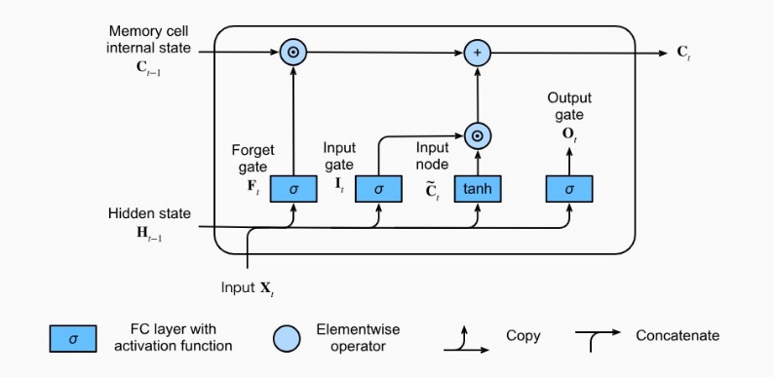foundation of this methodology rested on the construction and training of a sophisticated deep neural network. This neural network (LSTM) was meticulously designed and optimized to process a vast array of input variables encompassing a multitude of patient-specific characteristics, pre-hospital interventions, and pertinent post-resuscitation metrics. The dataset used for training and validation was extensive, comprising diverse cases sourced from various healthcare settings. To ensure the model's accuracy and reliability,

Fig.2. LSTM architecture

rigorous cross-validation using binary cross entropy techniques and performance assessments were employed throughout the training phase.

1. **Long-Short-Term-Memory (LSTM):**

In the realm of deep learning and artificial intelligence (AI), LSTMs are long short-term memory networks that make use of artificial neural networks (ANNs). These networks have feedback connections, which sets them apart from regular feed-forward neural networks, also known as recurrent neural networks.

Speech recognition, machine translation, video games, robotic control, unsegmented, networked handwriting recognition, and healthcare are just a few of the applications for LSTM.

Three distinct types of gates are present in an LSTM: forget, output, and input gates. The input gate controls the information that enters the memory cell. The forget gate controls the information that exits the memory cell.

1. **Forget Logic:**

1. **Save Logic:**
2. **Retrieve Logic:**

The output gate controls the data that exits the LSTM and enters the output. The sigmoid functions that are used in the construction of the input, forget, and output gates provide an output that is between 0 and 1. These gates are trained by a backpropagation mechanism via the network. The input gate controls which data gets saved in the memory cell. An input is taught to open when it is judged significant, and to close otherwise. Which information from the memory cell is deleted is chosen by the forget gate. Information is trained to close and then open when it becomes irrelevant. The output gate is in charge of choosing the data the LSTM will utilize for its output. It is designed to open in response to vital information and close in response to less significant information. The gates of an LSTM are programmed to open and close in response to input and the previous concealed state. Because of this, the LSTM can discern long-term dependencies more effectively by keeping or deleting information according to certain criteria.

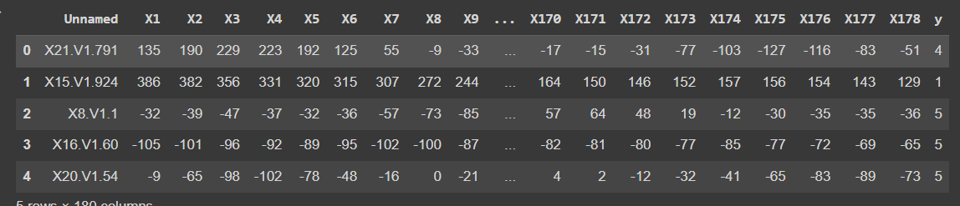 Long-short-term-memory in Recurrent neural networks (RNNs) are very efficient and have been used to many different fields. A few well-known uses for LSTMs are as follows:

**Language Simulation**: Machine translation, language modeling, text summarization, and other natural language processing tasks have been performed by language support vector machines (LSTMs). They may be trained to create meaningful and grammatically sound sentences by learning the relationships between words in a sentence.

**Voice Recognition:** Speech-to-text transcription and command recognition are two voice recognition tasks for which Long Short-Term Memory (LSTM) systems have been used. They may be trained to recognize speech patterns and connect them to pertinent content.

**Sentiment analysis:** LSTMs may be used to classify text sentiment as positive, negative, or neutral by recognizing the relationships between words and feelings.

**Time Series Prediction:** By figuring out the connections between previous and future values, long short-term memory (LSTM) models may be used to forecast future values in a time series.

**b. Dataset collection and preprocessing**

The foundation of this study involved meticulous curation and collection of a comprehensive dataset encompassing a diverse range of patient records post-cardiac arrest. The dataset amalgamated anonymized information from multiple healthcare 14 facilities, collating details such as demographic characteristics, pre-existing medical conditions, pre-hospital interventions, initial cardiac rhythms, duration of resuscitation.

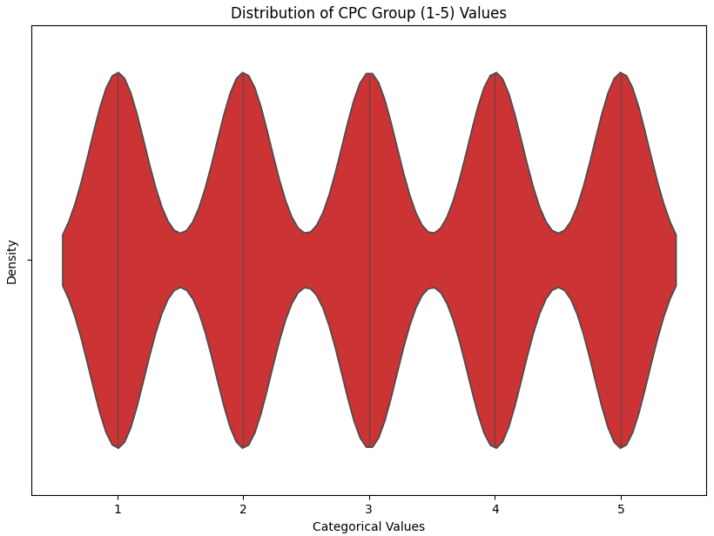efforts, post-resuscitation vital signs, laboratory values, and neurological assessments. Rigorous quality checks and data preprocessing steps were undertaken to ensure uniformity, completeness, and accuracy of the dataset. Missing data points were managed using appropriate imputation techniques, and feature normalization and scaling were implemented to standardize the input variables, optimizing them for model training.

Fig.3 CPC distribution in dataset

The obtained data set consists of 200 combinations of different EEG signal channels of 11500 patients. The data has been

Fig.4 Dataset description

obtained by keeping ethical considerations and patients’ privacy in mind to obtain a fair predictive model.

The preprocessing starts with eliminating null values and cleaning data by replacing null values in many ways such as medians and continuous mean.

1. Data points are studied for their statistical information such as skewness, mean, varience, standard deviation to obtain some fruitful conclusions based on numerical observations.
2. It is seen that the data points are negatively skewed with very high varience.
3. Data being recorded in continuous analog waveforms, during conversion into digital values, null points are not observed.
4. The 5 output classes are uniformly distributed among 2300 rows each i.e. Each output class has a frequency of 2300.
5. In order to make the data interpretable by the model and classify as good or bad, we now edit the output column and replace with binary values. Specifically, we replace {1,2} with {1} and {3,4,5} with {0}. This further indicates that the output {1} indicates a good and recoverable outcome for the respective patient, while {0} indicates bad to worst outcomes of the patient that require immediate attention.
6. Post modification we have {1} count as 4600 and {0} count as 6900 which creates non uniform distribution of data for efficient learning process.
7. The Obtained data points are oversampled in order to have proper and uniform distribution of output points i.e. {1} count becomes 9073 and {0} count becomes 9069.
8. In addition, the data frame is divided into training and testing phases at a ratio of 3:2. The testing data is again split in the ratio 1:1 to have validation dataset as well using python libraries.
9. The testing data is again split using python.

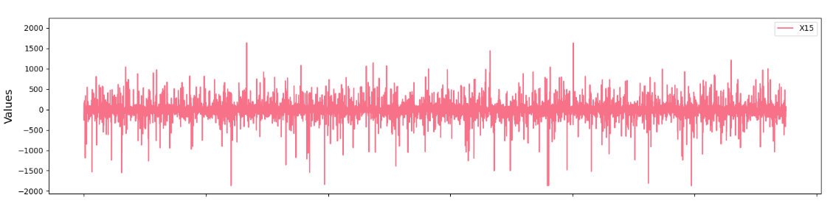

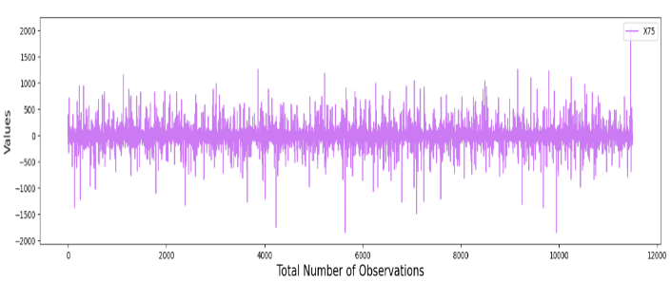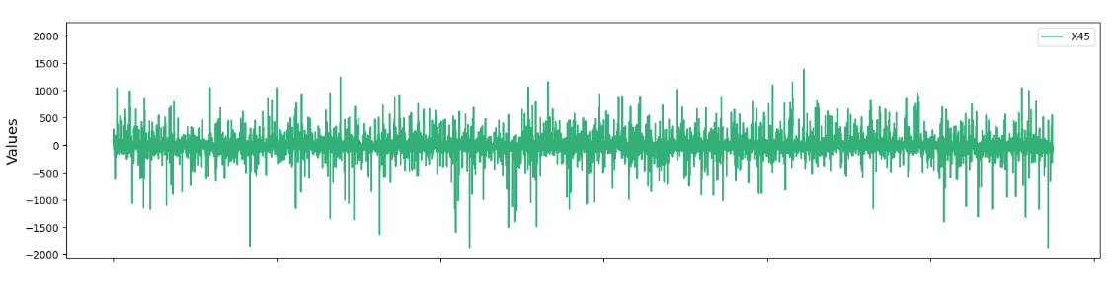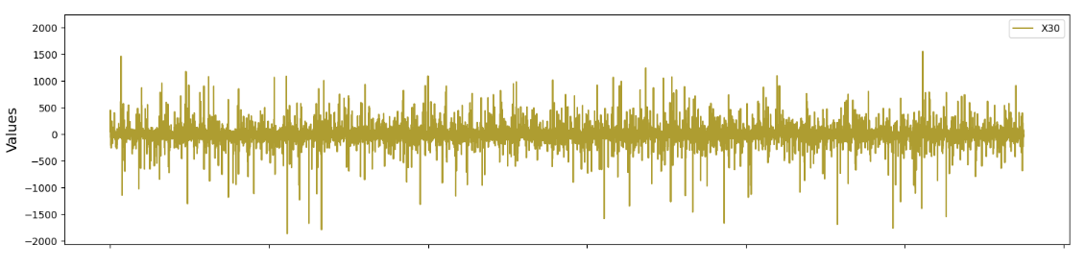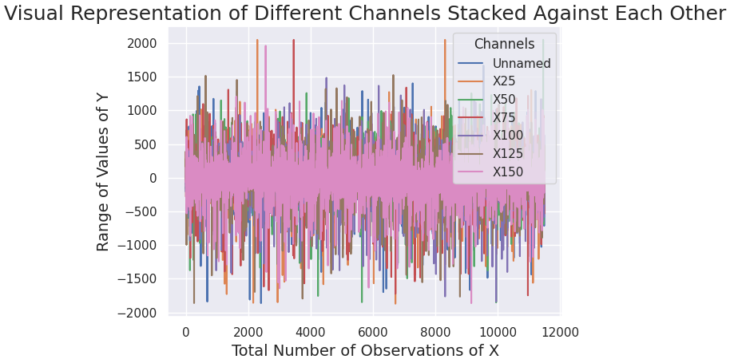

Fig. 5 Independent signal plots vs Stacked signal plots

**c.Model development and architecture**

The heart of this study lay in the construction and refinement of a deep neural network tailored for the specific task of predicting neurological recovery post-cardiac arrest.

Depending on the kind of input data, the model architecture used a carefully planned arrangement of layers to utilize the most recent deep learning approaches, including recurrent neural networks (RNNs), convolutional neural networks (CNNs), or a mix of both. In order to reduce overfitting, hyper-parameter optimization was used to improve the network's architecture, including the number of layers, neuron units, activation functions, and dropout rates.

Furthermore, various loss functions and optimization algorithms were explored to enhance the model's performance.

1. Multiple LSTM units are arranged in a neural network structure with multiple layers to have human brain like learning. The use of LSTM structures proves efficient in learning time dependent data.
2. The first layer of the network consists of 128 LSTM units, which are responsible for taking in inputs and based on the applied threshold give out the processed data.
3. The second layer of the network consists of 64 LSTM units, which are responsible for processing partially processed data given by first layer, also is termed as a hidden layer and comes up with fewer output classes for further layers.
4. 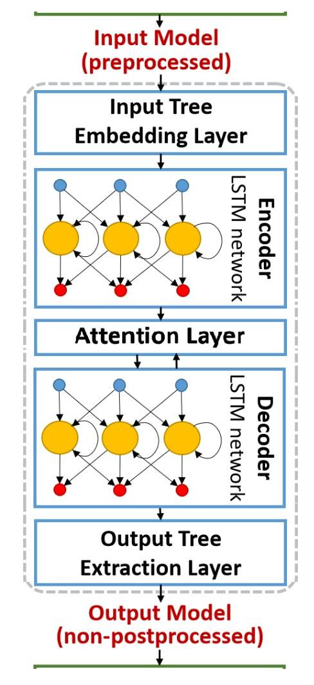Third and output layer is responsible for acting as final unit of the network consisting of a single unit

Fig. 6 Model architecture

of LSTM whose output is the full processed data and can be used for research purposes and 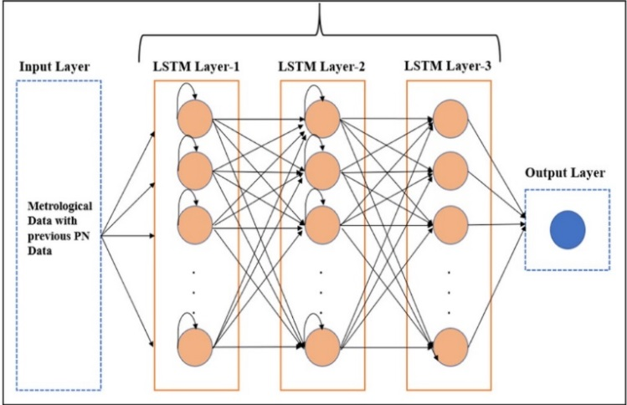commercial purposes as well.

Fig. 7: LSTM layers formation

**d. Train model and validate**

In order to preserve class balance, the dataset was divided into training, validation, and test sets using suitable techniques such stratified sampling. The training set was subjected to a large number of training iterations for the model, along with frequent validation checks to ensure that overfitting was avoided. The robustness and generalizability of the model were guaranteed by employing strategies like bootstrapping and cross-validation. A variety of measures, including as accuracy, precision, recall, F1-score, and receiver operating characteristic (ROC) curve analysis, were used to assess the model's performance in order to determine its predictive power and discriminatory capacity over a range of thresholds..

The training and testing data sets are randomized to be divided 7:3. Moreover, the exam is divided into three equal parts for validation and final testing. Scikit library provides the Python libraries required in the procedure.

Further, post training and development of the model.

In order to reduce the errors and improve the prediction accuracy of the model, validation is performed. The proper division of available testing data is to be done so as to cover all the critical points where there is high chance of wrong or erroneous performance of the model. After each epoch / attempt to train the model, validation checks are applied and based on the obtained accuracy levels the corresponding parameters are tuned within the model, such as, randomization of inputs and varying the weights of significant and insignificant input values.

This process is continued till a threshold level of accuracy is reached or there is betterment in the learning seen for few consecutive epochs of training.

The final stage of the model validation is done based on plots of AUC (Area Under Curve) scores, ROC curve which further is calculated based on number of true positives and false positives obtained during testing process. The higher the AUC score, the higher will be the prediction accuracy of the model.

Another measure of validating a model is using precision vs recall locus.

|  |  |
| --- | --- |
| Area-under-curve (A.U.C) | Meaning |
| 0.9 <=A.U.C | Outstanding |
| 0.8<=A.U.C<0.9 | Good |
| 0.7<=A.U.C<0.8 | Fair |
| 0.6<=A.U.C<0.7 | Poor |
| 0.5<=A.U.C<0.6 | Failure |

Fig. 8: AUC Interpretation

# **Ethical considerations and bias mitigation**

Ethical guidelines and privacy protocols were strictly adhered to throughout the data collection and analysis process to safeguard patient confidentiality and comply with regulatory standards. Additionally, steps were taken to address potentially short variations in healthcare practices across different institutions. Techniques like bias correction, fairness metrics

evaluation, and sensitivity analyses were employed to minimize biases and ensure the model's fairness and reliability across diverse patient populations.

The data signals obtained were carefully converted into a table of digital values using mathematical formulas and online available converters.

# **results**

1. **Metrics:**

Analyzing models performance is an important task as it allows us to understand better the mechanism followed to come up with a final output and to have a better comparison of expected and predicted outputs. This can be done in various ways such as error matrices for regression tasks and accuracy measurements for discrete output values. Either of these methods give fruitful information about the trained model, its architecture and learning methods. Which are further useful to help us improve the performance of the model in prediction of neurological recovery post cardiac arrest of patients.

1. **ROC (Receiver operating characteristics curve):**

A Receiver Operating Characteristic (ROC) curve is a graphical depiction of a binary classification model's performance over a range of classification criteria. Plotting the True Positive Rate (sensitivity) versus the False Positive Rate (one-specificity) is done. The ROC curve makes it simpler to identify the trade-offs between sensitivity and specificity at various decision levels. AUC-ROC has a range of 0 to 1, with 1.0 denoting ideal discrimination and 0.5 denoting no discrimination. Better performance in differentiating between the positive and negative classes is shown by a higher AUC-ROC.

AUC-ROC is particularly useful when dealing with imbalanced datasets or when the costs of false positives and false negatives vary.

**Interpreting A.U.C-R.O.C:**

When the AUC is 0.5, the model performs no better than chance.

AUC values between 0.5 to 1.0 indicate a degree of discrimination in the model, with higher values corresponding to better performance.

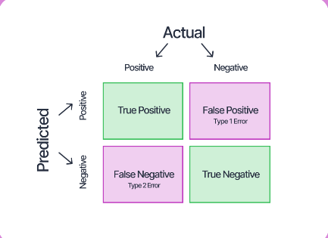The model attains perfect discrimination with an AUC of 1.0.

Fig. 9: Confusion matrix

1. **Precision recall:**

**Precision:** A classification model's precision is a measurement of how well its positive predictions turned out. It shows the part of correctly predicted positive cases over positive forecasts. The question "Of all the instances my model predicted as positive, how many were actually positive?" is answered with precision**.**

Mathematically, it’s the ratio of values which are actually true to all the positive values obtained.

***Precision* =**

**Recall (Sensitivity):** A classification model's recall is a statistic that shows how successfully it recognizes and captures all relevant occurrences of a positive class. It is also known as true positive rate or sensitivity at times. It displays the ratio of all actual positive events to the number of accurate positive forecasts. The question that remembers asks is, "Of all the actual positive instances, how many did my model correctly predict as positive?".

It is the ratio of genuine positives to the sum of false negatives and true positives, mathematically speaking.

***Recall* =**

1. **Accuracy**:

One important indicator of how close projected outputs are to actual values is accuracy. This statistic offers a broad assessment of how well the model predicts both positive and negative occurrences. Essentially, accuracy functions as a primary assessment criterion, providing information about the model's overall efficacy in a range of prediction scenarios.

***Accuracy* =**

1. **F1 Score:**

The F1-Score provides a thorough evaluation of a model's overall accuracy by utilizing a composite statistic that strikes a balance between recall and precision. The F1 score, a number between one and zero, shows how well the model aligns projected and expected values. An F1-Score of zero is acquired when there are no matches, and a score of one is obtained for a perfect match.

***F1 SCORE* =**

Fig. 10: Training loss vs Validation loss curve

Fig. 11: Training vs testing accuracy

# **DISCUSSION AND FUTURE SCOPE**

The application of the deep learning model yielded highly promising and encouraging results. The predictive capabilities of the model showcased commendable accuracy in categorizing and stratifying patients based on their likelihood of neurological recovery post-cardiac arrest. The model exhibited robustness in its ability to differentiate between varying degrees of neurological outcomes, effectively classifying patients into binary classes of good and bad outcomes. Notably, the evaluation metrics demonstrated impressive levels of sensitivity and specificity, affirming the model's proficiency in prognosticating neurological recovery. Additionally, the analysis of the model's performance revealed crucial insights into the influential factors driving predictive outcomes, shedding light on the significance of specific pre-hospital and post-resuscitation variables in determining neurological prognosis. The ensuing discussion delved deeper into the intricacies of the results, elucidating the pivotal role played by certain input features in shaping the predictive outcomes of the deep learning model. Noteworthy correlations were observed between pre-hospital interventions, physiological parameters during resuscitation, and subsequent neurological recovery. This analysis highlighted the critical impact of timely interventions, quality of cardiopulmonary resuscitation, initial cardiac rhythm, and other pertinent factors in influencing patient outcomes. Furthermore, considerations regarding the model's limitations and potential sources of bias were thoroughly examined, emphasizing the necessity for further refinement and validation to enhance its robustness and applicability in diverse clinical settings.

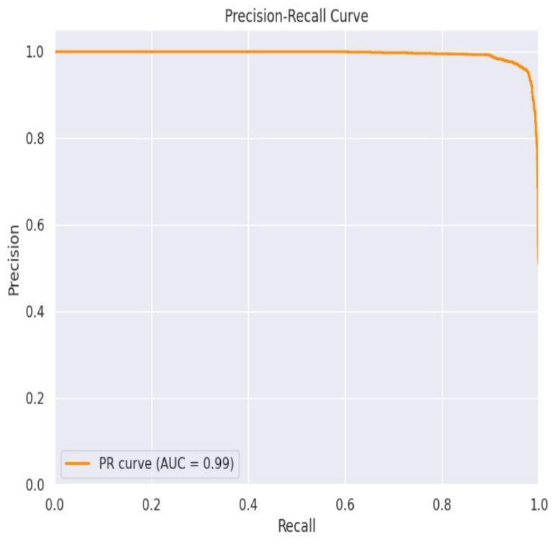Fig. 12: ROC curve

Fig. 13: Precision recall curve

From the above simulation, we clearly understand that there is tremendous change in technologies being used to solve data driven real-time problems. In the same regard , we aspire to perform various data augmentation techniques and make the data easily trainable by the machine learning models and ther emerging predictive tools. Observed predictions and learning from the Deep learning model provides clearer insights of significance of clinical and operational values obtained for research purposes.

# **references**

[1] C. Sandroni et al., “Prognostication in comatose survivors of cardiac arrest: An advisory statement from the European resuscitation council and the European society of intensive care medicine,” Intensive Care Med., vol. 40, no. 12, pp. 1816–1831, 2014.

[2] A. O. Rossetti, A. A. Rabinstein, and M. Oddo, “Neurological prognostication of outcome in patients in coma after cardiac arrest,” Lancet Neurol., vol. 15, no. 6, pp. 597–609, 2016.

[3] A. Sivaraju et al., “Prognostication of post-cardiac arrest coma: Early clinical and electroencephalographic predictors of outcome,” Intensive Care Med., vol. 41, no. 7, pp. 1264–1272, 2015.

[4] M. C. Tjepkema-Cloostermans et al., “Cerebral recovery index: Reliable help for prediction of neurologic outcome after cardiac arrest,” Crit. Care Med., vol. 45, no. 8, pp. e 789–e797, 2017.

[5] N. Ben-Hamouda et al., “Contemporary approach to neurologic prognostication of coma after cardiac arrest,” Chest, vol. 146, no. 5, pp. 1375–1386, 2014.

[6] Pothiawala S. Post-resuscitation care. Singapore Med J. 2017 Jul;58(7):404-407. doi: 10.11622/smedj.2017060. PMID: 28741014; PMCID: PMC5523091.

[7]Sedat Ozbay,Canan Akman,Neslihan Ergun Suzer,Ilknur Simsik,Mustafa Ayan,Orhan Ozsoy,Ozgur Karcioglu, Management of Post-Resuscitative Era in Patients with Cardiac Arrest: Post-Cardiac Arrest Syndrome, International Journal of Pharmaceutical Research and Allied Sciences, 12, 3, (78-87), (2023)

[8]Claudia Dos Santos, Leo Heunks, Hannah Wunsch. (2017) Update in Critical Care 2016. American Journal of Respiratory and Critical Care Medicine 196:1, 11-17.

Online publication date: 30-Jun-2017.

[9] A. Palagiri, F. Sadaka, and R. Lakshm, ‘Prognostication in Post Cardiac Arrest Patients Treated with Therapeutic Hypothermia’, Therapeutic Hypothermia in Brain Injury. InTech, Jan. 30, 2013. doi: 10.5772/55496.

[10] Hoiland RL, Rikhraj KJK, Thiara S, et al. Neurologic Prognostication After Cardiac Arrest Using Brain Biomarkers: A Systematic Review and Meta-analysis. JAMA Neurol. 2022;79(4):390–398. doi:10.1001/jamaneurol.2021.5598.

[11] Hoedemaekers C, Hofmeijer J, Horn J. Value of EEG in outcome prediction of hypoxic-ischemic brain injury in the ICU: A narrative review. Resuscitation. 2023 Aug;189:109900. doi: 10.1016/j.resuscitation.2023.109900. Epub 2023 Jul 5. PMID: 37419237.

[12] Ruijter, Barry & Hofmeijer, Jeannette & Tjepkema-Cloostermans, Marleen & van Putten, Michel. (2018). The prognostic value of discontinuous EEG patterns in postanoxic coma. Clinical Neurophysiology. 129. 10.1016/j.clinph.2018.04.745.

[13] Kim, YJ., Kim, MJ., Kim, Y.H. et al. Background frequency can enhance the prognostication power of EEG patterns categories in comatose cardiac arrest survivors: a prospective, multicenter, observational cohort study. Crit Care 25, 398 (2021).

[14] Benghanem, S., Mazeraud, A., Azabou, E. et al. Brainstem dysfunction in critically ill patients. Crit Care 24, 5 (2020).