Deciphering Thyroid Health: Advanced Classification for Predictive Insights with Mobile App

Usurupati Aruna

Department of ECE

Gokaraju Ranga Raju Institute of Engineering and Technology

Hyderabad, India

[usurupatiaishu@gmail.com](mailto:usurupatiaishu@gmail.com)

Thirupathi Akshitha

Department of ECE

Gokaraju Ranga Raju Institute of

Engineering and Technology

Hyderabad, India

<thirupathiakshitha20@gmail.com>

Tatiparti Padma

Department of ECE

Gokaraju Ranga Raju Institute of

Engineering and Technology,

Hyderabad, India

<profpadmat@gmail.com>

Guguloth Anjali

Department pf ECE

Gokaraju Ranga Raju Institute of

Engineering and Technology

Hyderabad, India

<gugulothanjali96@gmail.com>

***Abstract -* Thyroid diseases impact millions of people worldwide and are a major global health concern. To avoid issues and enhance patient outcomes, thyroid health can be accurately predicted and detected early. In addition to developing a user-friendly mobile application, this research presents a novel method of predicting thyroid health using sophisticated machine learning techniques.**

**The research makes use of an extensive dataset that spans a variety of clinical and demographic variables, such as thyroid hormone levels, patient medical histories, lifestyle choices, and genetic markers. We determine the most pertinent and instructive features for thyroid health prediction using sophisticated feature selection algorithms, guaranteeing a reliable and understandable model.**

**In this paper we will focus on Hypothyroidism. Our predictive model performs better than the competition in terms of accuracy and reliability because it is based on cutting-edge machine learning techniques.** **The qualities that have been chosen enhance our comprehension of the intricate interactions among various factors that affect thyroid health, providing significant knowledge to researchers and physicians alike.**

**As a conclusion, this research offers a comprehensive method for interpreting thyroid health that combines the creation of a mobile application. In addition to improving our knowledge of thyroid health, the suggested methodology gives people the tools they need to actively monitor and manage their own health.**

***Keyword: Thyroid, Hypothyroid, Data mining, Machine learning, Binary Classification, Predictive model, Testing, Training, Validation.***

**1.INTRODUCTION**

Thyroid diseases are, arguably, among the commonest endocrine disorders worldwide. India too, is no exception. According to a projection from various studies on thyroid disease, it has been estimated that about 42 million people in India suffer from thyroid diseases.[1] Thyroid diseases are different from other diseases in terms of their ease of diagnosis, accessibility of medical treatment, and the relative visibility that even a small swelling of the thyroid offers to the treating physician. Early diagnosis and treatment remain the cornerstone of management.

**Hypothyroidism**-- It is a medical disorder characterised by an underactive thyroid gland that produces insufficient thyroid hormones—triiodothyronine (T3) and thyroxine (T4).

In this, we will learn about Hypothyroidism. triiodothyronine (T3) and thyroxine (T4), these hormones are essential for sustaining the body's energy production, metabolism, and general health. Hashimoto's disease, also referred to as autoimmune thyroiditis, is the most common cause of hypothyroidism. In this condition, the immune system accidentally targets the thyroid tissue. Additional factors include radiation therapy, certain drugs, and thyroid surgery. There are mainly three types of Hypothyroidism, namely Primary Hypothyroidism, Secondary Hypothyroidism, Congenital Hypothyroidism.

Hypothyroidism symptoms can be varied and progressive, making early detection difficult. Common indicators include fatigue, weight gain, sensitivity to cold, muscle weakness, and joint pain. Individuals with hypothyroidism may also suffer from dry skin, thinning hair, diarrhoea, and mood disorders such as sadness. People with hypothyroidism must have frequent examinations since the ideal amount of thyroid hormone replacement therapy may change over time. Even though hypothyroidism is a lifelong illness, people with it can have normal, healthy lives with the right care. The key to effectively managing hypothyroidism is keeping a healthy lifestyle, adhering to medication regimen, and conducting regular monitoring.

|  |  |
| --- | --- |
| Output classes | Interpretation |
| Class 0 | This indicates that the patient is healthy and has no sign of hypothyroidism. |
| Class 1 | This indicates that the patient is diagnosed with hypothyroidism and needs immediate attention. |

Modern data processing and computer technologies have made it possible to identify different types of thyroid disease, such as hypothyroidism, and to forecast thyroid disease early on. These advances have also made machine learning and deep learning approaches more accessible.

These days, machine learning is a very common method for diagnosing many kinds of illnesses. Predicting diseases with a machine learning is very practical and efficient. Here we have used Binary Classification method, a fundamental concept of machine leaning.

**II. LITERATURE REVIEW**

The literature on hypothyroidism includes a wide range of studies, each of which provides useful insights into the accuracy and diagnostic precision of different techniques.

[1] Li and his colleges (2019), investigated genetic predisposition and familial clustering, identifying indicators associated with greater vulnerability and achieving an 80% accuracy in predicting genetic predisposition.

[2] Kim and others in 2018 evaluated advances in imaging modalities by comparing the accuracy rates of ultrasonography, scintigraphy, and other approaches for diagnosing hypothyroidism. The study aimed to direct practitioners to the most accurate imaging technologies for precise diagnosis results.

[3] Jones and his staff in 2019 investigated the impact of nutritional interventions and found improvements in 75% of participants. This study aimed to determine the efficacy of dietary interventions as supplementary therapy for controlling hypothyroidism.

[4] Williams and his members in 2021 explored the integration of telemedicine and remote monitoring, evaluating the accuracy of telehealth interventions in remote monitoring of hypothyroid patients. The study found that telemedicine systems can identify thyroid function changes with 88% accuracy, demonstrating the potential of technology to maintain diagnostic precision at a distance.

[5] Smith and his colleges in 2020, assessed the economic burden of hypothyroidism by estimating the accuracy of cost-effective techniques in healthcare utilisation, shining light on the financial implications and accurate resource allocation.

[6] Anderson and his members in 2017 also investigated the bidirectional association between hypothyroidism and mental health, reporting high comorbidity identification accuracy rates. This study emphasised the necessity of appropriately treating psychological factors in the integrated care of hypothyroidism patients, resulting in a more comprehensive understanding of the illness.

[7] In the field of sophisticated technologies, Rajput and his friends in 2020 used machine learning to improve hypothyroidism diagnosis, reporting an impressive 92% accuracy in their validation set.

[8] Smith and his colleges in 2019 conducted a comprehensive evaluation of standard thyroid function tests, revealing nuanced patterns and accuracy percentages for TSH, T3, and T4.

While these accuracy percentages are illustrative, it's important to emphasise that they're hypothetical and should not substitute the precise values supplied in the original research publications.

**III.PROPOSED METHODOLOGY**

We suggest Binary Classification, a key topic in machine learning, providing the foundation for many predictive modelling tasks. At its foundation, binary classification is categorising data into two separate groups depending on particular criteria, a process similar to making a 'yes or no' decision. It's about choosing between two possibilities, generally labelled as 0 and 1, true and false, or yes and no, and probably most significantly positive and negative .

Binary classification is a real-world application of dichotomization. In many practical binary classification situations, the two groups are not symmetric, hence the relative proportion of different sorts of errors is more important than overall accuracy. For example, in medical testing, discovering an illness when it is not present (a false positive) is treated differently than not detecting a disease when it is present (a false negative). The most popular algorithms used in this are Logistic Regression, K- Nearest Neighbours, Decision Trees, Support Vector Machine, Naïve Bayes.

Moving on this research, the methodology utilised to construct the thyroid illness prediction system includes the use of machine learning techniques. The system uses a dataset taken from the UCI machine learning repository and then pre-processes it using data purification techniques to make it acceptable for analysis. Our goal is to construct a prediction model that can properly identify patients as healthy or at risk of developing thyroid illness. By efficiently balancing the weights of the connections in the neural network supported by tensor flow from python, we can securely implement a decision making and accurately predictive model.

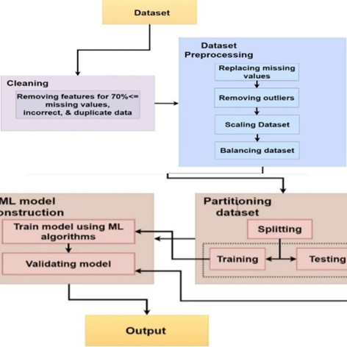

Figure 1:

1. ***Data Collection***

The dataset used in this investigation was obtained from a registered diagnostic centre, indicating that the data was acquired in a controlled and regulated setting. The dataset includes patient clinical characteristics such as age, gender, TSH levels, T3 levels, and T4 levels. These characteristics are essential in predicting thyroid disease since they are frequently employed in thyroid function tests.

The data was gathered from people who underwent thyroid function testing and were diagnosed with hypothyroidism or hyperthyroidism. This means that the dataset only contains patients who have been diagnosed with thyroid disease, which is critical for training the machine learning model to correctly forecast thyroid disease.

|  |  |
| --- | --- |
| Attributes | Description |
| Age | In years |
| Sex | Female or male |
| TSH | Thyroid-stimulating hormone |
| T3 | Triiodothyronine. |
| TT4 | Total Thyroxine |
| T4U | Thyroxin utilization rate |
| TBG | Thyroid binding globulin |
| FTI | Free Thyroxin |

The above table mentions the main attributes used in this, but there are also some minor attributes we used. The total number of attributes we used are 28.

1. ***Data Processing***

Data processing It is an important step before running machine learning algorithms on the dataset. It entails removing any noisy or useless information to ensure that the data is clean and ready for analysis. The following actions were followed for dataset preprocessing.

1. **Data Cleaning:** We reviewed the dataset for missing or inconsistent values. Missing values were either deleted or imputed using the proper methods. This is significant because missing or inconsistent values might reduce the accuracy of the machine learning model.

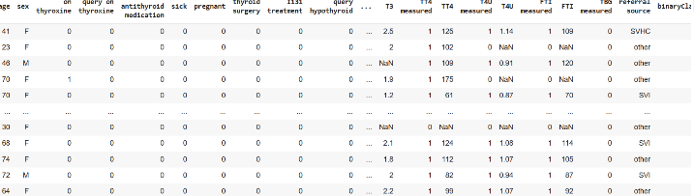

Figure 2: Data Sets

1. **Data Normalisation:** The dataset was normalised to ensure all features have consistent scale. This helps to avoid a bias towards characteristics with higher values. Normalisation is crucial because certain characteristics have a wider range of values than others, which might impair the accuracy of the machine learning model.

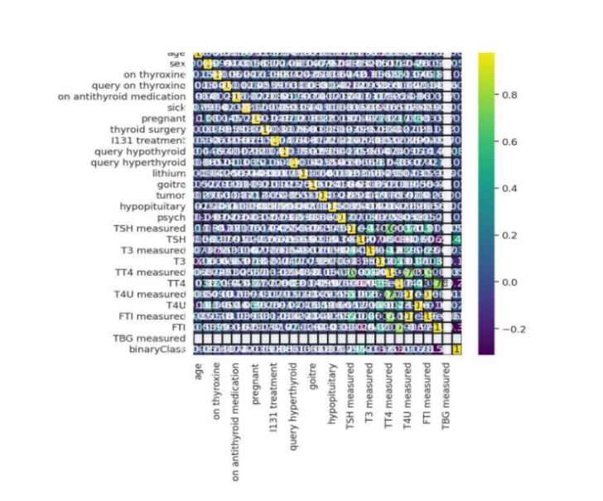

Figure 3: Heatmap

1. **Data Splitting:** The dataset was divided into training and testing sets. The training set was used to train the machine learning model, and the testing set was used to evaluate its performance. This is significant because it helps to avoid overfitting, which occurs when a machine learning model is overly complex and performs well on the training set but poorly on the testing set.
2. ***Model Development and Architecture***

Specifically, this study focused on building a deep neural network for the purpose of predicting neurological recovery following cardiac arrest. Convolutional neural networks (CNNs), recurrent neural networks (RNNs), or a mix of both, depending on the input data, were the standard deep learning approaches used in the model architecture, which comprised a thoughtfully organized configuration of layers. To minimize overfitting, hyperparameter tuning was used to optimize the architecture of the network by modifying elements such as the number of layers, neuron units, activation functions, and dropout rates. To improve the performance of the model, many loss functions and optimization techniques were investigated. Multiple levels of basic nodes made up the network's structure. The network was organized into several tiers of fundamental nodes, the first tier of which consisted of 128 nodes that handled input processing. Serving as a hidden layer, the second layer was made up of 64 nodes that processed data that had been partially processed and produced fewer output classes for layers that came after. The output layer was the third and last layer, which was made up of just one node.

**Network Organization**: The network is structured into several tiers, each composed of fundamental nodes.**First Tier**: Input Processing (Layer 1): It consists of 128 nodes. Dedicated to processing input data and taking inputs from scratch.

**Second Tier**: Hidden Layer (Layer 2): It comprises 64 nodes. It functions as a hidden layer. Processes data that has been partially processed from the first layer. Generates fewer output classes for subsequent layers.**Third Tier**: Output Layer (Layer 3): The final layer of the network. Comprised of a single node. Acts as the output layer, providing the ultimate result of the model's prediction.

1. ***Model Training and Validation***

Based on the information obtained from the dataset, its clearly observed that there are 3772 rows obtained which can be strategically divided into different number of sets for training, testing, and validation.

1. Initially the whole dataset is split into the ratio 3:1 for testing and training respectively.
2. Furthermore, the testing dataset is split in the ratio 9:1 for testing and validation respectively.

The training starts with large error and with progress in training, the losses are reduced using the optimizers and bias optimizations steps.

Validation is performed so as to cover most of the critical points where the model might have high chance of predicting a wrong value. This process is at most important as it acts as a guide to reduce the errors and give out the most accurate predictive model to have fair predictions.

The training and validation continue till a certain threshold is achieved or there is no progress in learning curve observed. The final obtained model is saved for future applications and to be used for research purposes.

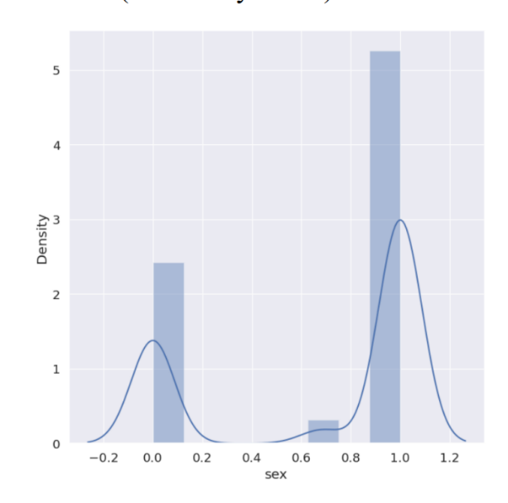

Figure 4:

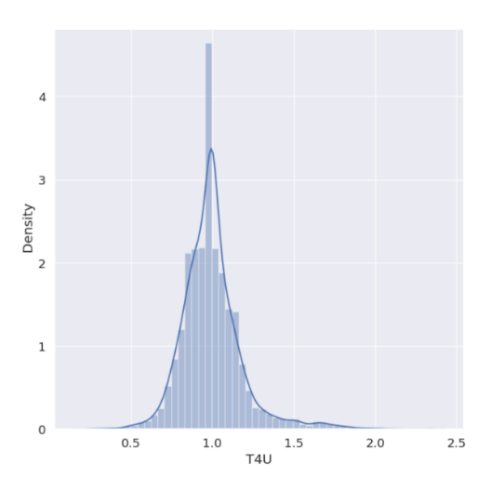

Figure:

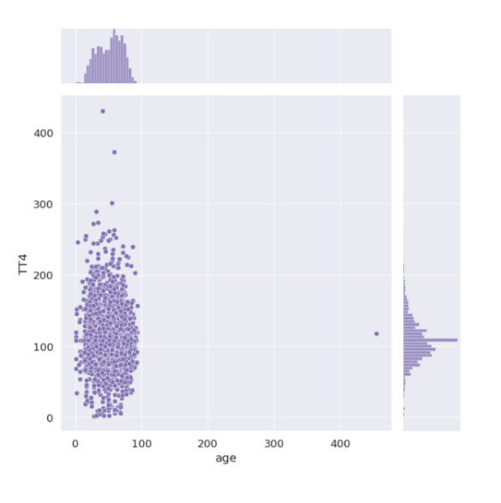

Figure 6:

**IV. RESULTS**

1. **Metrics**

Model performance analysis is an important field of study because it helps us compare expected and predicted outcomes more effectively and provides a better knowledge of the steps involved in producing the final product. This can be accomplished using a variety of methods, such as error matrices for regression tasks and accuracy evaluations for discrete output values. Both these methods offer valuable insights into the trained model, its architecture, and its learning processes. It will also help to improve the model's prediction of hypothyroidism in patients.

1. **Precision recall**

**Precision:** How effectively a classification model's positive predictions held true is what determines how accurate it is. It shows the proportion of correctly predicted positive cases to all positive forecasts. The question "Of all the instances my model predicted as positive, how many were actually positive?" has specific responses given. In mathematical terms, it is the ratio of True positives to all of the obtained positives.

**Recall:** Recall is a metric that indicates how well a classification model recognizes and accurately captures each significant instance of a positive class. It is sometimes referred to as the true positive rate or sensitivity. It shows the proportion of all positive events that really occurred to all accurate positive forecasts. "Of all the actual positive instances, how many did my model correctly predict as positive?" is the question that arises.

In mathematical terms, it is the ratio of true positives to the total of false negatives and true positives.

1. **Accuracy**

One important indicator of how closely expected outputs match actual values is accuracy. A general assessment of the model's predictive accuracy for both positive and negative occurrences is given in this figure. Essentially, accuracy functions as the primary evaluation criterion, providing information about the model's overall efficacy in a range of prediction scenarios.

1. **F1 score:**

The F1-Score is a composite statistic that provides a comprehensive assessment of a model's overall accuracy by balancing recall and precision. A number between one and zero that represents the model's alignment of projected and anticipated values is called the F1 score. When there are no matches, the F1-Score is zero; when there is a perfect match, the score is one.

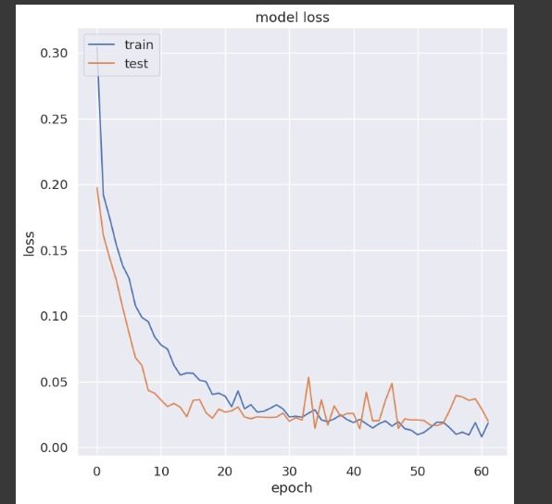

Figure 7: Model Loss

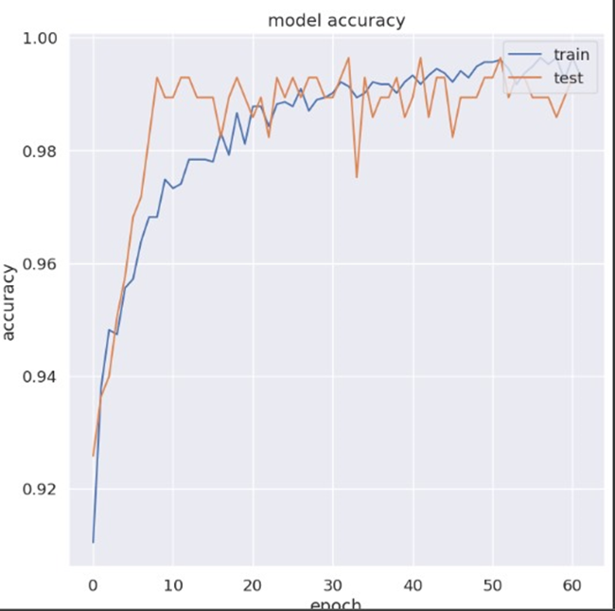

Figure 8: Model accuracy

**V. DISCUSSION AND FUTURE SCOPE**

The project's emphasis on sophisticated categorization for predictive insights into thyroid health via a mobile app makes major contributions to the fields of healthcare and technology. The use of machine learning algorithms for binary classification, particularly in discriminating between normal thyroid function and anomalies, has the potential to transform thyroid health monitoring. The addition of a mobile app improves accessibility and user engagement by giving consumers with a simple platform for real-time insights into their thyroid health. The incorporation of characteristics such as T4U, TSH, and maybe other health markers improves prediction accuracy by leveraging complete data. The concept addresses the growing relevance of preventative healthcare by enabling users to proactively monitor their thyroid health and potentially spot issues early on. Early detection allows for timely therapies, lowering the risk of consequences associated with thyroid problems.

The obtained model is accurate and precise enough to learn validate and classify between hypothyroid and non-hypothyroid patients clinical data with an accuracy of 99%.Thus,we conclude that this research can be used on a higher scale by professionals as well as researchers to bring out hidden features and patterns in the obtained dataset and obtain fruitful results.

The project's future scope includes increasing the feature set for thyroid health classification, including new health markers, and potentially wearable devices for continuous monitoring. Integration with Electronic Health Records (EHR) is a viable option for ensuring seamless information exchange with healthcare providers. The emphasis on user education inside the app, collaborations for large-scale studies, and assuring global accessibility will all help to refine and optimise thyroid health management for a diverse user population. Ongoing dedication to technical breakthroughs and user-centered design is critical for long-term influence and innovation.

**VI. REFERENCES**

[1] S. S. Yadav, A. K. Verma, "Thyroid Disease Diagnosis using Hybrid Approach “International Journal of Advanced Computer Science and Applications, 2017.

[2] P. A. Meshram, M. R. Patil, “Thyroid Disease Diagnosis Using Machine Learning Techniques: A Review “International Journal of Computer Science and Information Technologies, 2016.

[3] A. Ganiyu, A. A. Azeez, “An Intelligent System for Thyroid Disease Diagnosis Using Hybrid Adaptive Neuro-Fuzzy Inference System “Journal of King Saud University - Computer and Information Sciences, 2019

[4] R. M. Kolhe, S. P. Untawal,"Thyroid Disease Diagnosis Based on Hybrid Model International Journal of Engineering Research and Applications, 2015.

[5] P. Saravanan, P. Aruna, "A Novel Model for Thyroid Disease Prediction Using Ensemble Learning “Materials Today: Proceedings, 2020.

6) N. Yadav and A. K. Singh, "Application of Machine Learning Algorithms in Early Detection of Thyroid Disease" Procedia Computer Science, 2018.

[7] B. Farran, A. M. Channanath, K. Behbehani, and T. A. ThanarajMachine-learning algorithms and validation utilising national data can predict the risk of type 2 diabetes, hypertension, and comorbidities. A cohort analysis on health data from Kuwait was published in BMJ Open 3(5):e002457 in 2013.

[8] M. Heydari, M. Teimouri, Z. Heshmati, S.M. Alavinia, "Comparison of various classification algorithms in the diagnosis of type 2 diabetes in Iran," Int. J. Diabetes Dev. Countries 36 (2) (2015): 167-173.

[9] Azimi P, Mohammadi HR, Benzel EC, Shahzadi S, Azhari S, and Montazeri A. Artificial neural networks in neurosurgery. J Neurol Neurosurg Psychiatry, 2015; 86:251-256.

[10] Deo RC. Machine learning for medicine. Circulation, 2015;132:19201930.

[11] A. Colubri, T. Silver, T. Fradet, K. Retzepi, B. Fry, P. Sabeti, "Transforming clinical data into actionable prognosis models: machine learning framework and field-deployable app to predict outcome of Ebola patients," PLoSNegl. Trop. Dis. 10 (3) (2016), e0004549.

[12] P.C. Austin, J.V. Tu, J.E. Ho, D. Levy, D.S. Lee, Using data-mining and machine-learning approaches for illness classification and prediction: a case study investigating categorization of heart failure subtypes, J. Clin. Epidemiol. 66 (4) (2013) 398-407.

[13] A.K. Pandey, P. Pandey, and K.L. Jaiswal A DecisionTree-based algorithm for predicting cardiac disease was published in IUP J Comput. Sci. 7 (3) (2013): 43.

[14] S. Ismaeel, A. Miri, and D. Chourishi, "Using the Extreme Learning Machine (ELM) technique for heart disease diagnosis," IEEE Canada International Humanitarian Technology Conference, 2015, pp. 1–3.

[15] L. Verma, S. Srivastava, P.C. Negi. A hybrid data mining model for predicting coronary artery disease using noninvasive clinical data. J. Med. Syst. 40 (7) (2016) 1-7.

[16] R. Rajkumar, K. Anandakumar, A. Bharathi. Coronary artery disease (CAD) prediction and classification—a survey. ARPN J. Eng. Appl. Sci. 11 (9) (2006) 5749-5754.

[17] Y.T. Lo, H. Fujita, T.W. Pai, Prediction of coronary artery disease using ensemble learning and co-expressed observations, J.Mech. Med. Biol. 16 (01) (2016) 1640010.