Angular: (<https://developer.mozilla.org/en-US/docs/Web/API/Document>)

1. What is component in angular ?

<https://www.youtube.com/watch?v=16rQyEQtpyQ&t=423s>

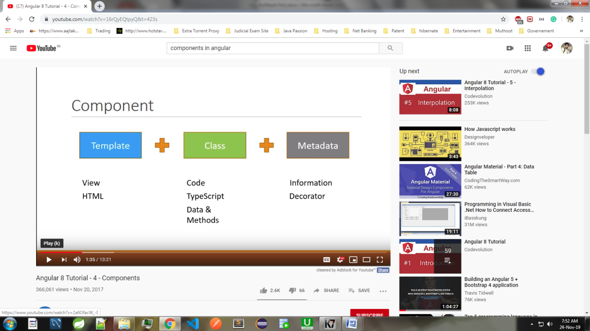

Component consists of 3 things HTML Template(View),Class and Metadata.

HTML Template:

* It is View that can be created using HTML.
* It is User Interface for your Application.

Class:

* It is a code that supports HTML View that is created using TypeScript.
* It contains variable and methods to control HTML elements i.e show or Hide in DOM.
* Class is always attached with Metadata.

Metadata:

* It is feature of TypeScript
* Metadata is defined using decorator to give idea to Angular whether it is a regular class or a component.
* @[Component](https://angular.io/api/core/Component)() decorator is a function that provides information about class
* selector: is a custom HTML tag to represent the component.
* templateUrl: points to HTML file that represents view for this component OR
* template:'<div> Testing </div>' ---->>>Write only template keyword when you write HTML code is .ts file
* styleUrls: points to CSS file that is specific to this component only. OR
* style:[' div { color:red ; }'] --->>Write only style keyword when you are writing css in .ts file

1. What is service in angular ?

Services are a great way to share information among classes that don't know each other.

@Injector() decorator is required by service class if you are injecting other services like HttpClient.

If there is no other service injected into service then @Injector() decorator is optional.

like below picture

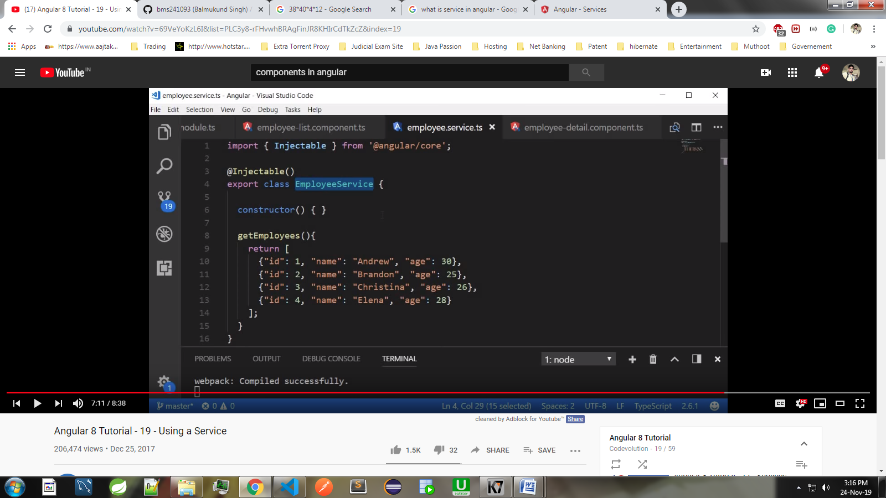

1. Different types of services in angular ?

HttpClient and Router Service

1. What is angular directives and different types directives in angular ?

<https://www.youtube.com/watch?v=kfUOqksBOpU>

Directives are elements which change the appearance or behavior of the DOM element.

Directives of 3 types

* Components: Component is also a type of directives with template ,style and logic that reflects in DOM element.
* Structural: Change DOM by adding or removing elements i.e *ngIf remove from DOM
* Attribute: Change the appearance or behavior of the DOM element. There are 2 built-in Attribute Directive in angular NgStyle and ngClass:

1. Which Component is root component in Angular ?

AppComponent

1. What is binding in angular

<https://www.youtube.com/watch?v=_W0udgI0QvA>

Data is passed from component to view or view to component

Sync between View and javascript model

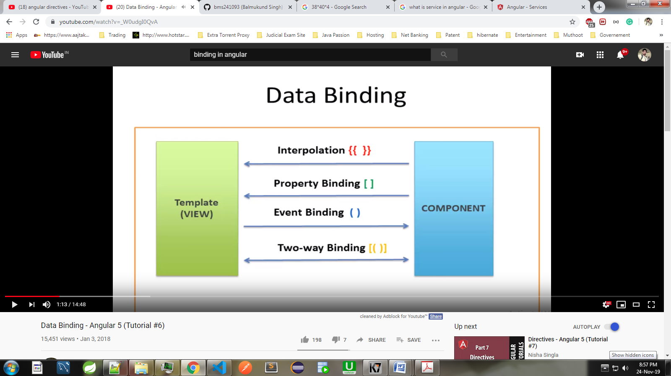 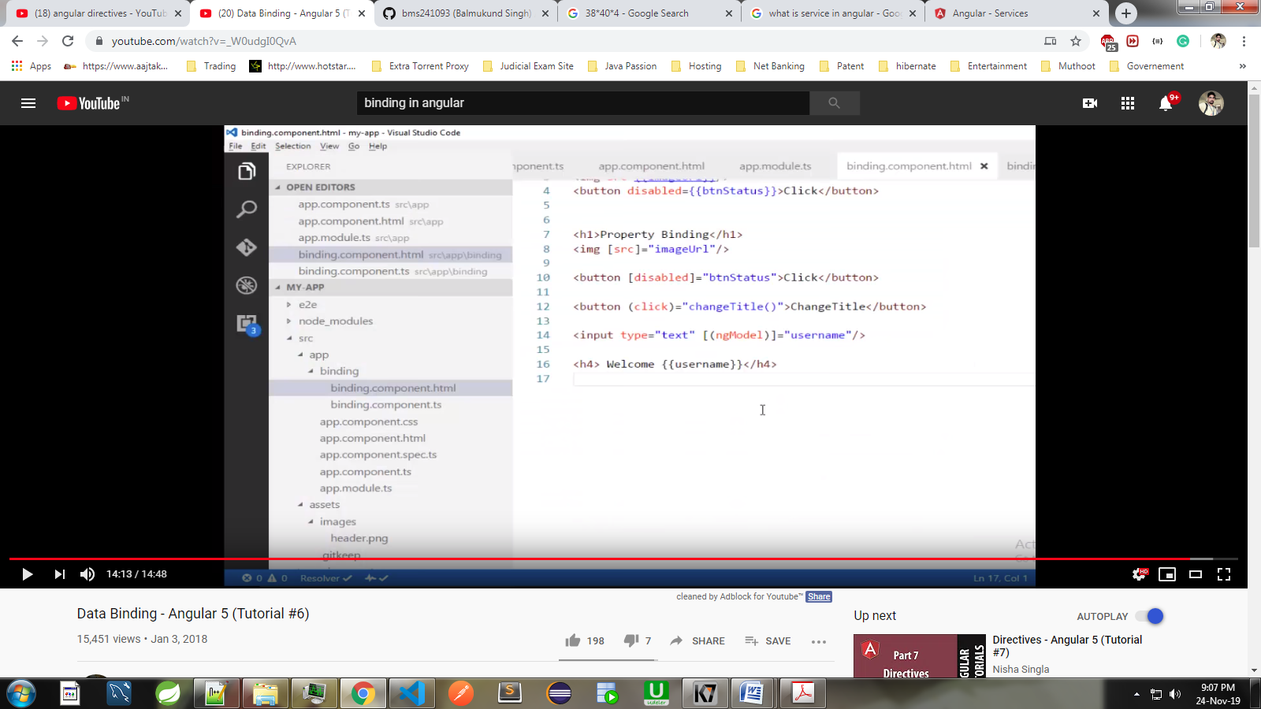

1. What is Angular Modules ? (declarations,imports,providers,bootstrap------>>>>DIP-B)

An NgModule*,* which provide a compilation context for components.

An NgModule can associate its components with services, to form functional units.

1. What is Angular models ?
2. What is Angular lifecycle hooks ?
3. What do you mean by subscribe ?
4. What is Subject and BehaviourSubject ?

Subject is a Observables , it uses next() method  
To pass value to other component.  
U cannot set initial value in subject.  
  
In BehaviourSubject we can set initial value  
i.e username = new BehaviourSubject ('Bms');

1. What is Angular Form ??

If u r using   
<form #empForm="ngForm"> tag in html with [(ngModel)]  
Then u have to use name attributes name="fullname".  
2. empForm is Template Reference Variable.  
3. Angular creates Form Model for us that keep track of all form controls  
4. {{ empForm | json }}

1. What is the difference between Let , Var and Const ?

a) let and const are blocked-scope but var is not block scope.  
b) var becomes window object i.e window.objectName but let and const are not window object.  
3) var and let have option of initialisation but const has to be initialised while declaration.  
i.e  
var a;   
a='bms';

1. What is difference between Promises and Obserables ?

Promise:  
a)To handle the promise we use then method.  
b)It has two parameters that call callback function  
onfulfilled: call back function called when promise is fulfill means it is called when request is completed  
Onrejected : call back function called when promise is rejected means it is called when request is rejected  
  
OBSERVABLES:  
a) subscribe method has three parameters Next, error and complete ().

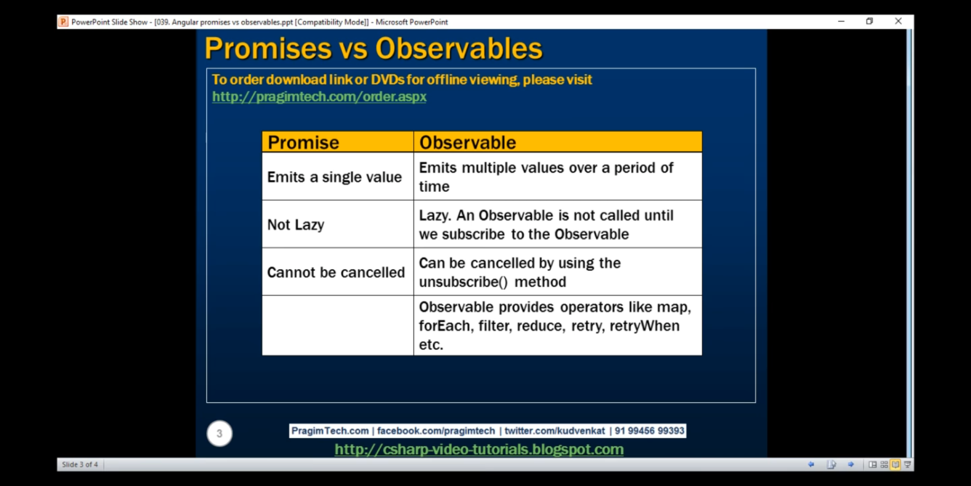

1. What is Router Outlet <router-outlet> ?
2. What is Template driven form ?
3. What is Route Gaurd in angular ?
4. Flow of angular application ?
5. What is Routing in angular ?
6. What is Lazy Loading ?
7. What is Angular Caching ?

Core Java:

1. For and forEach difference ?
2. What is Singleton class ?

Singleton one instance per class loader.

1. What is immutable class ?

There are many immutable classes like String, Boolean, Byte, Short, Integer, Long, Float, Double etc. In short, all the wrapper classes and String class is immutable.

1. What is autoboxing and unboxing ?
2. Can you override null pointer exception ?

The only way to handle null pointer exception is using OPTIONAL API in java 8.

1. Why do we need collection API ?
2. Difference Between Collection Framework and Stream API ?

Collection is not lazy initialisation where as Streams API is lazy initialisation.

1. Disadvantages of collection framework ?
2. Factory Pattern in java ?
3. What is Serialization in java ?
4. What is transient keyword ?
5. Who takes more memory LinkedList or ArrayList ?
6. What is Shallow copy and deep copy ?
7. What is Volatile variable ?
8. Difference between Sleep() and wait() ?
9. What are the Memory area in java ?
10. What is Connection pool in java ?
11. Scopes of variables in java ?
12. Covariant return type ?
13. How comparator provides multiple sort of sequence.
14. Difference between HashMap , LinkedHashMap and TreeMap?

HashMap and LinkedHashMap both are same in nature but LinkedHashMap maintains insertion order.

LinkedHashMap allow one null key and multiple null values.

TreeMap do not allow null key but can have null values.

TreeMap maintains ascending order according to key values.

1. Difference between ConcurrentHashMap and HashMap ?

On one object, one thread can perform read and another thread can write at same object.  
But on one object two different threads cannot perform either read or write at the same time

1. Difference between Equal operater and equal method ?

String overrides equal method and checks for content .

StringBuffer do not override equal method , hence it checks for memory address.

Spring:

1. What are the scopes in spring ?
2. What is @Autowired , @Service and @Repository ?
3. Why do we use ViewResolver and Multipart Resolver?
4. When to use setter injection and constructer injection ?
5. Difference between After advice and after returning advice ?
6. What are the Error Codes in REST APIs ?

Hibernate:

1. What are the scopes in spring ?
2. What is @Autowired , @Service and @Repository ?
3. What is default fetch type for hibernate relationship ?

By default, the JPA @ManyToOne and @OneToOne annotations are fetched EAGERly, while the @OneToMany and @ManyToMany relationships are considered LAZY. This is the default strategy of Hibernate.

1. Tell me about Hibernate relationship ?
2. What is JDBC Template ?
3. How to create composite key using hibernate ?
4. Why do we use ViewResolver ?
5. What is Dialect in spring ?
6. Isolation and propogation in transaction ?
7. What is the use of Session factory ?
8. Hibernate is stateless or statefull ?
9. How to configure transaction in project ?
10. What is Commit and flush ?
11. Who holds second level cache data ?

SessionFactory

1. What is Criteria query in hibernate ?

It is use to create Dynamic Query.

Database:

1 . What is index ??

Index Itself a database object that only holds the column data on which index is applied. There are two types of index   
 A clustered index can be applied only on one table.  
A non-clustered index can be applied to multiple columns in one table.

There are few implementation of index i.e Balance Tree, BITMAP etc.

2. Views and Materialize Views ?

3. Type object in Oracle ?

4. What is Trigger ?

5. What is Cursor ?

6. Order of execution of sql command ?

7. Difference between Primary Key and Unique Key ?

Primary Key is used to identify a row (record) in a table, whereas Unique-key is to prevent duplicate values in a column . Primary key column won't allow null value but Unique Key column allow multiple null values.

8. What is default index provided by SQL Engine ?

. Indexing: By default SQL-engine creates Clustered Index on primary-key if not exists and Non-Clustered Index on Unique-key.

9. What are the new features introduced in Oracle 12c ? (IITC)

a. Now you can provide multiple indexes on one column. Earlier 1 column= 1 index  
b. Parent child relationship u can delete parent data by cascade constraint.  
c. Trigger can be now disable. Earlier we have to drop trigger if it not in use.  
d. Generated identity features has been introduced.

10. What is 1st and Second phase in database ?

11. How do you create connection pool ?

12.