PLSQL Interview Question:

**DDL - Data definition Language**

**CREATE**: Create table with Primary Key

CREATE TABLE table_name (

emp_id INT,

emp_name VARCHAR(10),

emp_address VARCHAR(45),

mobile_no INT,

PRIMARY KEY (emp_id)

);

#Create table with Primary Key, Not Null, Unique and Auto Increment

create table table_name (

sr_no int **auto_increment**,

me_code varchar(15),

me_name varchar(25),

mobile_no int,

**primary key** (sr_no),

**UNIQUE INDEX** **me_code_UNIQUE** (me_code)

);

#Create table with Foreign Key

create table table_team(

team_name VARCHAR2(10),

team_profile varchar2(15),

emp_id int references table_name(emp_id)

);

ALTER:

a) Add Column

alter table table_name **add** **empid** int;

alter table table_name **add** **emp_address** varchar(45);

b)Remove Column

ALTER TABLE table_name **DROP** me_address;

ALTER TABLE table_name **DROP** column me_adhar_no;

c)Modify Column

alter table table_name **MODIFY** **emp_address** varchar(45);

alter table aksh4 modify mobile_no **bigint**;

d)Rename Table name

alter table table_name **rename** to table_name2 ;

e)Constraints Modify

alter table table_name add **UNIQUE INDEX** me_code_UNIQUE (me_code);

alter table table_name add constraint foreign_key_name foreign key (team_id) references table_name(emp_id);

e.g

alter table table_team add constraint foreign_key_name foreign key (emp_id) references table_name(emp_id);

CONSTRAINTS:

Primary Key: In Single table only on primary key is allowed

Foreign Key: One table can have multiple foreign key column

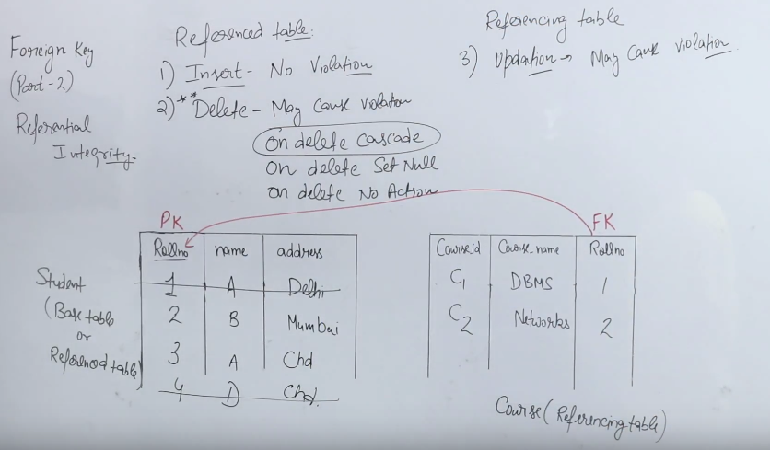

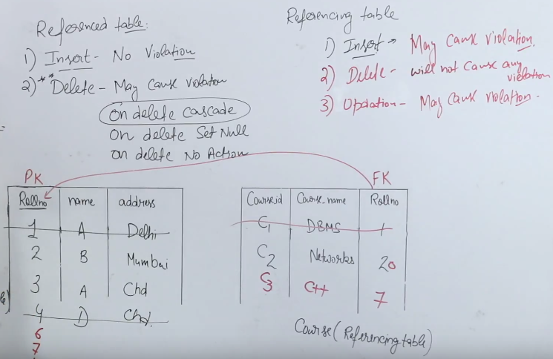

DROP:

drop table table_name;

TRUNCATE:

truncate table table_name;

**DML - Data Manipulation Language (DISU)**

**SET SQL_SAFE_UPDATES = 0;**

**SELECT :**

**LIKE CONDITION**

**select * from table_name where me_name like '%Sushil%';**

**select me_code,me_name from aksh4;.**

**select * from table_name:**

**SELECT COUNT(*) FROM CITY;**

**SELECT * FROM CITY order by Population asc;**

**SELECT * FROM CITY order by id desc;**

**SELECT * FROM CITY WHERE NAME='Kabul';**

**select * from city where countRycode='NLD' and district='Noord-Holland' and id=25;**

**select * from city where id between 100 and 105;**

**INSERT:**

**insert into table_name (empid,empname,empaddress) values (95,'sushil','mumbai');**

**insert into table_name (emp_name) values ('sushil');**

**UPDATE:**

**update** table_name **set mobile_no=8007306992461121458;**

**UPDATE** table_name **SET emp_add = 'navi mumbai' where sr_no=16;**

**UPDATE** table_name **SET EMP_NAME ='BMS';**

**DELETE:**

**delete from** table_name **where sr_no between 4 and 7;**

**Sequence:**

**CREATE SEQUENCE customers_seq**

**START WITH 1000**

**INCREMENT BY 1**

**NOCACHE**

**NOCYCLE;**

**E.g We have specify SEQUENCE**

**insert into aksh4 (SR_NO,me_code,me_name,mobile_no) values (SEQ_SR_NO.NEXTVAL,'A113','Sushil33',1234567892);**

**Auto Increment:**

**ALTER TABLE** table_name **AUTO_INCREMENT = 2000;**

**e.g No need to specify sr_no in insert query**

**insert into aksh4 (me_code,me_name,mobile_no) values ('A113','Sushil33',1234567892);**

**SELECT * FROM COLLEGESTD;**

**SELECT * FROM DEPT;**

**INSERT INTO COLLEGESTD (STD_ID,STD_NAME,STD_ADDRESS,MOBILE_NO,DEPT_ID) VALUES (6,'bhumi','delhi',78794563,102);**

**update COLLEGESTD set dept_id=100 where std_id=1;**

**select COLLEGESTD.std_id,COLLEGESTD.std_name,dept.std_name,COLLEGESTD. mobile_no from COLLEGESTD**

**join DEPT**

**on COLLEGESTD.dept_id = dept.dept_id**

**where COLLEGESTD.std_id in (select max(COLLEGESTD.std_id) from COLLEGESTD group by COLLEGESTD.dept_id) ;**

**MySQL Database**

**PL/SQL:**

**Example 1:**

**CREATE DEFINER=`root`@`localhost` PROCEDURE `addition_proc`(IN FIR int,IN SEC int,OUT THI int)**

**BEGIN**

**set THI=FIR+SEC;**

**END**

**To run:**

**set @FIR=10, @SEC=20 ;**

**CALL addition_proc(@FIR,@SEC,@THI);**

**select @THI;**

**Example 2:**

**CREATE DEFINER=`root`@`localhost` PROCEDURE `city_list`(IN CITY_ID INT, OUT CITY_NAME VARCHAR(255) )**

**BEGIN**

**SELECT NAME INTO CITY_NAME FROM CITY WHERE ID = CITY_ID;**

**END**

**To Run:**

**set @CITY_ID=2;**

**CALL city_list(@CITY_ID,@CITY_NAME);**

**SELECT @CITY_NAME;**

**SEQUENCE:**

**SELECT SEQ_MERCHANTCODE.NEXTVAL FROM DUAL;**

**DESC TABLE_NAME;**

**VIEWS:**

**FUNCTIONS:**

**TRIGGERS:**

**Joins IN SQL**

**NATURAL JOIN: if you are using natural join keyword in between then e_no should be same in both table , otherwise use (crossproduct + where conditions)**

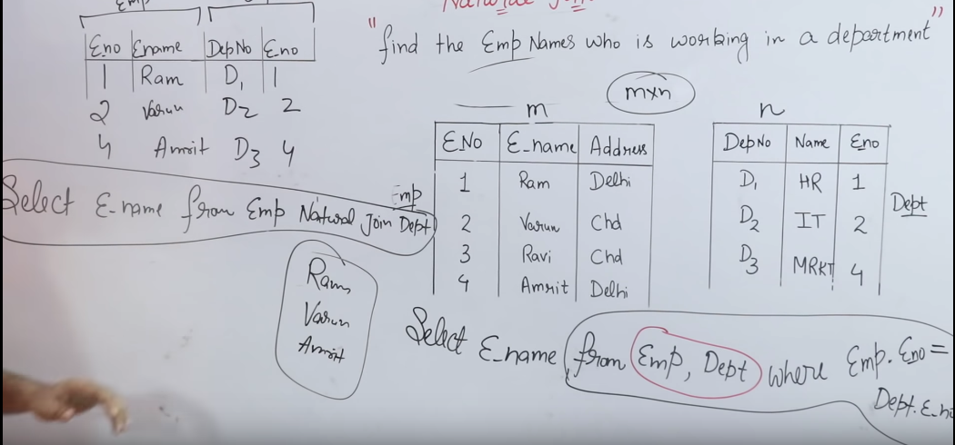

**Example 1:**

**CREATE OR REPLACE PROCEDURE PROC_EMPLOYEE(EMPNAME IN VARCHAR2,ADDRESS IN VARCHAR2,MOBILENO IN INT)**

**AS**

**SEQID INT;**

**BEGIN**

**SEQID :=SEQ_MERCHANTCODE.NEXTVAL;**

**INSERT**

**INTO TABLE_NAME**

**(**

**EMP_ID,**

**EMP_NAME,**

**EMP_ADDRESS,**

**MOBILE_NO**

**)**

**VALUES**

**(**

**SEQID,**

**EMPNAME,**

**ADDRESS,**

**MOBILENO**

**);**

**COMMIT;**

**DELETE FROM TABLE_NAME WHERE EMP_ID=(SEQID-5);**

**COMMIT;**

**DBMS_OUTPUT.PUT_LINE('HELLO WORLD');**

**END PROC_EMPLOYEE;**

**Example:2**

**create or replace PROCEDURE PROC_DEMO1 ( NUM1 IN NUMBER , NUM2 IN NUMBER , NUM3 OUT NUMBER ) AS**

**BEGIN**

**NUM3 := (NUM1+NUM2);**

**DBMS_OUTPUT.PUT_LINE(NUM3);**

**END PROC_DEMO1;**

***TO procedure execute using command:***

***declare***

***x number;***

***BEGIN***

***PROC_DEMO1(10,20,x);***

***end ;***

**To Create Package and inside package multiple procedure**

Package:

create or replace PACKAGE YOUR_PACKAGE_NAME AS

PROCEDURE GET_DATA ( MID VARCHAR2,FROMDATE DATE, MY_CURSOR OUT SYS_REFCURSOR ); END YOUR_PACKAGE_NAME;

create or replace PACKAGE BODY YOUR_PACKAGE_NAME AS

PROCEDURE GET_DATA ( MID VARCHAR2,FROMDATE DATE, MY_CURSOR OUT SYS_REFCURSOR )

IS BEGIN

IF MID IS NULL THEN OPEN MY_CURSOR FOR

SELECT * FROM TABLE_NAME1; ELSE

OPEN MY_CURSOR FOR

SELECT * FROM TABLE_NAME2;

END IF; EXCEPTION

WHEN OTHERS THEN RAISE;

END GET_DATA;

END YOUR_PACKAGE_NAME;

**Procedure:**

1. cannot return any values through the RETURN statement.

2. CREATE PROCEDURE instructs the compiler to create new procedure. Keyword 'OR REPLACE'

instructs the compile to replace the existing procedure (if any) with the current one.

3. Procedure name should be unique.

4. Keyword 'IS' will be used, when the procedure is nested into some other blocks. If the procedure is standalone then 'AS' will be used. Other than this coding standard, both have the same meaning.

EXAMPLE 1:

create or replace PACKAGE YOUR_PACKAGE_NAME AS

PROCEDURE GET_DATA (MY_CURSOR OUT SYS_REFCURSOR ); PROCEDURE GET_SINGLE_RESPONSE(P_RESPONSE OUT VARCHAR2);

END YOUR_PACKAGE_NAME;

--BODY

create or replace PACKAGE BODY YOUR_PACKAGE_NAME AS

PROCEDURE GET_DATA(MY_CURSOR OUT SYS_REFCURSOR ) IS

BEGIN

OPEN MY_CURSOR FOR

SELECT * FROM EPORTAL_TERMINAL; EXCEPTION

WHEN OTHERS THEN RAISE;

END GET_DATA;

PROCEDURE GET_SINGLE_RESPONSE(P_RESPONSE OUT VARCHAR2) IS

ERR_NUM NUMBER; ERR_MSG VARCHAR2(100); BEGIN

--ANY LOGIC CAN BE WRIITEN HERE

--SELECT * FROM EPORTAL_TERMINAL; P_RESPONSE :='SUCCESS BHACCHI'; EXCEPTION

WHEN OTHERS THEN P_RESPONSE :='ERROR'; RAISE;

END GET_SINGLE_RESPONSE; END YOUR_PACKAGE_NAME;

**What is Function?**

Functions is a standalone PL/SQL subprogram. Like PL/SQL procedure, functions have a unique name by which it can be referred. These are stored as PL/SQL database objects. Below are some of the characteristics of functions.

• Functions are a standalone block that is mainly used for calculation purpose.

• Function use RETURN keyword to return the value, and the datatype of this is defined at the time of creation.

• A Function should either return a value or raise the exception, i.e. return is mandatory in functions.

• Function with no DML statements can be directly called in SELECT query whereas the function with

DML operation can only be called from other PL/SQL blocks.

• It can have nested blocks, or it can be defined and nested inside the other blocks or packages.

• It contains declaration part (optional), execution part, exception handling part (optional).

• The values can be passed into the function or fetched from the procedure through the parameters.

• These parameters should be included in the calling statement.

|  |  |  |  |
| --- | --- | --- | --- |
| • Function can also return the value through | OUT parameters | other than using | RETURN. |

• Since it will always return the value, in calling statement it always accompanies with assignment operator to populate the variables.

**Procedure Vs. Function: Key Differences**

**Procedure Function**

• Used mainly to a execute certain process • Used mainly to perform some calculation

• Cannot call in SELECT statement • A Function that contains no DML statements can be called in SELECT statement

• Use OUT parameter to return the value • Use RETURN to return the value

• It is not mandatory to return the value • It is mandatory to return the value

• RETURN will simply exit the control from subprogram.

• RETURN will exit the control from subprogram and also returns the value

• Return datatype will not be specified at

the time of creation • Return datatype is mandatory at the time of creation

**Built-in Functions in PL/SQL**

PL/SQL contains various built-in functions to work with strings and date datatype. Here we are going to see the commonly used functions and their usage.

Conversion Functions

These built-in functions are used to convert one datatype to another datatype.

**Function Name Usage EXAMPLE**

TO_CHAR Converts the other datatype to character datatype TO_CHAR(123);

TO_DATE ( string, format )

Converts the given string to date. The string should match with the format.

TO_DATE('2015-JAN-15', 'YYYY- MON-DD');

Output: 1/15/2015

Select TO_NUMBER('1234','9999') fro m dual;

TO_NUMBER (text, format)

Converts the text to number type of the given format. Informat Output: 1234

'9' denotes the number of digits

Select TO_NUMBER('1,234.45','9,999.

99') from dual;

String Functions

These are the functions that are used on the character datatype.

Output: 1234

**Function Name Usage EXAMPLE**

INSTR(text, string, start

, occurance)

Gives the position of particular text in the given string.

• text – Main string

• string – text that need to be searched

• start – starting position of the search (optional)

Select INSTR('AEROPLANE','E',2,1) from dual

**Output**: 2 Select

INSTR('AEROPLANE','E',2,2) from dual

• accordance – occurrence of the searched string Output: 9 (2nd occurance of E) (optional)

SUBSTR ( text, start, le ngth)

Gives the substring value of the main string.

• text – main string

• start – starting position

• length – length to be sub stringed

select substr('aeroplane',1,7) from dual

**Output**: aeropla

UPPER ( text ) Returns the uppercase of the provided text

Select upper('guru99') from dual;

**Output**: GURU99

LOWER ( text ) Returns the lowercase of the provided text

Select lower ('AerOpLane') from dual;

**Output**: aeroplane

**Function Name Usage EXAMPLE**

INITCAP ( text)

Returns the given text with the starting letter in upper case.

Select ('guru99') from dual

**Output**: Guru99

Select ('my story') from dual

**Output**: My Story

LENGTH ( text ) Returns the length of the given string

Select LENGTH ('guru99') from dual;

**Output**: 6

LPAD ( text, length, pad_char)

Pads the string in the left side for the given length (total string) with the given character

Select LPAD('guru99', 10, '$') from dual;

**Output**: $$$$guru99

RPAD (text, length, pad_char)

Pads the string in the right side for the given length

(total string) with the given character

Select RPAD('guru99',10,'-') from dual

**Output**: guru99----

LTRIM ( text ) Trims the leading white space from the text

Select LTRIM(' Guru99') from dual;

**Output**: Guru99

RTRIM ( text ) Trims the trailing white space from the text

Select RTRIM('Guru99 ') from dual;

**Output**; Guru99

Date Functions

These are functions that are used for manipulating with dates.

**Function Name Usage EXAMPLE**

ADD_MONTHS (date, no.of

months) Adds the given months to the date

ADD_MONTH('2015-01-01',5);

**Output**: 05/01/2015

SYSDATE

Returns the current date and time of the server

Select SYSDATE from dual;

**Output**: 10/4/2015 2:11:43 PM

TRUNC

Round of the date variable to the lower possible value

select sysdate, TRUNC(sysdate) from dual; **Output**:

10/4/2015 2:12:39 PM 10/4/2015

ROUND

MONTHS_BETWEEN

Rounds the date to the nearest limit either higher or lower

Returns the number of months between two dates

Select sysdate, ROUND(sysdate) from dual **Output**:

10/4/2015 2:14:34 PM 10/5/2015

Select MONTHS_BETWEEN (sysdate+60, sysdate) from dual

**Output**:

**Q #3) How will you differentiate between VARCHAR & VARCHAR2?**

VARCHAR can store characters up to 2000 bytes while VARCHAR2 can store up to 4000 bytes.

VARCHAR will hold the space for characters defined during declaration even if all of them are not used whereas VARCHAR2 will release the unused space.

**Q #4) What is the difference between TRUNCATE & DELETE command? Ans:** Both the commands are used to remove data from a database.

**The finer differences between the two include:**

• TRUNCATE is a DDL operation while DELETE is a DML operation.

• The TRUNCATE command will free the object storage space while the DELETE command does not.

**Q #7) What is the difference between SUBSTR & INSTR functions?**

**Ans:** SUBSTR function returns the sub-part identified by numeric values from the provided string.

**Example:** [Select SUBSTR (‘India is my country’, 1, 4) from dual] will return “Indi”.

INSTR will return the position number of the sub-string within the string.

**Example:** [SELECT INSTR (‘India is my country’, ‘a’) from dual] will return 5.

**Q #8) How can we find out the duplicate values in an Oracle table?**

SELECT EMP_NAME, COUNT (EMP_NAME) FROM EMP

GROUP BY EMP_NAME

HAVING COUNT (EMP_NAME) > 1;

**Q #10) What is a NVL function? How can it be used?**

**Ans:** NVL is a function, which helps the user to substitute a value if null is encountered for an expression.

**It can be used as the below syntax.**

[NVL (Value_In, Replace_With)]

**Q #11) What is the difference between a Primary Key & a Unique Key?**

**Ans:** Primary key is used to identify each table row uniquely, while a Unique Key prevents duplicate values in a table column.

**Given below are few differences:**

• The primary key cannot hold null value at all while Unique key allows multiple null values.

• The primary key is a clustered index while a unique key is a non-clustered index.

**Q #32) What is meant by an index?**

**Ans:** An index is a schema object, which is created to search the data efficiently within the table. Indexes are usually created on certain columns of the table, which are accessed the most.

Indexes can be clustered or non-clustered.

**Q #13) How can we find out the current date and time in Oracle?**

SELECT SYSDATE into CURRENT_DATE from dual;

**Q #17) What is the quickest way to fetch the data from a table?**

**Ans:** The quickest way to fetch the data would be to use primary key column with index in the SQL Query.

**Q #21) What is the use of Aggregate functions in Oracle?**

**Ans:** Aggregate functions perform summary operations on a set of values to provide a single value. There are several aggregate functions that we use in our code to perform calculations.

**Few of them are listed below:**

• AVG

• MIN

• MAX

• COUNT

• SUM

• STDEV

**Q #15) How will you write a query to get a 5th RANK student from a table STUDENT_REPORT? Ans: The Query will be as follows:**

SELECT TOP 1 RANK

FROM (SELECT TOP 5 RANK FROM STUDENT_REPORT

ORDER BY RANK DESC) AS STUDENT

ORDER BY RANK ASC;

**Q #22) What are the set operators UNION, UNION ALL, MINUS & INTERSECT meant to do? Ans:** Set operator facilitates the user to fetch the data from two or more than two tables at once if the columns and relative data types are same in the source tables.

• UNION operator returns all the rows from both the tables except the duplicate rows.

• UNION ALL returns all the rows from both the tables along with the duplicate rows.

• MINUS returns rows from the first table, which does not exist in the second table.

• INTERSECT returns only the common rows in both the tables.

**Q #23) Can we convert a date to char in Oracle and if so, what would be the syntax? Ans:** We can use the TO_CHAR function to do the above conversion.

**The syntax will be as follows:**

[SELECT to_char (to_date ('30-01-2018′, ‘DD-MM-YYYY'), ‘YYYY-MM-DD') FROM dual;]

**Q #24) What do you mean by a database transaction & what all TCL statements are available in**

**Oracle?**

**Ans:** Transaction occurs when a set of SQL statements are executed in one go. To control the execution of these statements, Oracle has introduced TCL i.e. Transaction Control Statements that use a set of statements.

**The set of statements include:**

• **COMMIT:** Used to make a transaction permanent.

• **ROLLBACK:** Used to roll back the state of DB to last the commit point.

• **SAVEPOINT:** Helps to specify a transaction point to which rollback can be done later.

**Q #25) What do you understand by a database object? Can you list a few of them?**

**Ans:** An object used to store the data or references of the data in a database is known as a Database object.

The database consists of various types of DB objects such as tables, views, indexes, constraints, stored procedures, triggers etc.

**Q #27) Can we save images in a database and if yes, how?**

**Ans:** BLOB stands for Binary Large Object, which is a datatype that is generally used to hold images, audio & video files or some binary executables.

This datatype has the capacity of holding data up to 4 GB.

**Q #28) What do you understand by database schema and what does it hold?**

**Ans:** Schema is a collection of database objects owned by a database user who can create or manipulate new objects within this schema.

The schema can contain any DB objects like table, view, indexes, clusters, stored procs, functions etc.

**Q #30) What is a View and how is it different from a table?**

**Ans:** A view is a user-defined database object that is used to store the results of a SQL query, which can be referenced later. Views do not store this data physically but as a virtual table, hence it can be referred

as a logical table.

A table can hold data but not SQL Query results whereas View can save the query results, which can be used in another SQL Query as a whole.

The table can be updated or deleted while Views cannot be done so.

**Q #31) What is meant by a deadlock situation?**

**Ans:** Deadlock is a situation when two or more users are simultaneously waiting for the data, which is locked by each other and hence, results in all blocked user sessions.

**Q #37) What are the parameters that we can pass through a stored procedure?**

**Ans:** We can pass IN, OUT & INOUT parameters through a stored procedure and they should be defined while declaring the procedure itself.

**Q #38) What is a trigger and what are its types?**

**Ans:** A trigger is a stored program which is written in such a way that it gets executed automatically when some event occurs. This event can be any DML or a DDL operation.

**PL/SQL supports two types of triggers:**

• Row Level

• Statement Level

**Q #39) How will you distinguish a global variable with a local variable in PL/SQL?**

**Ans:** Global variable is the one, which is defined at the beginning of the program and survives until the end.

It can be accessed by any methods or procedures within the program, while the access to the local variable is limited to the procedure or method where it is declared.

**Q #40) What are the packages in PL SQL?**

**Ans:** A Package is a group of related database objects like stored procs, functions, types, triggers, cursors etc. that are stored in Oracle database. It is a kind of library of related objects which can be accessed by multiple applications if permitted.

**My Oracle Installation Guide:**

**winx64_12102_database_1of2**

**winx64_12102_database_2of2**

**Fixing missing files in Oracle 12c installation**

Oracle 12c has a pretty dumb way of packaging the installer into two zip files along with the instructions of extracting the two zip files into one directory. This is commonly misunderstood as putting ***winx64_12c_database_1of2*** directory and  ***winx64_12c_database_2of2*** directory in the one directory say oracle. This is also due to the default setting of the common extraction tools, such as Winzip etc.

However on using this instruction when the installation is started using the ***setup.exe*** the following error is returned:

[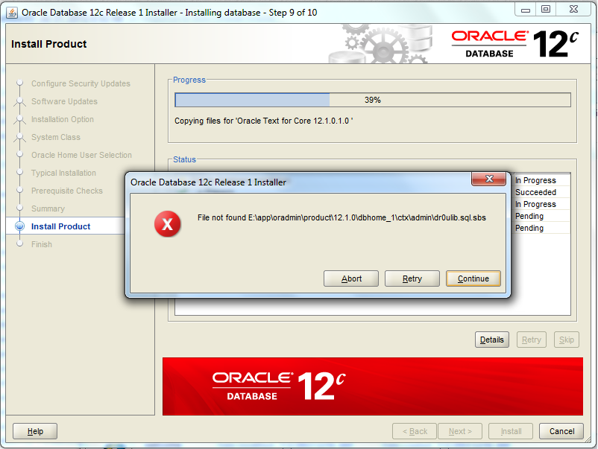](http://2.bp.blogspot.com/-6nHEPlC6pWM/UzPwqboE2vI/AAAAAAAAEA4/_79j2MjQhHI/s1600/pic1.png)

Files, such as ***dr0ulib.sql.sbs*** are reported by the installer as not found. To solve these you need to do the following:

1) Abort the current installer

2) Open the ***winx64_12c_database_2of2*** directory and navigate to ..\***winx64_12c_database_2of2\database\stage\Components*** directory copy all the files

3) Paste all files to the following location ***..\winx64_12c_database_1of2\database\stage\Components***

Now run the ***setup.exe*** as admin and follow the instructions to complete the installation without error.

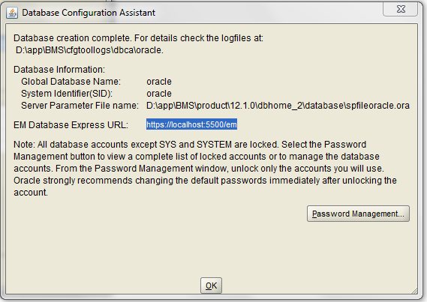

**NOte: Role should be SYSDBA**

**Password: Asdf1234**

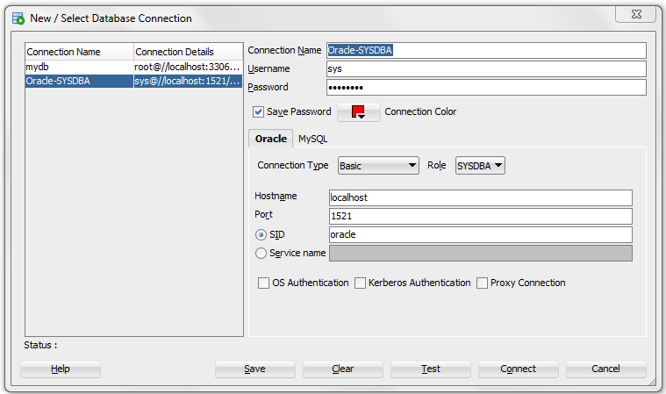

TO connect to HR schema

Step 1: Open tnsnames.ora file , you can get in the below path

Path: D:\app\BMS\product\12.1.0\dbhome_2\NETWORK\ADMIN\tnsnames.ora

Step 2: Add below line and save it , close it

PDBORCL =

(DESCRIPTION =

(ADDRESS = (PROTOCOL = TCP)(HOST = localhost)(PORT = 1521))

(CONNECT_DATA =

(SERVER = DEDICATED)

(SERVICE_NAME = pdborcl)

)

)

Step 3: Open CMD as administrator , type this ' lsnrctl reload'

Step 4: sqlplus / as sysdba

Step 5: show con_name

Step 6: alter session set container = pdborcl;

Step 7: select name, open_mode from v$pdbs;

Step 8: alter pluggable database open;

Step 9: alter user hr identified by hr account unlock;

Step 10: conn hr/hr@PDBORCL

**Note: Username : hr , Password : hr**

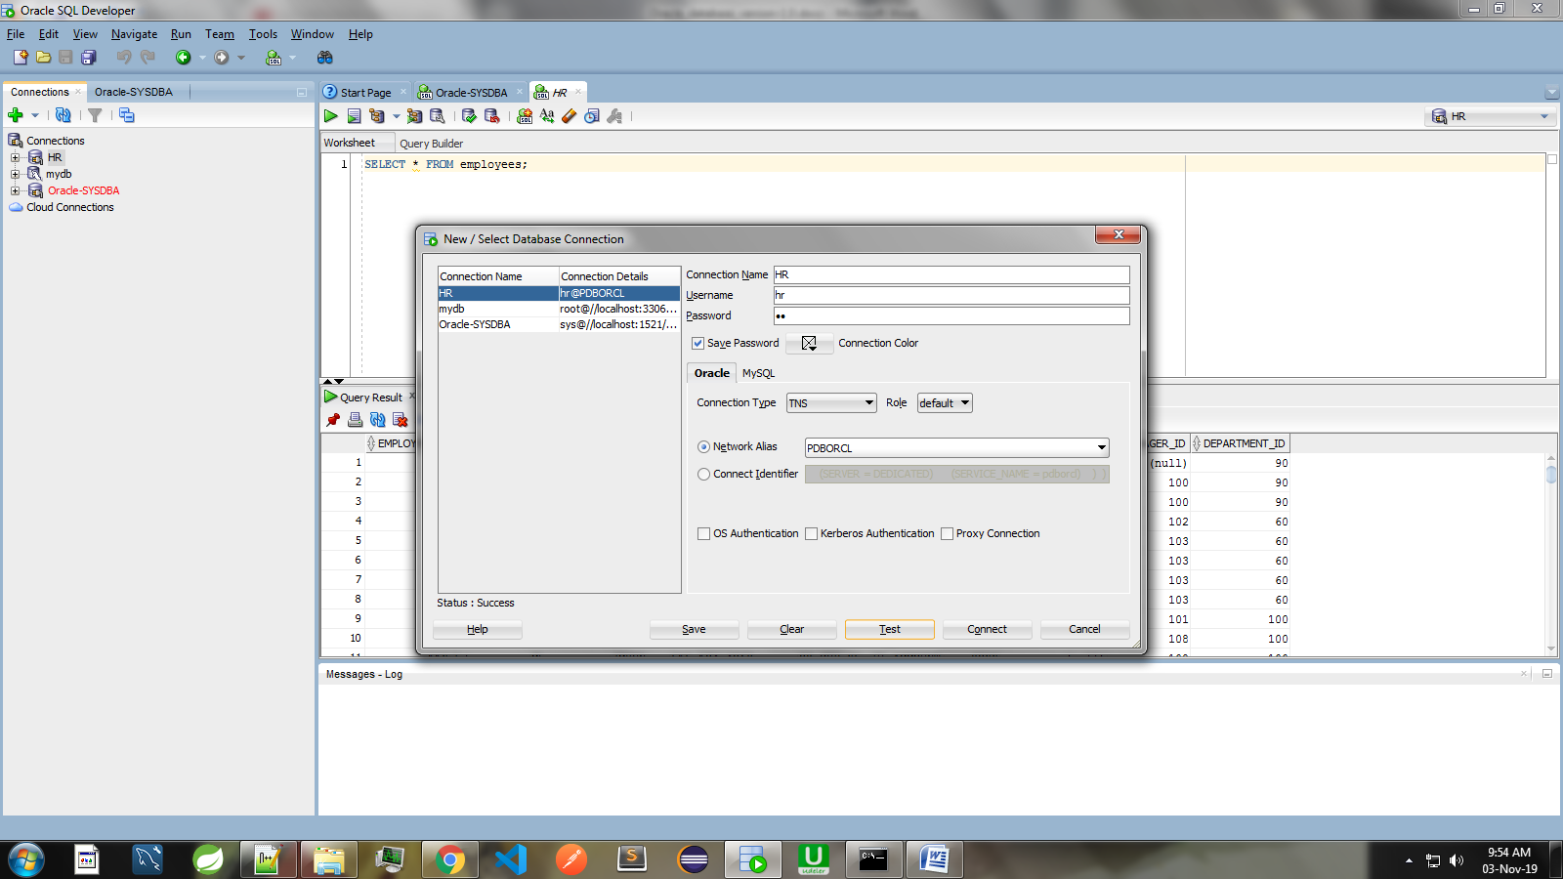

**After Computer restart you wont be able to connect to HR schema , so do the following steps.**

Step 1: Open CMD

Step 2: sqlplus / as sysdba

Step 3: alter session set container = pdborcl;

Step 4: alter pluggable database open;

Now, connect HR schema.