**Q-1 Show Me The List Of Maximum Salary Paid By Each Department, Count Of Employees From Each Department And Department Name.**

**SELECT**

D.DEPARTMENT_NAME,

**COUNT**(D.DEPARTMENT_NAME),

**MAX**(E.SALARY)

FROM EMPLOYEES E **JOIN** DEPARTMENTS D

**ON** E.DEPARTMENT_ID = D.DEPARTMENT_ID

**GROUP** BY D.DEPARTMENT_NAME;

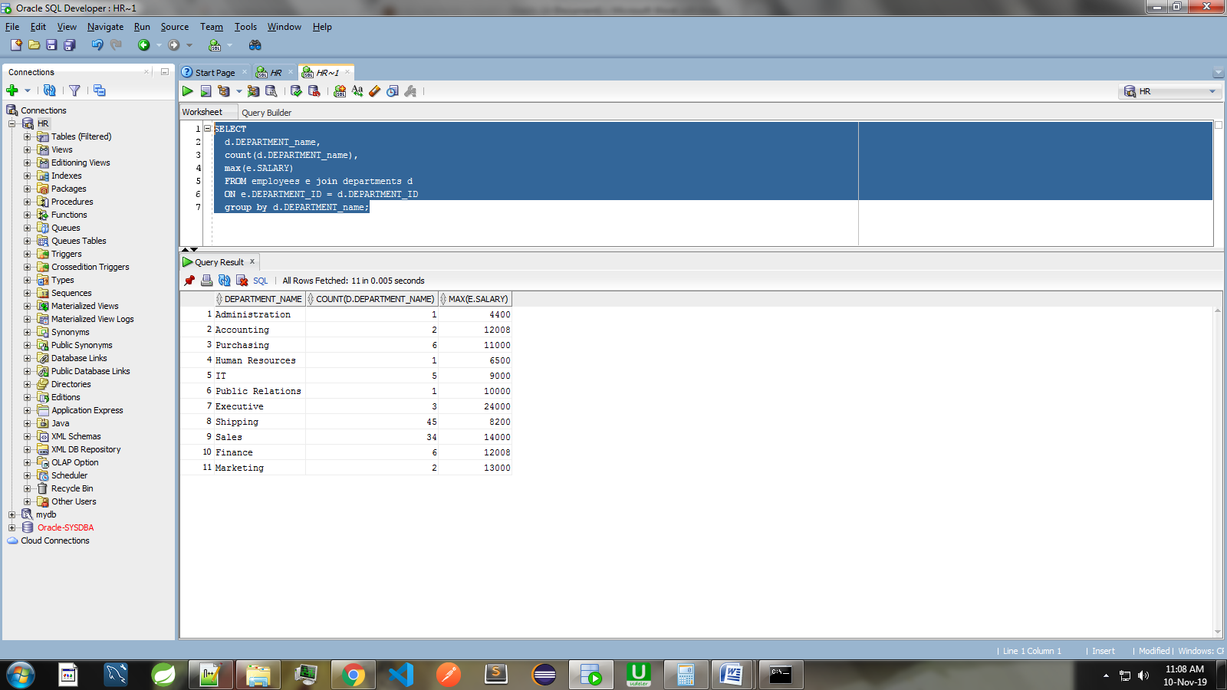

**Q-2 Show Me The List Of Avg Salary Paid By Each Department And Their Department Name.**

**SELECT**

**AVG**(E.SALARY) SALARY,

D.DEPARTMENT_NAME

**FROM** EMPLOYEES E JOIN DEPARTMENTS D

**ON** E.DEPARTMENT_ID=D.DEPARTMENT_ID

**GROUP** BY D.DEPARTMENT_NAME

**HAVING** **AVG**(E.SALARY) <10000;

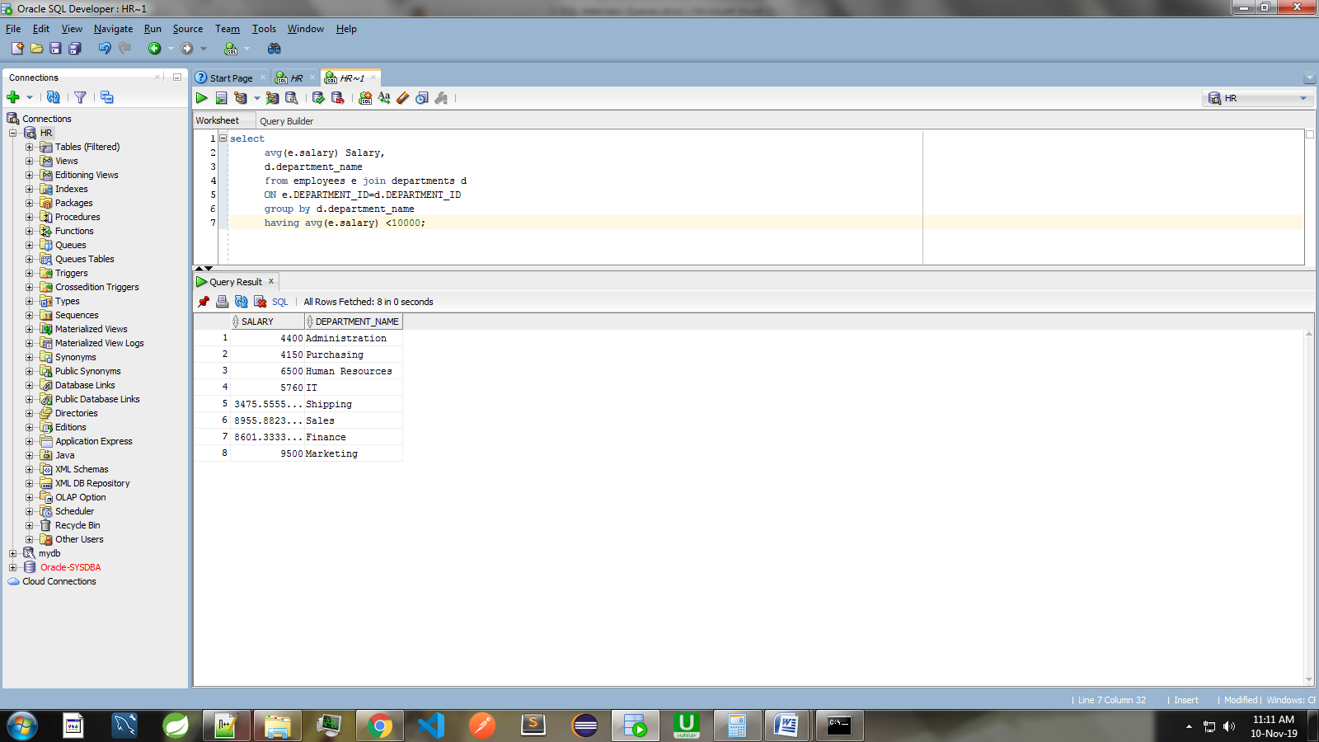

**Q-3 Show Me The List of employees name as of hire date is 17 Sep 2003**

**SELECT** * **FROM** EMPLOYEES **WHERE** HIRE_DATE <= '17-SEP-03';

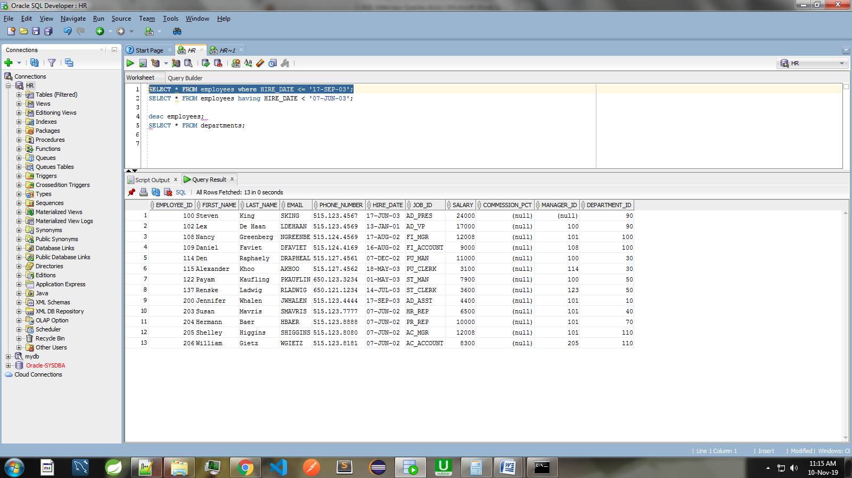

**Q-4 Total Salary Distributed By Comapany For Each Department Wise Report :**

**SELECT**

D.DEPARTMENT_NAME ,

**SUM**(E.SALARY) **FROM** EMPLOYEES E **JOIN** DEPARTMENTS D

**ON** E.DEPARTMENT_ID=D.DEPARTMENT_ID

**GROUP** BY D.DEPARTMENT_NAME;

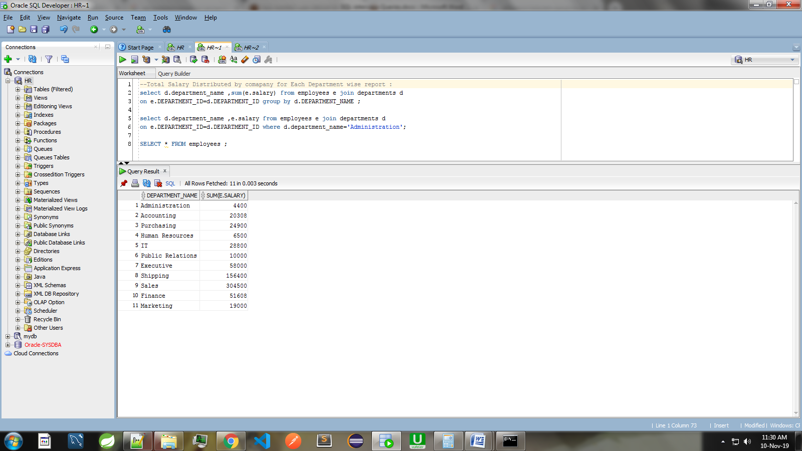

**Q-5 Show Data Of Department Whose Having Employess More Than 10;**

**SELECT**

D.DEPARTMENT_NAME ,

**COUNT**(D.DEPARTMENT_NAME)

FROM EMPLOYEES E **JOIN** DEPARTMENTS D

ON E.DEPARTMENT_ID=D.DEPARTMENT_ID

**GROUP** BY D.DEPARTMENT_NAME

**HAVING** COUNT(D.DEPARTMENT_NAME) >5;

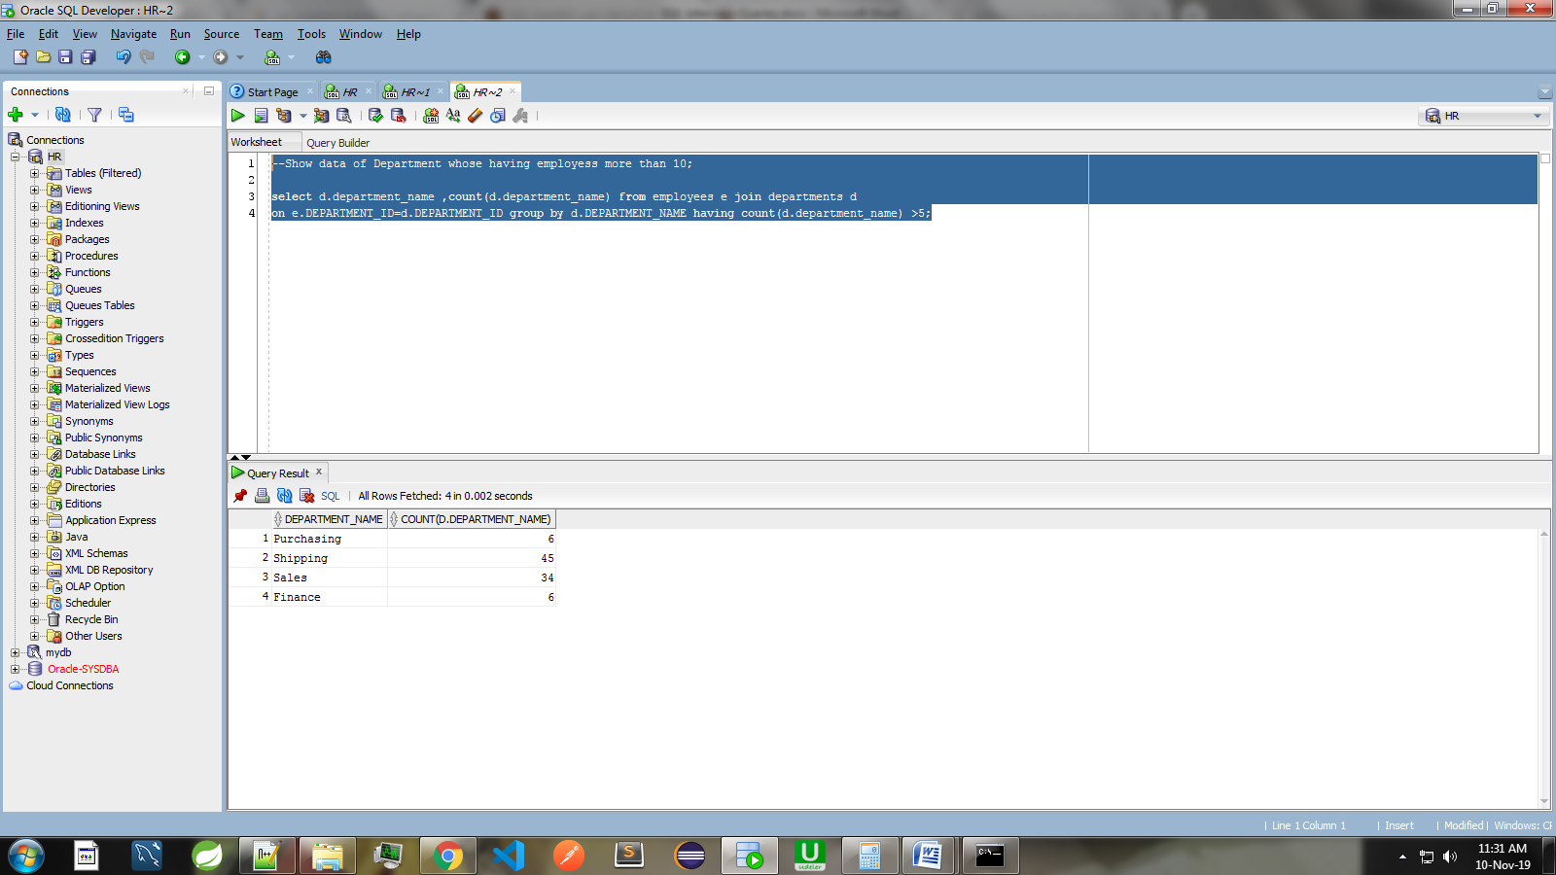

**Q-6 List The Number Of EMPLOYEES In Each DEPARTMENT, Except The SHIPPING, Sorted High To Low.**

**Only Include DEPARTMENT With 5 Or More EMPLOYEES.**

SELECT

D.DEPARTMENT_NAME,

**COUNT**(D.DEPARTMENT_NAME)

**FROM** DEPARTMENTS D JOIN EMPLOYEES E

**ON** D.DEPARTMENT_ID = E.DEPARTMENT_ID

**WHERE** D.DEPARTMENT_NAME <> 'Shipping'

**GROUP** BY D.DEPARTMENT_NAME

**HAVING**  **COUNT**(D.DEPARTMENT_NAME) > 5

**ORDER** **BY**  **COUNT**(D.DEPARTMENT_NAME) **DESC**;

