**Reverse the First K Elements in the Queue**

For a given queue containing all integer data, reverse the first K elements.

You have been required to make the desired change in the input queue itself.

**Example:**

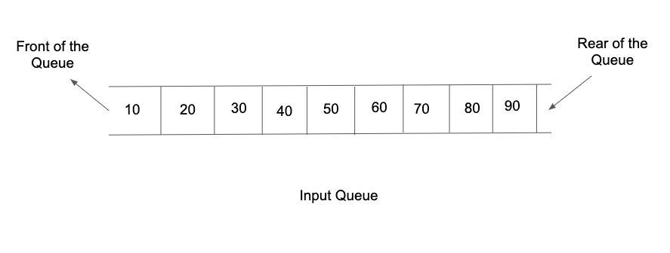

For the above input queue, if K = 4 then after reversing the first 4 elements, the queue will be updated as:

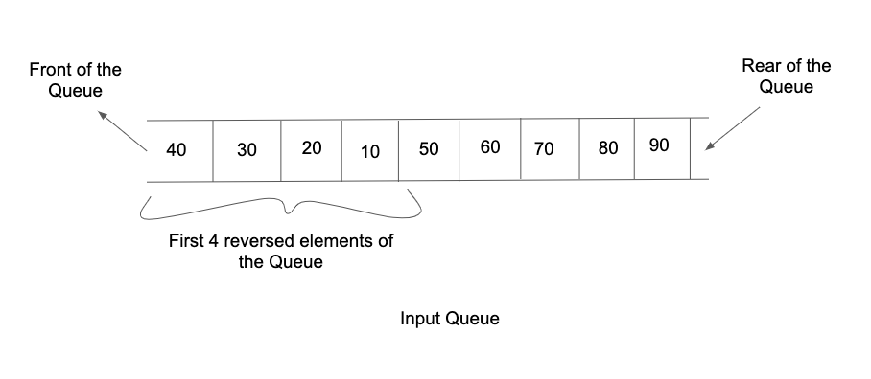

**Input Format :**

The first line of input would contain two integers N and K, separated by a single space. They denote the total number of elements in the queue and the count with which the elements need to be reversed respectively.

The second line of input contains N integers separated by a single space, representing the order in which the elements are enqueued into the queue.

**Output Format:**

The only line of output prints the updated order in which the queue elements are dequeued, all of them separated by a single space.

**Note:**

You are not required to print the expected output explicitly, it has already been taken care of. Just make the changes in the input queue itself.

**Contraints :**

1 <= N <= 10^6

1 <= K <= N

-2^31 <= data <= 2^31 - 1

Time Limit: 1sec

**Sample Input 1:**

5 3

1 2 3 4 5

**Sample Output 1:**

3 2 1 4 5

**Sample Input 2:**

7 7

3 4 2 5 6 7 8

**Sample Output 2:**

8 7 6 5 2 4 3