You have been given a queue that can store integers as the data. You are required to write a function that reverses the populated queue itself without using any other data structures.

**Example:**

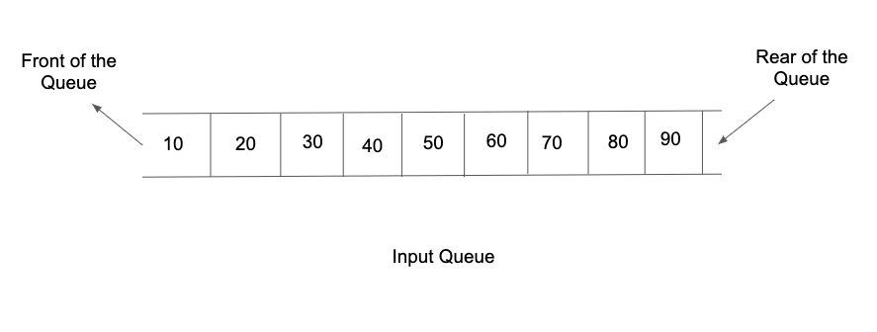

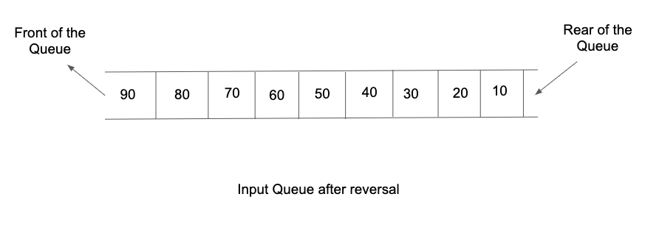

**Input Format:**

The first list of input contains an integer 't' denoting the number of test cases/queries to be run.

Then the test cases follow.

The first line input for each test case/query contains an integer N, denoting the total number of elements in the queue.

The second line of input contains N integers separated by a single space, representing the order in which the elements are enqueued into the queue.

**Output Format:**

For each test case/query, the only line of output prints the order in which the queue elements are dequeued, all of them separated by a single space.

Output for every test case/query will be printed on a new line.

**Note:**

You are not required to print the expected output explicitly, it has already been taken care of. Just make the changes in the input queue itself.

**Constraints:**

1 <= t <= 100

1 <= N <= 10^4

-2^31 <= data <= 2^31 - 1

Time Limit: 1sec

**Sample Input 1:**

1

6

1 2 3 4 5 10

**Note:**

Here, 1 is at the front and 10 is at the rear of the queue.

**Sample Output 1:**

10 5 4 3 2 1

**Sample Input 2:**

2

5

2 8 15 1 10

3

10 20 30

**Sample Output 2:**

10 1 15 8 2

30 20 10

**Sample Input 3:**

1

1

2

**Sample Output 3:**

2

**Sample Input 4:**

1

2

2 8

**Sample Output 4:**

8 2