**SnapShots:**

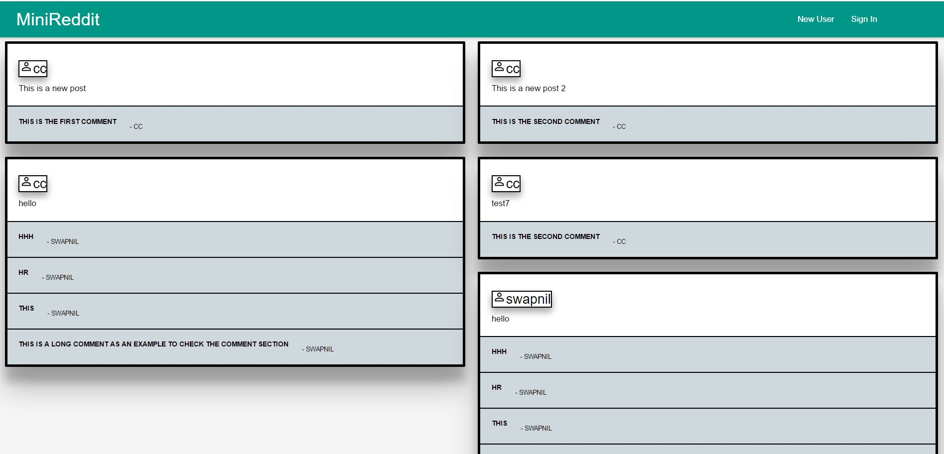

**Homepage**

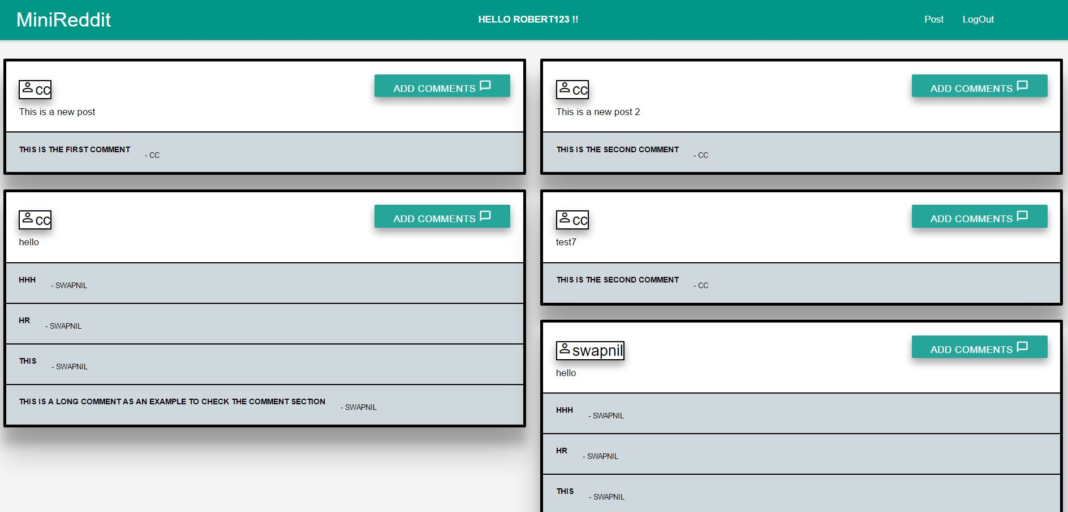

**Login**

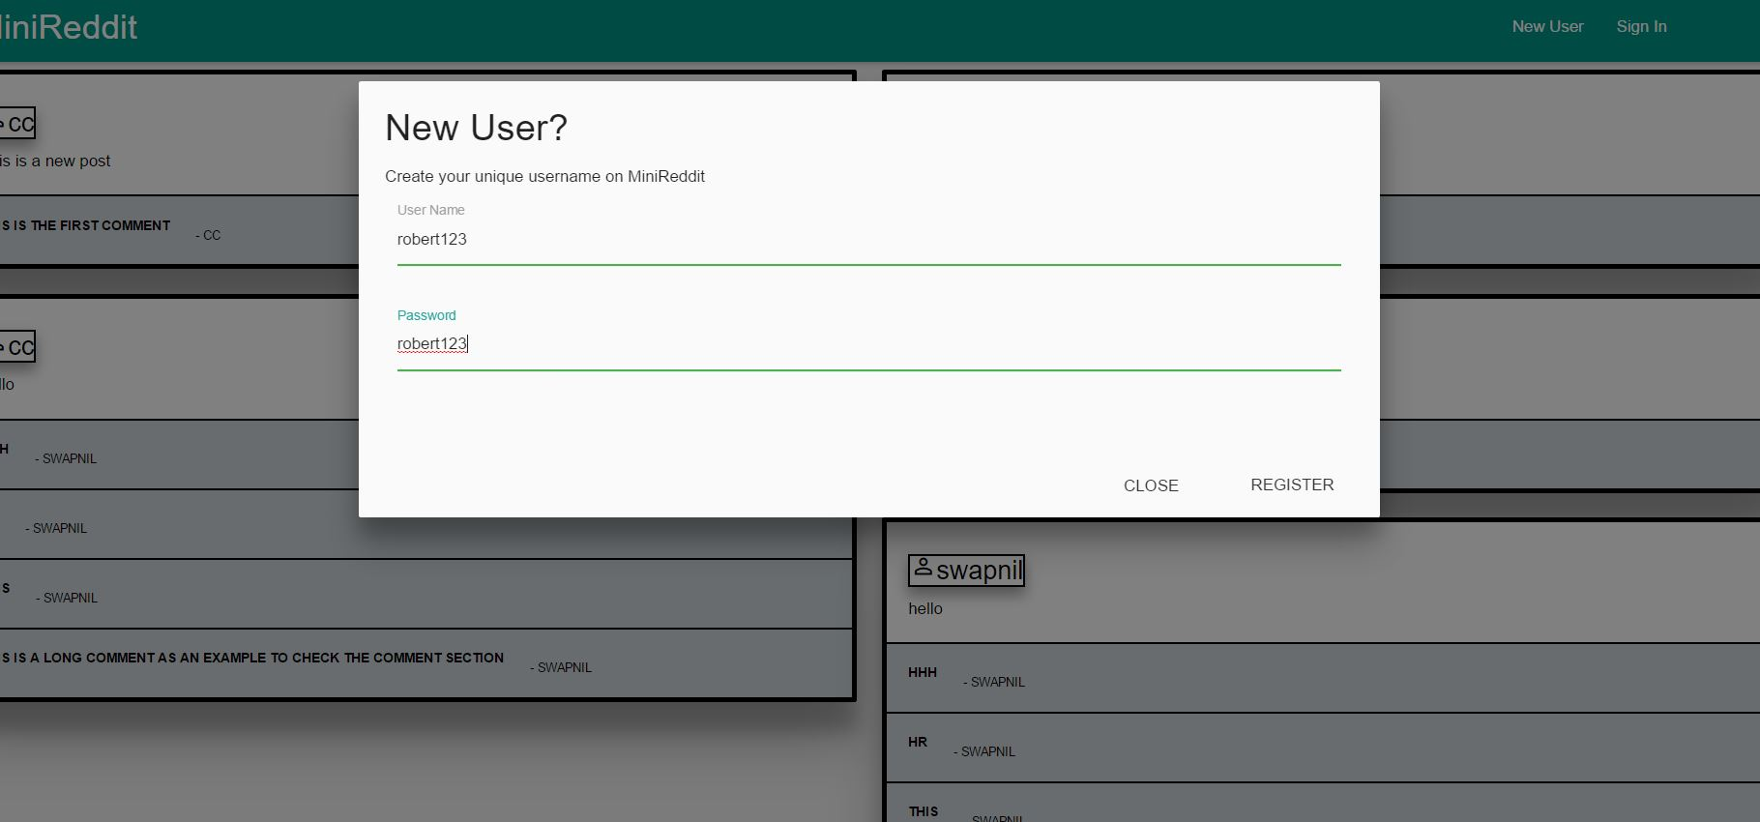

**New User signuo**

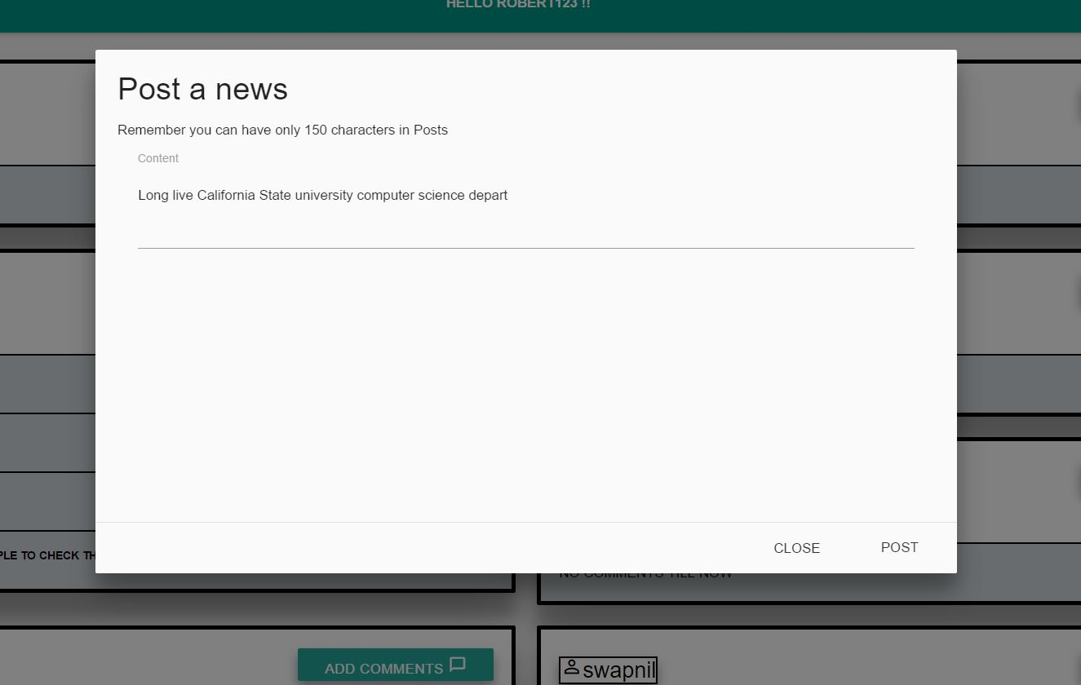

**Post something**

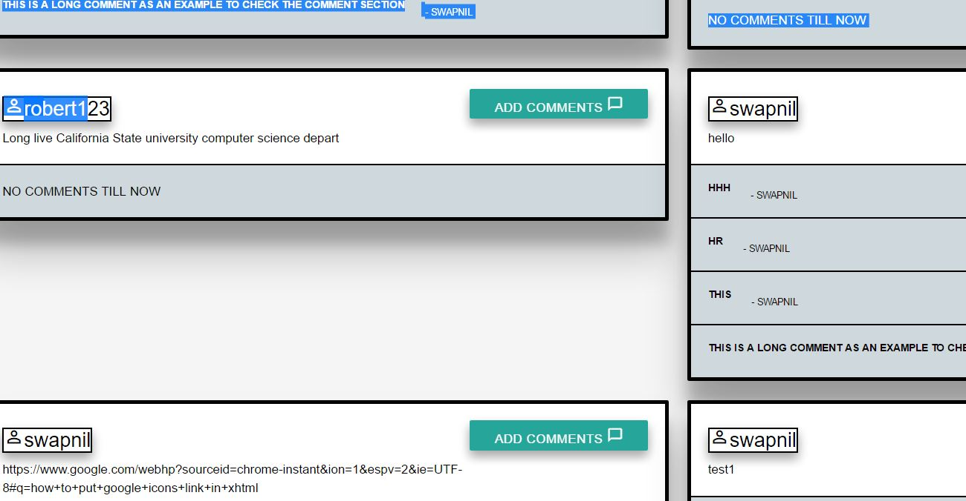

**Comments**

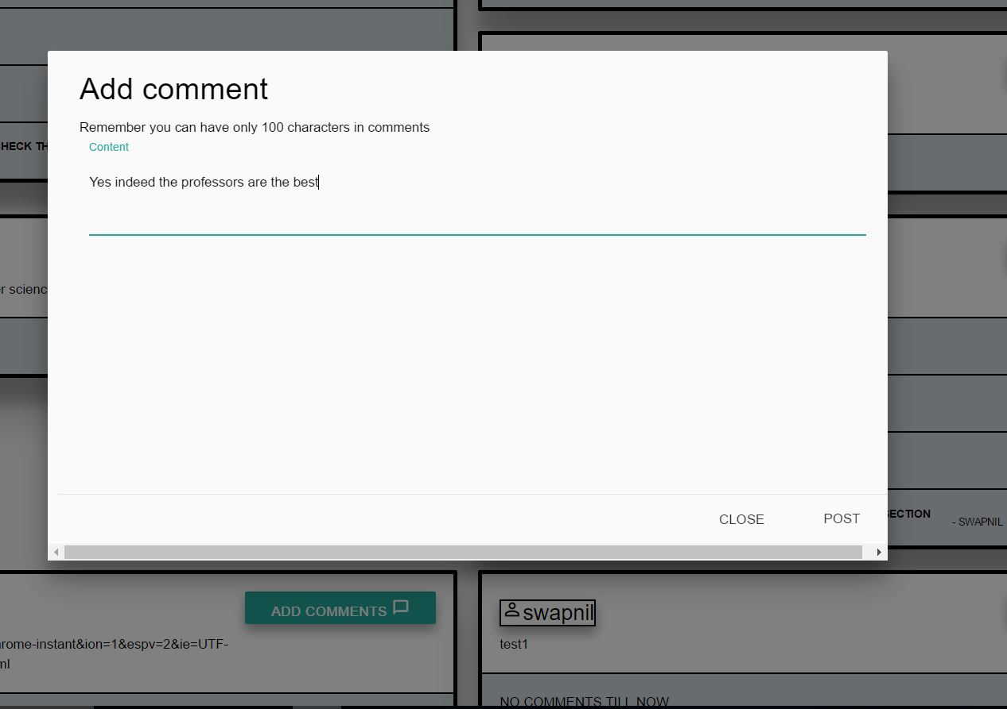

**Add comments**

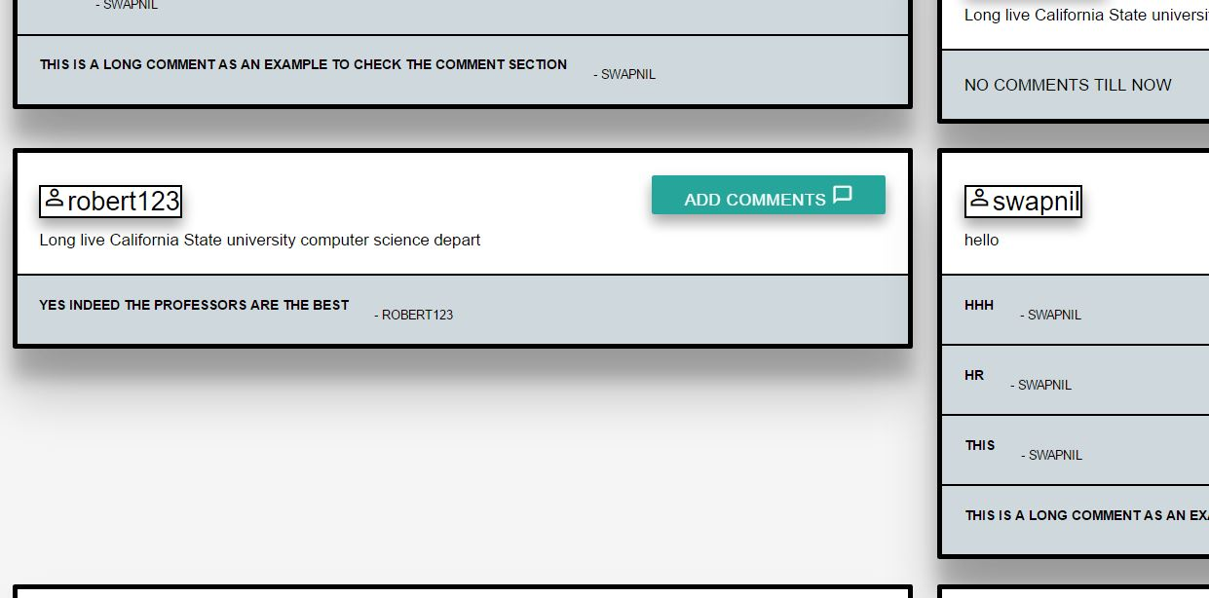

**Comments results**

**Datebase**

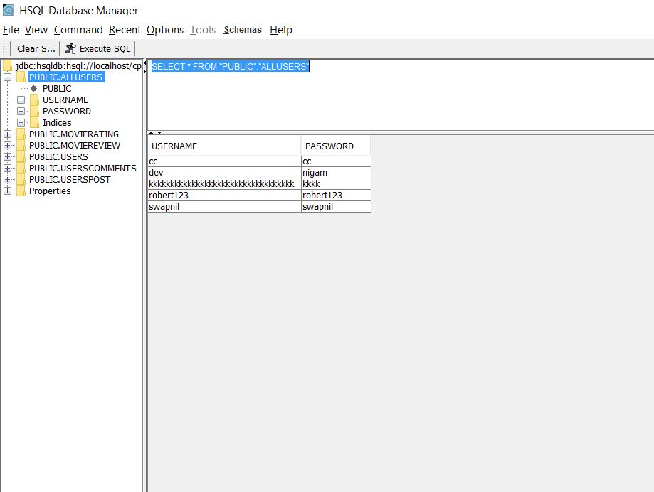

**Users**

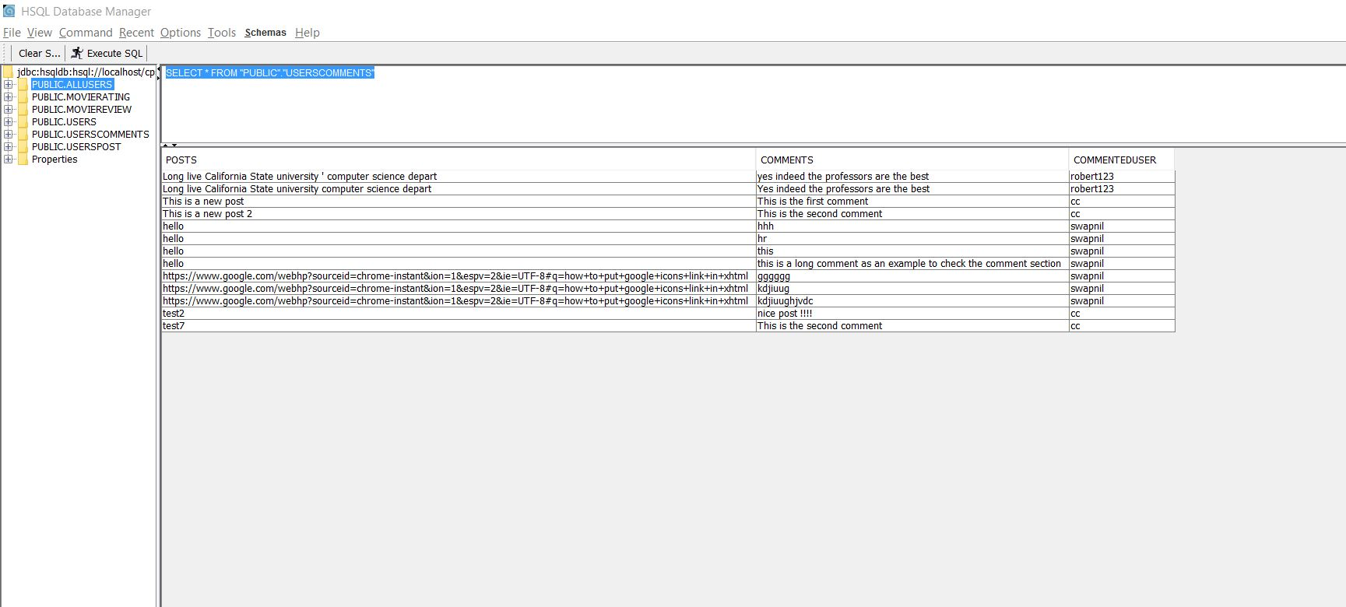

**Db post**

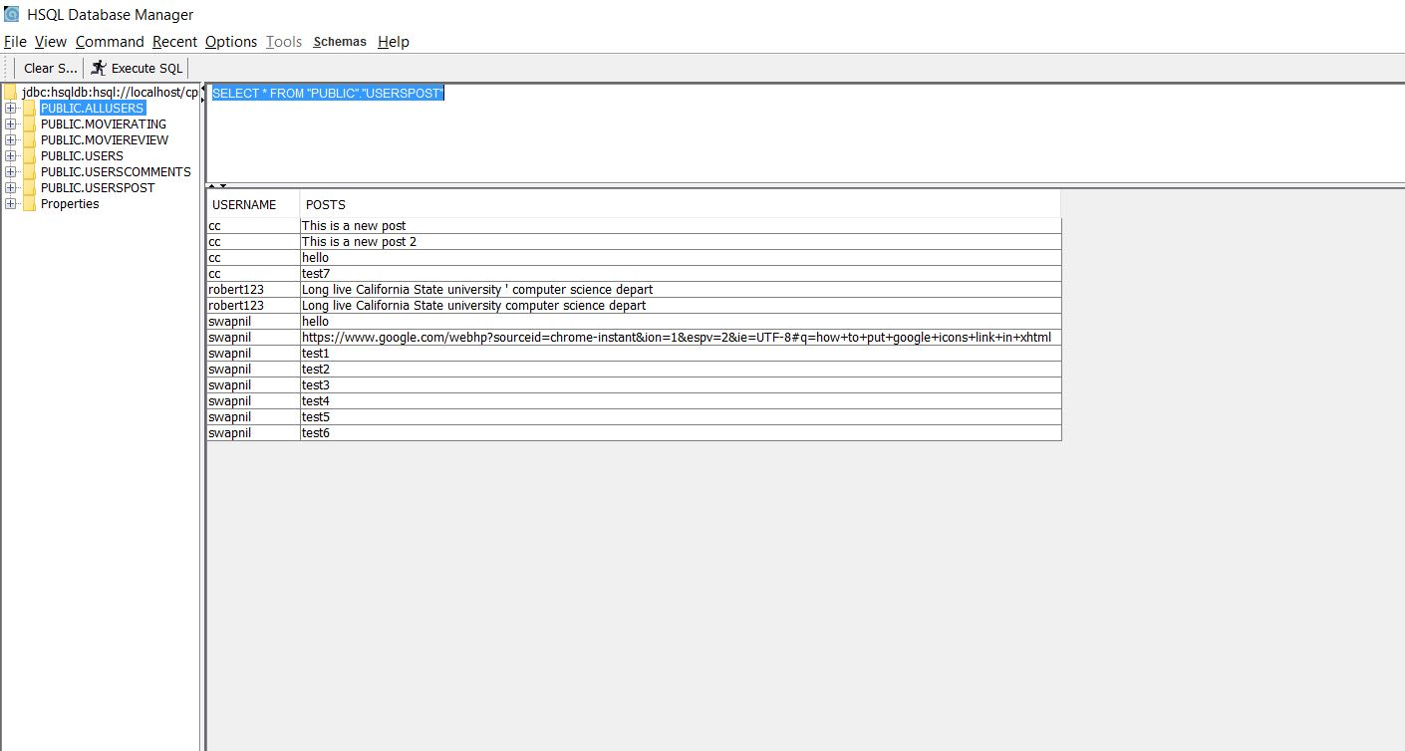

**SQL Instructions:**

**Run commands as specified:**

CREATE TABLE IF NOT EXISTS ALLUSERS(USERNAME VARCHAR(50) NOT NULL PRIMARY KEY,PASSWORD VARCHAR(50) NOT NULL);

CREATE TABLE IF NOT EXISTS USERSPOST (USERNAME VARCHAR(50) NOT NULL,POSTS VARCHAR(150) NOT NULL, PRIMARY KEY(USERNAME,POSTS));

CREATE TABLE IF NOT EXISTS USERSCOMMENTS (POSTS VARCHAR(150) NOT NULL,COMMENTS VARCHAR(100) NOT NULL,COMMENTEDUSER VARCHAR(50),PRIMARY KEY(POSTS,COMMENTS));

INSERT INTO ALLUSERS(USERNAME,PASSWORD) VALUES('DEV','DEV');

INSERT INTO ALLUSERS(USERNAME,PASSWORD) VALUES('CC','CC');

INSERT INTO ALLUSERS(USERNAME,PASSWORD) VALUES('NIMMO','NIMMO');

INSERT INTO USERSPOST(USERNAME,POSTS) VALUES('DEV', ‘Every day it gets easier, because memories fade, your voice grows softer, life goes on, and one day you will be forgotten');

INSERT INTO USERSPOST(USERNAME,POSTS) VALUES('DEV', ‘Stay awake, Titans! Just a few more days to go. You can do this!’);

INSERT INTO USERSPOST(USERNAME,POSTS) VALUES('CC', ‘Alex Smith is Chiefs nominee for NFL Man of the Year award');

INSERT INTO USERSPOST(USERNAME,POSTS) VALUES('CC', 'This class has been a great experience');

INSERT INTO USERSCOMMENTS(POSTS,COMMENTS,COMMENTEDUSER) VALUES(‘Every day it gets easier, because memories fade, your voice grows softer, life goes on, and one day you will be forgotten','INDEED','CC');

INSERT INTO USERSCOMMENTS(POSTS,COMMENTS,COMMENTEDUSER) VALUES(‘Every day it gets easier, because memories fade, your voice grows softer, life goes on, and one day you will be forgotten','YES','NIMMO');

INSERT INTO USERSCOMMENTS(POSTS,COMMENTS,COMMENTEDUSER) VALUES(‘Every day it gets easier, because memories fade, your voice grows softer, life goes on, and one day you will be forgotten','NO','DEV');

**Installation Instructions:**

Step 1: Downloading Apache Maven 3.3.9: Download .zip file from apache maven from its

repository " https://maven.apache.org/download.cgi"

Step 2: Extract the zip contents.

Step 3: Downloading Apache Ant 3.3.9: Download .zip file from apache ant from its repository " <https://ant.apache.org/bindownload.cgi>”

Step 4: Extract the zip contents.

Step 5: Copy paste the attached “build.xml” in bin directory of apache ant.

Step 6: Open cmd in bin folder, and run command ant init and after that ant start.

Step 7: Go to bin Folder of apache maven and copy paste "Pom.xml" and "src folder" of the zip file of project attached.

Step 8: Open command prompt in the bin folder of apache maven and run command mvn clean package.

Step 9: After build successful, check the miniReddit476.war in target folder created.

Step 10: Copy UrlShort2.war created to the webapps directory of apache tomcat.

Step 11: Open cmd in bin directory of apache tomcat and run command startup.bat

Step 12: Run command ant manage in command prompt of apache ant

Step 13: Hit URL "http://localhost:8080/miniReddit476"