**Simulation Modeling and Methods**

**Final Project: North-Route Shuttle Simulation with Arena**

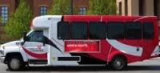

**Author: Swapnil Sharma**

**Contents**

1. **Introduction Page 3**
2. **Motivation and Objective Page 4**
3. **Data Collection Page 4**
4. **Assumptions Page 4**
5. **Input Analyzer Page 5**
6. **Arena Model Page 6**
7. **Animation Page 8**
8. **Statistical Analysis Page 10**
9. **Results Page 12**
10. **Conclusions Page 12**
11. **References Page 13**

**Introduction**

University of Cincinnati runs North Route shuttle service under Bearcats Transportation System (BTS). North Route operates from Monday through Friday in a continuous loop approximately every 25 minutes. It begins at stop 1 (ERC) at 6:00 AM and ends at 12:00 AM. There are total 13 stops in the route including initial point.

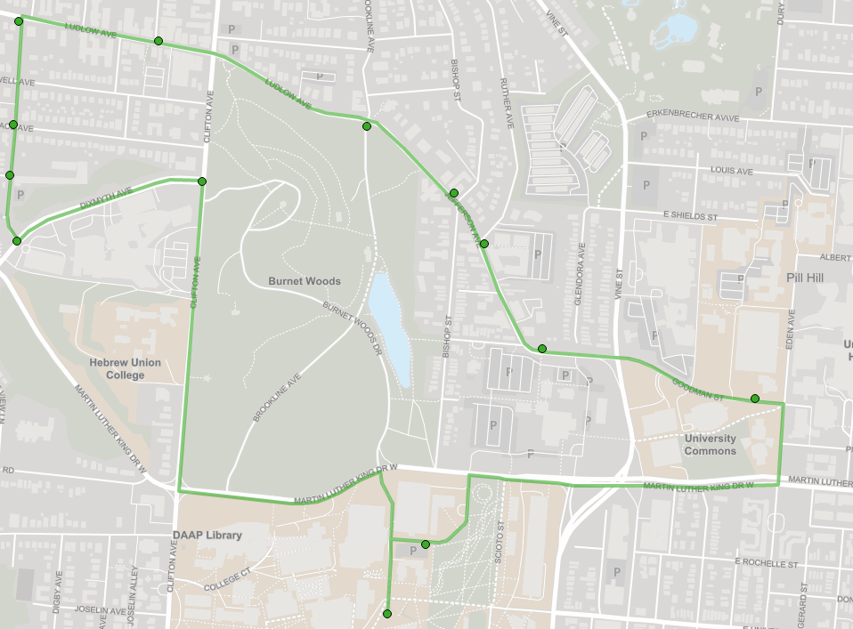

Figure 1. Aerial view of North-Route Shuttle Route

**Motivation and Objective**

The objective of the project was to reduce the wait time of passengers and make system more efficient with same resources. Currently 2 buses run at peak time (morning and evening hours when classes begin and end) on the route. An attempt was made to split the route in two and run a single bus on each route to study the wait time, travel time and total time.

**Data Collection**

* Wait time at each stop was noted during peak hours (evening 5 – 9).
* Time taken by shuttle to travel between two stations were noted during peak hours (evening 5 – 9). This data is summarized in table 1. The data was randomly collected during different days of the week.

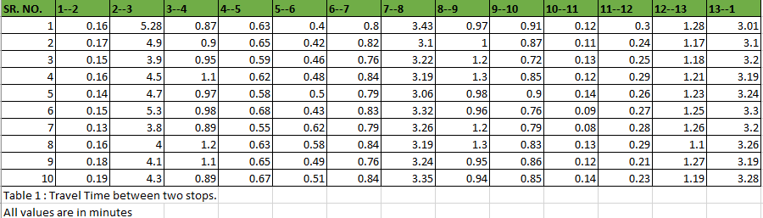

**Table 1**

Above data was recorded using Double- Map Application.

**Assumptions**

* Inter-arrival time between passengers at each station is assumed based on busy stations.
* The distribution of passengers getting down at different stops from Initial Stop is assumed based on where popular housing locations are there. Generally North Route shuttle is used by students living near Campus.
* Students use North Route shuttle only to reach ERC from their respective housing location is one of the major assumptions made. This can be supported by the argument that as data is recorded during peak hours when classes end or start students will go to University only.
* Time between ERC and new route suggested is approximated based on distance and time taken on similar routes.

**Input Analyzer**

* Data collected was fed to Input Analyzer of Arena to get the best fit distribution for time between stations. Table 2 gives the distributions used for same.

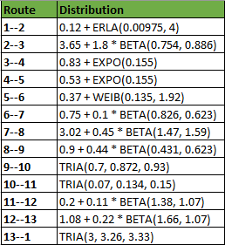

**Table 2**

Following is the example of best fit output given by input analyzer for Inter-arrival time between 1-2.

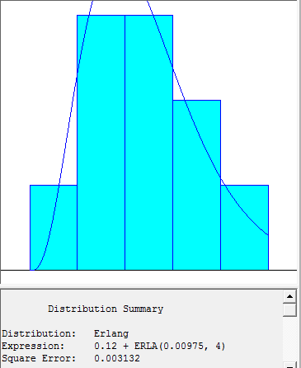

**Arena Model**

Model is inspired from sample model built in Arena on Public Transportation.

Total of 3 Arena models are built with one simulating the current situation and other two suggesting the proposed route. Model contains combination of basic Process, Advanced process and Advanced Transfer.

Model is divided into three parts:

Part 1:

* Passengers are created as entity at different stops and their inter-arrival time is fed as mentioned in assumption in the create module.
* Assign module is used to give attribute to each entity showing how they will get down at different stops from initial stop. This is again fed based on assumption and DISC function is used to do so.
* Entities then move to Hold Module where they wait to get in the shuttle till it arrives at each stop.

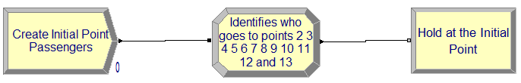

Figure 2: Part 1 of Module

* Similar modules are created for 13 stops.

Part 2:

* Station and Route module are used to animate as well as input travel time between two stations. Data is fed based on the expression we get from Input Analyzer.
* Create module is used at initial point to create two buses as entities which run at a constant interval of 25 minutes.
* From Advance Process Delay, Search, Pick-up, Drop-off Modules are used.
* Delay module is used to input wait time at each stop. Data is fed based on data observed. Range of Values is quite small hence a uniform distribution is assumed for same.
* Search Module searches the passengers for given attribute to drop them at given stop.
* Pickup module similarly picks up the passengers from stops based on the entities created in part 1.
* To dispose passengers at all the stops a route module is introduced with time of 0. Dispose module could also be used here but I could not do it due to limit for maximum number of modules was crossed in student version.

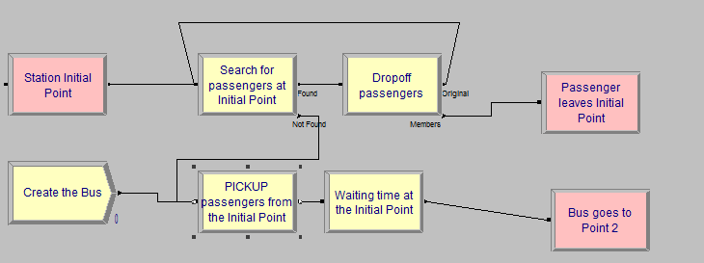

Figure 3: Part 2 of Module

* Similar modules are created for 13 stops

Part 3

* Here Departure station and dispose module is used to dispose-off all the passengers at different stations.

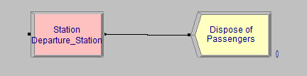

Figure 4: Part 3 of Module

**Animation**

Animation shows different stops in the current situation and proposed new routes.

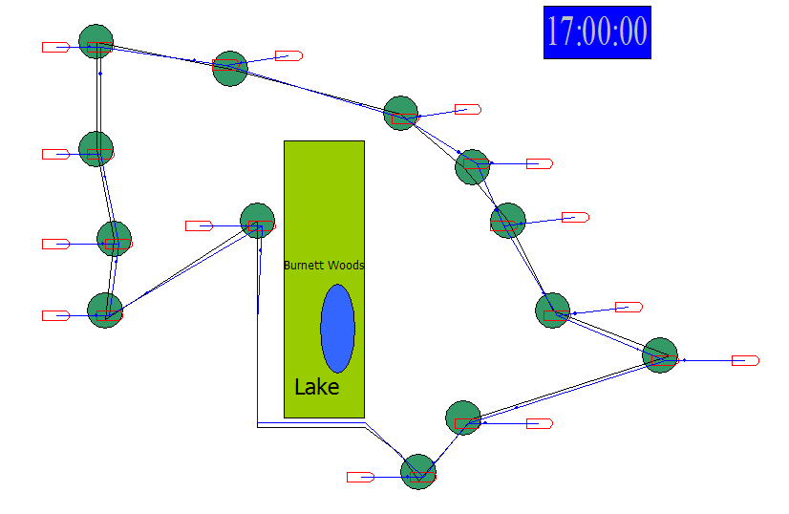

Figure 4: Current Route

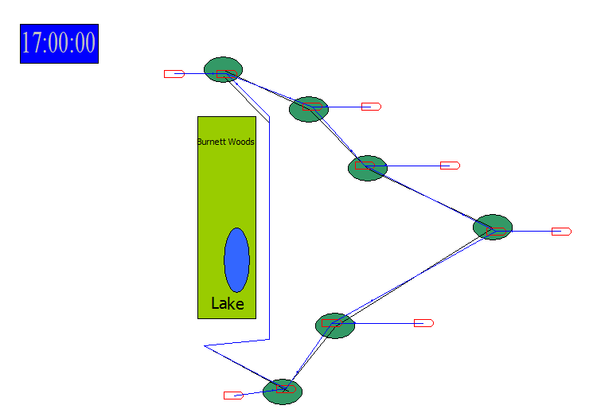

Figure 5: Suggested Route 1

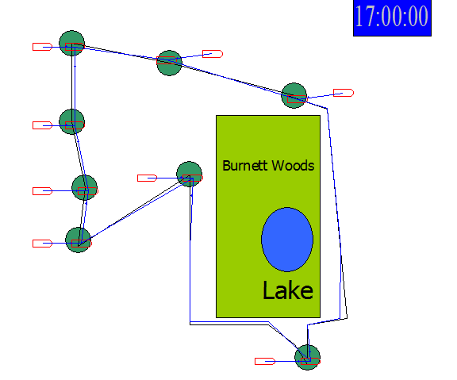

Figure 6: Suggested Route 2

*An attempt to create a lookalike route map in animation was made. Figures are approximate and not to the scale.

An idea of splitting the current route to suggested route came from my own experience. This route will split the students living on one side of Burnett woods and the other without any infrastructure cost of creating new stops and also take care of current stops at the same time.

**Changes made in new suggested route**

* Inter-arrival time between passengers at different stations will remain same but at ERC it will be reduced due to passengers will be divided in two queues for different shuttles on different route.
* Disc function used to give probability distribution is also changed proportionately for smaller routes.
* Time between last stop and ERC of new route is inserted based on assumption as mentioned before.

**Statistical Analysis using PAN (Process Analyzer)**

* PAN analyzer is used to compare the different scenarios of current route vs new route suggested.
* Total of 100 replications are run for 4-hour time period on each model to record the values. Following chart summarizes the best case scenario which gives lower wait time, lower travel time and lower total time in system.

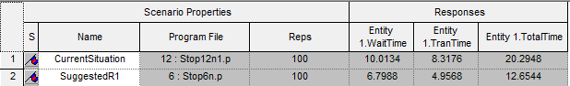

Figure 7: PAN Analyzer Output for Current Route v/s Suggested Route 1

Passenger staying on this route will be tremendously benefitted due to lower wait time, travel time and total time.

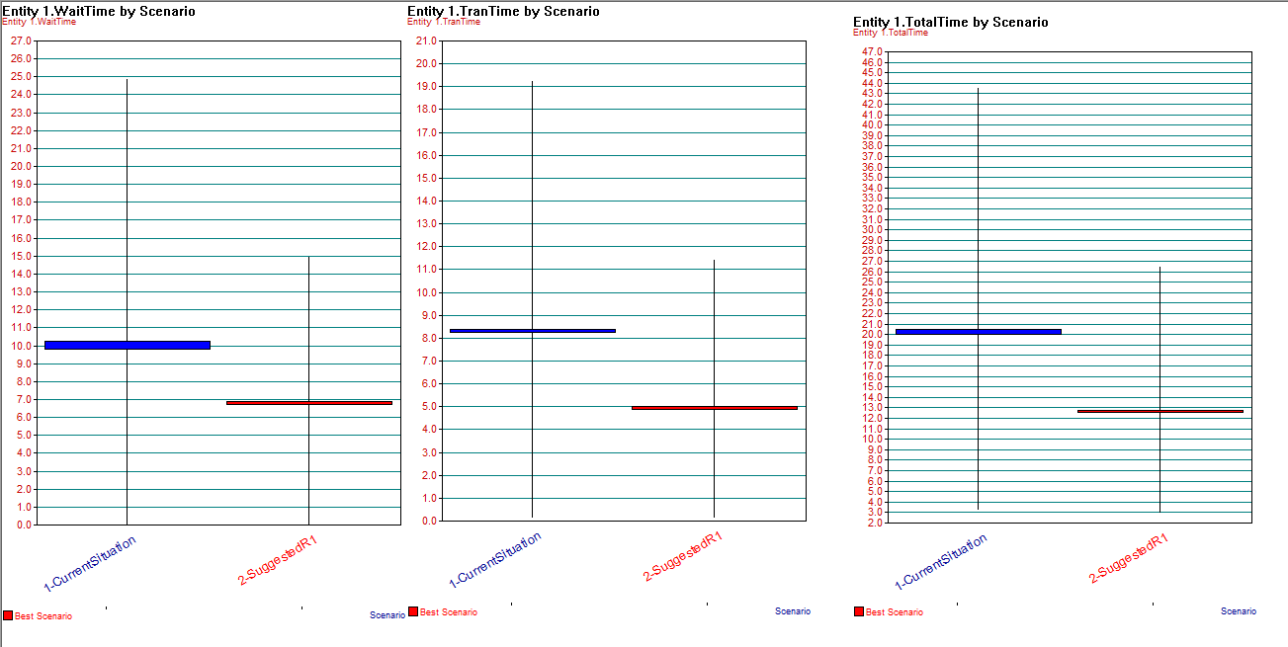

Figure 8: Box Plot giving best Scenario for Wait time, Travel time and Total Time for Current Route v/s Suggested Route 1

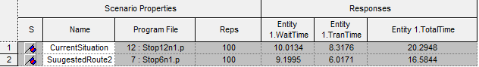

Figure 9: PAN Analyzer Output for Current Route v/s Suggested Route 2

Passenger staying on this route will have a major advantage due to reduced travel time which there by reduces Total time.

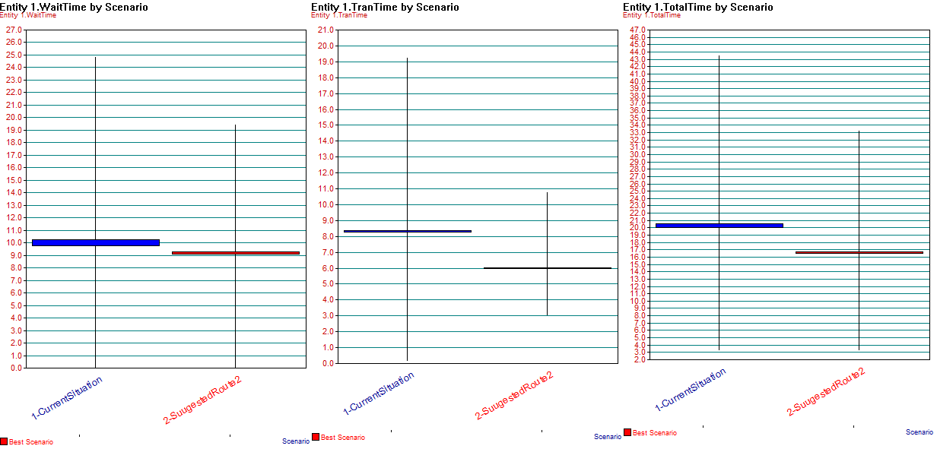

Figure 9: Box Plot giving best Scenario for Wait time, Travel time and Total Time for Current Route v/s Suggested Route 2

**Results**

Thus it can be seen from PAN output that if 1 shuttle is run on each suggested route than running 2 shuttles on current route the average wait time, travel time and total time for passengers will go down. The result is also statistically significant. Thereby using the same resources available there are chances of reducing the wait time of passengers which is highly desirable situation. No cost is incurred in implementing the suggested solution and improve the situation which is a significant result of the project.

**Conclusion**

As the result shows statistically significant reductions in wait-time, travel time and total time in system for passengers a further detailed study can be carried out to validate the assumptions made while building the model and required actions should be taken for building more efficient shuttle transport for passengers.

**References**

1.  File available in Arena example folder.
2. <http://www.uc.edu/content/dam/uc/af/facilities/bts/BTS-NORTH-(MtoF).pdf>
3. <https://uc.doublemap.com/map/>
4. <https://www.uc.edu/af/facilities/services/shuttle.html>
5. Simulation with Arena 6th Edition -