1. Applicant not receiving SMS, when a hearing is scheduled by APA.
2. In the first appeal acknowledgement letter, the date format is not consistent with the rest of our application, or within the RTI module itself. The format used in letter is MM/DD/YYYY. The first appeal was done on 5TH October, 2016.

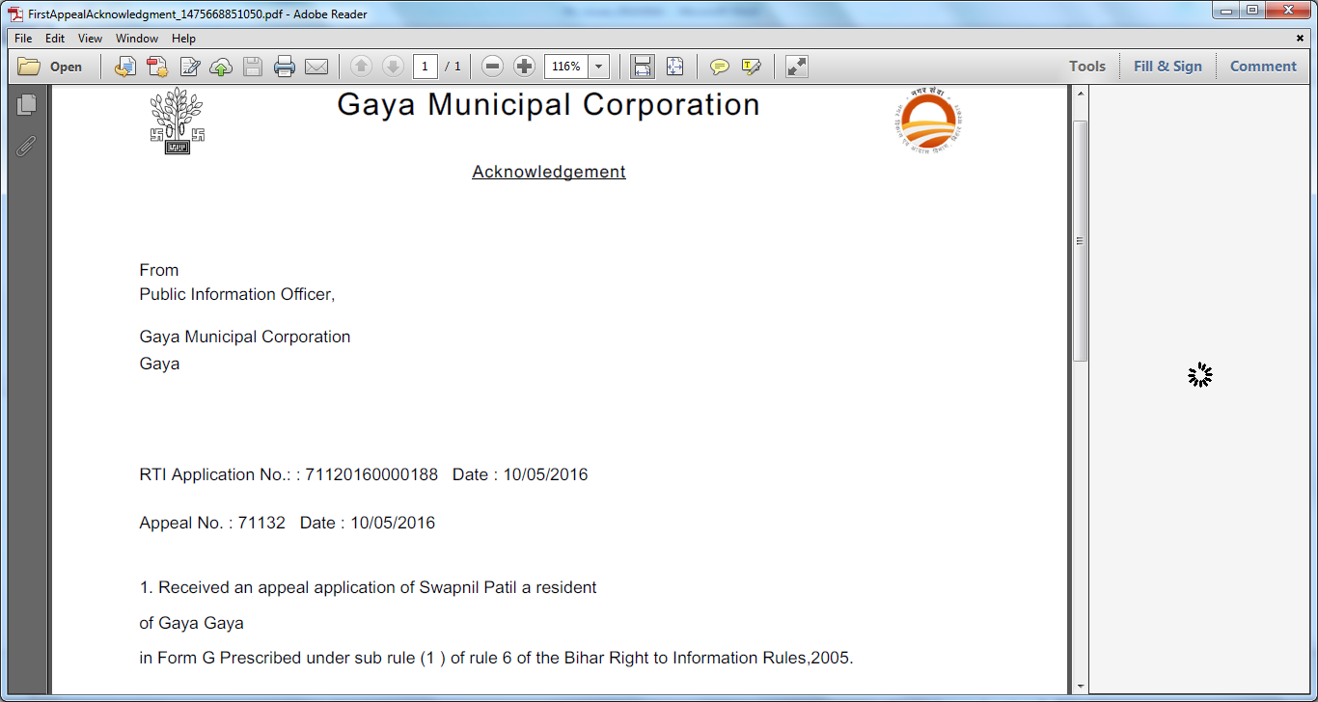

1. In the view page on RTI Dispatch details, the spelling of Type of applicant is incorrect.

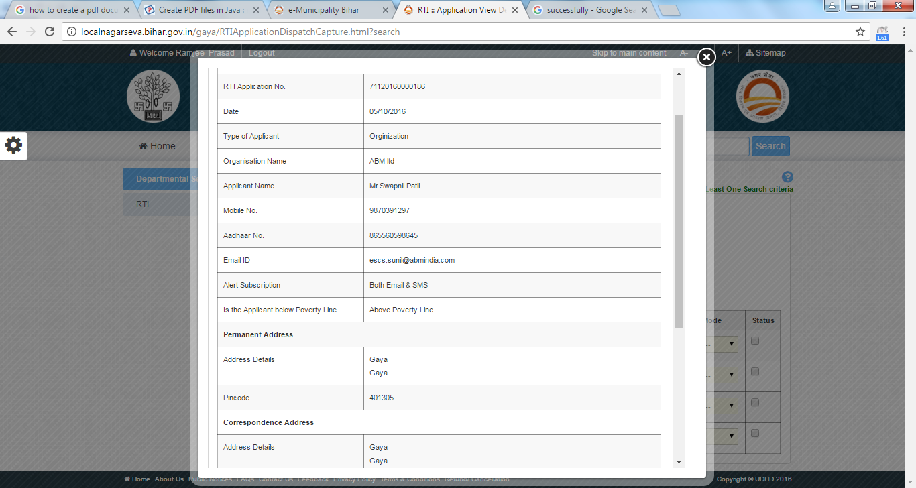

1. The spelling of successfully is different when application is dispatch using collect at office mode.

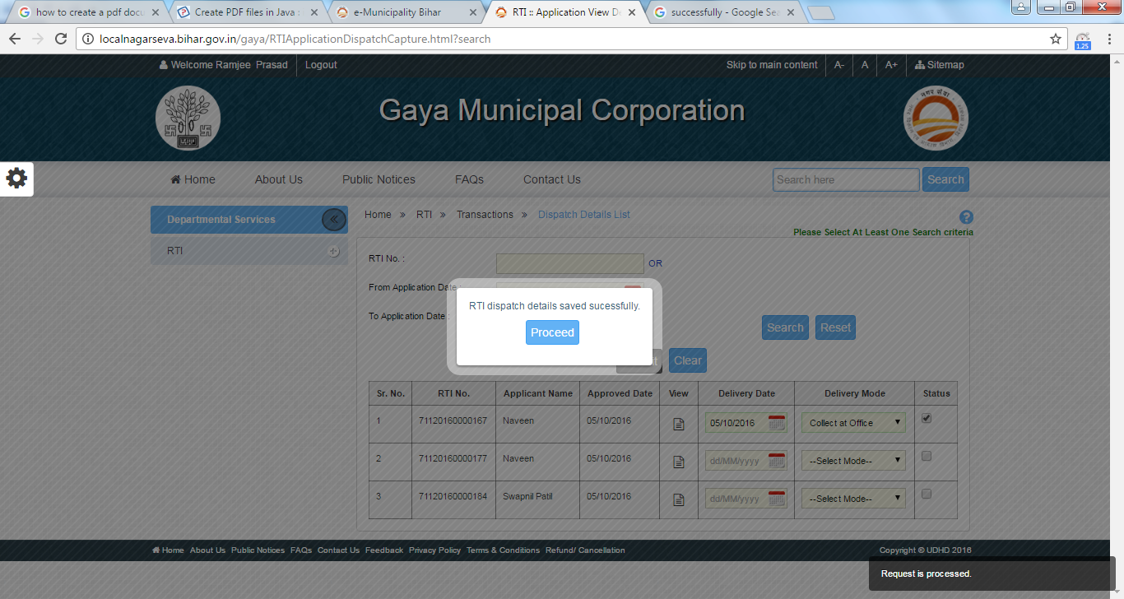

1. For the APA login, the grid of First Appeal List does not seem to follow any pattern after loading, unlike the RTI Response grid for PIO which loads the latest applications first in the grid.

