1. Spelling of correspondence is incorrect on second appeal response form.

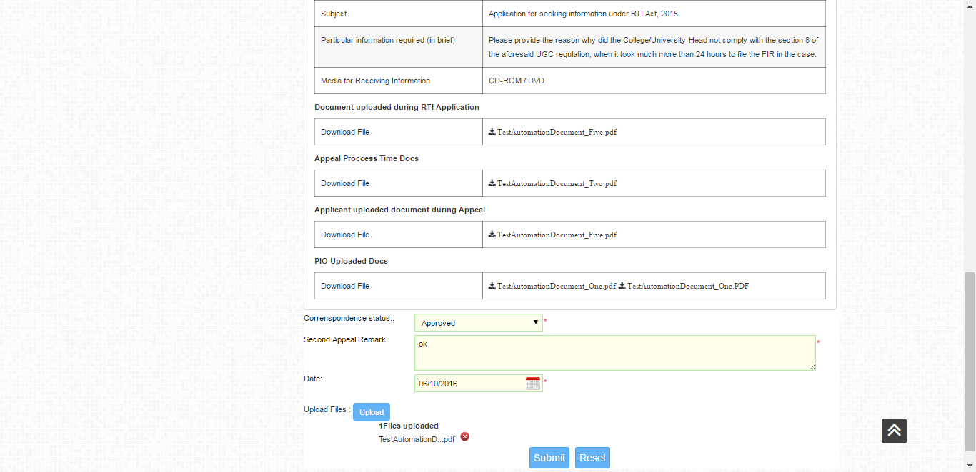

1. In second appeal response form, the date picker allows to pick only the date. But when an invalid date is selected and submitted, the date picker field shows the time as well.
2. 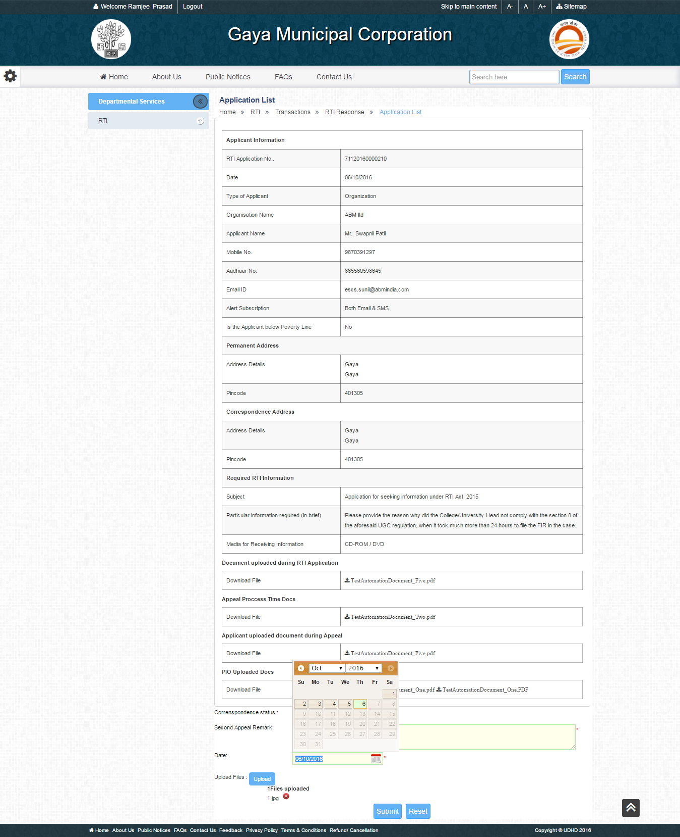
3. 