1. No uniformity in displaying application details after clicking on proceed button on RTI Application Entry form. This variation in display is seen when selecting non-BPL and making payment via form e and non-judicial stamp paper

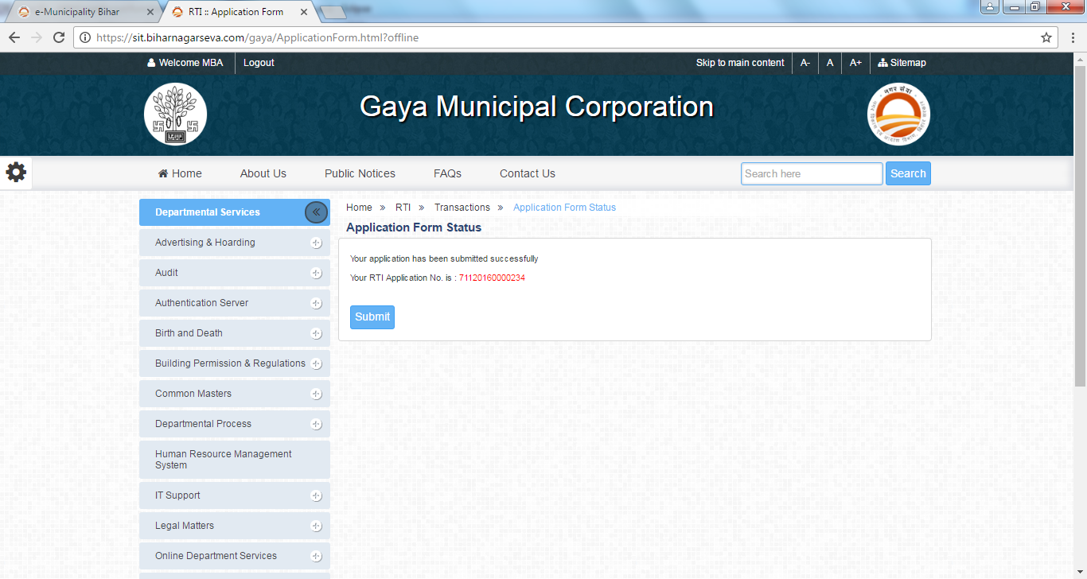

1. Not receiving SMS after making a RTI Application entry as NON-BPL and selecting form e while making an rti application entry.
2. While making an application as BPL user, in the upload documents table, the document name is coming in hindi.

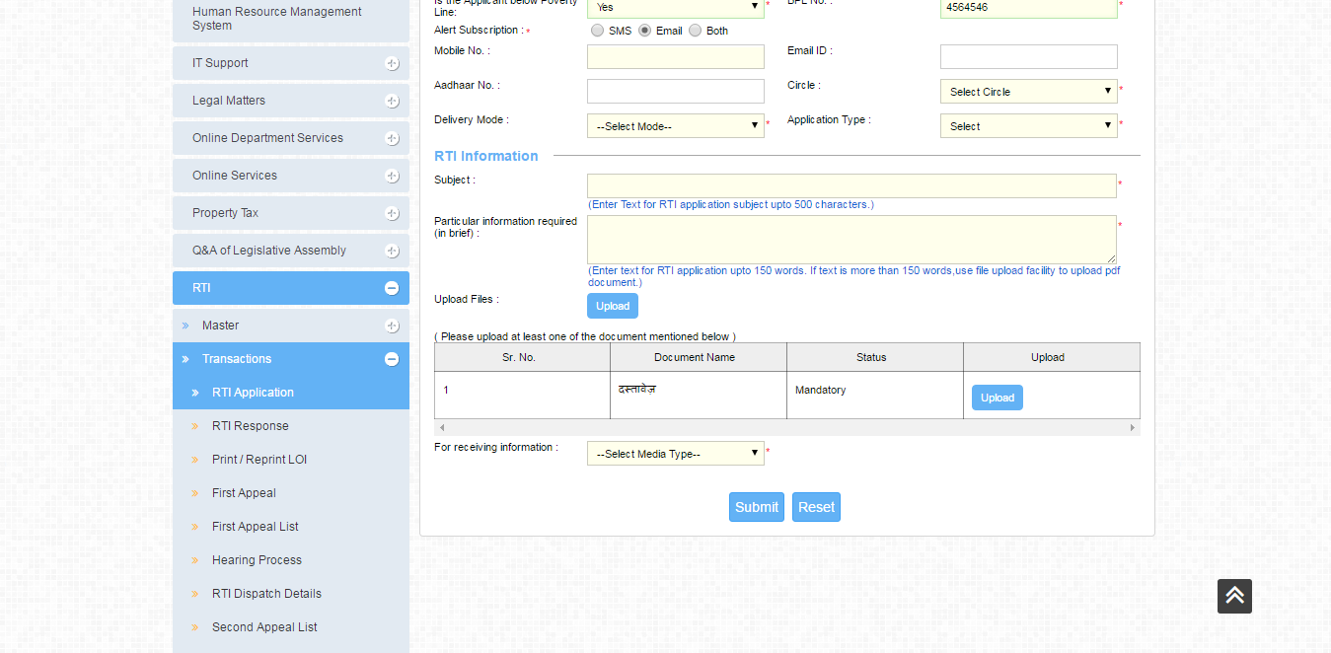

1. a) In the receipt of Challan @ ULB Counter, when making a payment with pay order, the pay order number and pay order date come under the cheque no and cheque date fields.

b) In the office copy it is showing Amount in Words… while in the citizen copy only Amount In is displayed

