1. a) Serial No column occupying lots of space when upload table for BPL appears on RTI application entry form. Due to this, viewing is getting affected of table.

b) Improper message above the upload table. The table itself mentioning which documents are mandatory for uploading. Hence the message above of “please upload at least one of the document mentioned below” is contradictory.

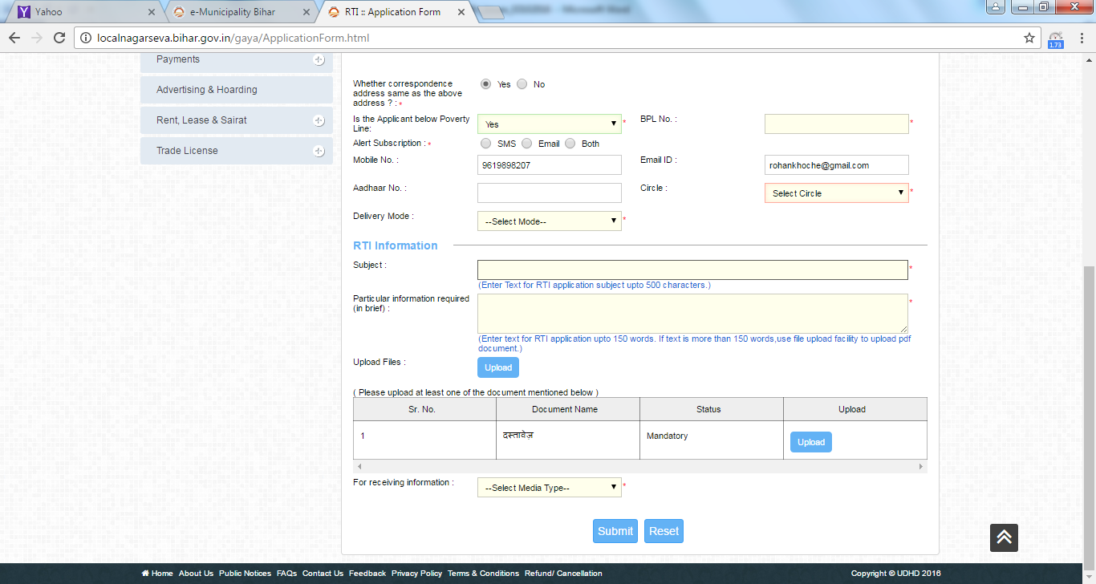

1. **Dispatch details sms received mentions delivery mode as a number.(watsapp.ed u the image.)**
2. **When making payment through department, using Pay@ULB Counter as option, on the next page, after clicking on proceed, PRINT CHALLAN button is displayed. As a receipt for payment is getting generated, the label is not correct.**

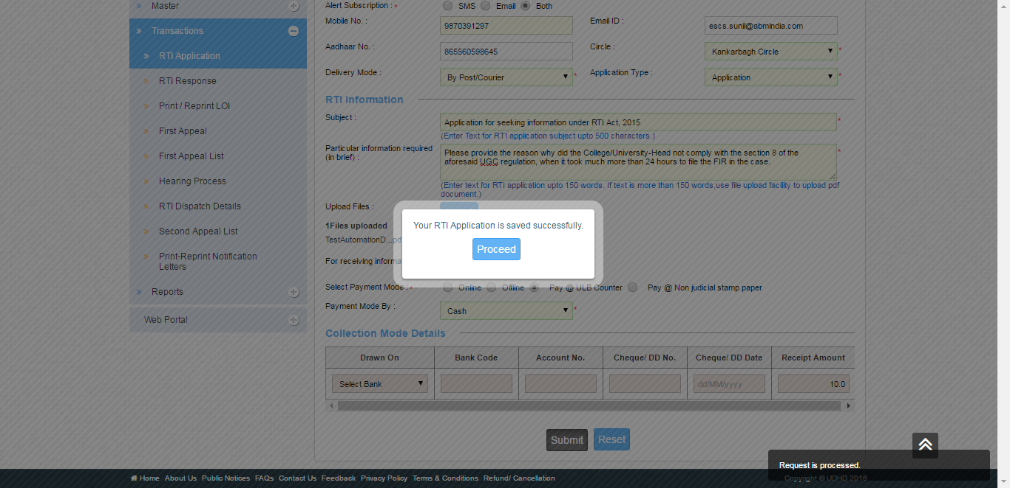

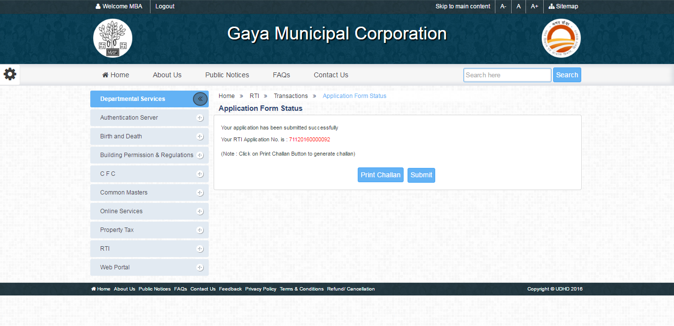

1. While configuring charge master, no intimation is provided on the charges which have expired, to the PIO.
2. Also, w.r.t to the above point 4, if a user forgets to configure charge master for a few days, and then configures it, the applications made during the period for which there was no configuration for charge master, cannot be responded to by PIO.

In fact, even if charges were defined during the same day with the same date, the applications made before the charges are defined, cannot be responded to by the PIO and the error as mentioned below in the snap occurs.

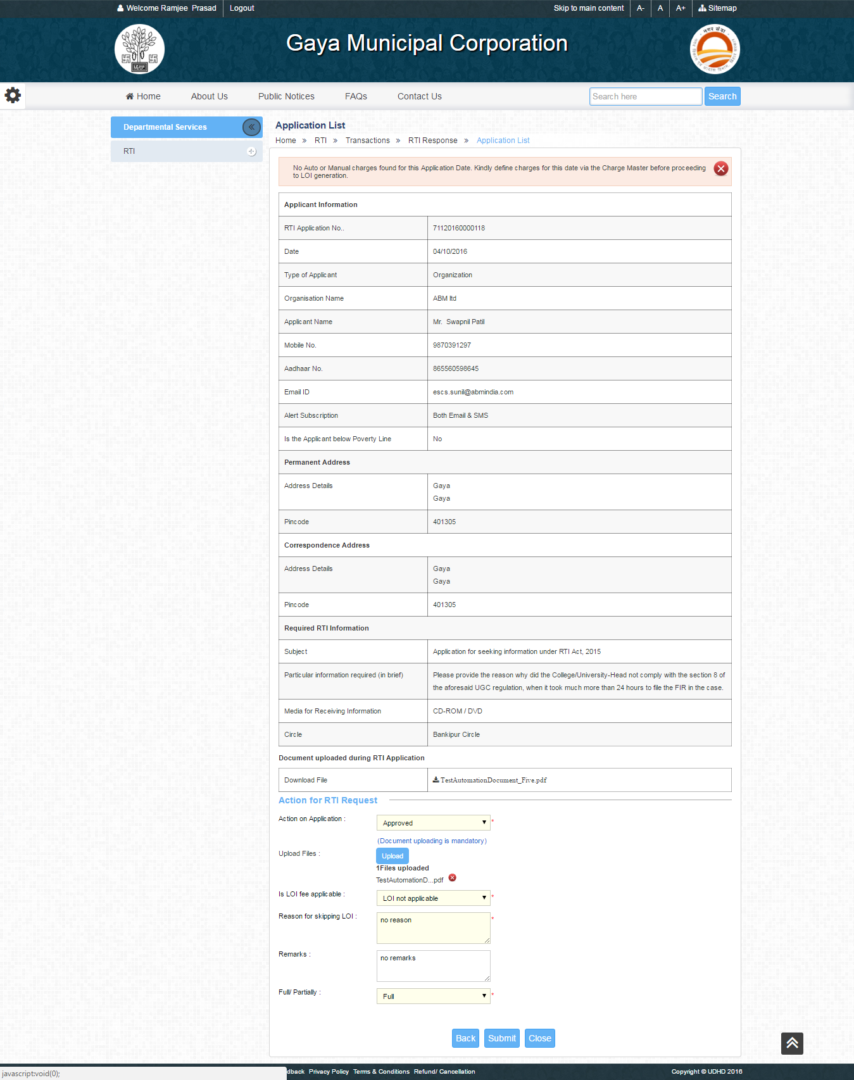

1. When a PIO uses option of **Forward to Relevant Officer**, the sms received does not specify whom to contact to the user. .(I have sent you image on whatsapp.)
2. When a PIO uses option of **Forward to Relevant Officer,** the applicant does not receive any SMS, and the person whose contact number is mentioned during response gets 2 SMSes. How exactly will the applicant move forward with the process when no intimation is provided.

Also, email wasn’t checked, as email isn’t configured on localnagarseva url.

1. The format of SMS when PIO approves during second appeal, the format of time is difficult to decipher.(I have sent you image on whatsapp.)