KES's Rajarambapu Institute of Technology, Rajaramnagar
An Empowered Autonomous Institute, Affiliated to Shivaji University, Kolhapur
Department of Computer Science & Engineering
Academic Year: 2025–26
Mini Project Report
Project Title | Margin — A Full-Stack Notes Management Web Application
Project Domain | Web Application Development using MERN Stack
Live URL | https://margin-notes-001.vercel.app
Project Guide

Team Details
Sr. No. | Roll No. | Name | Email | Phone | Sign
1
2
3
4
5

Sign of Batch Incharge: ___________________

Index

Sr. No. | Particulars | Page No.
1 | Introduction | 1
2 | Objectives | 2
3 | Problem Definition | 3
4 | System Requirements | 4
5 | System Design | 5
6 | Implementation | 6
7 | Results and Output | 7
8 | Conclusion | 8
9 | References | 9

1. Introduction
Margin is a lightweight, full-stack web application built for creating, organizing, and managing personal notes. Developed using the MERN stack — MongoDB, Express.js, React.js, and Node.js — the application provides users with a clean, minimal interface to jot down thoughts, record information, and retrieve or update notes at any time from any device with an internet connection.
The name Margin reflects the idea of writing notes in the margins of one's work — quick, accessible, and always there when needed. The application adopts a dark-themed, card-based design built with React and DaisyUI, offering a polished user experience without unnecessary complexity.
Margin follows a decoupled client-server architecture. The React frontend, deployed on Vercel's global CDN, communicates with an Express.js REST API backend hosted on Render. All persistent data is stored in a MongoDB Atlas cloud cluster, ensuring durability and availability. This separation of concerns makes the application scalable, maintainable, and straightforward to extend.
The entire project was developed as a practical exercise in building and deploying a production-grade full-stack web application, from designing the RESTful API to configuring cloud environments and custom domain routing.

2. Objectives
- To design and implement a responsive, full-stack notes application using the MERN stack (MongoDB, Express.js, React.js, Node.js).
- To apply all four CRUD operations — Create, Read, Update, and Delete — through a RESTful API backed by MongoDB Atlas.
- To build a component-based frontend using React 19 with React Router for client-side navigation across multiple pages.
- To deploy the frontend on Vercel and the backend on Render, establishing a production-ready, continuously deployable cloud environment.
- To configure environment-based API URL management using import.meta.env (Vite) so that local development and production environments operate independently without code changes.
- To practise real-world Git workflow — maintaining clean commits, proper .gitignore hygiene, and a well-structured repository pushed to GitHub.
- To produce a usable, publicly accessible notes tool that demonstrates end-to-end web development proficiency.

3. Problem Definition
Managing short, personal notes digitally often requires either installing heavy desktop applications or relying on vendor-locked proprietary platforms that offer excessive features for simple use cases. Students and developers frequently need a lightweight, browser-based tool to quickly save a note, edit it later, or delete it — without signing up for accounts or dealing with cluttered interfaces.
Additionally, building a CRUD-based application from scratch presents a practical problem in system design: how do you correctly structure a REST API, connect it to a cloud database, serve a dynamic frontend that consumes it, and deploy both in a way that is maintainable and accessible publicly?
Margin addresses both of these needs. It provides an end-to-end solution for personal note-taking while serving as a hands-on project that demonstrates real-world skills in API design, frontend component architecture, database modelling, CORS configuration, environment variable management, and cloud deployment.

4. System Requirements
a) Software Requirements
Component | Technology / Tool | Version
Runtime | Node.js | v24.x
Database | MongoDB Atlas | Cloud (M0 Free Tier)
Frontend Framework | React | v19.x
Build Tool | Vite | v8.x
CSS Framework | TailwindCSS + DaisyUI | v4.x / v5.x
Backend Framework | Express.js | v5.x
HTTP Client | Axios | v1.x
Routing | React Router | v8.x
Notifications | React Hot Toast | v2.x
Icons | Lucide React | v1.x
ODM | Mongoose | v9.x
Version Control | Git + GitHub | —
Code Editor | Visual Studio Code | —
Frontend Hosting | Vercel | —
Backend Hosting | Render | Free Tier

b) Hardware Requirements
Component | Minimum Specification
RAM | 4 GB
Processor | Dual-core, 2.0 GHz or above
Storage | 512 MB free (for local development)
Network | Stable internet connection

5. System Design
a) Architecture Diagram
The application follows a three-tier architecture:
1. Presentation Tier: React + Vite frontend hosted on Vercel (margin-notes-001.vercel.app)
2. Application Tier: Express.js REST API hosted on Render (margin-m1z8.onrender.com)
3. Data Tier: MongoDB Atlas cloud cluster (margin_db)
The frontend communicates with the backend exclusively through HTTPS REST API calls using Axios. The backend interacts with MongoDB Atlas using the Mongoose ODM. Each tier is independently deployable and scalable.
b) Database Schema
Collection: notes
Field | Type | Required | Description
_id | ObjectId | Auto | Unique identifier (MongoDB auto-generated)
title | String | Yes | Title of the note
description | String | Yes | Body / content of the note
createdAt | Date | Auto | Timestamp when note was created
updatedAt | Date | Auto | Timestamp of most recent update

c) REST API Endpoints
Method | Endpoint | Description | Response
GET | /api/notes | Fetch all notes, sorted newest first | 200 [notes]
GET | /api/notes/:id | Fetch a single note by ID | 200 note
POST | /api/notes | Create a new note | 201 savedNote
PUT | /api/notes/:id | Update an existing note | 200 updatedNote
DELETE | /api/notes/:id | Delete a note by ID | 200 deletedNote

6. Implementation
Step 1 — Database Setup
A free-tier MongoDB Atlas cluster was created. A database named margin_db and a collection notes were initialized. The connection string (with credentials embedded) was stored as an environment variable MONGODB_URL and kept outside of version control using .gitignore.
Step 2 — Backend Development
An Express.js server was configured with the following middleware stack: express.json() for body parsing, cors for cross-origin resource sharing, and dotenv for environment variable loading. The notescontroller.js implemented all five CRUD functions: getAllNotes, getNote, createNote, updateNote, and deleteNote. Routes were registered under /api/notes and the server listens on process.env.PORT.
Step 3 — Frontend Development
The React frontend was scaffolded with Vite. Three pages were created: HomePage — fetches and displays all notes in a responsive grid using the NoteCard component; CreateNotePage — renders a form to input a note title and description and POSTs it to the API; NotePage — displays a single note's full content and provides an inline edit form and a delete button. React Router v8 was used for client-side routing. Axios was configured via a shared api instance (src/lib/axios.js) which reads the backend URL from import.meta.env.VITE_API_URL.
Step 4 — CORS and Environment Configuration
The backend's CORS middleware was configured to dynamically accept requests from localhost:5173 during development and any .vercel.app domain in production, controlled by the CLIENT_URL environment variable.
Step 5 — Deployment
The backend was deployed on Render with MONGODB_URL set as a secret environment variable. The frontend was deployed on Vercel with VITE_API_URL pointing to the live Render backend URL. A vercel.json rewrite rule was added so React Router's client-side navigation does not result in 404 errors on page refresh.
Step 6 — Repository Hygiene
node_modules, dist/, .env, and IDE files were added to .gitignore. The previously tracked backend/node_modules was removed from the Git index using git rm -r --cached, keeping the repository lean and deployment-ready.

7. Results and Output
Home Page — Notes Dashboard
The home page displays all saved notes as cards in a responsive grid layout. Each card shows the note title, a truncated preview of the content, the creation date, and quick action icons for editing and deleting.
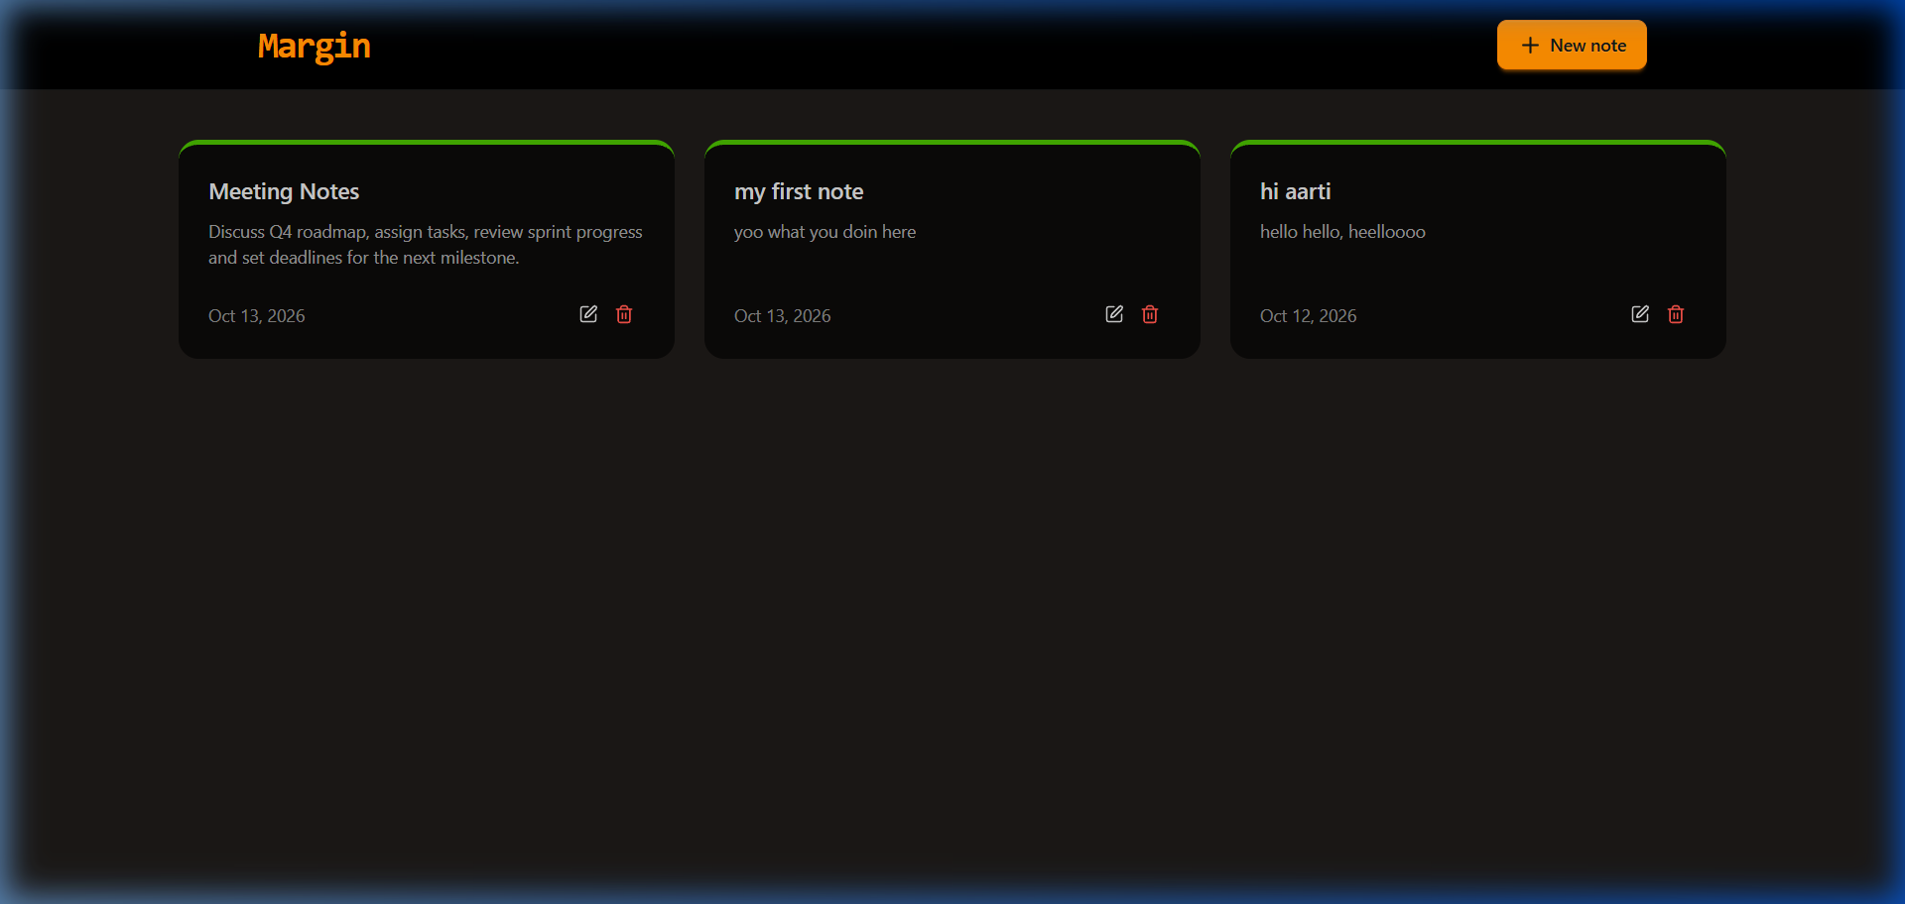
Figure 1: Home Page — Notes Dashboard

Create Note Page
The Create Note page presents a clean form with a title field and a content textarea. On submission, the note is sent to the backend via a POST /api/notes request, a success toast notification is shown, and the user is redirected to the home page.
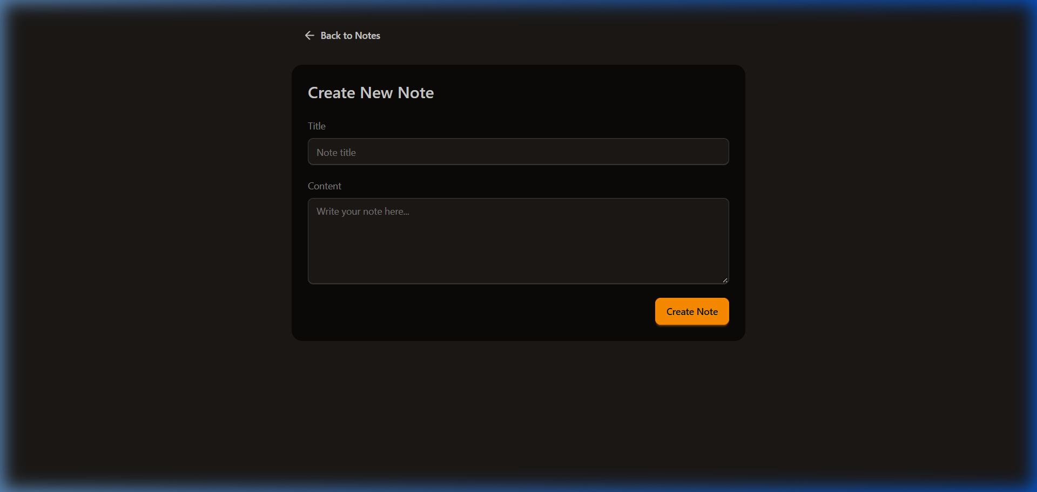
Figure 2: Create Note Page

Note Detail and Edit Page
Clicking any note card navigates to the individual note page. Here the user can read the full content, edit the title or description inline, and save changes via PUT or permanently delete the note via DELETE.
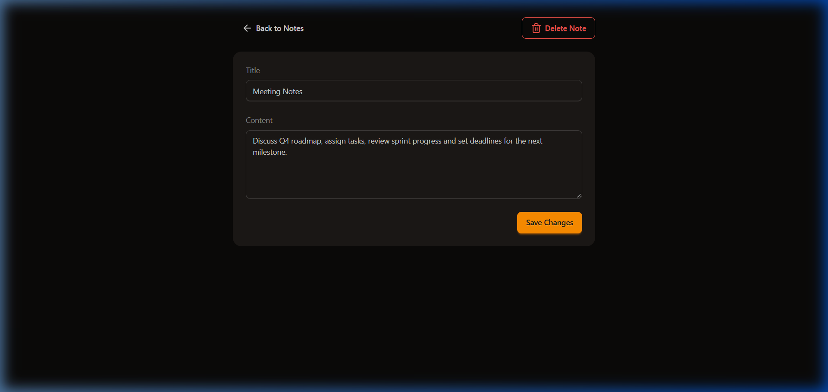
Figure 3: Note Detail and Edit Page

Empty State
When no notes exist, the application displays an empty-state illustration with a friendly prompt to create the first note, ensuring a polished experience even on first use.
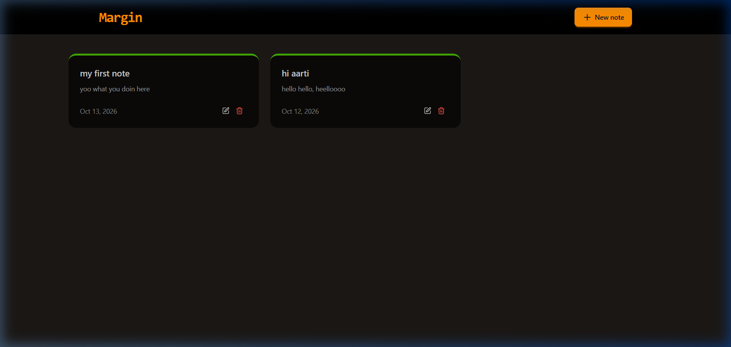
Figure 4: Empty State — No Notes Found

Live Deployment URLs
Service | URL
Frontend (Vercel) | https://margin-notes-001.vercel.app
Backend Health (Render) | https://margin-m1z8.onrender.com/

8. Conclusion
Margin successfully demonstrates the complete lifecycle of a production-grade full-stack web application. Starting from a blank project, the team designed a RESTful API with Express.js and Mongoose, built a component-based React frontend, and deployed both services independently to the cloud — each auto-deploying from GitHub on every commit.
The project reinforces core MERN stack principles: stateless REST API design, client-side routing, environment-driven configuration, and cross-origin request handling. By deploying to Vercel and Render with a live MongoDB Atlas database, the application operates as a real-world tool accessible from any device without any local setup.
Key takeaways from the project include the importance of keeping secrets out of version control, correctly structuring a Git repository to avoid submodule pitfalls, and the value of a health-check endpoint for cloud service monitoring. The application is fully extensible — future iterations could add user authentication, rich-text editing, note tagging, or search functionality.

9. References
- MongoDB Official Documentation — https://www.mongodb.com/docs/
- Mongoose ODM Documentation — https://mongoosejs.com/docs/
- Express.js API Reference — https://expressjs.com/
- React Official Documentation — https://react.dev/
- React Router Documentation — https://reactrouter.com/
- Vite Build Tool Documentation — https://vitejs.dev/guide/
- DaisyUI Component Library — https://daisyui.com/
- Axios HTTP Client — https://axios-http.com/docs/intro
- Vercel Deployment Guide — https://vercel.com/docs
- Render.com Documentation — https://render.com/docs
- MongoDB Atlas Setup — https://www.mongodb.com/docs/atlas/
- Lucide Icons — https://lucide.dev/

