Assignment IV: Implementation of Text
Preprocessing Techniques and Sentiment Analysis Using R Programming
Dataset: Cleaned_Demonetisation_Twitter_Dataset.csv
Dataset location: D:/SWAPNIL FOLDER/ADYPU/FY Notes ( Sem 7)/DAR/Assignment- 4/
Objective: To apply text preprocessing, tokenization, stemming, lemmatization, word frequency analysis and lexicon-based sentiment analysis to tweets related to demonetisation.

Introduction
This assignment uses R programming to process and analyse a collection of Twitter posts related to demonetisation. The text column contains the tweet content. The workflow cleans the text, converts it into individual tokens, studies frequent terms and estimates the sentiment of each tweet using the Bing sentiment lexicon.

Dataset overview
Property | Details
File name | Cleaned_Demonetisation_Twitter_Dataset.csv
Rows and columns | 15,844 rows × 16 columns
Text field used | text
Analysis identifier | tweet_id (created using row_number())

Step 1: Install and load required packages
The following packages are used for data import, text cleaning, tokenization, stemming, lemmatization and visualization.
install.packages(c("tidyverse", "tm", "tidytext", "stopwords", "SnowballC", "textstem"))
library(tidyverse) library(tm) library(tidytext) library(stopwords) library(SnowballC) library(textstem)
(Fig. 1.1) Required packages are installed and loaded in RStudio.

Step 2: Import the Twitter dataset
The CSV file is imported from the specified folder using read_csv(). The imported data is stored in the object tweets.
tweets <- read_csv( "D:/SWAPNIL FOLDER/ADYPU/FY Notes ( Sem 7)/DAR/Assignment- 4/Cleaned_Demonetisation_Twitter_Dataset.csv", show_col_types = FALSE )
head(tweets)
(Fig. 1.2) Reads the demonetisation Twitter dataset into R.

Step 3: Explore and inspect the dataset
The dataset dimensions, column names, structure, missing values and duplicate records are checked. The text column is selected for text analysis.
dim(tweets) colnames(tweets) str(tweets) colSums(is.na(tweets)) sum(duplicated(tweets)) sum(duplicated(tweets$text))
(Fig. 1.3) Displays the dataset structure and basic quality checks.

Step 4: Create tweet IDs and convert text to lowercase
A unique row identifier is created for each tweet. All tweet text is converted to lowercase so that words with different capitalization are treated consistently.
tweets <- tweets %>% mutate( tweet_id = row_number(), lower_text = tolower(text) )
tweets %>% select(text, lower_text) %>% head(10)
(Fig. 2.1) Converts tweet text into lowercase.

Step 5: Remove punctuation
Punctuation marks such as commas, full stops, question marks and exclamation marks are removed from the lowercase text.
tweets <- tweets %>% mutate(clean_text = removePunctuation(lower_text))
tweets %>% select(lower_text, clean_text) %>% head(10)
(Fig. 2.2) Removes punctuation marks from the tweets.

Step 6: Remove numbers
Numerical characters are removed because the analysis focuses on words and their sentiment.
tweets <- tweets %>%
mutate(no_numbers = removeNumbers(clean_text))
(Fig. 2.3) Removes numerical values from the text.

Step 7: Remove special characters
The regular expression keeps alphabetic characters and whitespace, replacing other characters with spaces.
tweets <- tweets %>% mutate(no_special = str_replace_all( no_numbers, "[^a-zA-Z\\s]", " " ))
(Fig. 2.4) Removes unwanted special characters.

Step 8: Remove extra spaces
Multiple spaces, leading spaces and trailing spaces are reduced to a clean single-space format using str_squish().
The final cleaned text is stored in clean_text.
tweets <- tweets %>% mutate(clean_text = str_squish(no_special))
tweets %>% select(text, clean_text) %>% head(10)
(Fig. 2.5) Produces the final cleaned tweet text.

Step 9: Stop-word removal
Stop words are common words such as “the”, “is”, “and” and “are”. The English stop-word list is obtained from the stopwords package. The tweet text is tokenized and common stop words are filtered out. stop_words_list <- stopwords::stopwords("en")
tokens <- tweets %>% select(tweet_id, clean_text) %>% unnest_tokens(word, clean_text) %>% filter(!word %in% stop_words_list)
head(tokens, 20)
(Fig. 3.1) Removes common English stop words from the tokenized text.

Step 10: Tokenization
Tokenization splits each tweet into individual words called tokens. The unnest_tokens() function creates one word per row. The number of tokens and unique words can be checked.
head(tokens$word, 20) nrow(tokens) n_distinct(tokens$word)
(Fig. 3.2) Displays individual tokens extracted from the tweets.

Step 11: Stemming
Stemming reduces words to a stem by removing common word endings. A stem may not always be a complete dictionary word. The SnowballC package is used for English stemming.
stemmed_tokens <- tokens %>% mutate(stemmed_word = wordStem( word, language = "english" ))
stemmed_tokens %>% select(word, stemmed_word) %>% head(20)
(Fig. 3.3) Shows original tokens alongside their stemmed forms.

Step 12: Lemmatization
Lemmatization converts a word into its meaningful dictionary base form. The textstem package is used.
Lemmatization is applied to the original token rather than the stemmed result.
lemmatized_tokens <- stemmed_tokens %>% mutate(lemma = lemmatize_words(word))
lemmatized_tokens %>% select(word, stemmed_word, lemma) %>% head(30)
(Fig. 3.4) Compares original words, stems and lemmas.

Step 13: Word frequency analysis
Word frequency analysis counts how often each lemmatized word appears. The results are sorted in descending order and the 20 most frequent words are selected for visualization.
word_frequency <- lemmatized_tokens %>% count(lemma, sort = TRUE)
top_20_words <- word_frequency %>% slice_max(order_by = n, n = 20)
print(top_20_words)
The top-frequency chart generated from the dataset is shown below.
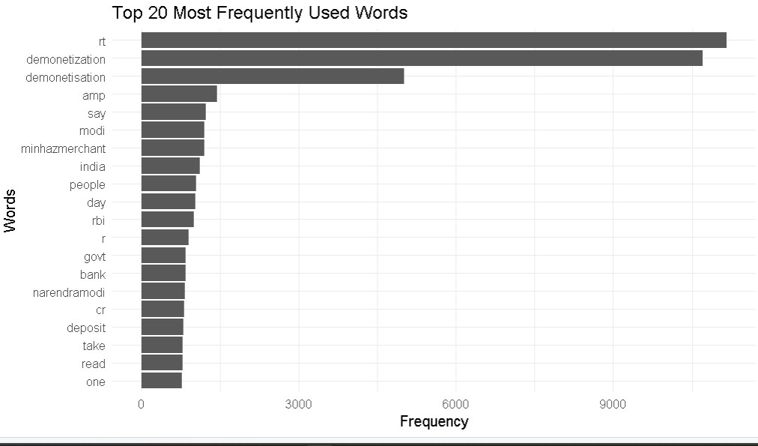
(Fig. 4.1) Top 20 most frequently used words in the demonetisation tweets.
The chart shows that “rt”, “demonetization” and “demonetisation” occur frequently. Other prominent terms include
“modi”, “india”, “people”, “rbi” and “bank”. The presence of “rt” and “amp” indicates that some retweet markers and HTML text artifacts may remain in the processed text.

Step 14: Load the sentiment lexicon
The Bing sentiment lexicon contains words labelled as positive or negative. It is loaded using get_sentiments() from tidytext.
bing_lexicon <- get_sentiments("bing") head(bing_lexicon, 20)
(Fig. 4.2) Loads sample words from the Bing sentiment dictionary.

Step 15: Prepare tweets and tokenize for sentiment analysis
For sentiment analysis, the original cleaned tweet text is used rather than the stop-word-removed token table. This retains words such as “not”, which may influence sentiment. The terms “rt” and “amp” are removed from this sentiment-specific text.
sentiment_tokens <- tweets %>% select(tweet_id, clean_text) %>% mutate(clean_text = str_remove_all( clean_text, "\\brt\\b|\\bamp\\b" )) %>%
unnest_tokens(word, clean_text)
(Fig. 4.3) Prepares individual words for sentiment matching.

Step 16: Match tweet words with sentiment words
The tweet tokens are joined with the Bing lexicon. Only words present in the sentiment dictionary are retained for scoring.
sentiment_words <- sentiment_tokens %>% inner_join(bing_lexicon, by = "word")
head(sentiment_words, 20)
(Fig. 5.1) Matches tweet words with positive and negative lexicon entries.

Step 17: Calculate sentiment scores
Each positive word is assigned a score of +1 and each negative word is assigned a score of -1. The scores are added for each tweet to obtain its sentiment score.
tweet_sentiment <- sentiment_words %>% mutate(score = ifelse(sentiment == "positive", 1, -1)) %>% group_by(tweet_id) %>% summarise( sentiment_score = sum(score), .groups = "drop"
)
(Fig. 5.2) Calculates an overall sentiment score for each tweet.

Step 18: Classify tweets into sentiment categories
The tweet scores are joined back to the original tweet records. Tweets with a score greater than zero are labelled Positive, scores below zero are labelled Negative, and a score of zero is labelled Neutral. Tweets with no matched sentiment words receive a score of zero.
sentiment_results <- tweets %>% select(tweet_id, text, clean_text) %>% left_join(tweet_sentiment, by = "tweet_id") %>% mutate( sentiment_score = replace_na(sentiment_score, 0), sentiment_category = case_when( sentiment_score > 0 ~ "Positive", sentiment_score < 0 ~ "Negative", TRUE ~ "Neutral"
) )
head(sentiment_results, 20)
(Fig. 5.3) Displays tweets with their sentiment score and category.

Step 19: Calculate sentiment distribution
The number of tweets in each sentiment category is counted. The percentage of each category is calculated relative to the total number of tweets.
sentiment_summary <- sentiment_results %>% count(sentiment_category, name = "total_tweets") %>% mutate( percentage = round(
total_tweets / sum(total_tweets) * 100, 2 ) )
print(sentiment_summary)
(Fig. 5.4) Summarizes the number and percentage of positive, negative and neutral tweets.

Step 20: Sentiment visualization
A bar chart is created to compare the three sentiment categories. The chart displays the number of tweets and their percentage distribution.
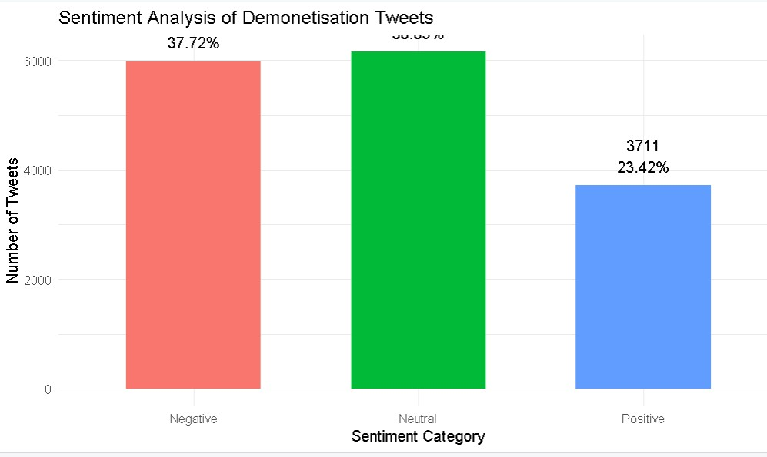
(Fig. 5.5) Sentiment analysis distribution of demonetisation tweets.
The chart indicates that neutral tweets form the largest category, closely followed by negative tweets. Positive tweets represent the smallest category.

Step 21: Save the results
The classified tweet data, sentiment summary and visualizations are saved so they can be used in the final submission.
dir.create("output", showWarnings = FALSE, recursive = TRUE) dir.create("data/processed", showWarnings = FALSE, recursive = TRUE)
write.csv( sentiment_results, "data/processed/sentiment_results.csv", row.names = FALSE )
write.csv( sentiment_summary, "output/sentiment_summary.csv", row.names = FALSE )
write.csv( word_frequency, "output/word_frequency.csv", row.names = FALSE )
ggsave("output/sentiment_distribution.png", width = 10, height = 6, dpi = 300)
(Fig. 6.1) Saves the sentiment results, word frequencies and chart files.

Results and observations
Sentiment category | Percentage shown in chart
Negative | 37.72%
Neutral | Approximately 38.86%
Positive | 23.42%
- The dataset was successfully imported and analysed using R programming.
- Text preprocessing operations removed punctuation, numbers, special characters and extra spaces, andconverted the text to lowercase.
- Stop-word removal and tokenization converted tweets into individual words for further analysis.
- Stemming and lemmatization were applied to reduce tokens to their stem and dictionary base form.
- Word frequency analysis identified frequently used terms related to demonetisation, including demonetization,demonetisation, Modi, India, people, RBI and bank.
- The sentiment chart shows approximately 37.72% negative, 38.86% neutral and 23.42% positive tweets. Neutraltweets form the largest group, while positive tweets form the smallest group.
- The visualizations make it easier to compare the most frequent words and the estimated sentiment distribution.

Conclusion
The assignment demonstrated how R programming can be used for text preprocessing, tokenization, stemming, lemmatization, word frequency analysis and basic sentiment classification of social media text. The results provide an overview of frequently discussed terms and the estimated sentiment expressed in the demonetisation tweets.
Limitation: The Bing lexicon method is dictionary-based. It does not fully understand context, sarcasm, or phrases involving negation (for example, “not good”). Therefore, the sentiment labels are estimates and should not be treated as a perfect measure of public opinion.

