git add
Go to stage
Git commit
Take photo

git restore --staged names.txt
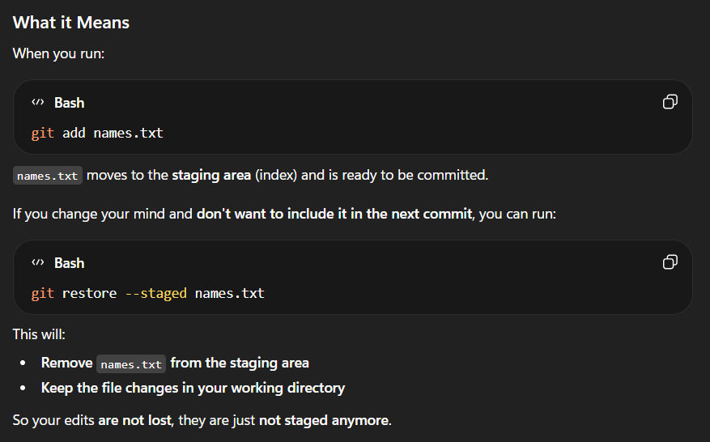
git log
Shows commit (stack ds)
We cannot delete commit in between; Hash IDs are there for each commit; Copy the hash ID of latest commit which you want to keep then
git reset hashid
Previous commits content is now in unstaged area

git stash
To send staged(tracked) content to backstage and bring when needed
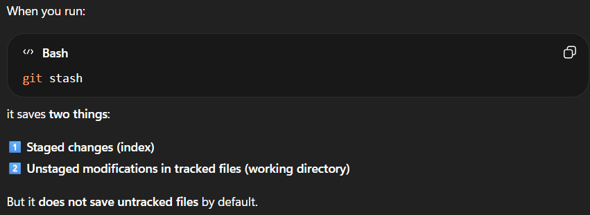
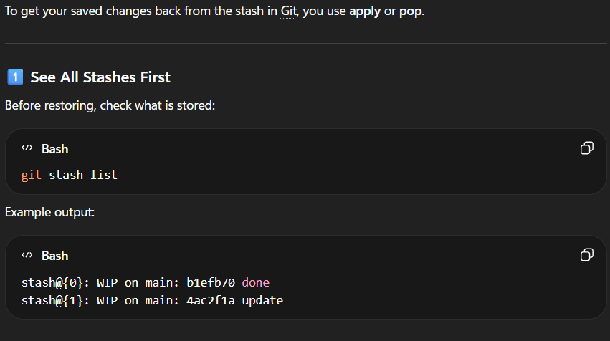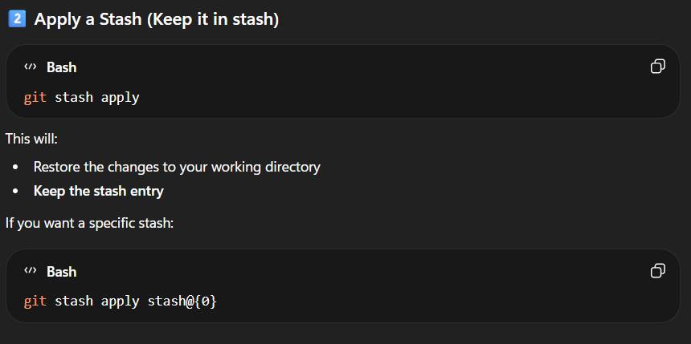
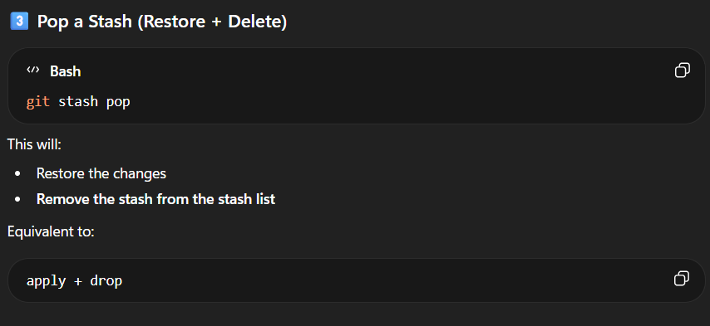
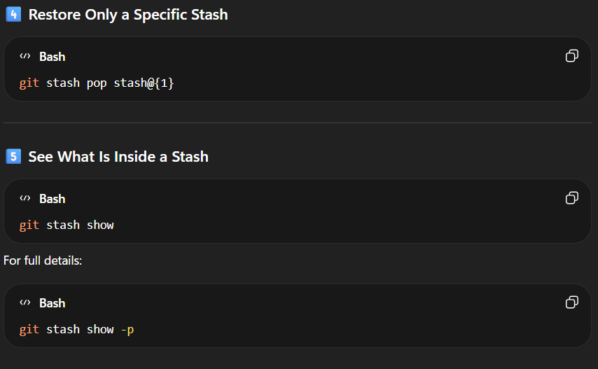

git stash clear
Delete all stash
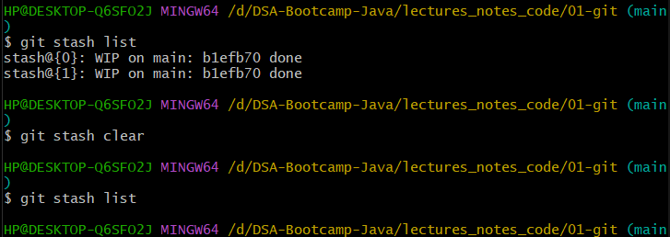

GITHUB
git remote -v
git remote add origin …….url…….. (origin is the name of url)
git push origin …branch_name……..

