SafeT App

Key Concepts:

Sometimes such incidents happens like accidents,heart attack, etc. So person will not able to perform.SafeT app is used to get a help in unwanted situations like, accident,car crash,heart attack,etc.It is design for android smart watch. Smart watch will continuously records physical and internal health. So whenever sudden change in users health occures. It will generate reports of users health.

Requirement of Application
Software Architecture
Testing
Marketing

Requirement of Application:

In today's world, people using smart phones have increased rapidly and hence, a smart phone can be used efficiently for personal security or various other protection purposes.so along with most applications some apps are very useful for every person.
Some applications are not useful when installed on mobile because sometimes access of mobile will not possible. Therefore application used in wareables are more efficient.

Software Architecture

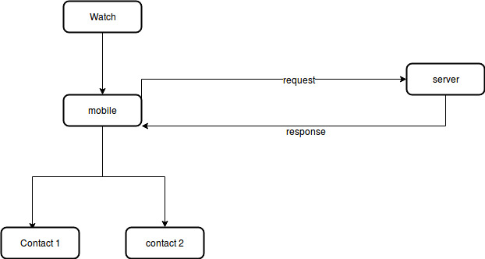

Flow of Application:

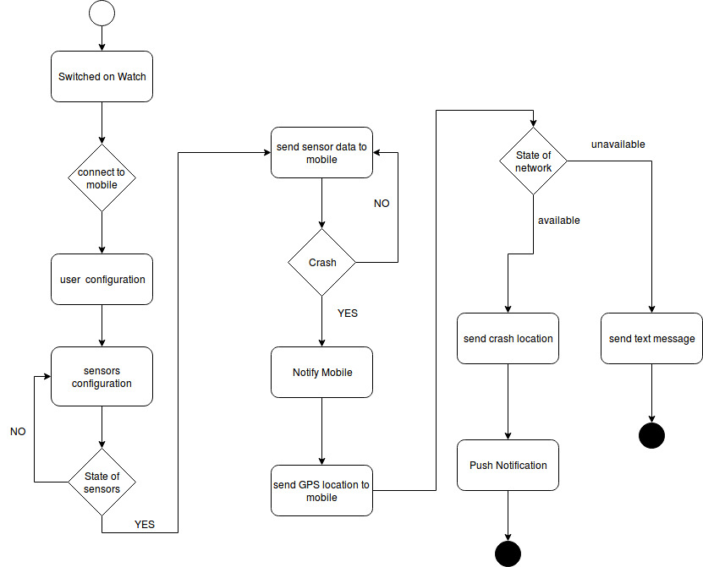

Tools used in developement:

Android Studio 3.2.1 (Android and Wearable)

Testing Tools:

android device
Android smart watch.

Marketing:
Its a free application available on play store. User can easily download. Its an application which every user should have. It provides safety.

Some screenshots of Mobile application:

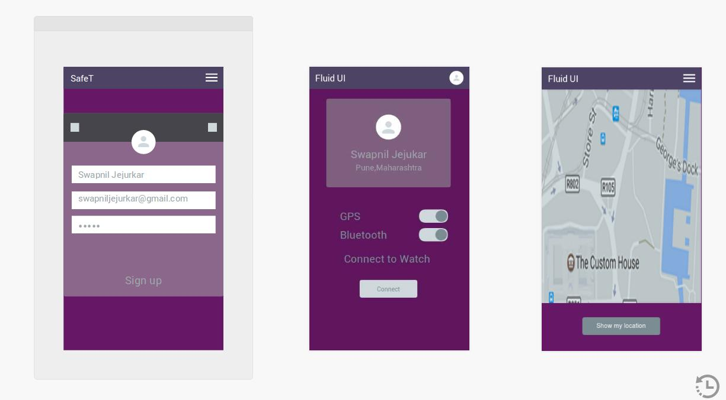

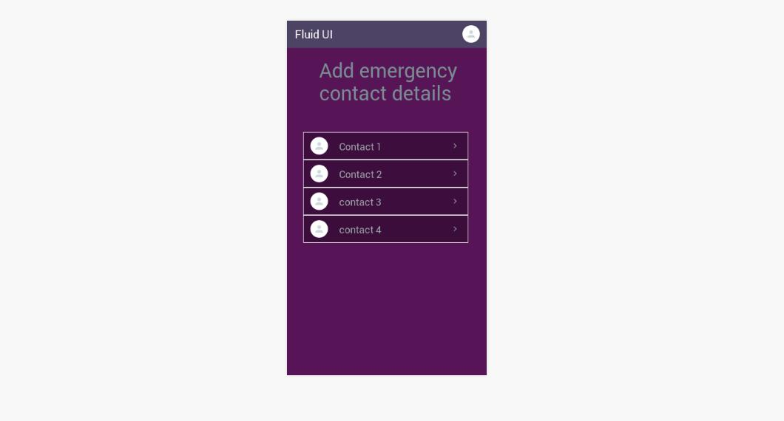

Smart Watch Screens:

