1. **Creating VPC**

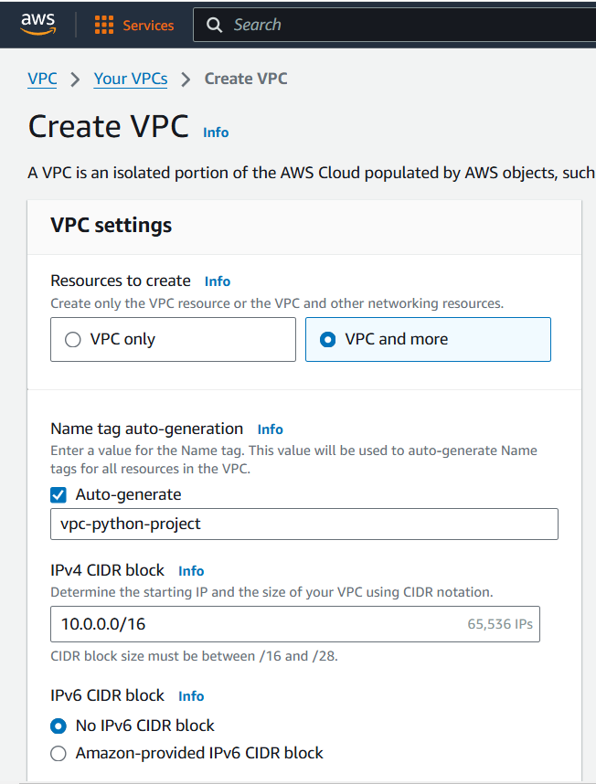

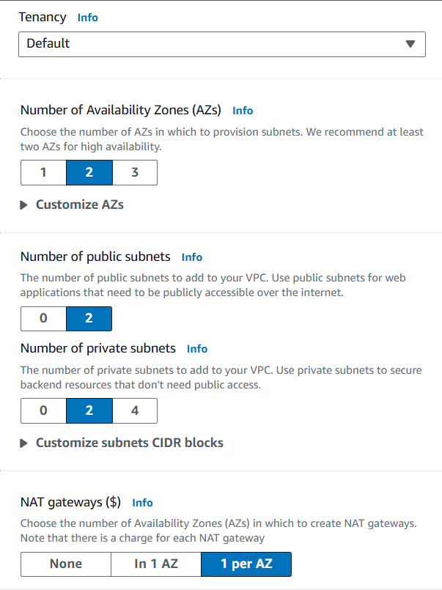

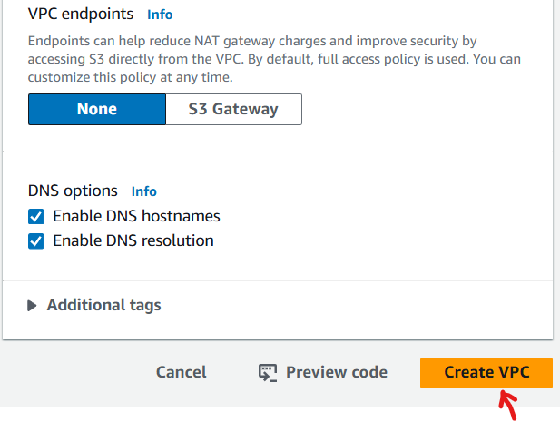

* **Resource map will be look like below post creation of VPC.**

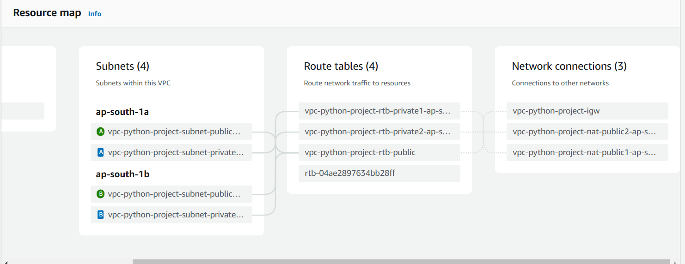

1. **Creating launch template for auto scaling group**

* **You need to create launch template first before creating the auto scaling group.**

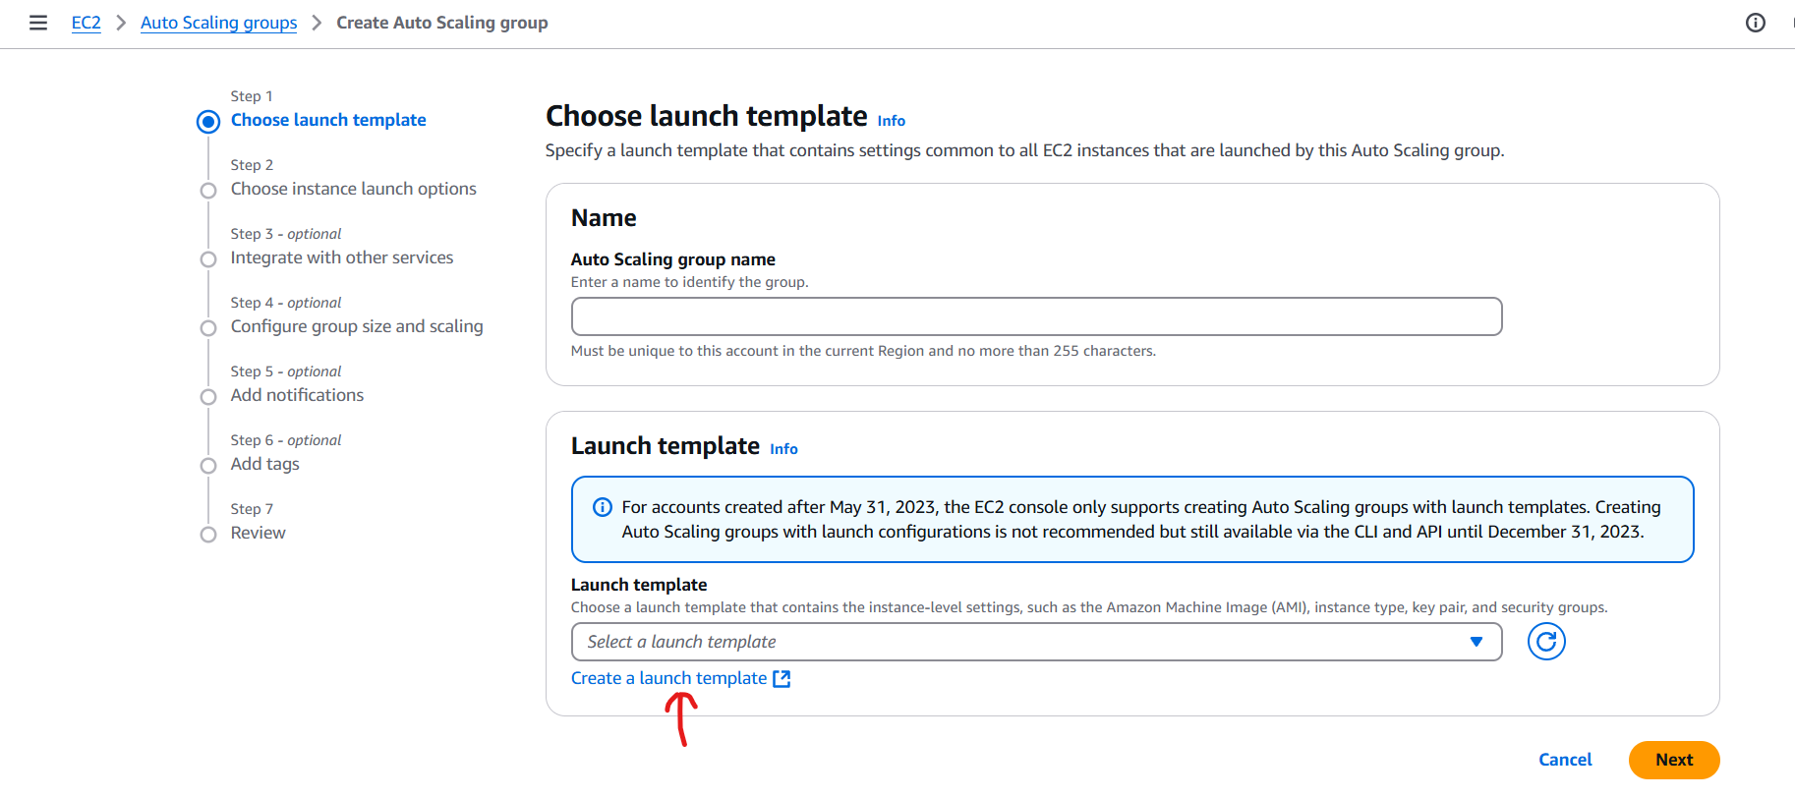

* **Creating launch template**

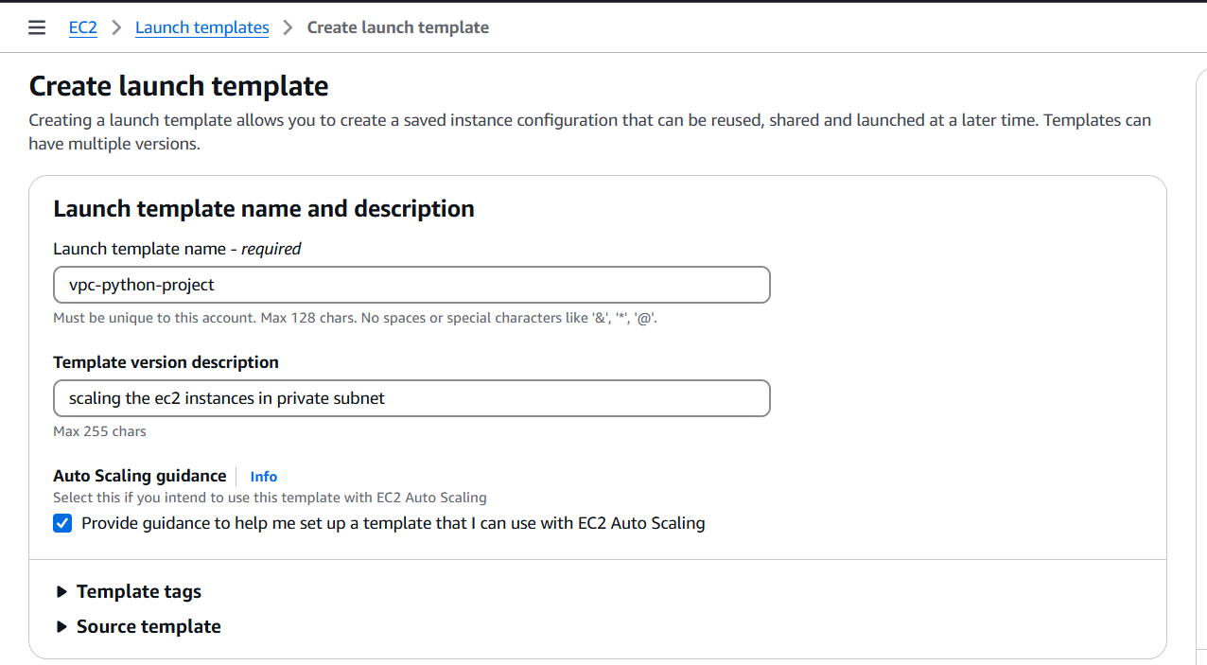

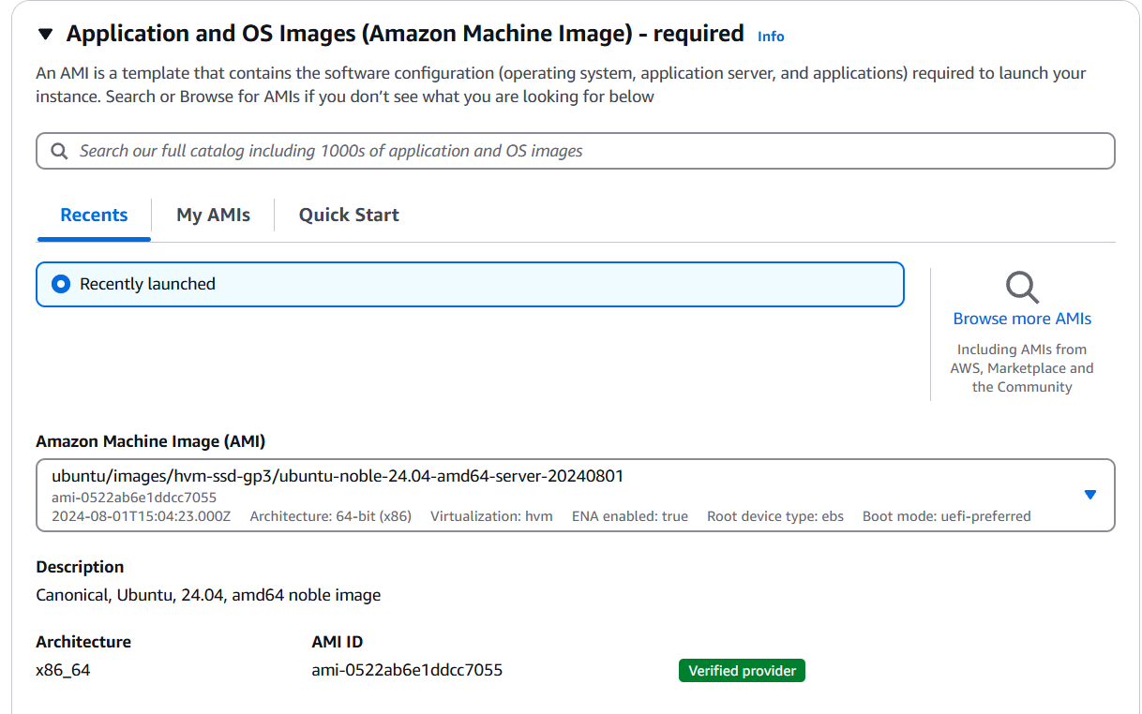

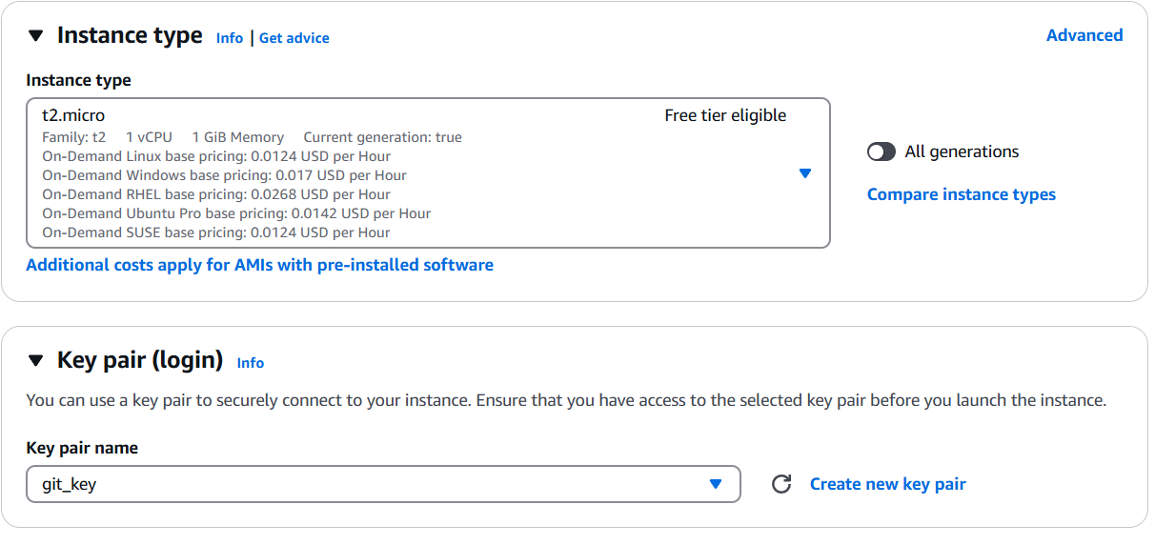

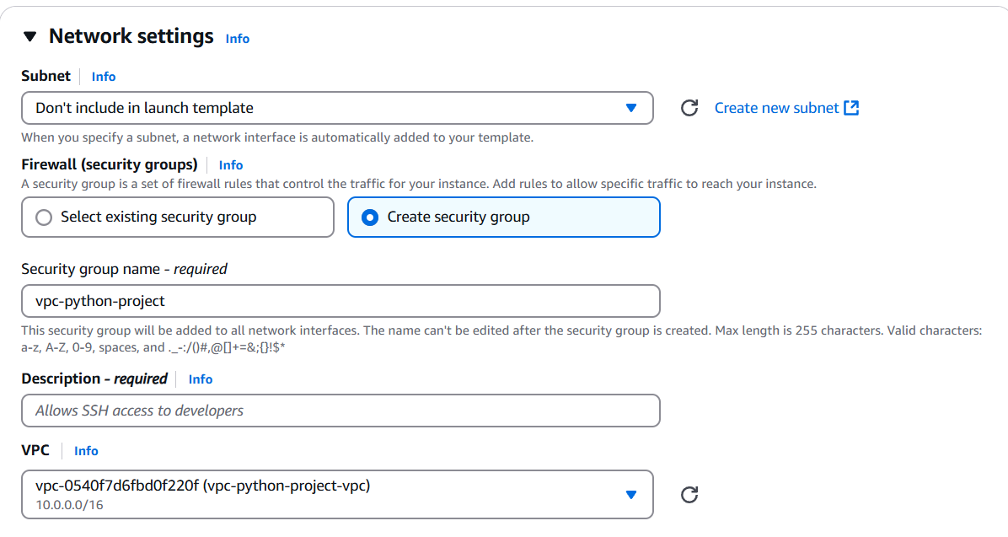

* **Creating inbound security group rule for ssh and application custom port 8000 which we are going to deploy on these instances.**

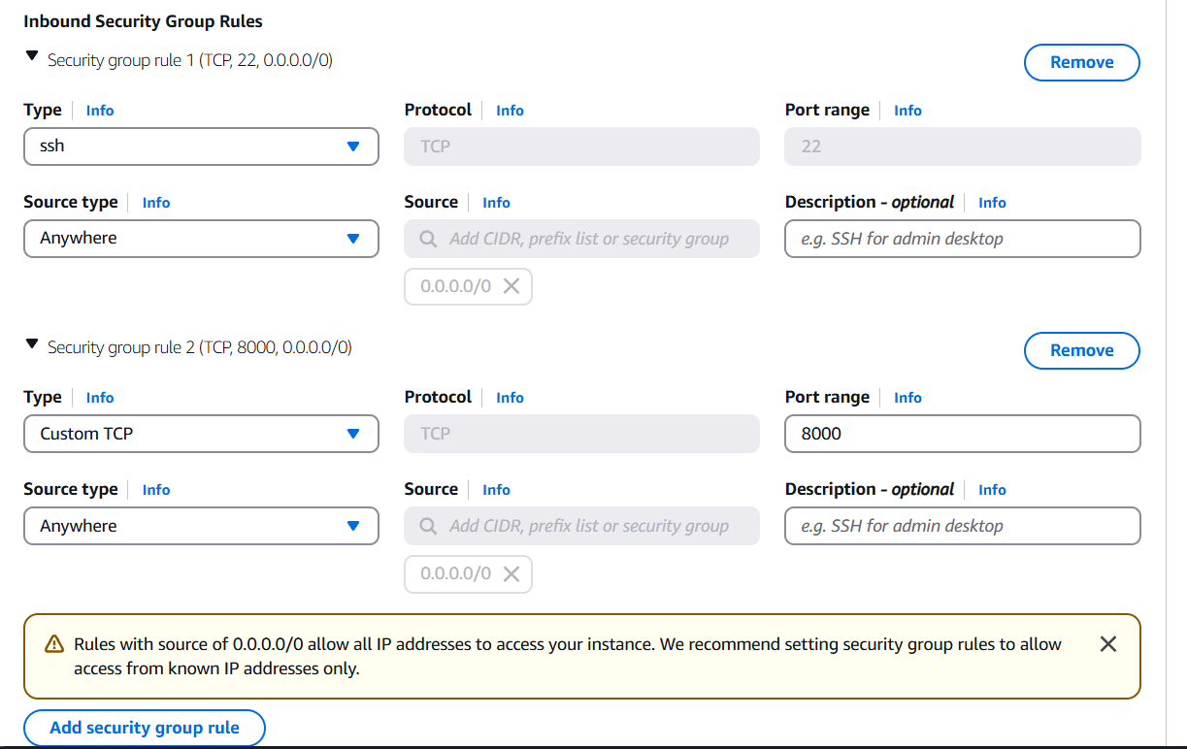

* **Click on create launch template**

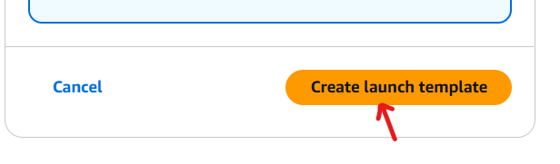

1. **Creating auto scaling group**

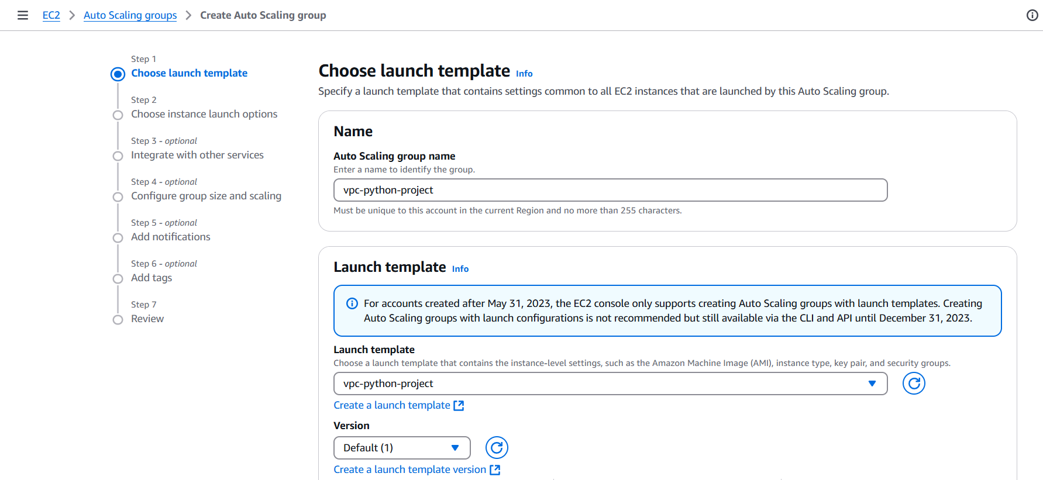

* **Select your VPC with private subnet since we have to keep our application secure do not want to expose it over the internet.**

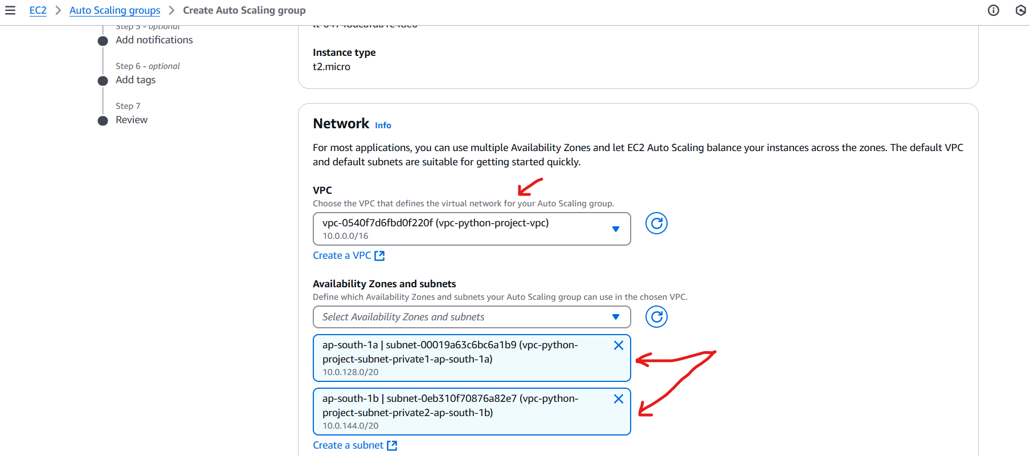

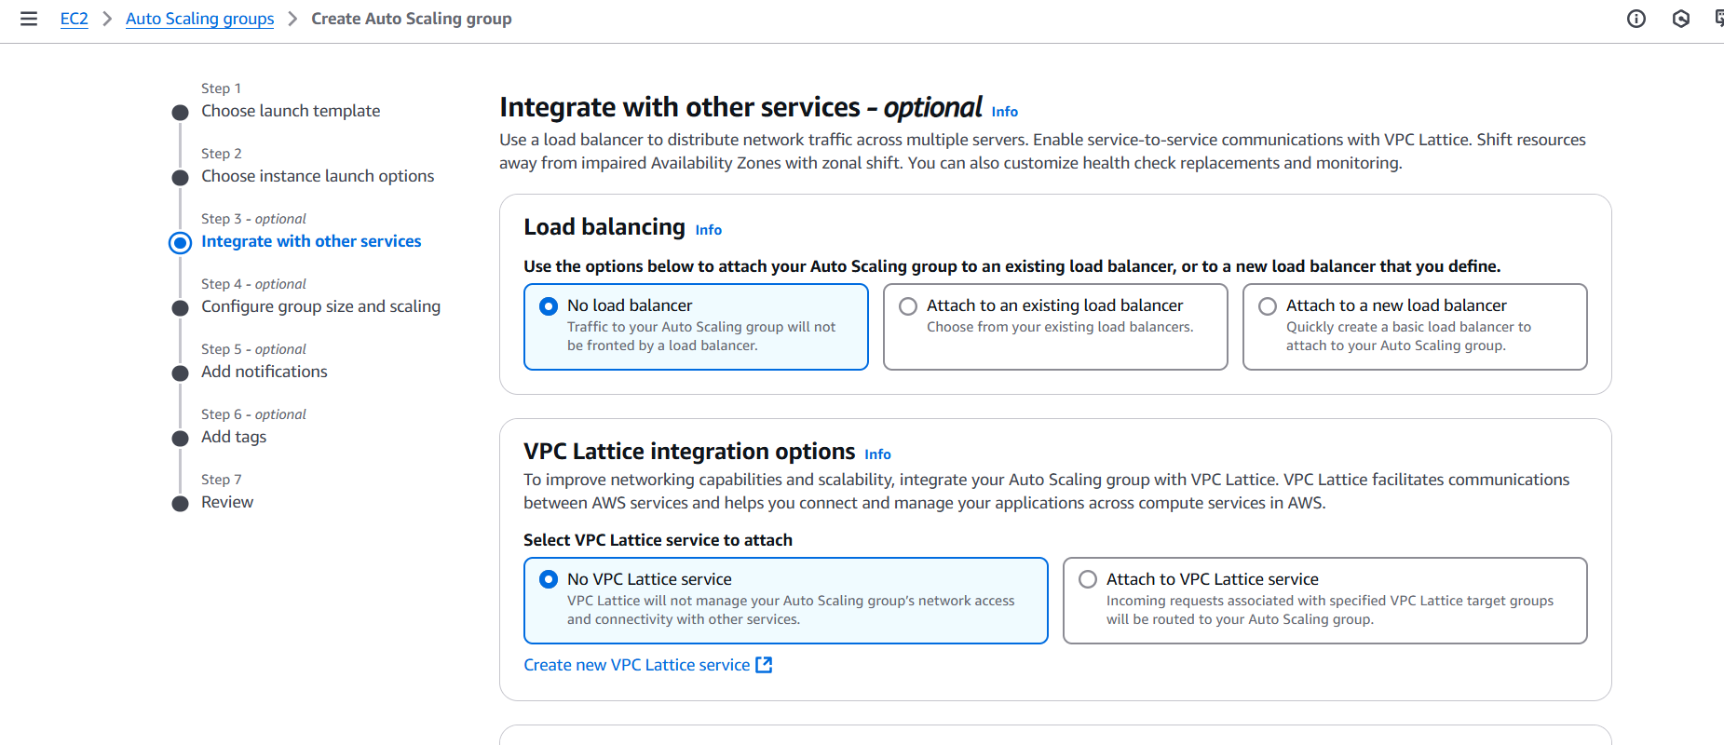

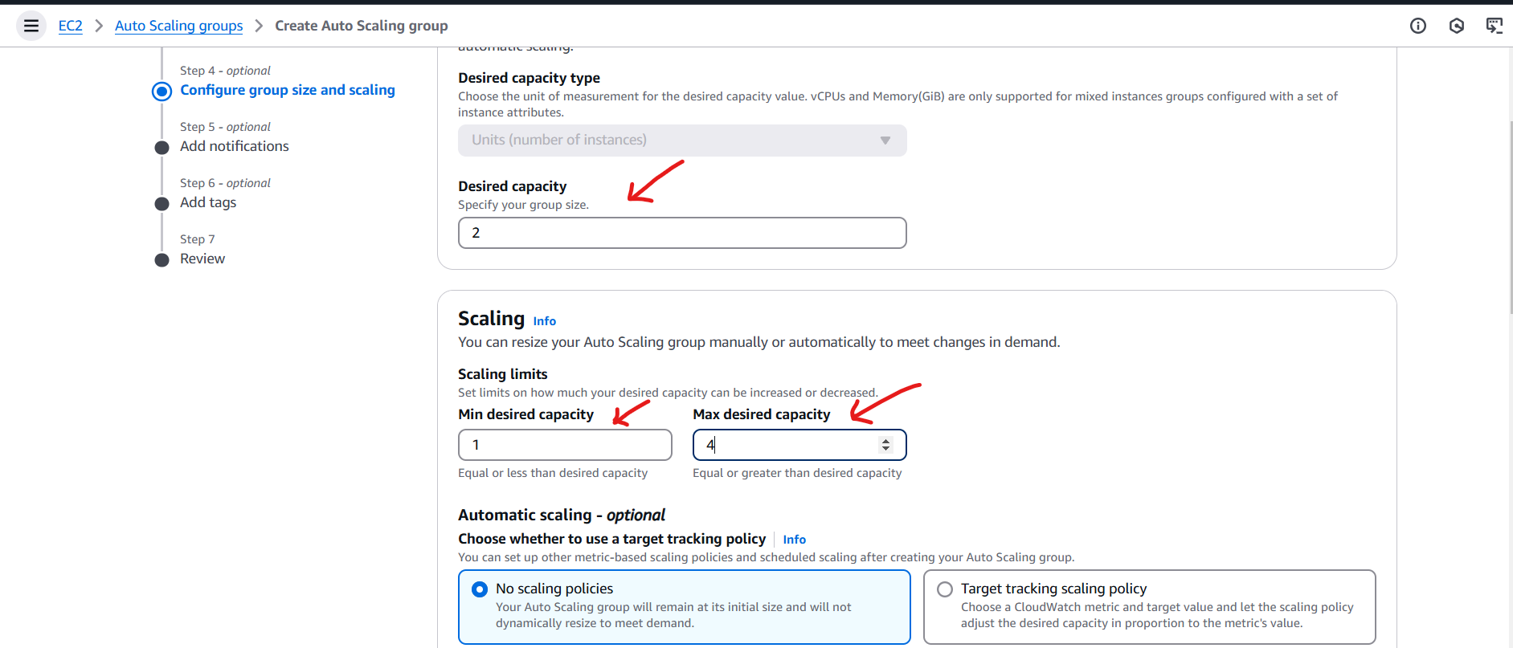

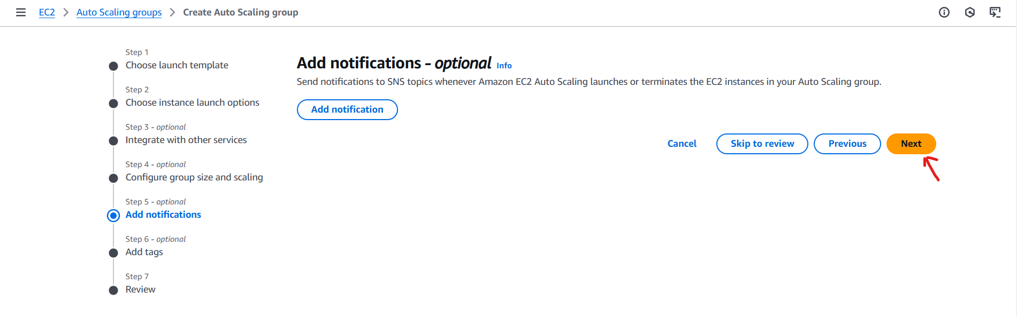

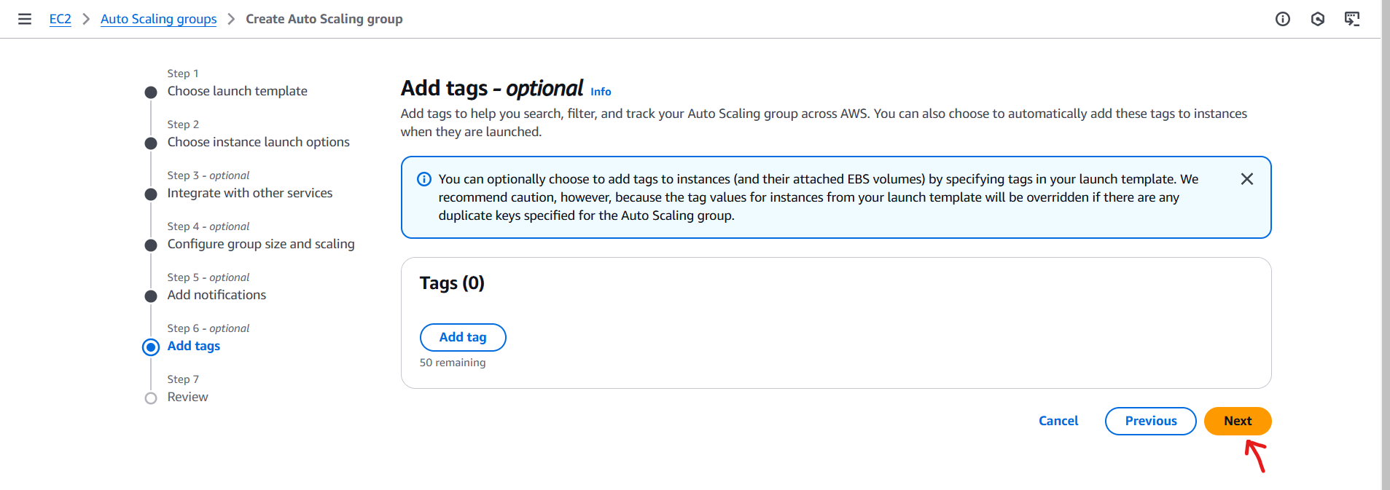

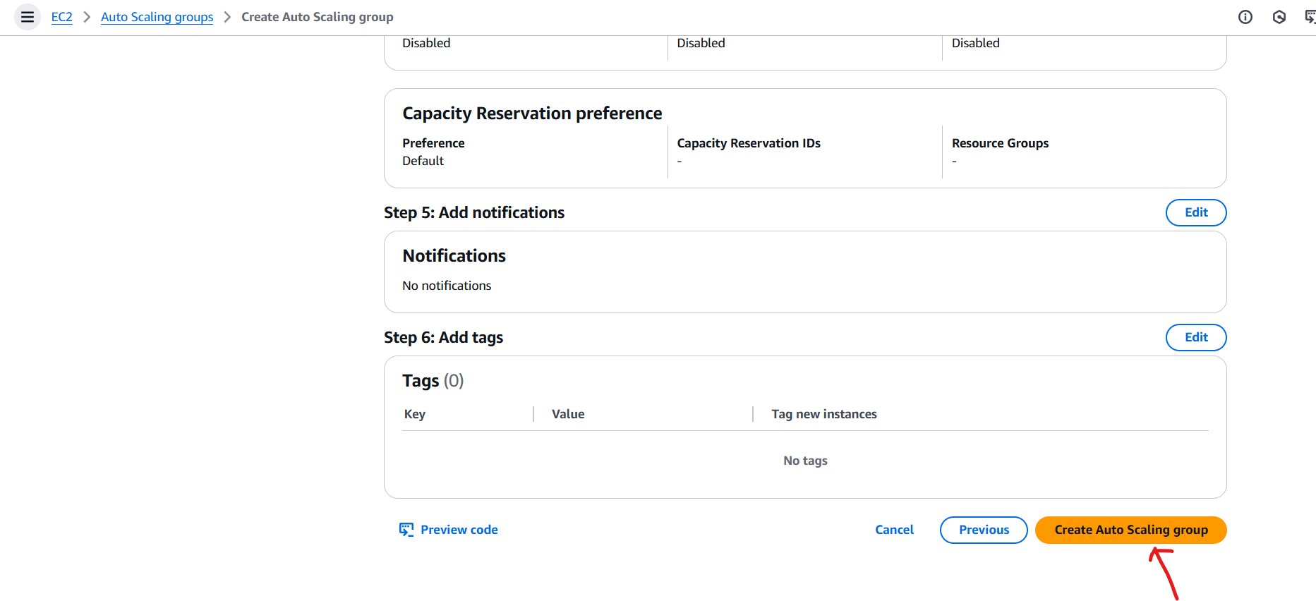

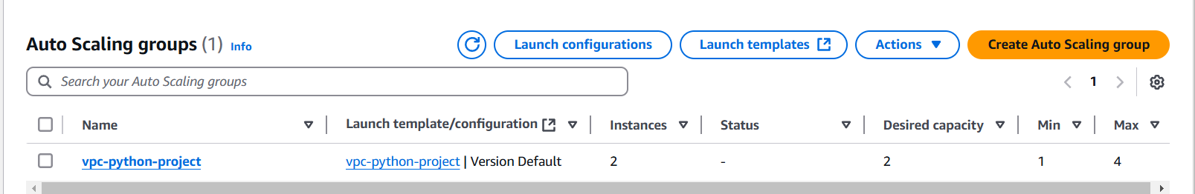

* **Now auto scaling group will create the instances as per desired capacity mentioned with private ips.**

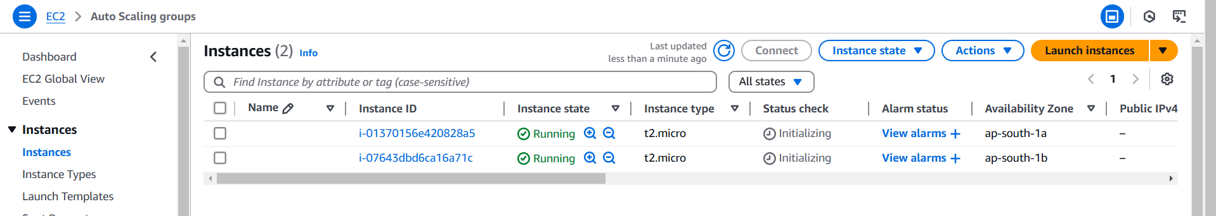

1. **Creating Bastion or jump host to access these instances since it do not have public ips. Bastion host is act as a mediator between private subnet and public subnet.**

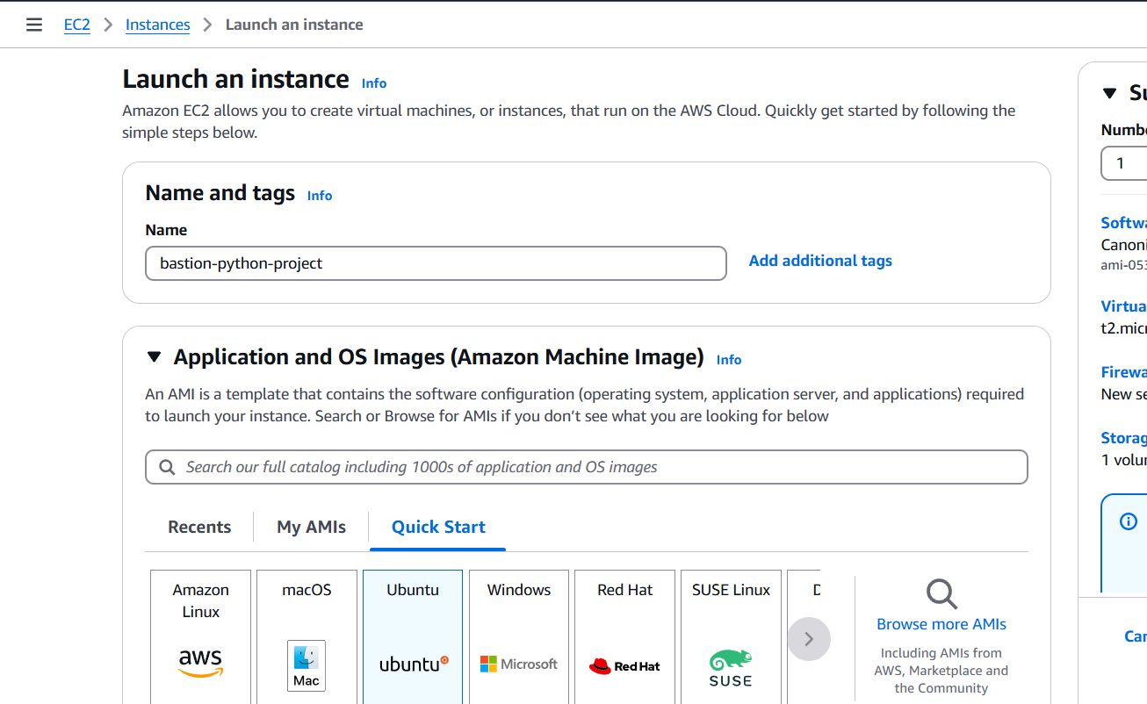

* **Selecting our VPC with public subnet.**

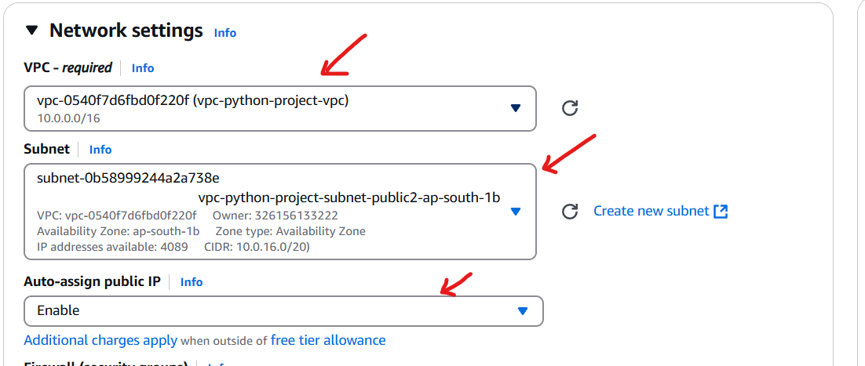

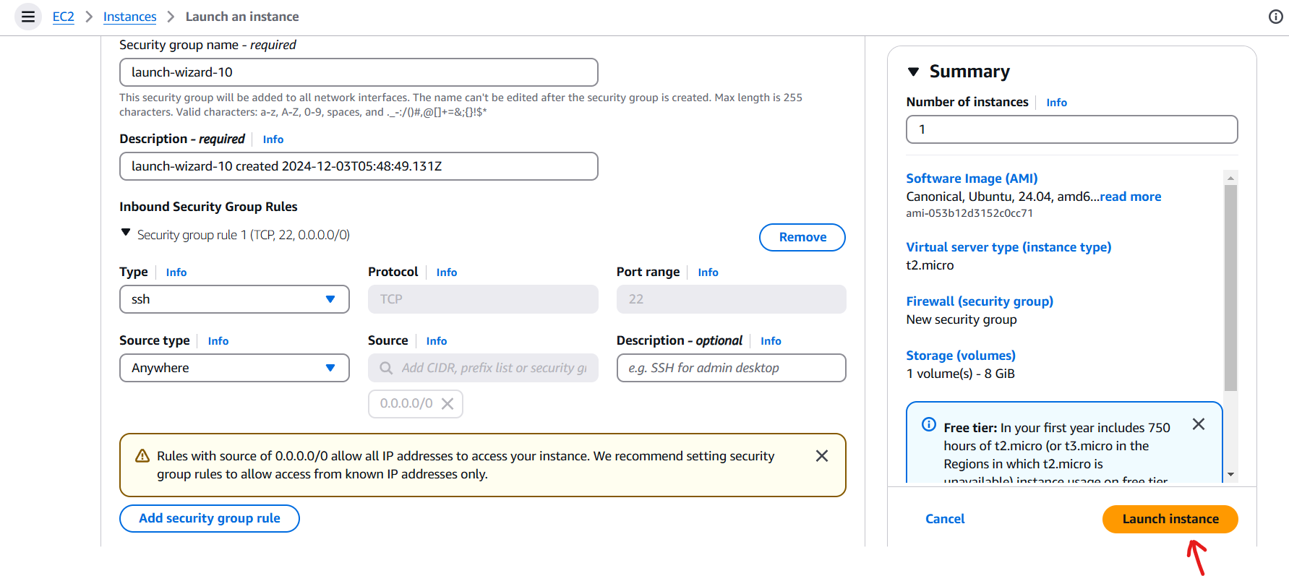

* **Copying pem key from local machine to bastion host to access application instance from bastion host.**



* **Successfully logged in to one of the application instance from bastion host.**

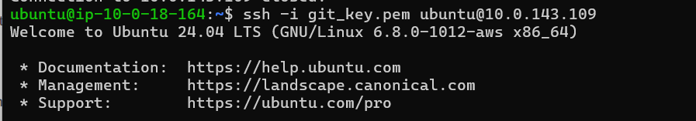

* **Running python server with sample index.html file on application instance.**

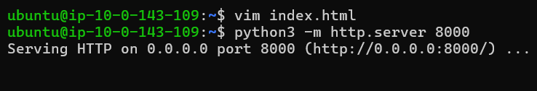

1. **Creating Application load balancer to incoming requests to your application**

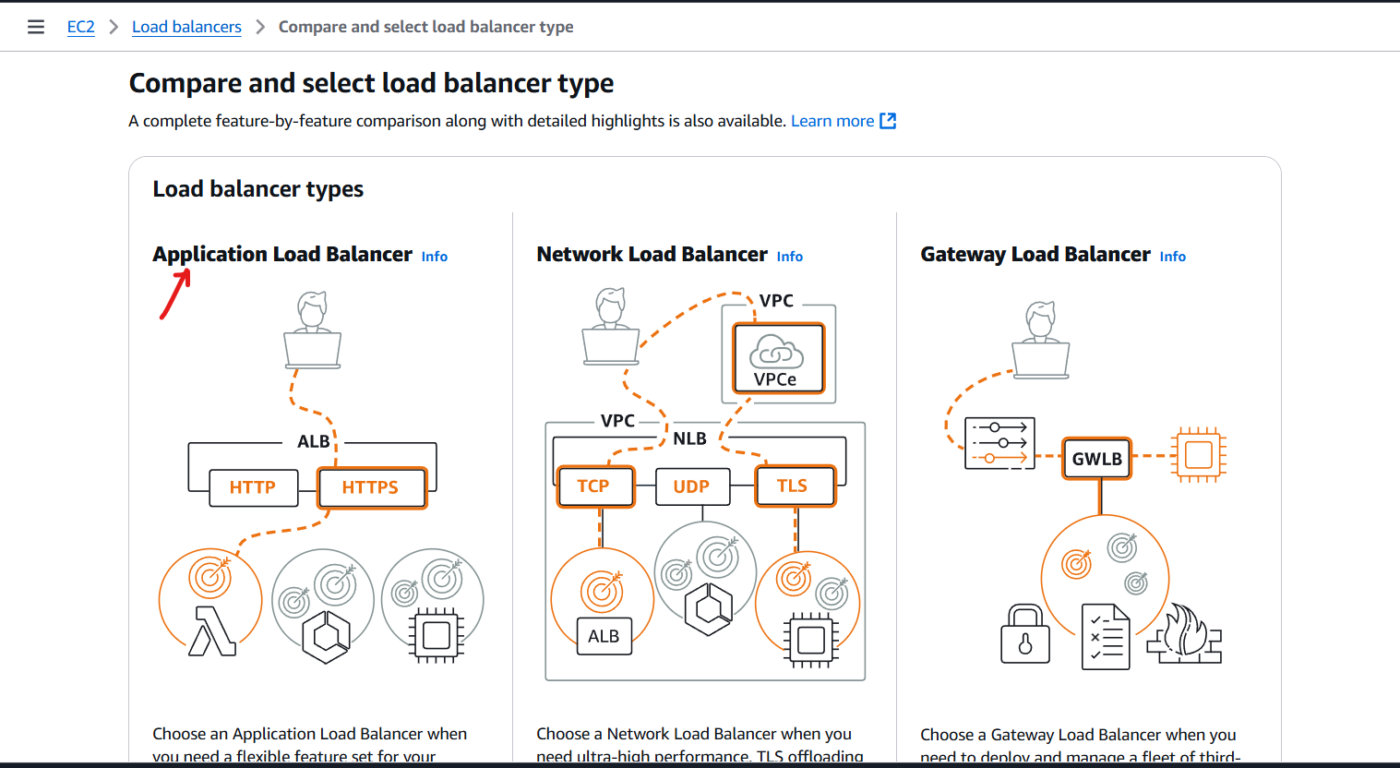

* **LB should be internet facing.**

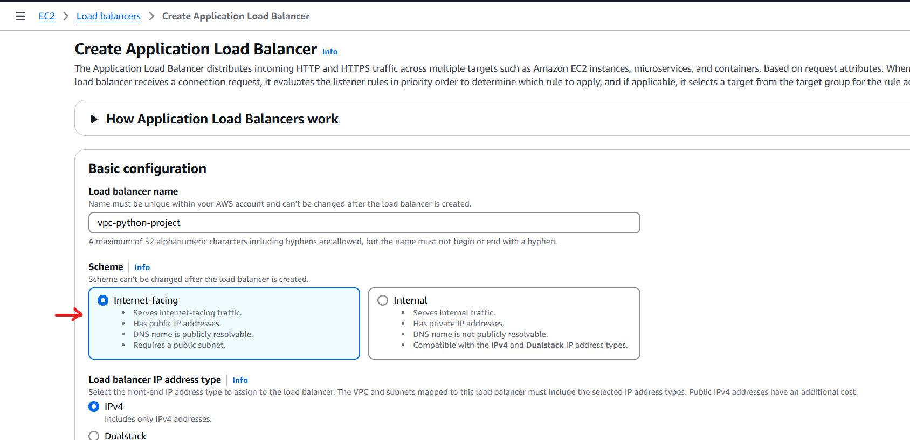

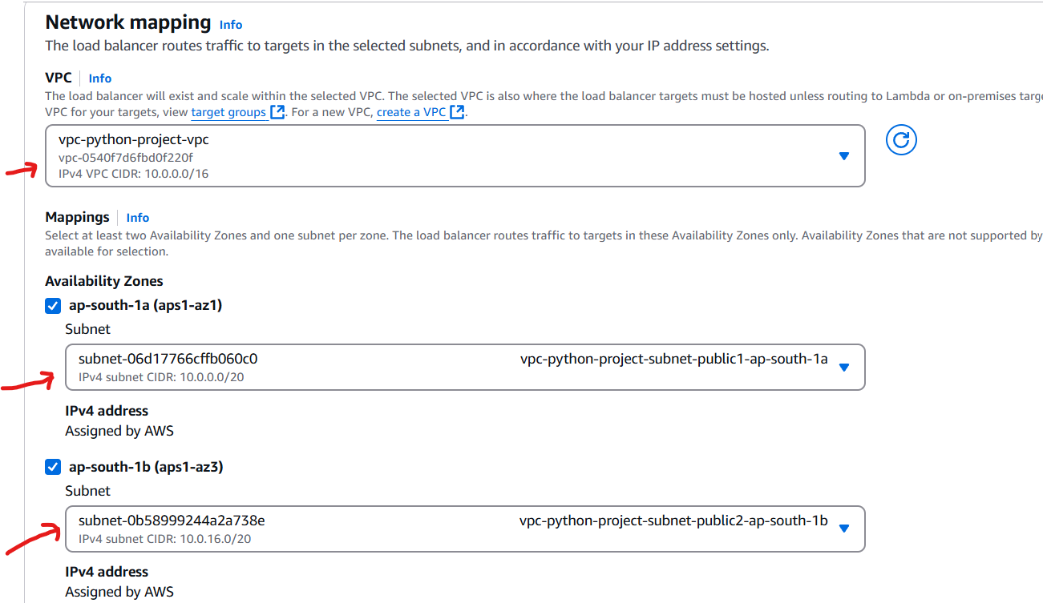

* **Creating target group**

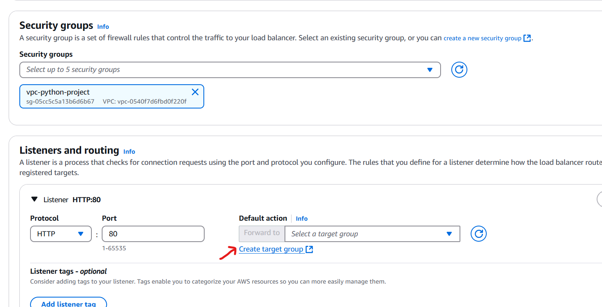

* **Selecting port 8000 since our application is running on same port.**

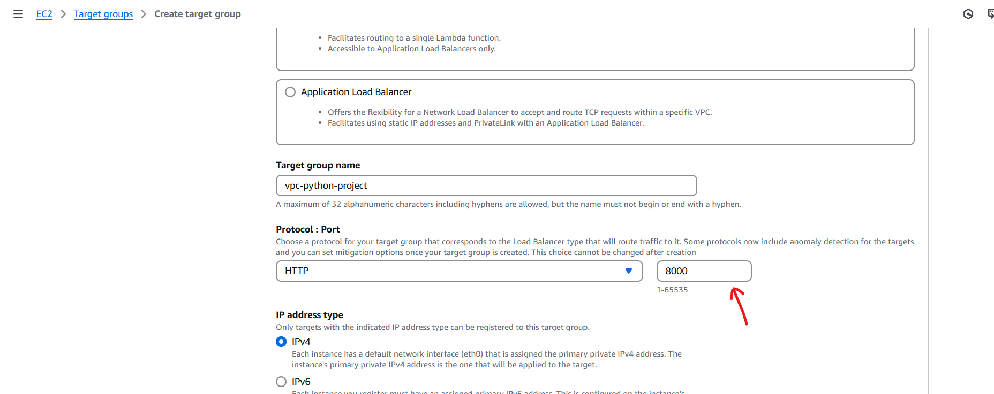

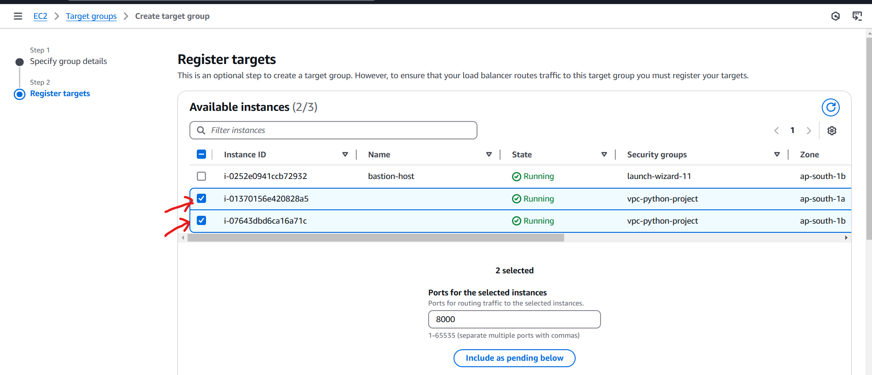

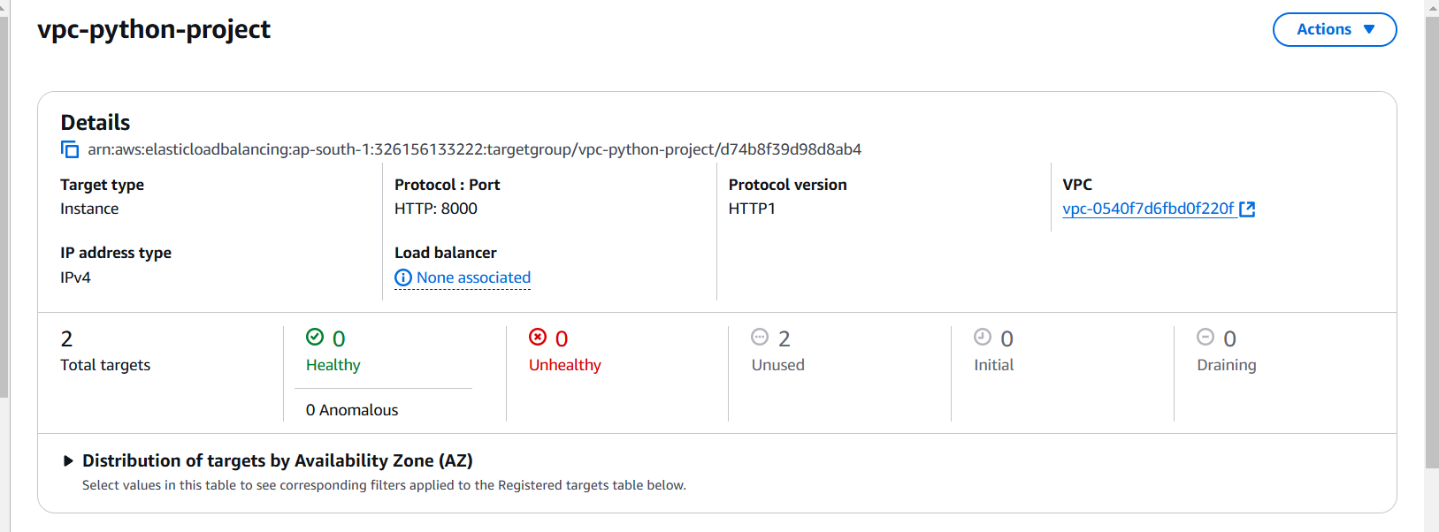

* **Back to the ALB configuration.**

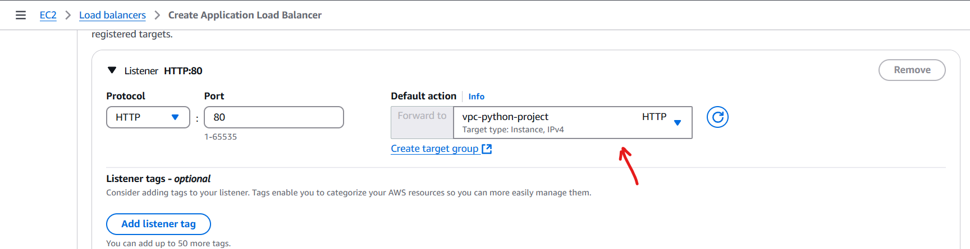

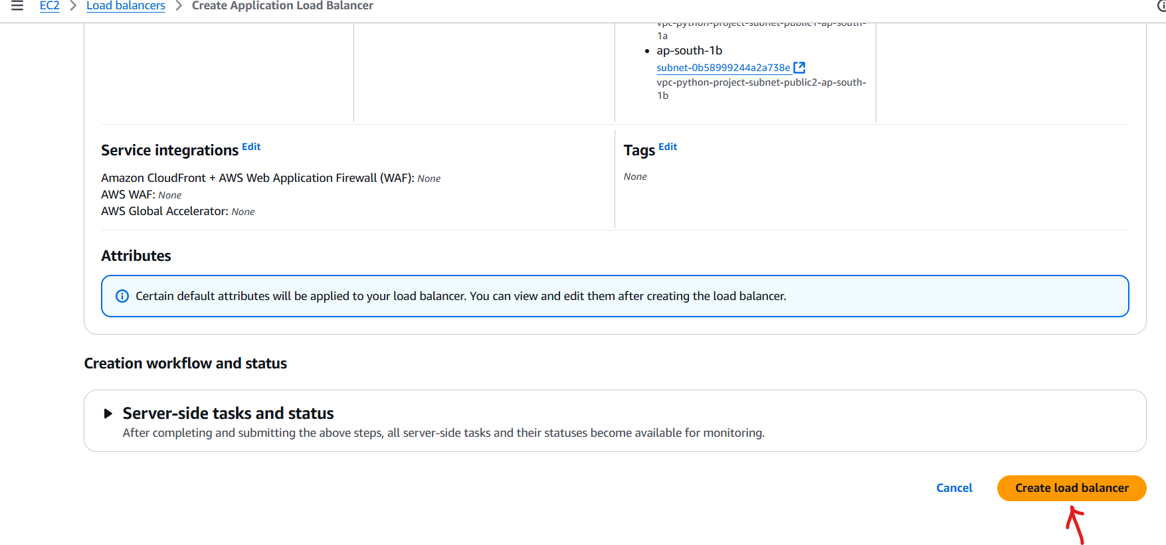

* **Try to access your page by using DNS name present in LB.**

