1. **Download the code repo from github to local machine/server.**

**# git clone** [**https://github.com/verma-kunal/AWS-Session.git**](https://github.com/verma-kunal/AWS-Session.git)

1. **Refer readme and dockerfile and follow the steps.**

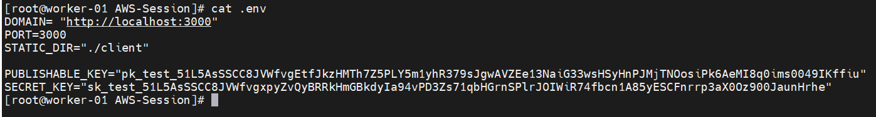

1. **# yum install npm**
2. **# npm install**
3. **# npm start**

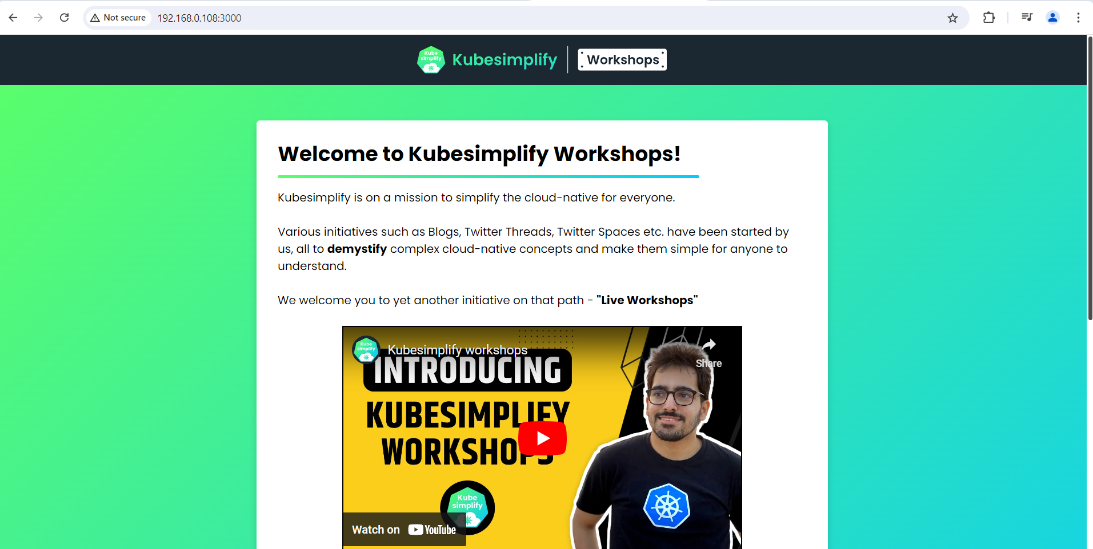

**Now will deploy the it on AWS EC2 instance. Refer Readme file.**

**Note: You can refer digital ocean documentation for any query.**