EsLint :install eslint plugin

Install globally : npm install -g eslint

To create eslint configuration :Elint --init

|  |
| --- |
| E:\myproject\webpack-4 starter kit>eslint --init  ? How would you like to configure ESLint? Use a popular style guide  ? Which style guide do you want to follow? Standard  ? What format do you want your config file to be in? JSON  Checking peerDependencies of eslint-config-standard@latest  Installing eslint-config-standard@latest, eslint-plugin-import@>=2.8.0, eslint-  lugin-node@>=5.2.1, eslint-plugin-promise@>=3.6.0, eslint-plugin-standard@>=3.0  1  npm WARN webpack-4@1.0.0 No description  npm WARN webpack-4@1.0.0 No repository field.  npm WARN optional SKIPPING OPTIONAL DEPENDENCY: fsevents@1.1.3 (node_modules\fs  vents):  npm WARN notsup SKIPPING OPTIONAL DEPENDENCY: Unsupported platform for fsevents  1.1.3: wanted {"os":"darwin","arch":"any"} (current: {"os":"win32","arch":"x64"  )  + eslint-plugin-promise@3.7.0  + eslint-plugin-node@6.0.1  + eslint-config-standard@11.0.0  + eslint-plugin-standard@3.1.0  + eslint-plugin-import@2.11.0  added 20 packages from 9 contributors in 19.165s  Successfully created .eslintrc.json file in E:\myproject\webpack-4 starter kit |

Create .eslintrc file in project

And use set the rules which you want like:

*"extends"*: ["react-app","prettier"],

*"rules"*: {

*"no-restricted-imports"*:"off",

*"no-else-return"*:"error"

}

}

Here key is rule and value are errors

Eg. Key= *no-restricted-imports*

*Value=off*

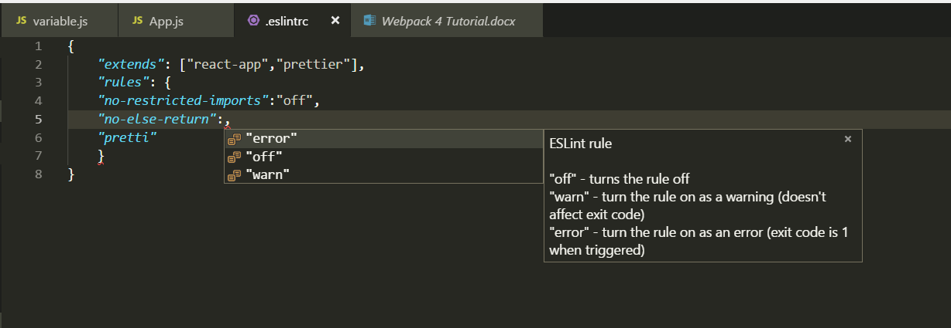

|  |
| --- |
| {  *"extends"*: [  "standard",  "plugin:prettier/recommended",  "plugin:react/recommended"  ],  *"rules"*: {  *"no-duplicate-imports"*: "error",  *"no-extra-semi"*: "off"  }  } |

Install react-eslint plugin :

no-unused-var for react package imports

why ex:

suppose you imported react from react package.and not using it then eslint will show no-unused-var error to void it install this plugin and extend it in .eslint.json file as shown above

npm install eslint-plugin-react -D

Prettier to automatically beautify the code

Install prettier plugin:

Then install below node packages:

npm i prettier eslint-config-prettier eslint-plugin-prettier –D

VS CODE EDITOR SETTINGS:

user setting in VS: ctrl + ,

change user setting of editor

*"eslint.autoFixOnSave"*: true,// this will auto fix the error if it can

*"editor.formatOnSave"*: true ,//AUTO FORMAT

|  |
| --- |
| {  *"files.autoSave"*: "onFocusChange",  *"workbench.colorTheme"*: "Monokai",  *"editor.formatOnSave"*: true, //AUTO FORMAT  *"[javascript]"*: {  *"editor.formatOnSave"*: false  },  *"eslint.autoFixOnSave"*: true,  *"prettier.disableLanguages"*: [  "js"  ],  } |