Marathwada **Mitra Mandal’s**

**COLLEGE OF ENGINEERING, KARVENAGAR, PUNE**

Permanently Affiliated to SPPU | Accredited with ‘A’ grade by NAAC | Recipient of ‘Best College’ award by SPPU, Accredited by NBA (Electrical Eng. and Mechanical Eng.) Recognized under 2(f) and 12(B) of UGC Act 1956 |ISO 9001:2015 certified

**DEPARTMENT OF COMPUTER ENGINEERING**

A.Y. 2022-23 SEM-I

**BE PROJECT SYNOPSIS**

**Group ID: P34**

1. **Title of the project:** Lung Cancer Detection Using Deep Learning
2. **Domain of the Project:** Deep Learning.
3. **Keywords:** Healthcare, Prediction, Multi-classifier, Support Vector Machine, Computer Tomography, Lung Disease Diagnosis, Image Processing Techniques.
4. **Problem Definition:** To develop a model based on convolutional neural network (CNN), for the classification of lung cancer detection.

# Abstract:

Lung Cancer is one of the leading life taking cancer worldwide. Early detection and treatment are crucial for patient recovery. Medical professionals use histopathological images of biopsied tissue from potentially infected areas of lungs for diagnosis. Most of the time, the diagnosis regarding the types of lung cancer are error-prone and time- consuming. Convolutional Neural networks can identify and classify lung cancer types with greater accuracy in a shorter period, which is crucial for determining patients' right treatment procedure and their survival rate. Benign tissue, Adenocarcinoma, and squamous cell carcinoma are considered in this research work.

Through this research, a Computer-aided system introduced for detecting lung cancer in a dataset collected and by using a convolutional neural network technique for helping with the diagnosis of the patient's cases: normal, benign, or malignant.

# Scope of the Project:

This process reduces the time complexity and increases the diagnosis confidence. The collected data contain noise the noises are removed. And then segmentation of the lung images and after that the image is separated. The output image is trained by using the CNN model and the diagnosis is made from the output. .

We are trying to develop the automated medical image processing tools in which it detects the cancer cells in advance.

# System Architecture (Functional Diagram):

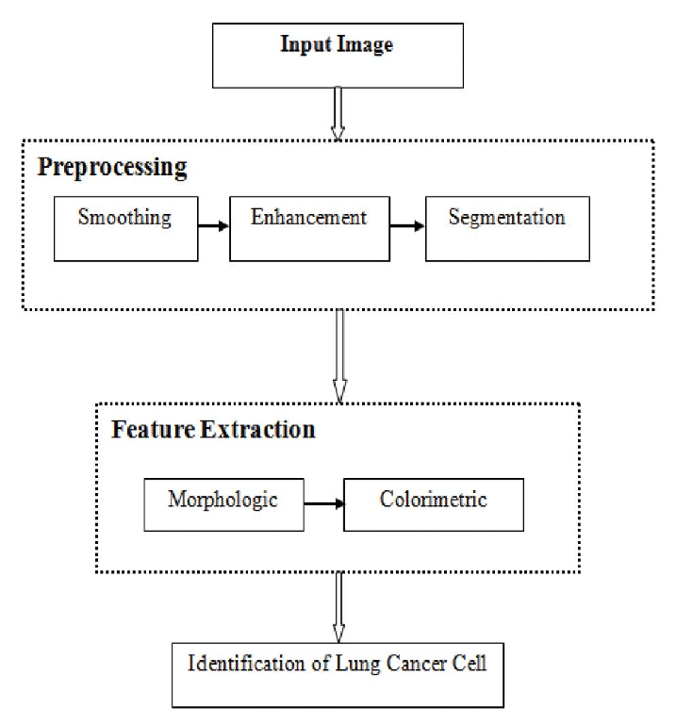

1. **Software & Hardware Requirements:**

Software:

IDE- Visual-studio-code

Language – Python 3.8

Hardware:

Hard Disk: Greater than 500 GB RAM: Greater than 4 GB Processor: I3 and Above

# Expected Outcomes:

All the diseases will be getting predicted correctly.

# Team Members:

|  |  |  |  |
| --- | --- | --- | --- |
| **Roll No.** | **Name of Student** | **Mobile Number** | **Sign** |
| BC107 | Bandal Swapnil | 9156432568 |  |
| BC247 | Shreyas Padmawar | 9307221031 |  |
| BC212 | Akash Deshmukh | 9665408760 |  |

1. **Guide/Mentor Details:**

|  |  |  |  |  |
| --- | --- | --- | --- | --- |
| **Guide/Mentor** | **Name** | **Organization** | **Email-ID** | **Mobile No.** |
| Internal Guide | Ms. Smita Chaudhari | MMCOE |  |  |

# References

* 1. Muthazhagan B, Ravi T, Rajinigirinath D. An enhanced computer-assisted lung cancer detection method using content-based image retrieval and data mining techniques. Journal of Ambient Intelligence and Humanized Computing. 2020 Jun 2:1-9.
  2. Sajja T, Devarapalli R, Kalluri H. Lung Cancer Detection Based on CT Scan Images by Using Deep Transfer Learning. Traitement du Signal. 2019 Oct;36(4):339-44.
  3. Masud M, Sikder N, Nahid AA, Bairagi AK, AlZain MA. A machine learning approach to diagnosing lung and colon cancer using a deep learning-based classification framework. Sensors. 2021 Jan;21(3):748.
  4. Tripathi P, Tyagi S, Nath M. A comparative analysis of segmentation techniques for lung cancer detection. Pattern Recognition and Image Analysis. 2019 Jan;29(1):167-73.
  5. T. Saba, A. Sameh, F. Khan, S.A Shad, and M. Sharif. “Lung Nodule Detection based on Ensemble of Hand Crafted and Deep Features” Journal of medical systems 43 (12), 332, 2019.
  6. S. A. Khan, M. Nazir, M. A. Khan, T. Saba, K. Javed and A. Rehman, "Lungs nodule detection framework from computed tomography images using support vector machine", Microsc. Res. Technique, vol. 82, no. 8, pp. 1256-1266, Aug. 2019.
  7. M. Anthimopoulos, S. Christodoulidis, L. Ebner, A. Christe, s Mougiakakou, lungpattern classification for ınterstitial lung diseases using a deep convolution neural network. IEEE Tran. Med. Imag. 35, 1207–1216 (2016)

**A dated sign of Project Guide with the name**