Angular JS MVC Architecture:

* **Model** − It is the lowest level of the pattern responsible for maintaining data.
* **View** − It is responsible for displaying all or a portion of the data to the user.
* **Controller** − It is a software Code that controls the interactions between the Model and View.

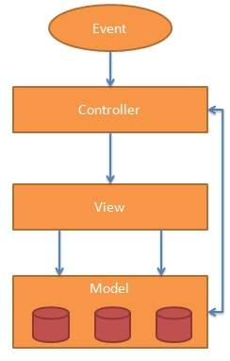

The Model

In AngularJS, model consists of all primitive data type such as integer, string and Boolean and complex type in form of object. In simple word model is just a plain JavaScript object. But you can build your model from any database like Sql Server or MySQL or from JSON file.

The View

In AngularJS, view is the DOM elements which are used to display data. To display data from controller, use expression in view. Since AngularJS supports two-way data binding any changes in model data, view will update automatically.

The Controller

In AngularJS, controller provide great control over view and model in order to fetch the data as per request and display in the view. Most important thing here is your model is lives inside the controller