

PROPOSAL REPORT
TECHNOLOGY PARK MALAYSIA

CT050-3-2-WAPP
WEB APPLICATIONS

NP2F2511IT

Hand out date: 2026-04-15
Hand in date: 2026-06-26

Submitted To: Santosh Kumar Sah
Submitted By:
Name | NP Number
Chandra Prakash Bhatta (Leader) | NP070498
Bijay Khadka | NP070532
Babin Aryal | NP070630
Swapnil Katuwal | NP070613

Acknowledgement
I sincerely wish to express my deepest sense of appreciation to my lecturer MR. Santosh Kumar Sah who has been with me through the entire process of this project, guided and mentored me for the useful feedback and constant encouragement, to give it a deserved accomplishment. Thanks a million for all that I have received from him. I will forever be indebted to my university Asia Pacific of Technology and Innovation (APU) and college Lord Buddha Education and Foundation (LBEF) for the learning environment, the facilities and resource that she has made available for me to succeed in this task. Furthermore, thanks go to my colleagues with who I’ve had useful discussions and suggestion during the planning and implementation phases of my project.

Table of Contents
Acknowledgement 2
Introduction 4
Aim 5
Objectives 5
Mission Statement 5
Audience Modelling 5
User Personas 5
Project Scope 8
Website Design 8
Database Design and Integration 8
User Role Management Students 9
Data Validation and Security 9
Features (Multimedia & Interactive) 9
Extra Features 9
Technical Specification 10
Expected Outcome 10
Conclusion 10
References 11

List of Figures
Figure 1 5
Figure 2 7
Figure 3 8

List of Tables
Table 1 6
Table 2 10

Website Title: Code Room
“Learn, Code and Grow”

Introduction
Digital technology has revolutionized the learning opportunities for students and how they learn. With their flexibility, accessibility, and interactive learning opportunities, online learning platforms have taken on greater significance in the world of education. Students in the contemporary era demand centralized platforms that make it possible for them to access learning materials, take part in evaluations, monitor their development and execute self-paced learning exercises. Code-Room is an online education platform tailored to those who want to enhance their programming, web design, cybersecurity, cloud computing, database management and other tech expertise. The platform will feature a range of structured learning materials, interactive quizzes, progress tracking, multimedia resources, and user management features. The system will be developed with the help of HTML, CSS, JavaScript, ASP.NET Core (.NET), and MySQL. It will show how to connect to a database, how to provide a user with processing on the client and how to provide processing on the server, how to embed multimedia, how to authenticate users and how to implement comprehensive CRUD operations. It will provide an enjoyable and safe environment for students and administration, and meet all the demands of the Web Application Development assignment.
Figure 1
Company Logo
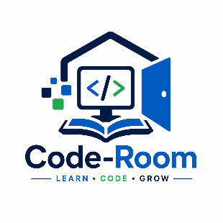

Aim
This project aims to develop a full learning technology solution for the web to allow learning online on any kind of technology focused knowledge, in which the user will not only learn but also have experience. This learning experience must also have a great control over the knowledge and must feel secured, while in use, as far as safety/security aspect of use and managing knowledge is concern.

Objectives
- To create a user-friendly interface which adheres to good interface design and offers intuitive navigation for all types of users.
- To establish a secure user registration and login for guest, registered Learners, educators and administrators with role-based access.
- To create a classified online library of video tutorials, coding exercises, virtual labs, simulations and interactive learning objects on programming and technology.
- To show how the database can be used for dynamic content delivery, user data storage, tracking progress and resource management with a relational database.
- To build a security system authentication & authorization at ASP.Net Core (.net) with role basis for users including Students, Admins, and many more.

Mission Statement
Code-Room’s mission is to give everybody access to an interactive and secure learning environment where skills can be learned on IT and programming. We develop learning materials, assessment modules, monitoring tools to manage learning progress and an individual learning path. These features increase the learning outcomes and also support managing resources and students for administrates.

Audience Modelling
Code-Room has various kinds of people to fulfill their education purposes and technical knowledge with varied system requirements. Following are these user kinds:
Table 1
User Personas

User Personas
Target Audience | Role in System | Key Needs
System Administrator | Control the overall administration of the system | Controls the user access level system security and report for any transaction and also data backup for the database
Admin | Controls the websites’ management | Access to view student, control subject’s detail, lesson detail, online quizzes and also announcement (CRUD) and also manages learning resources (CRUD)
Student | Accesses the website’s content | Can register, enrolled to subject, takes online quiz, download materials, view and access to view learning progress and personal details control
Visitors | Accesses the public content of the websites | View information about the subjects, website information, FAQs and can also register to get an account to be a student
Instructors | Lecturers (to be enhanced) | Create the learning materials | upload and maintain subjects, online lesson and online quizzes, monitor the students’ progress of each student
Parents / guardians (to be enhanced) | Monitors the students’ progress | View the subjects, quizzes results and the students’ learning progression (Rice & Nash, 2022)

Figure 2
Gantt-Chart
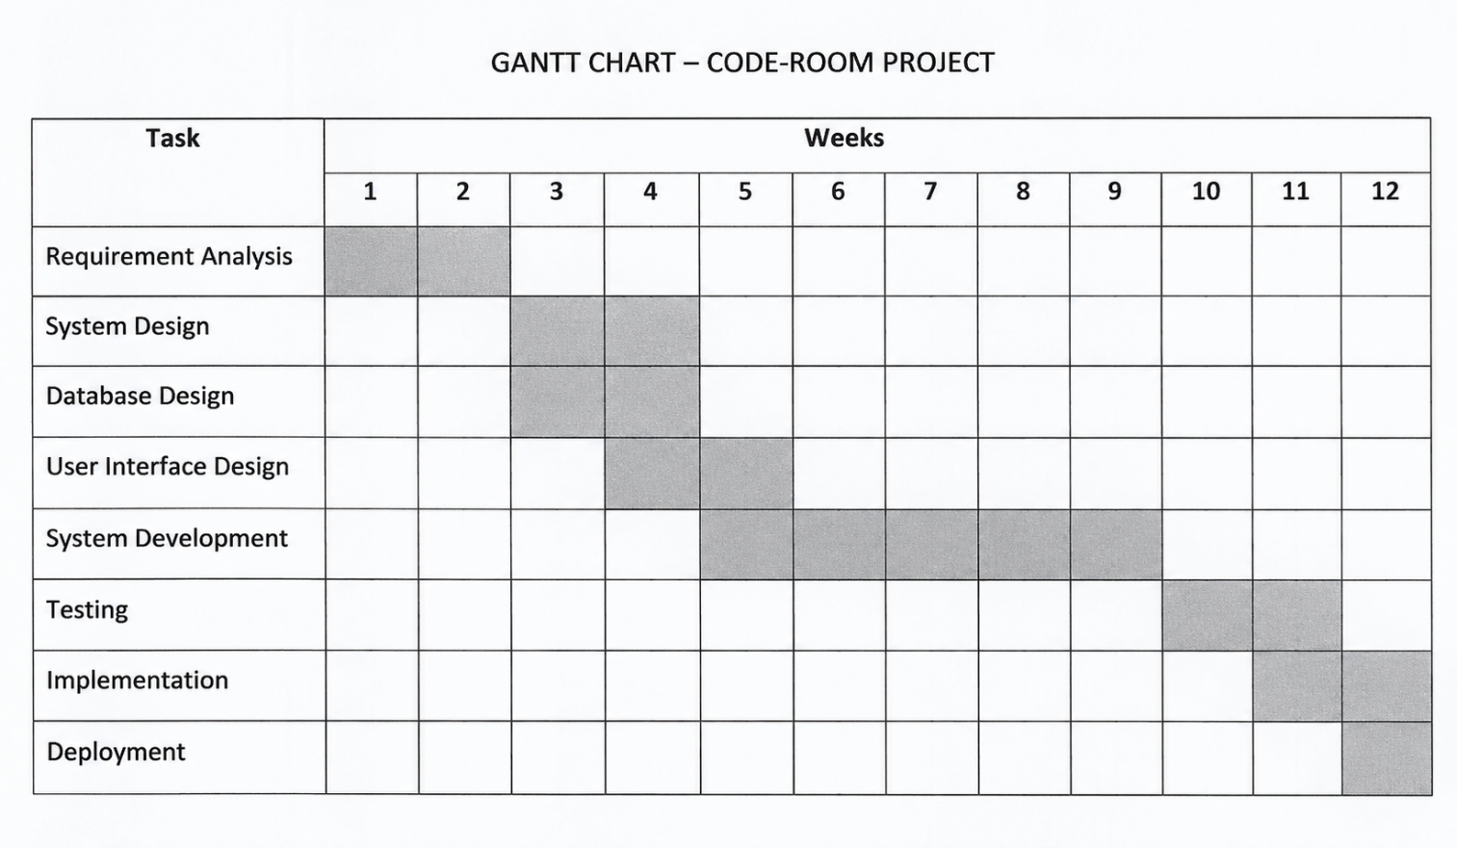

Figure 3
DFD Diagram
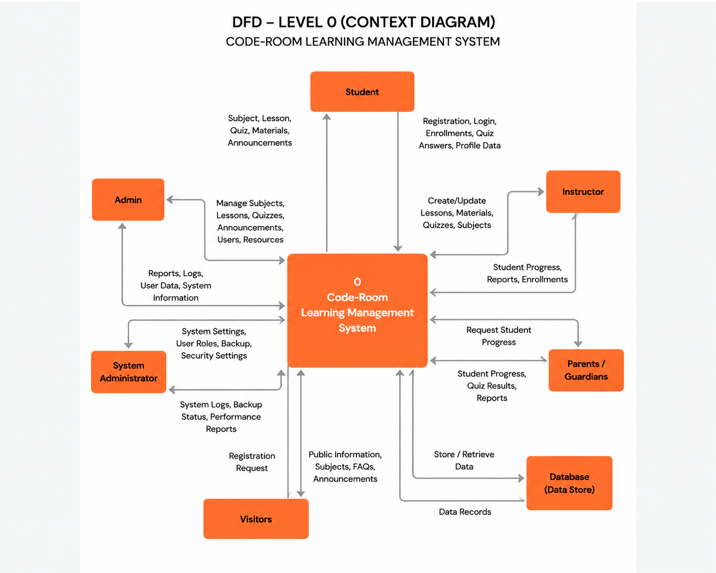

Project Scope
The Code-Room platform will be a web-based application providing an end-to-end solution in content delivery, student interactivity and backend management.

Website Design
- Provide common layouts, navigation bars (header, footer, breadcrumbs), tables.
- Provide a friendly UI, ease of use in the interface.
- Design a clean UI/UX as per the trends (Robbins, 2018).

Database Design and Integration
- Create a normalized database with MySQL.
- Provide secure connection through asp.net core (.net) (Lock, 2023).
- Store student login data, course data, lesson content, quiz data and student progress.
- Support all CRUD operations for major module.

User Role Management Students
- View their enrolled courses, view lesson content, attempts the quiz etc.
- Administrators: Add/Edit/Delete course content, view student progress, etc Super Administrators: Perform all administrative functions.
- Protect unauthorized access to some specific data and modules

Data Validation and Security
- Client-side validation using java script. Server-side validation using asp.net core.
- Protection against SQL Injection, Cross-Site Scripting (XSS).
- Protect against CSRF. Encrypt the password data using proper encryption technique.
- Proper session management.

Features (Multimedia & Interactive)
- Tutorial Videos and Image insertion for content.
- Quizzes, MCQ’s and tests for learners to get assessed.
- Track student progress.
- Support for downloading PDF, notes, tutorials for offline learning.

Extra Features
- User Profile Management Upload user’s picture User can switch to dark or light mode
- Student dashboard Personalized experience in student dashboard
- Manage Course enrolment Track progress and performance.

Table 2
Technical Specification

Technical Specification

Components | Technology
Front-end | HTML, CSS and Java-Script
Back-end | ASP.net Core (.NET)
Database | MySQL
IDE | Visual Studio 2022
Validation | Java-Script and ASP.NET Core Validation

Expected Outcome
At the end of the project development, it is expected to achieve the 100% fully working web-based Learning Management System (LMS) called ‘Code-Room’ which will be secure, easy-to-use & more enjoyable to learn a technology for a student & admin. The system will have user validation for registration & login, Interactive e-content on technologies, 100% complete C.R.U.D operations for Courses, Lessons, Quizzes, Users. Admin has access for content management, performance tracking for a student, progress tracking, multimedia integration & multimedia learning experience. The system will be accessible for all device & screen sizes (Responsive). It will be secure and with the database connectivity and reliable server client processes & complete Web Application Development Assignment Requirements.

Conclusion
We propose the Web based Learning system i.e ‘Code-Room’ that will make technology-based education accessible, effective and engaging for everyone. By providing all components – learning materials, testing tools, visual media, tracking systems and management system and this website would be a beneficial and a valuable learning system for the teachers as well as students. We will be developing the system by using ASP.NET Core(.Net) framework with MYSQL as our database technology and HTML, CSS and JavaScript as front-end technologies to get better performance, scalability and security. We meet all requirement stated in assignment and we are well enough to scale our project further. In the future we are planning to implement coding-challenge, certification and Gamification features in our learning website. We are well set up for incorporating intelligent learning system.

References
Lock, A. (2023, 7). ASP.NET Core in Action, Third Edition. Retrieved from Manning Publications: https://www.manning.com/books/asp-net-core-in-action-third-edition
Rice, W., & Nash, S. S. (2022, 6 30). Moodle 4 E-Learning Course Development. Retrieved from Packt Publishing: https://www.packtpub.com/en-DE/product/moodle-4-e-learning-course-development-9781801079037
Robbins, J. N. (2018, 5 11). Learning Web Design, 5th Edition. Retrieved from O'Reilly Media: https://www.oreilly.com/library/view/learning-web-design/9781491960196/

