Table of Contents
1 Introduction 2
2 Installation Steps 5
1. Install Dependencies: 5
2. Git to Clone Poky: 5
3. Check out the Branch: 5
4. Building Image: 5
5. Download BSP from vendor: 6
3 References 7

Introduction

The Yocto Project is an open source collaboration project that helps developers create custom Linux-based systems for embedded products, regardless of the hardware architecture. The project provides a flexible set of tools and a space where embedded developers worldwide can share technologies, software stacks, configurations and best practices which can be used to create tailored Linux images for embedded devices. https://www.yoctoproject.org/software-overview/
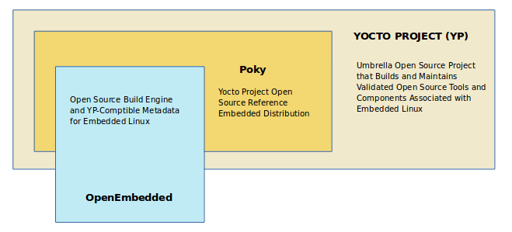
- The Yocto Project: umbrella project and community
- OpenEmbedded: build system and community
- Reference Distribution (Poky): Poky is the Yocto Project reference distribution. It contains the OpenEmbedded Build System (BitBake and OE-Core) as well as a set of metadata to get you started building your own distribution.
- BitBake: BitBake is a core component of the Yocto Project and is used by the OpenEmbedded build system to build images. While BitBake is key to the build system, BitBake is maintained separately from the Yocto Project.
- OpenEmbedded-Core: (OE-Core) is a common layer of metadata (i.e. recipes, classes, and associated files) used by OpenEmbedded-derived systems, which includes the Yocto Project. The Yocto Project and the OpenEmbedded Project both maintain the OpenEmbedded-Core.
- Metadata: files containing information about how to build an image
- Recipe: file with instructions to build one or more packages
- Layer: directory containing grouped metadata (start with “meta-”)
- Board support package (BSP): layer that defines how to build for board (usually maintained by vendor)
- Distribution: specific implementation of Linux (kernel version, rootfs, etc.)
- Machine: defines the architecture, pins, buses, BSP, etc.
- Image: output of build process (bootable and executable Linux OS)

The OpenEmbedded Build System Workflow
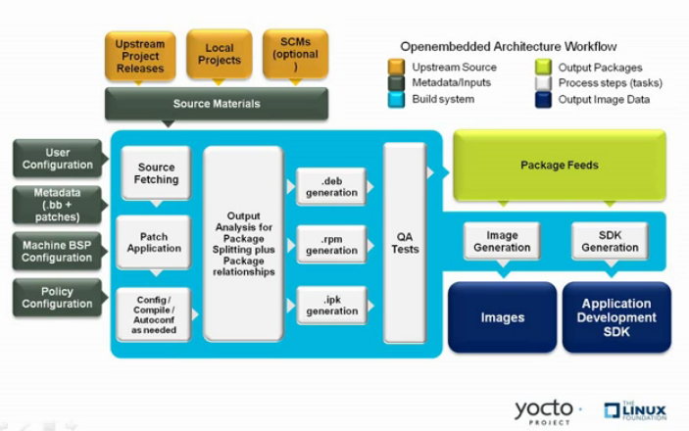
Introduction to the Yocto Project, Poky, and Bitbake :
https://tutorialadda.com/yocto/what-is-yocto-project-poky-and-bitbake
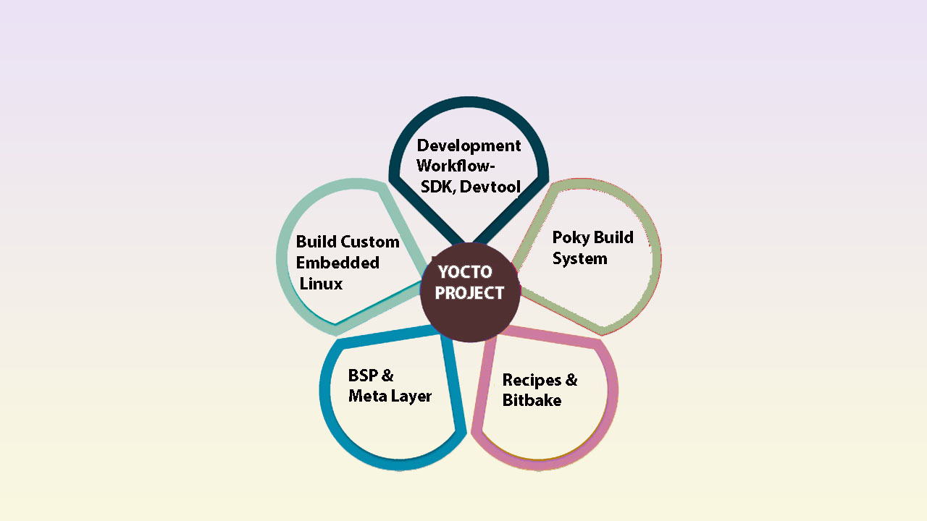

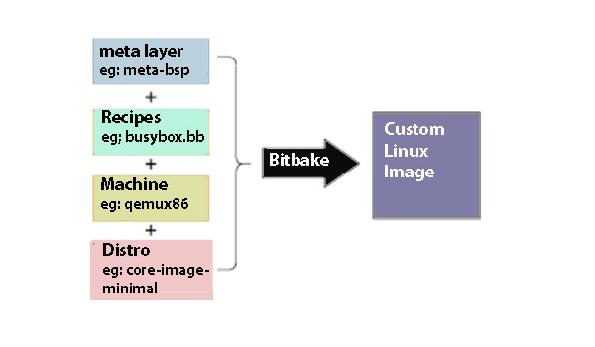
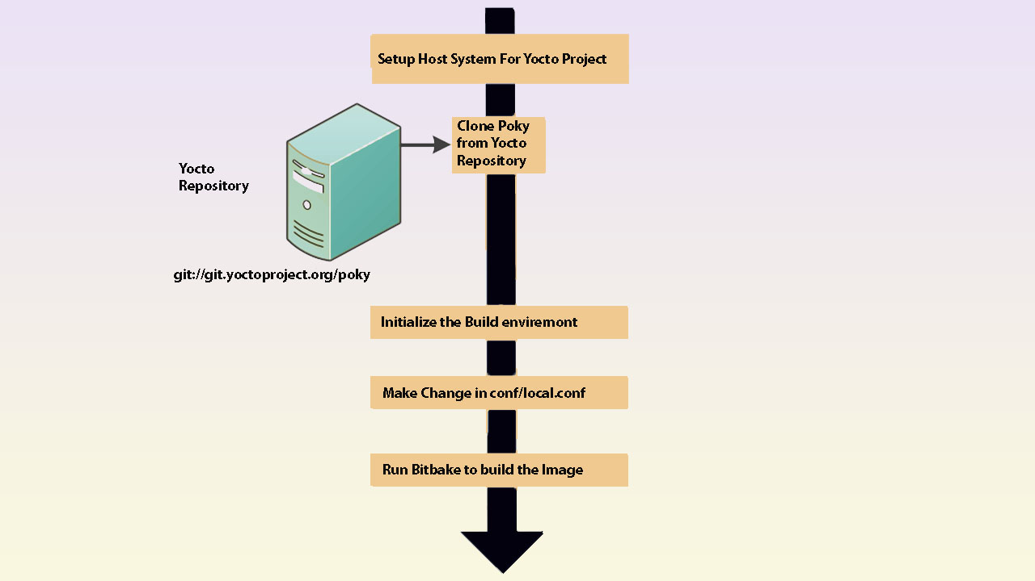

Installation Steps

1. Install Dependencies:
sudo apt update
sudo apt upgrade
sudo apt install -y bc build-essential chrpath cpio diffstat gawk git texinfo wget gdisk python3 python3-pip

2. Git to Clone Poky:
$ git clone git://git.yoctoproject.org/poky
$ cd poky
$ git branch -a // take a look at existing branches

3. Check out the Branch:
Check out the development branch in which you want to work. For example, to access the files for the Yocto Project release https://wiki.yoctoproject.org/wiki/Releases
We’re going to have all layers be on the “dunfell” branch.
$ git checkout dunfell
$ git branch
$ less meta-poky/conf/distro/poky.conf

4. Building Image:
Use the following steps to build your image. The build process creates an entire Linux
distribution, including the toolchain, from source.
Step.1 : Initialize the Build Environment:
$ cd poky
$ source oe-init-build-env
$ ls
$ bitbake-layers show-layers
Step.2 : Configure Kernel
$ bitbake -c menuconfig virtual/kernel
Step.3 : Build Image
$ bitbake core-image-minimal
Step.4 : Add or include BBLAYER (BSP):
Create a new meta layer and add it to bblayer.conf file
$ source oe-init-build-env
$ bitbake-layers create-layer ../meta-tutorialHello
$ bitbake-layers add-layer ../meta-tutorialHello
$ bitbake-layers show-layers
$ bitbake core-image-minimal // build image
Step.5: Simulate Your Image Using QEMU
$ runqemu qemux86-64
$ runqemu qemux86-64 nographic // launch the QEMU image on the host system.
Step.6: Run the QEMU image and verify the installed Package
$ runqemu qemux86-64 nographic // launch the QEMU image on the host system.
$ hello
$ ls /usr/bin
Step.7: Run the ‘hello’ program on QEMU
Create a New Meta Layer and Write a Hello World Recipe in Yocto Project.
https://tutorialadda.com/yocto/create-a-new-meta-layer-and-write-new-recipe-in-yocto-project
1. Create a new meta layer and add it to bblayer.conf file
2. Create Directory For Recipe and Source Files
3. Write the simple hello world c program
4. Write the simple hello recipe file
5. Select machine configuration and Add hello package to rootsfs
6. Build Image
7. Run the QEMU image and verify the installed Package
$ source oe-init-build-env
$ bitbake core-image-minimal // build image
$ runqemu qemux86-64 nographic
$ hello

5. Download BSP from vendor:
Open Embedded list of layers (BSP) maintained by vendors :
https://layers.openembedded.org/layerindex/branch/dunfell/layers/

References

- Yocto project:
https://www.yoctoproject.org/software-overview/
https://docs.yoctoproject.org/brief-yoctoprojectqs/index.html
- Tutorial Yocto project Digikey:
https://www.youtube.com/watch?v=2-PwskQrZac&ab_channel=Digi-Key
- Intro to Embedded Linux Part 2 - Yocto Project: https://www.digikey.com/en/maker/projects/intro-to-embedded-linux-part-2-yocto-project/2c08a1ad09d74f20b9844e566d332da4
- Getting Started with the Yocto Project:
https://www.youtube.com/watch?v=zNLYanJAQ3s&ab_channel=YoctoProject
- Yocto Project Board Support Package Developer’s Guide
https://docs.yoctoproject.org/bsp-guide/index.html
https://layers.openembedded.org/layerindex/branch/dunfell/layers/
- Tutorial Ladda
https://tutorialadda.com/yocto

