

Maincrafts Technology | AI & ML Internship Program

Project Report on
“California House Price Predictor”

House Price Prediction using Machine Learning

Internship Task:
Model Comparison and Evaluation - Task [2]

Submitted By:
Swapnil Prabhakar Chavan (AI & ML Intern)

Organization:
Maincrafts Technology Date of Submission: 28 March 2026

Introduction

The goal of this project was to build and compare multiple machine learning models to predict house prices using the California Housing dataset. This task involved data preprocessing, feature engineering, and evaluating different regression algorithms to find the most accurate predictor.

Methodology

To ensure a robust and accurate model, the following steps were performed:
- Data Acquisition:

The dataset was loaded using sklearn.datasets.fetch_california_housing, consisting of 20,640 samples and 8 features (like Median Income, House Age, etc.).

Feature Scaling:

Because features like Population and MedInc have vastly different ranges, I applied StandardScaler. This standardizes the data (mean=0, variance=1), ensuring that no single feature dominates the model due to its scale.

Data Splitting:

The data was split into 80% Training and 20% Testing sets to evaluate the models on unseen data and prevent overfitting.

Model Selection:

Three distinct algorithms were chosen for comparison:
- Linear Regression: To establish a baseline performance.
- Ridge Regression: A regularized linear model to prevent overfitting.
- Decision Tree Regressor: To capture potential non-linear relationships in the housing data.

- Results & Comparison
After training the models on the training set, they were evaluated using the test set. The results are summarized in the table below:

Model | RMSE | R² Score
Linear Regression | 0.7456 | 0.5758
Ridge Regression | 0.7456 | 0.5758
Decision Tree | 0.7242 | 0.5997

Note: RMSE (Root Mean Squared Error) measures the average error in price predictions, while R² indicates how much variance the model explains.
- Visual Performance Analysis
The Actual vs. Predicted scatter plot for the final model shows a strong positive correlation.
- Observations: Most data points cluster around the 45-degree identity line (red), indicating high accuracy.
- Data Cap: A visible vertical line at 5.0 ($500,000) confirms a cap in the original dataset where all houses above this value were grouped together.

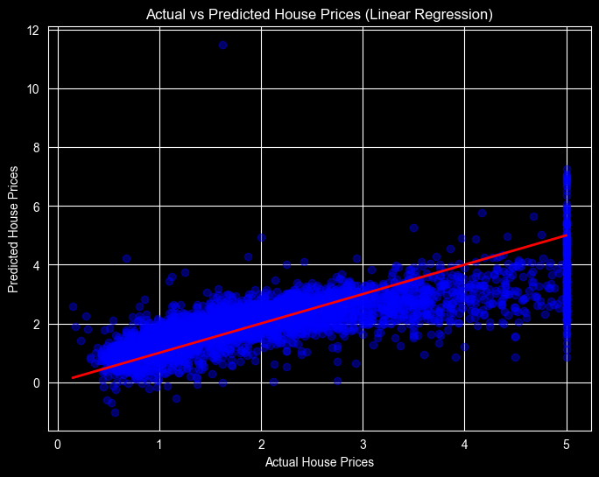
Figure: Actual vs Predicted House Price (Linear Regression)
- Conclusion
In conclusion, the performance comparison reveals that the Decision Tree model is the most effective predictor for this dataset, achieving the highest R² score of 0.5997 and the lowest RMSE of 0.7242. This indicates that the Decision Tree successfully explains approximately 60% of the variance in the target variable, outperforming the linear models. Interestingly, both Linear Regression and Ridge Regression yielded identical results (RMSE: 0.7456, R²: 0.5758), suggesting that the dataset likely does not suffer from high multicollinearity, as the L2 regularization provided by the Ridge Regression did not offer a performance advantage over the standard Linear Regression. While the Decision Tree provides the best fit, an overall R² score near 0.60 indicates a moderate predictive capability, suggesting that further improvements could be sought through feature engineering or by implementing more complex ensemble methods.

