PLAYERS GUIDE

Written By
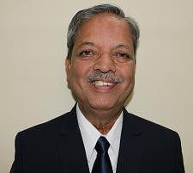

Shri. Arun Deshpande
For practical - Visit my YouTube channel “Arun Deshpande Carrom”. Please subscribe the channel.

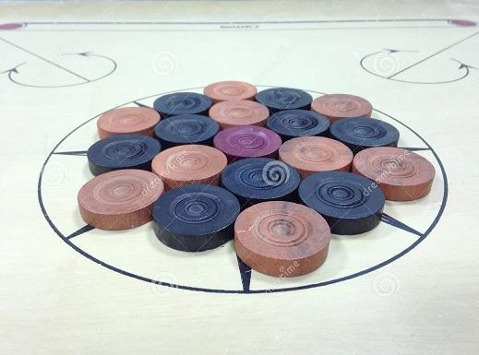

FORWARD
I wrote my first book in Marathi and was published by Majestic Publication in January 1982. Thanks to Late Mr. Keshavrao Kothavale for giving me opening. I translated the book in English by some additions in it and was published again by Majestic Publication, this time by Mr. Ashok Kothavale who took a risk because this was his first publication in English. Thanks a million to him for giving me platform not only in the other states in India but also in many carrom loving countries. I thought there is nothing to write more on this subject as I tried to include everything in this book. My wife Anjali was after me for many years asking me to write another book. I shifted my carrom career from playing to coaching and then I learned the intricacies of the game by solving other players’ problems. I started to enjoy carrom problems of many players may it be a problem of nails of the fingers or a grip or any position on the carrom board. I thank all my students who indirectly helped me writing this book by giving me their problems. I sincerely thank Banks sports board, State Carrom Association, All India Carrom Federation and Carrom Federations of Switzerland, Germany, Italy, France, UK, Maldives and SriLanka Who gave me opportunities of coaching which helped me to gather lot of material through difficulties of the players. I discussed many subjects in details with my wife Anjali on carrom and she suggested many topics which inspired me to write this book. It took many years to write this book. I hope all the players throughout the globe will like this book and their comments will definitely inspire me to write more on my beloved game.

AIM
Chapter 1

Basics
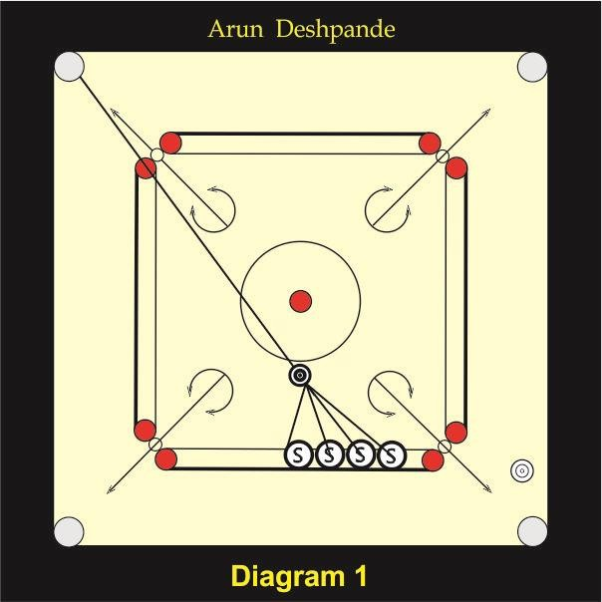

In billiards you can take aim by riffle view but in carrom you have to take aim by bird’s eye view. Taking aim by bird’s eye view is always difficult than taking aim by riffle view. For taking aim, you have to take an imaginary line from the center of the pocket and pass it through the center of coin that is to be pocketed. The point from where this line comes out of coin is a point where your aim should be. You may place your striker at different places as per situation but your hitting point will remain same. Sometimes there is a position where an opponent’s coin is in between your coin and the pocket as an obstacle in the path of your coin but still there is a hair margin for your coin to go to the pocket. This margin cannot be judged by bird’ eye view. In such situation you can bend and close your one eye and see by other eye, the path from your coin to the pocket by riffle view and you will be immediately come to know whether there is a possibility of pocketing such coin.

Force
Many players know the different strokes but they don’t know the force required for such strokes. You should understand the simple principle of force in carrom. When your striker goes in the direction of the pocket where the coin is going, you will need a less force because maximum force of the striker is transferred onto the coin. When your striker is going away from the pocket where the coin is going, you will need more force because part of the striker’s force is transferred onto the coin and the part of the force is wasted. You can use this wasted force for releasing your other difficult coins. Same principle is used in bomb stroke where a coin gets a very little force and the maximum wasted force is used for other purpose like destroying position of opponent’s coins or making your own difficult coin easy as you can drive your striker all over the board Because of this principle you can play the bomb stroke very hard when it is required.

SITTING POSITION
Sitting position is very important in carrom. Some players are placing their chair or stool far away from the carrom board and from the edge of the chair or stool. In this position the players find it very difficult to balance themselves and are afraid of falling down from the chair or stool. Another disadvantage in this position is that the legs may cross the imaginary line which is a foul. If you keep too much distance between your seat and carrom board then you have to stretch your hand for paying, which can develop tension in the playing hand. Correct position to sit is to see that your knees and frame of the carrom board lye in parallel line. Occupy more than half portion of the chair or stool to sit and place your legs in front. While playing your body should move towards the path of the striker after striker hitting the coin. For example if you are placing your striker in such a way that the pocket, the coin and the striker are in one straight line then you have bring your body in the straight line of the pocket. If you try to pocket your coin by straight cut then your body should move at the direction of the path of the striker. There are two methods for body movement. 1) Upper body movement and 2) Full body movement.
Upper body movement - In this type of movement you can move your only upper body bringing in the intended direction. By doing the perfect footwork

you can move your upper body easily do not cross your legs beyond imaginary lines
Full body movement - In this type of movement you can move your full body in the intended direction. For this type of movement it becomes necessary to move on the seat. Before moving on your seat hold your chair firmly and take a comfortable position by moving on the seat, then release your hands from the chair and play. Taking support of the char is a foul. This is to be done because there is a possibility of moving your chair on the floor, which is a foul. This possibility is when there is a light plastic chair or when there is powder on the floor where the chair is placed.

Footwork
If I talk about footwork in carrom everybody will laugh at me because they know that footwork required only in outdoor games. But as a player you should know how important footwork is for taking a comfortable position on your chair. Many of the players put their legs inside the stand while playing. If you sit like this, you will not be able to take a good position to play your strokes. Some players feel comfortable by removing shoes or chappals while playing; others feel comfortable by wearing shoes. I feel that it is easy to do footwork with the shoes particularly sports shoes as it has grip. In my opinion you have to practice footwork by wearing shoes. You have to make a practice to move your feet to take a comfortable sitting position. Moving feet does not only facilitate you to take a comfortable sitting position but it also helps in the blood circulation in your legs.

HEIGHT

Height of the stand and the chair frequently change from one tournament to another depending upon the availability of the chairs and stands to the tournament organizers. Most of the time height of the stand is more for the Asian players as Asian players are generally short in height. If you are short what you have to do is to carry a pillow or a bed sheet whenever you are going to play a match. Sometimes when the height difference is not much, then bed sheet is preferred over a pillow as thickness of the bed sheet can be adjusted by folding it accordingly. Height of each player varies and therefore he/she has to adjust to the comfortable height. Your grip will change if there is a variation in height of the stand and the chair. The change in the grip is so minute that

you don’t feel it, but it affects your game considerably. Therefore you should maintain the constant height in every tournament.
I remember in 1970 nationals held at Madras (Chennai) WE found in practice session that the height of the stands was more. We immediately rushed to the Moor market, which was near to the venue and purchased pillows for all Maharashtra players. We did not tell our officials to bring pillows but we ourselves brought it. We could perform well in that tournament only because we could adjust height by purchasing pillows.

Grips
Grip is very important in the game of carrom. You should develop a natural grip.

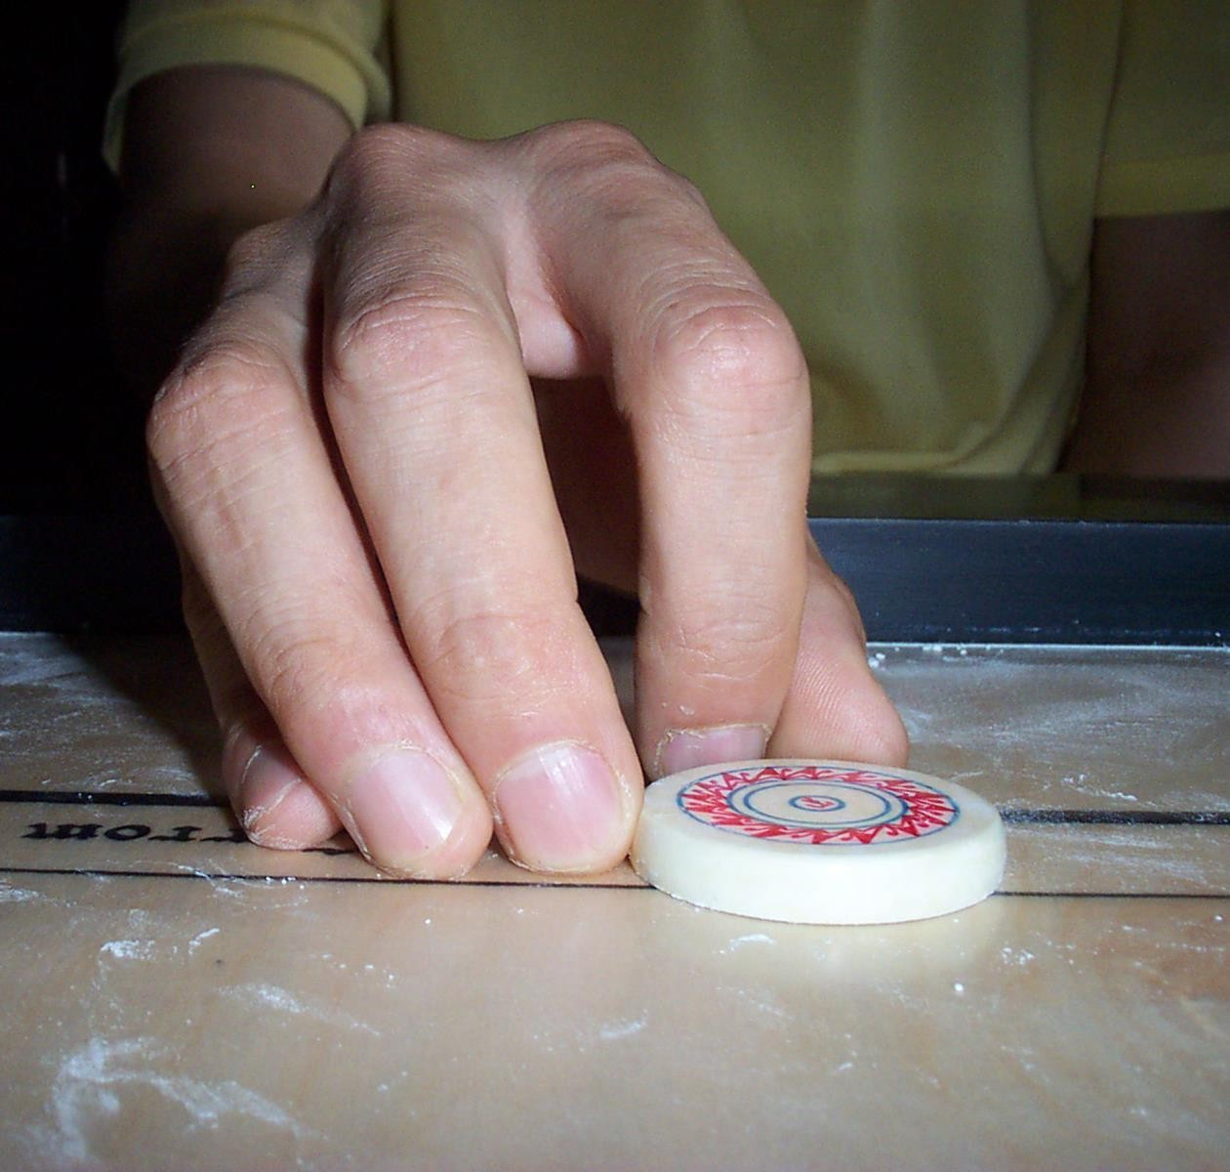

NATURAL GRIP
There are many types of grips. The most common grip is the combination of the index finger and the thumb. See the above photo. This is a very easy grip and requires less practice. In this grip all other fingers rest on the plywood. This

grip has many advantages. With this grip a player can keep maximum control over the striker. This grip remains steady and firm as all other fingers get the support of the plywood. A player of this grip can play with minimum space.

Sometimes when there is insufficient place available for placing grip a player can play with the index finger lifting all other fingers from the plywood. With this grip a player can play with equal ease on both sides (left or right) of the carrom board. Therefore player’s game does not remain weak at any side. In this grip the nails of all fingers touch the plywood. Therefore if any one nail has grown more than usual, there will be change in the grip. Such minor things are very important in carrom. .

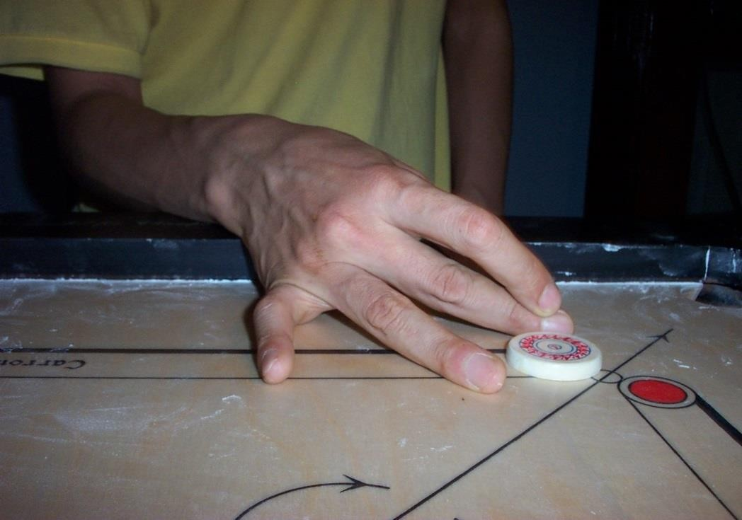

SCISSOR GRIP
It is used basically for the break in India. It is used as a natural grip in SriLanka and Maldives. In India only Ivon Marquis and Kadirkhan used this grip as natural grip. There are many disadvantages in this grip. It is very difficult to play from the right side

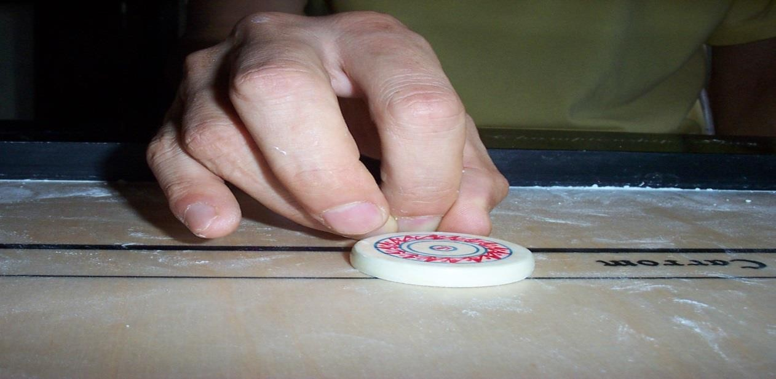

LOCKING GRIP
You should learn this grip if you don’t have locking grip as your natural grip. With this grip you can get a power to play powerful strokes. I was with Suhas Kambli in 1982 in Delhi for one month and we were practicing hard to play demonstration games in Asian games when I observed Suhas Kambli playing many powerful strokes with his natural locking grip. His natural grip is a combination of thumb, first finger and little finger, but whenever he required extra force he was changing his little finger to third finger. I just tried it and began to hit hard with this grip. I enjoyed using it and then whenever I got a chance to use it, I used it. Suhas was laughing at me because I couldn’t aim properly with this grip. I had to put all my efforts to get mastery in this grip. You have to lock your first finger between thumb and third finger for this type of grip. Generally in this grip first finger by which, stroke is played, does not touch the playing surface.

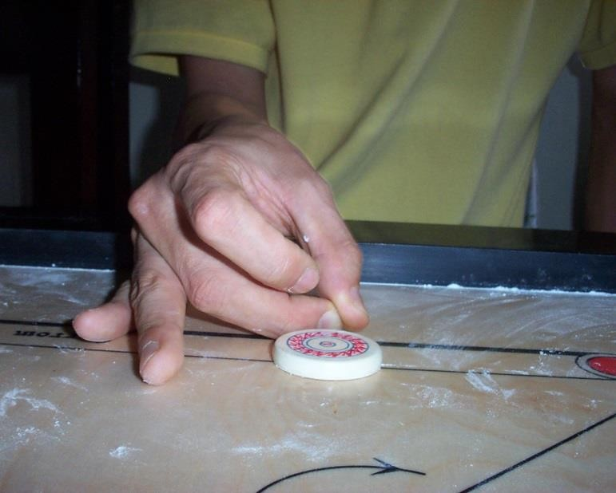

MIDDLE FINGER FLAT GRIP
This grip gives spin to the striker. There are many positions on the carrom board where without spin you can’t play the stroke successfully. In this grip you don’t have to make an effort to create spin, it is automatically created.
Therefore it is called natural spin. The spin is anticlockwise. You should develop this useful grip. You can play it with the left hand also to play the strokes on the other side.

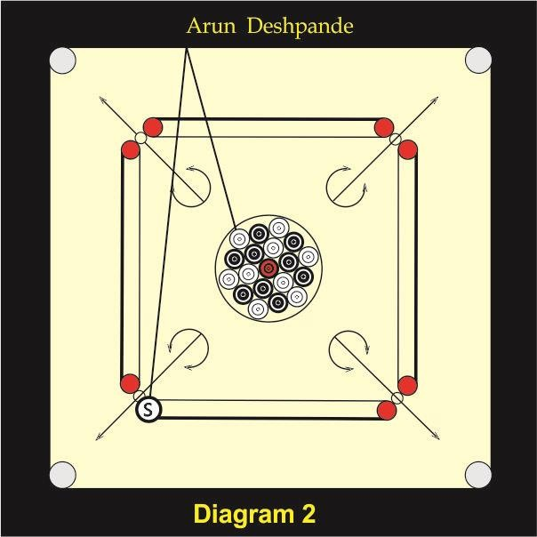

Break from left base circle
This method is the best method and is used by majority of the players. Many players take blind aim from the opposite frame for the break. If you place your striker on the left base circle then your striker should pass through the first arrow of the opposite left half circle as shown in the above figure. You can see the actual point from where your striker should pass and therefore you can play the stroke accurately. If you don’t use this method and try to take an imaginary point on the opposite frame then there is a chance of varying this imaginary point resulting in failure of the break. This break should be made preferably by scissor grip or by any flat grip.

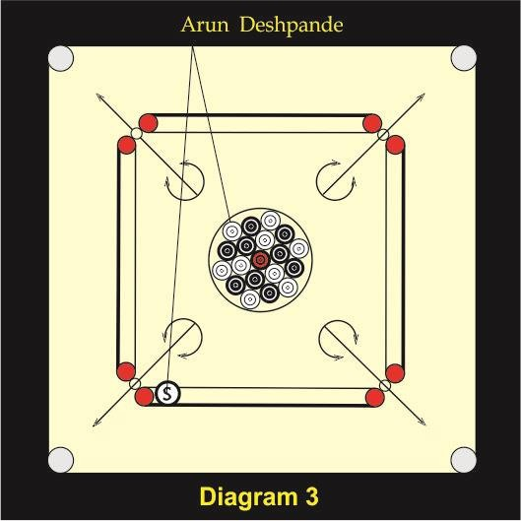

BREAK FROM NEAR THE LEFT BASE CIRCLE
If you are afraid of playing the stroke from the left circle due to a possibility of making a foul then you can play from near the base circle. In this method your striker should pass through the second arrow of the opposite left half circle as shown in the above figure. This break also should be made by scissor grip or any flat grip.

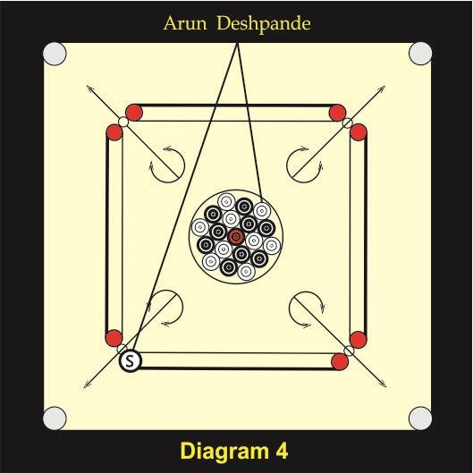

Reverse break- In this type of break you can arrange a shot of the break to your left pocket and break from the left side. If you break accurately then you will notice that there remains a bunch of four coins in such a way that you can play a touch stroke and open the board thereby getting a chance for a white slam. The disadvantage of this break is that if you fail to break correctly, then either you may hit the other coins or your striker may just touch your aimed white coins resulting bad break.

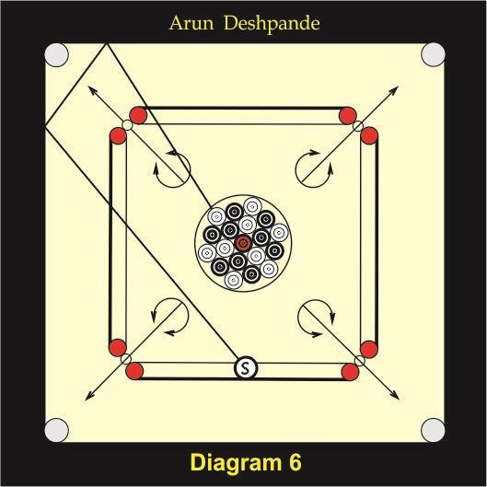

Circular break- This is a very rare break. Sometimes en opposite frame has some defect and your striker is jumping while breaking then you can try this break. For this type of break place your striker nearly in the middle portion of the base line in a straight line of a black coins from the arranged coins for a break. Hit your striker at the point where an arrow going towards pocket ends with a scissor grip or any flat grip. See above figure.

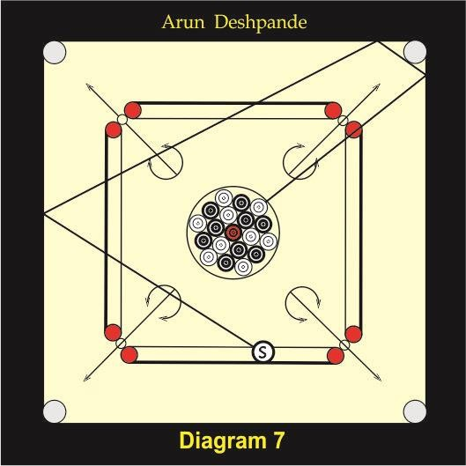

Exhibition break- This break is useful for playing exhibition matches. In exhibition matches spectators expect you to do something different. In the new generation of carom boards there is very good stroke to the frames, which, is artificially developed, and therefore it has a good bounce. On such boards if you know the angle, then it is easy to have a good break. Spectators are amazed to see this break.

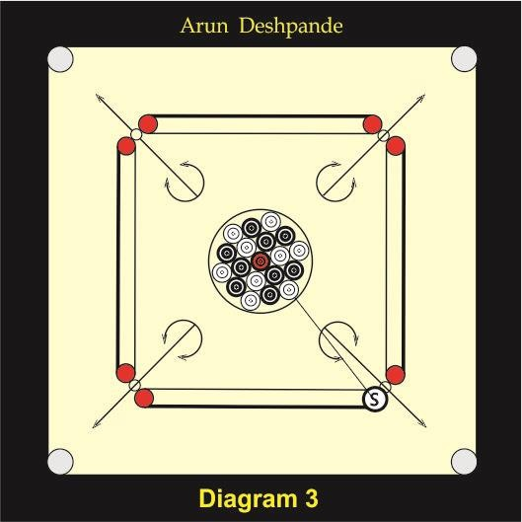

Forward break- In doubles, you have to break straight to drive coins near to your partner. In such type of break you should always break from your right side making the shot of the break towards your opposite left pocket because after your turn your opponent sitting on your right side gets a turn and he should not get the coins near to him. If you break from your left side then your right side opponent will get all coins near to him and your partner may not get a turn. Therefore even if you are a left-handed player you should always break from your right side. Ideal break for doubles is from the right base circle.

Chapter 2

SCIENCE BEHIND THE GAME
The game of carrom is a complete. Three subjects are involved in it.
- Physics, 2) Geometry, 3) Mathematics

PHYSICS
The physics is all about force. Every stroke requires different force. There is a simple logic behind how much force you should apply.
If the coin, striker and the pocket are in one straight line then 100 percent force of the striker is transferred on to the coin and therefore you should apply less force. The force will be increased as the striker goes away from the pocket where the coin is going. You can apply maximum force when the hitting point reaches to the tangent point as you can see in this stroke.

GEOMETRY
Geometry is about the certain angles you must know to play many strokes. There are many strokes which are like theorems in geometry. If you know all theorems then you can solve any rider. Just like that if you know principals of all these strokes you can handle any position on the board.

MATHEMATICS
The mathematics is about the turns. After each break and during the board you must count how many turns you are going to get from your opponent and how many turn you are going to give to the opponent. If you have plus one turn you will win the board. If you have minus one turn that means you are losing the board. So you strategy must be to increase opponent’s turns and reduce your turns. This is possible only when you make use of all these strokes.

Chapter 3

STROKES
I have discussed all basic strokes and some advanced strokes in my earlier book, “Carrom Skill And Technique “ here I am giving you some more strokes.

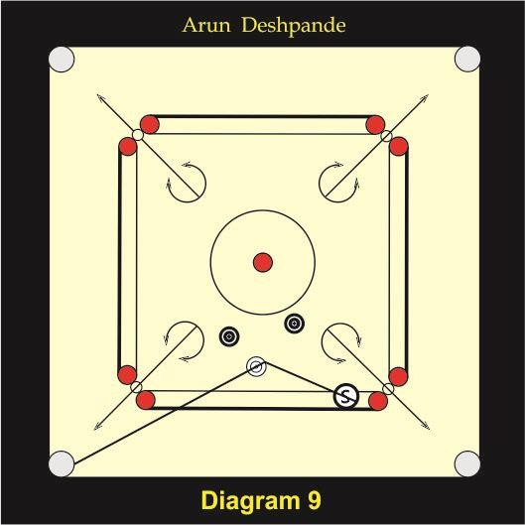

In the diagram 9 white coin has no access in the front pocket. Many of you will try to make a defense by removing any of the black coin trying to bring it to the base frame but in this effort you will pass the turn to the opponent and you never know what move the opponent will make and perhaps you may lose the board. You can cut your white coin in to the left or right base pocket by cut as shown in the diagram.

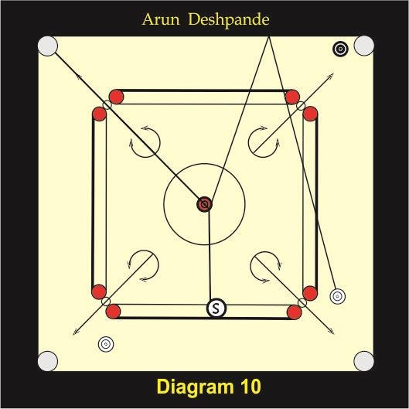

In the diagram 10 Queen is in the center circle, one white is coin near to the left base pocket and the other is at the rebound position. Your opponent is having only one black coin easy for him. Most of the payers will pocket Queen into the front pocket and will cover it with pocket in a white coin that is near to your left pocket and then will try to pocket the difficult white coin by rebound or or will try to make opponent’s coin difficult. Believe me we never played such a game. We would cut the Queen into the opposite left pocket ad drag the the striker to remove the difficult coin that is at the rebound position. We believed that as far as possible we should not give the turn to the opponent even if we have to take a risk.

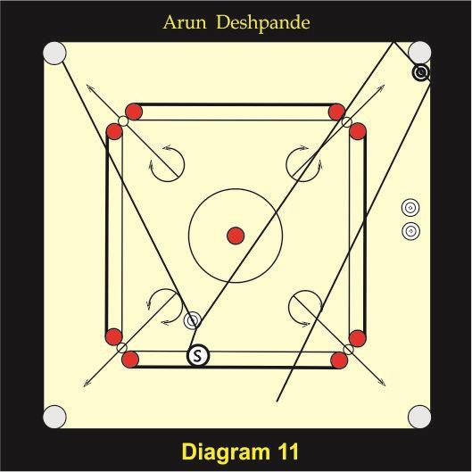

In the diagram 11 you have one white coin easy and other two are difficult because they are blocked by opponents black coin. Here again most of the players will play easy coin first and will try to pull the opponent’s coin little up. In this position it is very easy to cut your easy coin and send the striker to the opposite frame near to the pocket so that opponent’s coin can be removed and space can be created to pocket your difficult coins.

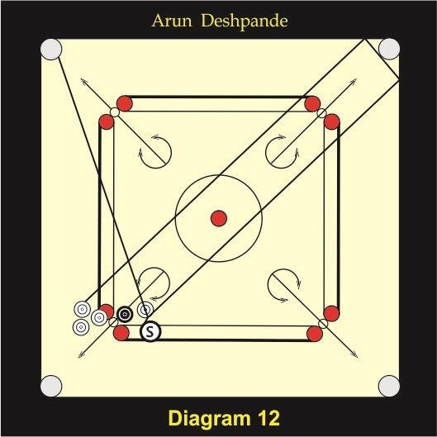

In diagram 12 you can see that there are three white coins at the rebound position but you cannot play rebound because opponent’s two black coins are in the path of the rebound. Therefore you should take the advantage of your other coin that is just above your base lines. You should play this coin just like a bomb stroke driving your striker at the right frame near opposite right pocket. Your coin will be pocketed into the opposite left pocket and the striker will take an angle and will come onto the coins at rebound side making them easy for the next stroke.

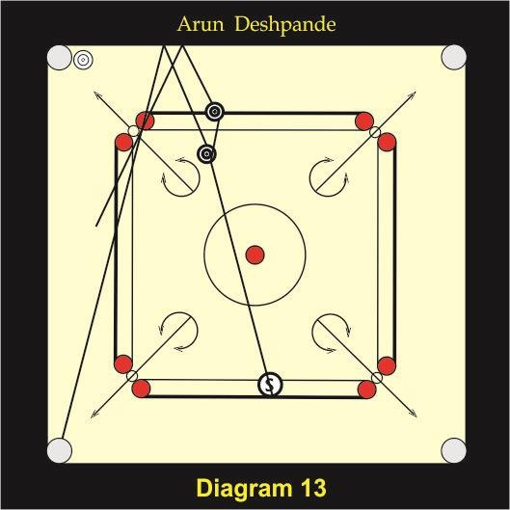

In diagram 13 your two black coins are near to the opposite base lines. The opposite left pocket is blocked by the opponents white coin. Some of the players will try to pocket the first black coin by cut and will try to remove the other black. Some may play the two black coins by double separately. I suggest you to play first black by double and send the striker onto the second black coin to remove it from that position and make easy to finish the board.

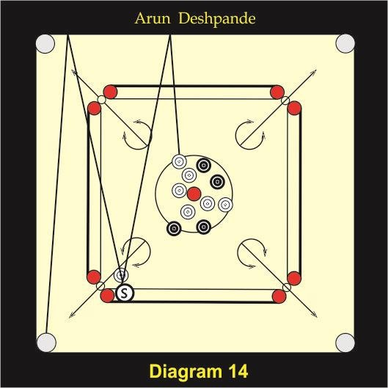

In diagram 14 there is one white coin just above the base lines and there are few whites in the bunch that is in the circle. If you try to pocket the coin into the front pocket and try to open the bunch by sending the striker directly into the bunch, you will have to apply little more force. There is a chance of the coin vomiting from the pocket due to extra force. Instead if you play the coin by double and send the striker into the bunch you can apply more force to open the bunch. Apparently no one will think of playing such a coin by double. If you observe the hitting point on the opposite frame you will realize that the point is very near to the opposite pocket.

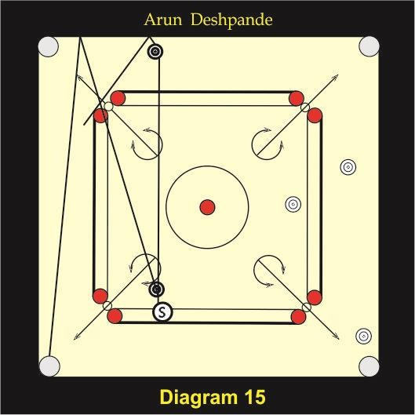

In diagram 15 one easy and one difficult black coin is there. You have to play blacks. You will notice that the distance between the black coin ad the striker is more and therefore you cannot try to pocket the coin into the front pocket and send the striker onto the other coin which is near to the opposite frame. In this situation you will have to play the coin by double ad send the striker onto the other coin to make it easy. Thus you can finish the board thereby not giving chance to the opponent.

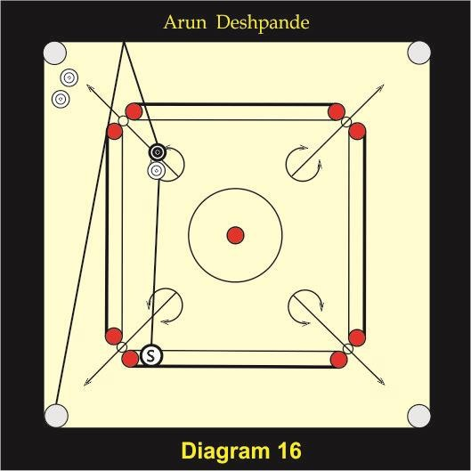

In diagram 16 your black coin I sticking to the opponent’s white coin and seems to be difficult because these two coins are in a straight line but black is little towards right side. If you play the stroke as shown in the diagram you can pocket the black coin. You have to hit onto the white coin little on the right side and send the striker to the opposite frame.

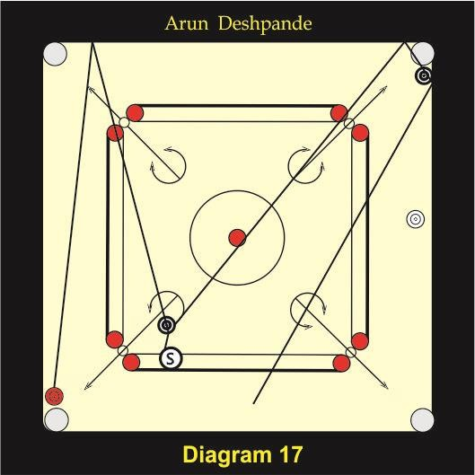

In the diagram 17 one white, Queen and opponent’s two black coins are there. The position seems to be very difficult because even if you pocket the Queen your white coin is difficult and you have to try to pocket this difficult coin by rebound or into the opposite left pocket by cross third pocket. As the coin is very near to the frame, while playing cross third there is a chance of double touch. Therefore it is easy to pocket the Queen by driving opponent’s coin onto the Queen by double and at the same time driving the striker to the opposite frame very near to the pocket to remove the opponent’s coin from there to finish the board. Here you are using opponent’s coin as a striker.

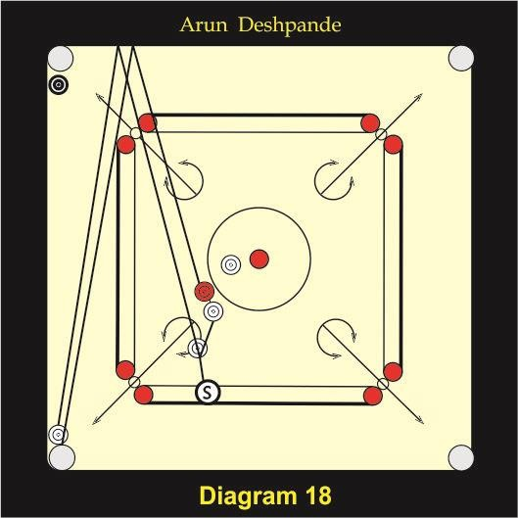

As shown in diagram 18 your only black coin is near to the opposite left pocket but Queen is difficult as it is blocked by a white coin. Any payer will just pull the Queen towards base frame. But if you observe carefully, you will notice that the position of the Queen and the adjacent white coin is such that the Queen can be played with the help of white coin by double but there is another white coin at the mouth of the left pocket. So you have to think of removing it there is another white coin near to your base lines. You can take advantage of this coin for opening the left base pocket. Play this white coin by double onto the other coin that is at the mouth of the left base pocket little hard and send the striker onto the other white coin which is near to the Queen. In this process white coin that is on the mouth of the pocket will be removed by another white coin and pocket will be opened for the entry of the Queen in this pocket.

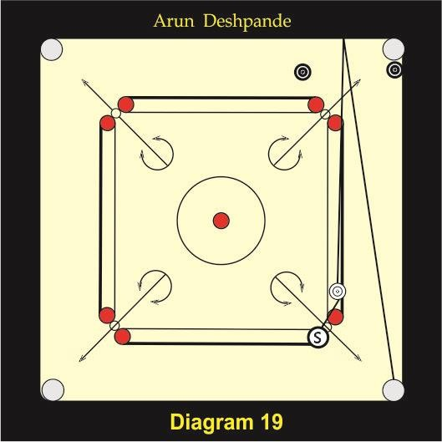

In the diagram 19 there are three options to pocket your white coin. These are rebound, third pocket and cross double. For playing rebound you need a very wide angle as there is an opponent’s black coin near to the opposite frame. You can play third pocket but if you observe you will notice that the position of your coin is such that cross double is easier than third pocket. So cross double is the best option for this position.

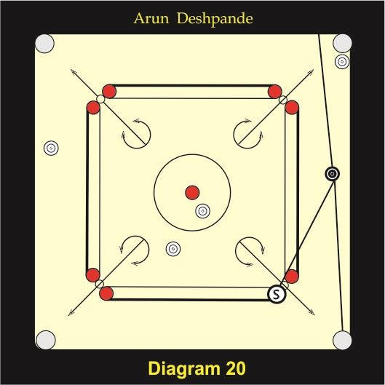

In the diagram 20, opponent’s five white coins are there and your only one black coin is there. Many of the players will think of playing defense. Some may try to pull the coin that is on the mouth of the opposite right pocket which has blocked the path of the black coin. Some may try to play glancing white coin that is in the circle and send the striker to remove the coin from the mouth of the opposite right pocket. In both cases you give turn to your opponent thereby giving him/her a chance to reduce all easy coins. If you play cross double and succeed then you can get a big board.

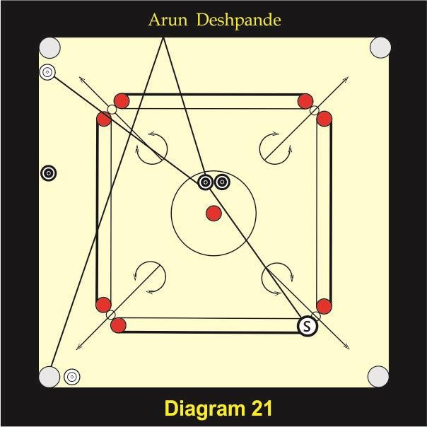

Diagram 21
In the diagram 21 all the three black coins are difficult for you and all white coins are easy for your opponent. Many players will try to pull the coin from the opposite left pocket. Some may try to play a glance on one of your two difficult coins sticking together in the circle and send the striker at the opposite frame to pull the coin which is blocking your black coin. But again by doing so you are giving your opponent a chance to reduce many of the easy coins If you play a cross double as shown in the diagram you can finish the board. You can get an advantage of opponent’s coin that is near to your left base pocket even if your coin from the circle which you hit doesn’t come accurately into the left base pocket, it will touch the white coin that is near to the left base pocket and will go into the pocket.

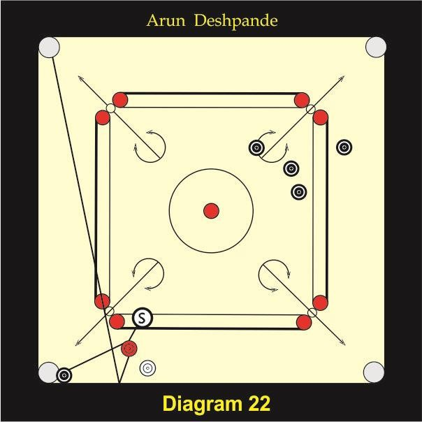

Diagram 22
In diagram 22 there is only your one white coin and Queen on the carrom board. Whereas there are there are five coins for the opponent. You will think that in this position the stroke called follow can be played but if you observe the position you will come to know that the opponent’s coin that is on the mouth of the pocketis sticking to the frame and therefore follow is not possible. Turning is possible but it requires great accuracy and in the process you may follow the striker into the pocket with the Queen thereby making a double due Therefore as shown in the diagram cross double is the best option for such a position where you can pocket the Queen into the opposite left pocket and make the way for your coin by removing the obstacle from the mouth of the pocket.

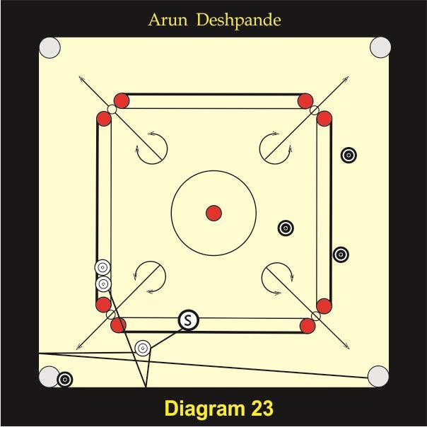

Diagram 23
In the diagram 23 you have to play two white coins which are difficult to you. You may think that you will remove opponent’s black coin from the mouth of the left base pocket because you have one more turn from the opponent But in the process your opponent can pocket three easy black coins and then go for a defense and there will be no guaranty of winning a board. Even if you win the board you will not win the big as there will be only one opponenet’s coin remaining on the board, If you play cross second as shown in the diagram you can finish the board and can win the big board In certain situations you must take a risk.

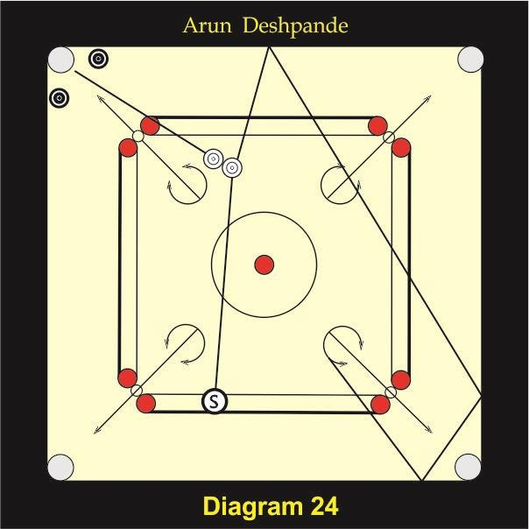

In the diagram 24 there is an easy wrong shot for you. If you play this shot from the left base circle your one coin will go to the opposite frame and will become difficult for you. If you play shot as shown in the diagram while pocketing your coin your other coin will hi the opposite frame and come back rand will be easy for you it in the next stroke. For playing this stroke you must apply a little more force as the principle of the force discussed earlier.

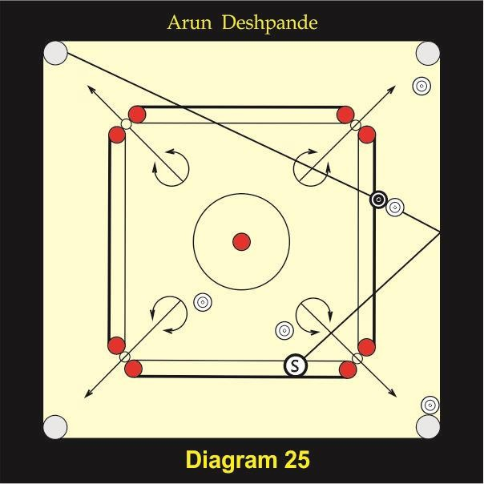

As shown in the diagram 25 you are having only one black coin and your opponent is having four white coins. You will try to remove the white coin from the opposite right pocket but if you watch the position carefully, you will notice that there is a shot facing toward the opposite left pocket. If you hit the correct point of the right frame you can pocket this shot very easily.

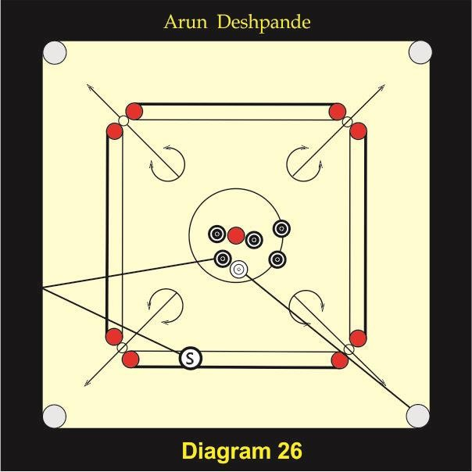

In the diagram 26 there is a one white coin in the cluster of black coins. I had played this shot in one of the National championships. After the match my opponent Govindraj said “I was not expecting you to play the shot like this, instead I was expecting you to pull the bunch towards you.” If you observe you will notice that the shot is not facing towards the pocket but it is facing towards base frame. So this is a wrong shot. If it is a wrong shot then only you can play this shot. If the shot is facing towards the pocket then it is not possible to pocket the black coin as you cannot reach the desired hitting point by this angle.

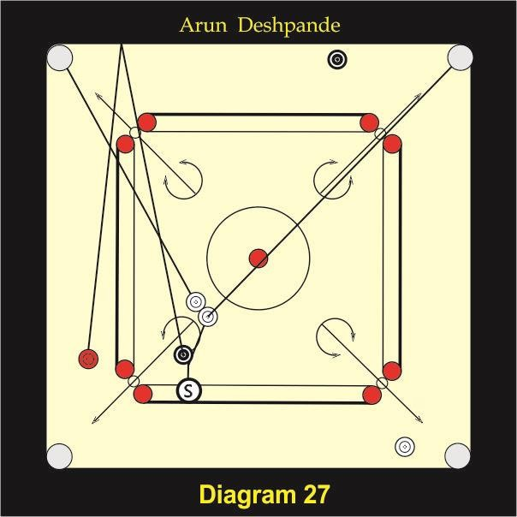

In the diagram there are three white coins of yours. Queen and two black coins of tour opponent are there. You have all three coins easy but Queen is difficult as it is at the rebound position. One of the black is in such a position, that you can take advantage of this black coin for making Queen easy. Drive the black coin on the Queen by double and send the striker to hit the shot. In this situation there are three chances. 1) Two whites and Queen can be pocketed simultaneously. 2) Two white coins can be pocketed simultaneously. 2) Two whites can be pocketed making the Queen easy. 3) One white can be pocketed and the other white and Queen can become easy. These two white coins can be pocketed if the position of these two coins is a wrong shot. One white of the shot is certainly going to be pocketed into the opposite left pocket and therefore you should go for such a stroke. You should not pocket your another easy coin that is near to the right base pocket otherwise you may lose the board if you pocket both the coins of the shot simultaneously and not the Queen as in the second possibility.

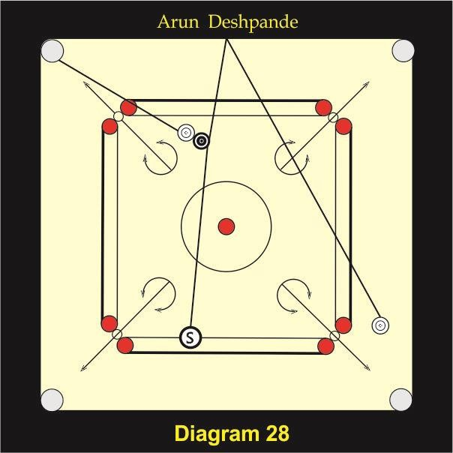

Diagram 28
In diagram 28 you have two white coins and there is one black coin of the opponent. There is a very small gap between the white and the black coin which are near to each other. One of your coin is at the rebound position hence is difficult for you. In this situation you can play the shot from the different place and drive the striker onto the opposite frame in such an angle that when it rebound, it comes on your difficult coin thereby allowing you to finish the board.

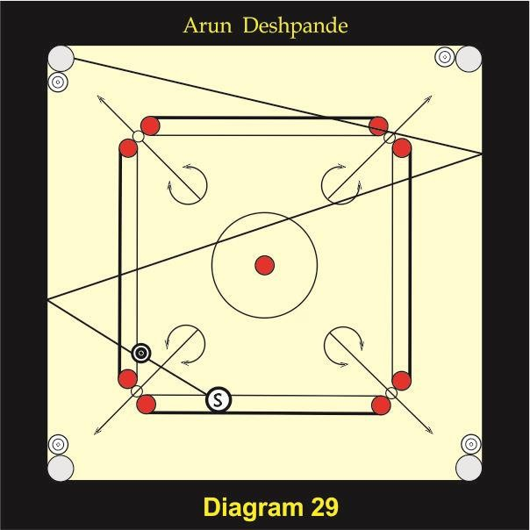

In the diagram 29 your black coin is blocked by white coins which are on all four pockets. In this situation you cannot play it straight or by third pocket or by cross double or by Quadrangle 0. Z route is only solution by which you can pocket your black coin into opposite left pocket as shown in the diagram.

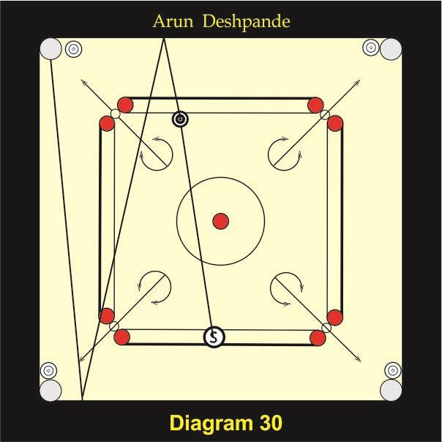

In diagram 30 all four pockets are closed by white coins. There is no direct access for your black coin to any pocket. You can pocket this coin by hitting the coin in such a way that it strikes onto the opposite frame then hit onto the base frame and go to the opposite left pocket. Notice that you must play this coin in such away that it hits very near to your left base pocket.

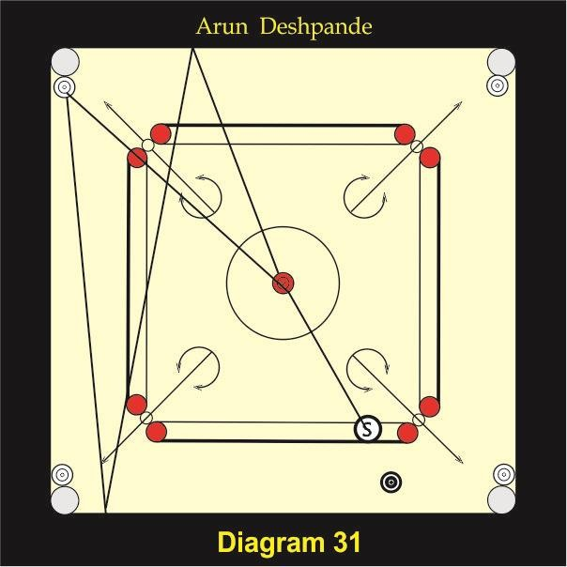

In the diagram 31 all four pockets are closed by white coins and you have to play the black coin that is in the center circle. You must play glance on the black in such a way that you can remove the obstacle from the opposite left pocket by the striker and at the same point your coin should hit the opposite frame and base frame and should travel to the opposite left pocket from where the obstacle has been removed by the striker. This is a very difficult stroke but not impossible to play.

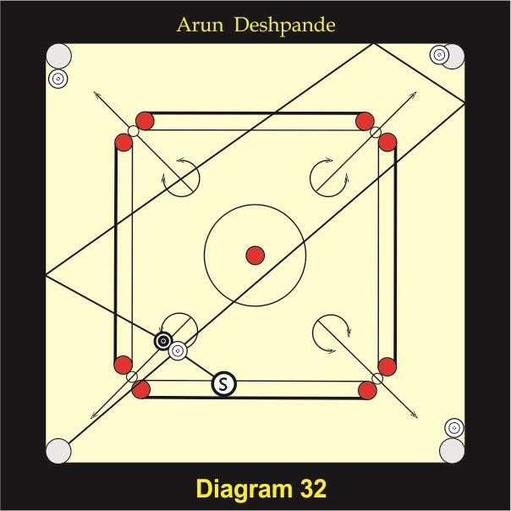

In the diagram 32 four pockets are blocked by white coins and there are white and black coins near to each other. You have to play black coin which has no direct access to any of the pockets. You can pocket this black coin By ‘G’ route as shown in the diagram.

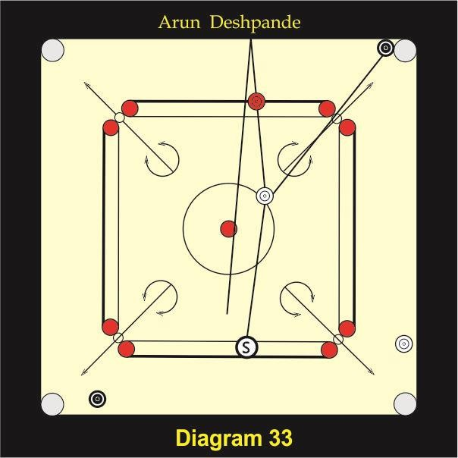

In the diagram 33 your two black coins are easy but Queen is difficult you can take advantage of your opponent’s white coin which you can glance on Queen and send striker to your black coin to pocket it. By this stroke Queen can come near to you and will become easy for your next stroke. Thus you can finish the board.

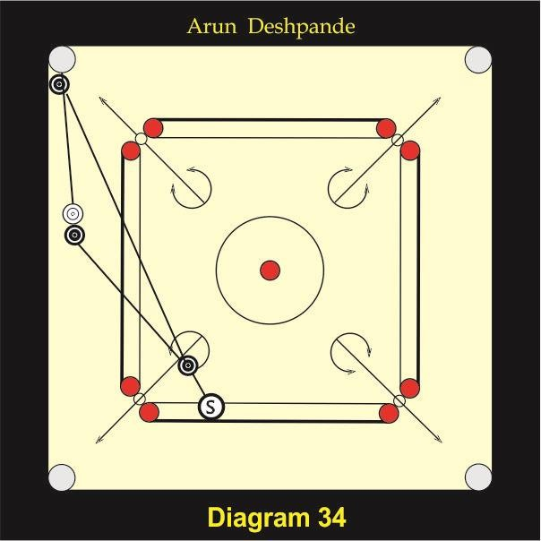

In the diagram 34 your white coin is difficult. Many players will think to play glance to the black coin and pocket or remove the other black coin whichis on the pocket. As shown in the diagram if you drive black coin onto the other black coin which is on the pocket, and send the striker to the shot, then black coin on the pocket can be removed by another black coin and your white coin can be pocketed into the same pocket simultaneously. This is a very easy stroke.

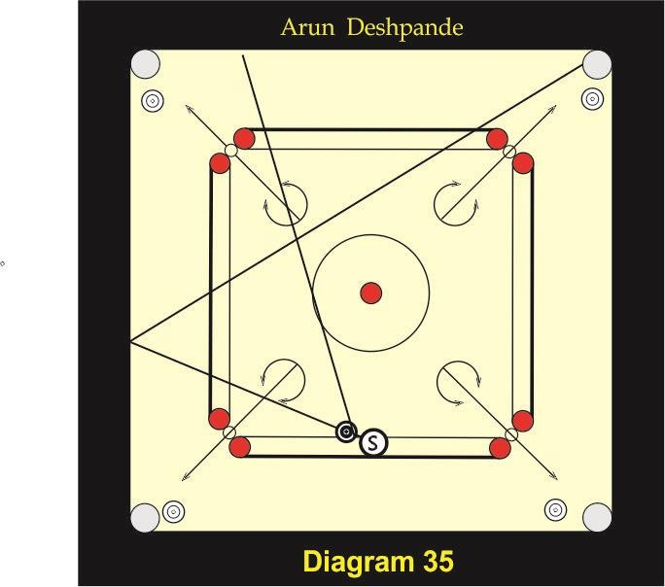

In the diagram 35 there are four white coins on all four pockets and your black coin is on the base lines. You cannot pocket it into your left or right pocket by cut as there is no way for5 your coin to go to these pockets. But if you observe properly you can notice that this difficult coin can be pocketed by cross third pocket to your opposite right pocket. There is an advantage of the opponent’s coin on that pocket.

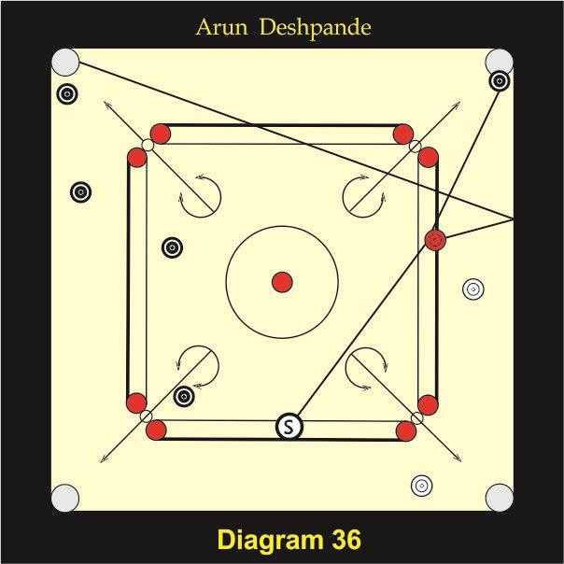

In the diagram 36 you have to play the white coin. Here your one coin and Queen are difficult as there is an obstruction of your opponent’s black coin which is on your opposite right pocket. Many players will think of taking back opponent’s black coin from the pocket, But by doing this you are giving your opponent a chance of pocketing his other four coins which are easy for him. If you pocket the Queen by cross third pocket and drive the striker simultaneously on the black coin on the pocket you can finish the board and can get a big board.

Chapter 4

DICIPLINE

Behaviour
  - Punctuality BEHAVIOR
Behavior of a player is very important.

Behavior with umpire
I have seen some players talking very rudely with umpires thereby spoiling relation with them. I really don’t understand why players misbehave with umpires? What do they gain? Sometimes players feel that they know rules in a better way than umpire and therefore they argue. I tell you, in no other game the facility of calling chief referee can be availed of by any player as is availed in this game. If you are not satisfied with umpire’s decision you can call chief referee. Even if chief referee’s decision also goes against you then you have a right to play on their protest by paying protest fees and lodging a protest in writing, quoting the incident and the rule. Such a facility is not available in any other sport if such a protection is given to you why should you argue with the umpire? On the other hand if you behave nicely with the umpire, he/she will have a respect for you. I have seen Suhas Kambli, five times national champion from Mumbai behaving with the umpire in such a way that every umpire was eager to refer his match. We had never any problem with any umpire even sometimes he was a good friend of our opponents. In tournaments held in Maharashtra I had requested many times friends of my opponents to refer matches in spite of knowing that they were well-wishers of my opponents. I never faced any problem with any one of them. If you have good intentions nothing wrong will happen to you. In olden days the organizers of the tournament used to level the boards before the match. I sat on my match in Madras (Chennai) and immediately realized that our board was not properly leveled. I asked our umpire to give me packing for leveling the board but the umpire was reluctant to give packing saying that the board was already leveled. My opponent also agreed for leveling

the board but the umpire did not listen to our request. The slope on one side was so much that we could not have given our best to the spectators. I did a trick. I asked the umpire politely about his plying carrom. He said that he was plating carrom regularly. I requested him to sit on my seat. I placed one coin at the opposite pocket near to the opposite frame and asked him to play it slowly. He very confidently took striker from his pocket and played the coin but to his surprise his striker did not hit the coin, instead it went into the pocket. Then without saying anything he went from the board and brought the packing. The spectators were watching the drama; I felt that the atmosphere was tense I immediately said sorry to the umpire for convincing him in that manner. He was so pleased of hearing my words “Sorry” and immediately replied, “Sir, you were right I was wrong” After the match was over I took him for the cup of tea and told him everything about the level of the board and how to do it correctly. He was very pleased of getting knowledge of level in the board. He then became very good friend of mine. Therefore I don’t feel that there is any loss by behaving nice with umpire.

Behaviour with spectators
How to behave with spectators is a great problem for many players. You should understand the basic thing that the spectators are your inspiration. A true champion will never enjoy a match without the presence of spectators. You gain confidence when spectators applause for your good stroke. Sometimes you get disturbed by spectators due to much crowd. At this juncture you should not lose your temper. You can simply request them not to disturb you. Once I was playing state championship doubles final. My partner was Ramesh Chitty. Our opponents were Suhas Kambli and Vijay Sangam. Both the pairs were strong. We had a chance of creating record of a hat trick. Arrangements of the stands were made but the crowd was

so much that for each stroke all of us were requesting them to get back and allow us to play. They were controlling themselves. We knew that they could not stand properly due to tremendous pressure. The match lasted for nearly three hours. Due to understanding of all the four players there was no rift between players and spectators.
The area of carrom is very small as compared to table tennis or billiards and therefore generally spectators are very near to you. Sometimes some spectators make comments. Any comments should not disturb you. You should behave in such a nice way that those bad comments will never come to you. If you get angry and lose your temper, then more bad comments will come from them. I quote here the classic example of Vijay Sangam a well-known carrom player from Maharashtra. In Vanmali hall tournament at Dadar, Mumbai, Vijay Sangam was playing against Suhas Kambli. One mischievous spectator loudly said to Sangam as kala patthar (black stone) during the match knowing that the crowd was so much and Sangam would not be able to identify him. Can you guess what Sangam did? He did not get angry but he simply saw in the crowd from where the sound came and gave a wonderful smile. The person who had commented fall so much ashamed that after the incident not a single comment came from him or any other person. After the match was over he came to Sangam and apologized. You should always have a great respect for the spectators as they come from a far distance paying for a ticket to watch your match. You should speak to them politely. They don’t expect anything more than that. If you speak to them giving them respect they enjoy it. They become your fans. 80 Year old gentleman was coming to witness my match. When I used to see him before the match I was always going to him before he came to me and was enquiring about his health and praised him for his

interest in the game. He was feeling very happy when we were meeting in the tournament. I cannot express in words what satisfaction I was getting to see him happy. When you will feel it, you will enjoy it.

Luck
In every game, luck factor is there. In carrom also with good game little luck also is required to win crucial matches. Where this luck comes from? It comes from the blessings of your fans and well- wishers. They always pray for your win. How will you feel when a person comes to you and says that he watched your match 36 years back and had enjoyed it very much? Yes, it happened to me when I went as a coach to Hyderabad in 1995, an old gentleman came to me and told me that he had watched my match in 1959 nationals and had enjoyed. He came to the tournament hall after coming to know that I had come to city of Hyderabad. I was surprised. I was very happy to know that one of my fans came after 36 years to meet me with love. I told him to wait for some time as one of our players was playing a crucial match. As soon as the match was finished I congratulated my player and went out with my old fan for a cup of tea. We enjoyed time and had a discussion of the game. I had the same experience in Madras. This time 75 years of my old fan was describing my game quoting the board no. on which I had played in a match many years back. He described the full match, board by board and what strokes I played in each board.

Behaviors with opponents
When you sit to play a match then any player is your opponent. During the match your aim is to win. I have seen today’s generation not appreciating their opponent’s good strokes even in the practice thinking that if they appreciate,

their opponents will play much better and therefore they do not show any expression on their face. In our days even if we were appreciating our opponents we were winning tournaments. Take the example of Suhas Kambli. He was appreciating his opponent’s good strokes even then he won five National championships. Apparao was another example. That in spite of appreciating his opponents he won three National championships in a row. Therefore the concept of not appreciating opponent is wrong.
During the match you are the opponents to each other’s but after the match you should be friends. This will show your sportsmanship.
Popularity is temporary. Respect is timeless. The only way you can get respect is to earn it. You can’t get respect by demanding. You get respect by your behavior and your work.

Punctuality
You should be punctual all the time whether you are going for the match or at work. Punctuality is a habit and you should develop it. If you are punctual in your life then you will see how many benefits are there. I and Ramesh Chitty, my doubles partner played lot of exhibition matches. We were deciding to meet at a particular spot at a particular time and were going together for the exhibition match. We were very particular about the timing and were never late. The best example of punctuality I have seen is D> Nazir, president Maldives. He had conducted coaching camp for his players. I was invited as a coach I still remember it that he used to start the session exactly on time and close it on time.

CHAPTER 5
QUALITIES REQUIRED FOR A PLAYER TO BECOME CHAMPION
I have discussed the qualities required for a player to become champion in my last book “carrom Technique and skill”.
Here I am going to discuss few more qualities and trying to give more material for the qualities already discussed.

CONCENTRATION
What is concentration? Concentration is
- Ability to focus attention
- Ability to broaden the focus of attention
- Ability to shift focus of attention
Concentration is very essential in this game. You have to concentrate on carrom board only. I have seen many players looking out of the board during their match. If you concentrate on the board you feel after sometime that the pockets of the carrom board are bigger. On the other hand if you do not concentrate on the board you feel that the pockets are smaller. Therefore if you concentrate on the carrom board you automatically gain confidence. Concentration from the very beginning is essential. No figure skater can afford lack of concentration. No driver can afford lack of concentration even for a small drive. In the same way all players must consider each practice and every second of competitive play to be their major challenge, responsibility and opportunity to prove the stuff they are made of.
Once I was playing a match in Bombay. One of my relative had come from Pune to watch my match. I was playing that match with a strong opponent. I had to play three games with him and won the match. After finishing the match my relative came to me and said that he was trying to divert my attention towards him by standing t the every corner of the board but I did not see him. I told him If I had not concentrated so much, I would have lost the match. Mahendra Tambe’s concentration is wonderful. Once I was playing a match with him. When I was playing and whenever my striker was going near

to his frame he was pushing the striker he was pushing the striker only an inch or two. Towards me His gesture frustrated me and I looked at him nearly for 10seconds but to my surprise he did not even notice that I was looking at him. All the time he was looking at the board. He won the match. I shall quote the best example of concentration from Mahabharata. Dronacharya, the greatest teacher of all times, held an examination by aiming by arrow for his students. He placed a statue of a parrot on a tree and told his students to pierce the eye of the parrot He asked all his students what they could see. All of them except Arjuna told their teacher as they could see all like sky, tree, parrot etc. on the tree. Only Arjuna replied differently He said that he could see only the eye of the parrot. Such was his concentration. You should aim the hitting point of the coin and concentrate fully on it.

OBSERVATION
Concentration is an art. There is a vast difference between seeing, watching and observing. Observation requires not only open eyes but open mind too. Many times we only see and watch but a very few people observe. You should always ask yourself a question ‘why’. Then you will really understand what carrom is. You should not only play the game but you must study it. There is a need to observe lot of things in the game of carrom. A few of them are stated here.
  - Rhythm
  - Level of the carrom board

  - Running of the carrom board
  - Bounce of the frames
  - Pockets vomiting coins
  - Running of the coins
  - Weight of the coins
  - Diameter of the coins
  - Level of the coins

  - Playing over offence or over defense
  - Strong points and weak points of your opponent’s and yours.

RHYTHM
Every player has his/her rhythm of playing. Some players play fast, some play slow and some players play very slow. Every player takes his/her own time to play each stroke. As long as you are playing in accordance with the rules and playing good game, you should not change your style of playing. I remember D.
K. Sumra from Mumbai was playing very fast game in his younger days. His play was so fast that in one of the matches, he finished the game in four boards in just seven minutes against Abdul Jabbar who was a great player from Mumbai and was in very good form. Sumra’s game was basically a brushing game, which was a very complicated game. He could think his plans very fast. It was amazing. He produced his best game when he beat Suhas Kambli in finals in just 25 minutes. The best example of a very slow player in our time was Paramsivam of Trichanapally. He was taking 28 to 29 seconds for every stroke when the time limit was 30 seconds. He was very accurate. He beat all the great players including Abdul Jabbar and reached finals in the 1961 nationals at Mumbai. He played his final against Suhas Kambli and lost. It was a very well fought match He lost third game on 26 points. When he was on 26 he made a break and didn’t know that he had pocketed white coin. Everybody thought he was taking his own time as usual to play his next stroke. Suhas knew that Paramsivam didn’t know about he had pocketed white coin. Paramsivam thought that it was Suhas’ turn. When umpire declared time up, Paramsivam put his striker on the carrom board to play; Umpire told him that it was his time up It was bad luck for Paramsivam. His big mistake was he did not count the coins on the board.
Many players ask me that they play better game in practice than in tournaments. My simple answer to them is when they play in practice they play fast game and when they play in the tournaments they play slow game. It means their rhythm is changed. If you want to perform better in tournaments, you should try to keep the same rhythm in practice and in tournaments.

LEVEL OF THE CARROM BOARD
I suggest all of you to level the board before the match. Many times there is a manufacturing defect in the carrom board. You should always observe the carrom board in every tournament. Without sitting on the carrom board when other players are playing, you can observe on which pocket the players are missing. Sometimes players cannot even touch the coin on the pocket when the level of that particular pocket is up. Sometimes players cannot pocket coin which is on the pocket because the striker travels down due to a slope in the pocket area. This may also happen when the carrom board is not leveled properly. In all tournaments including Nationals and Internationals, carrom boards are just placed on the stands and they are never leveled. Players must level the boards themselves. It is not easy for the sub juniors and cadets to level the boards. In our time the organizers of the tournament were leveling the carrom boards. You should learn to level the carrom board and also learn how to pay on unleveled or the boards that have manufacturing defect. In Ambernath Nationals all boards had a common manufacturing defect. All the carrom boards had their center area up and are on all four pockets was down. I was watching a match of a champion. He could not break successfully and in each break his striker was not hitting white coin on the targeted point but the striker was just touching the coin. The coins were not scattered, as he wanted it to be scattered. After the match he came to me and asked me why it happened like that. I told him the condition of the carrom boards and suggested him to aim at the black coin instead of white coin. In the next match he did what I had told him to do and he was successful. Immediately after the match he came to me and thanked me. It was his greatness that in spite of being a National champion, he went to somebody for the solution of his problem and not only that he also came and thanked.

SMOOTHNESS OF PLAYING SURFACE
I have seen in many championships including National and International tournaments carrom boards are not maintained properly. After playing for a few matches powder gets stuck up on the carrom boards due to the perspiration of some players. To maintain smoothness of the carrom boards this stuck powder should be removed by wiping the carrom boards with a wet cloth if the carrom boards are waterproof or by emery paper or by fine wire

gauze if playing surface is not waterproof. You can learn this process. You can do it by rubbing two pieces of emery paper on each other to remove all glass particles from it and then rubbing the emery paper on the playing surface in small circular motions. There are two types of papers available in the market. They are for wood and for metal. You have to use the paper that is used for the wood. The number of the paper should be 120 or 150.
Sometimes, particularly in the afternoon the smoothness of the carrom boards is in excess and it becomes difficult for the players to control the speed of the striker. In one of the National championships in semifinal I was playing with him. The board was too fast. In the trial board we both could not control the speed of the striker. In fact because of my easy grip it was easy for me to play on that carrom board. Suhas Kambli had a difficult locking grip and therefore it was difficult for him to play on that carrom board but he adopted a different tactic. He pocketed some coins hard into the pockets in trial board and noticed that the pockets were not vomiting cons, he started to pocket them in his usual force directly into the pockets accurately. He won the match. I had another problem. My nails were grown up and I was afraid of cutting it and bring it to normal level. I thought that if I cut my nails I could not have played a better game but I was wrong. I rectified this mistake in other matches. Whenever I felt that my nails were grown up, I cut it and played a better game. I always used to carry a nail cutter with me. Then I started to give advice to everyone to carry a nail cutter.

BOUNCE OF THE FRAME
In olden days pure rosewood was used for the frames in manufacturing carrom boards. Rosewood is a dense wood and therefore it has a good bounce. After some period rosewood became rare and it was replaced by hardwood. In hardwood frames there was no stroke and therefore was no bounce. It became very difficult for junior players to compete with senior payers, as the biggest disadvantage for them was break because they had no strength and the game became of power more than the skill. I tried to improve bounce of the frame by artificial way. I suggested my idea to Surco the no. 1 company of carrom manufacturers at that time but he never took interest because such boards would have more life and his business would suffer. Ultimately the owner of precise Industrial Corporation, Mr. Mahendra Bhalani approached me. He

wanted to manufacture carrom boards. He was manufacturing wooden TV cabinets. When I saw the carrom board I was very happy because he had used the same idea, which was in my mind for many years. He had used a Bakelite strip in the frame, which was giving a big sound when striker was hit on it. We changed the material. Another idea was to make a playing surface waterproof. Then we introduced the product in the market. My dream of several years came into reality, which could benefit the players. Now all manufacturers started to manufacture carrom boards with same technique.
I have seen many players applying maximum force for the break in spite of frames are having very good bounce resulting in the failure of the break. Therefore you should study the bounce of the frames of the carrom boards and apply correct force for the break. If the payer applies full force then some coins are hitting the base frame and come back and jumble with each other, spoiling the position of the coins on the carrom board.

POCKETS VOMITING COINS
Sometimes there is a manufacturing defect in the pockets of the carrom board. Generally a coin pocketed hard accurately, the pockets should not vomit it. In such conditions you should be able to apply limited force as if the coin is just dropping into the pocket.

RUNNING OF THE COINS
Speed of coins depends on two factors, weight of the coin and smoothness of the coin. The denser is the coin it is smoother.

WEIGHT OF THE COINS
If the weight If the weight of the coin is less then running of the coin is more and therefore you should apply less force. If the coins are heavy then there running is less and therefore you should apply more force.

SMOOTHNESS OF THE COINS
If the coins are well polished then there will be no burr and therefore the running will be more.

WEIGHT OF THE COINS
Weight of the coins affects two things.

Running of the coins
- Deflection of the striker
Running of the coins is discussed above. The more the weight of the coins, more is the deflection. Dense wood is always heavy. Dense wood can be polished well. Red and black coloured wood is generally heavy. Deflection of the striker will affect two strokes. Namely brush and glance. Therefore you should always use different coins for practice, which will allow you to understand the deflection and judge it.

DIAMETER OF THE COINS
The diameter of the coin should be 3.18 cm according to rules, but sometimes is less. You can judge it by observing the arrangement of the coins in the outer circle. If they are very much inside the circle then you can conclude that the coins are smaller in diameter. Or you can check it by placing a coin on the red base circle and judge it because the diameter of the coin and the base circle is 3.18 cm. If the coins are small they are easy to pocket and therefore you can play more confidently on such coins. Generally it happens when a manufacturer makes a rod of 3.18 cm in diameter first and then polishes it by emery paper, which reduces it in diameter. Coins made out of such rods become smaller in diameter. In one of the tournaments I was playing a match, our umpire told me to place Queen correctly in the center circle occupying it fully, when I arranged the coins for the break. I brought it to the notice of the umpire that the coins were smaller in diameter. I removed all coins except the Queen from the circle. He could see that the Queen was smaller than the center circle and was convinced.

LEVEL OF THE COINS
Sometimes there is a point at the center of the coin if the coins are not polished on sand paper properly. Such coin rotates after the break when the coins are scattered. If the players do not notice the rotating coin and touch the striker then umpire will declare a foul. You should notice which

coin is rotating. After the board is finished you should tell the umpire to replace it. If you try to pocket such coin with your usual force it will not reach the pocket. If you do not notice this coin you may lose the board.

PLAYING MORE OFFENCE OR MORE DEFENCE
There are many good players who have lost their matches due to over offensive game. The players play over offensive game because of the spectators’ appreciation. Whenever they play good offensive stroke, they get appreciation in the form of clapping from the spectators. They are so happy to get clapping that they even don’t think about the position of the other coins, which could come to the disadvantageous position to them or advantageous position to their opponents after such stroke is played. Nalini Bolinjkar is the best example for over offensive game. In Faridabad I practiced with her every morning and stopped her every time she wanted to play a complicated stroke and explained to her how the position of the other coins will not be favourable to her after playing such stroke only for the pleasure. She was releasing opponent’s difficult coins making everything easy for the opponent. I told her that she should stop playing complicated strokes but she should think when it is advantageous and when it is not. She listened to my advice and won the National championship.
David Joseph is the perfect example of over defensive player. He could pocket all coins more accurately and consistently than other champions but never took the risk and always played defense. If you want to become champion then you should take a risk. A perfect combination of offence and defense makes a player champion. Suhas Kambli and Maria Irudayam are the best examples that used offence and defense very cleverly against their opponents.

STRONG POINTS AND WEAK POINTS OF YOU AND YOUR OPPONENTS
You must know strong points and weak points of you and your opponents. Particularly in the national, international and in all major tournaments you should watch the other players’ game not only as a spectator but you should study their game. Only then you can know their strong and weak points. Sometimes great players may have simple weak point for example Arun Kedar, a national champion from Maharashtra developed

psychological problem for the thumbing of which many players of Mumbai started to take advantage of his weak point. In one of the matches in doubles, Jagan Bengle purposely pushed Arun Kedar’s last coin to his base frame as a defense knowing his weak point. Arun Kedar could not reach his striker to the coin and therefore it remained difficult for his partner also. Nobody would dare play such a defense but Jagan had a full confidence of his opponent’s weak point. Suhas Kambli knew the weak point of Tamilnadu players. Tamilnadu players couldn’t play on wrongly leveled boards. Suhas never tried to level the boards and he took advantage of the weak points of his opponents who could not play on wrongly leveled carrom boards.
Middle finger flat grip or scissor grip players are very good on their left side because of the natural generated in the striker due to their flat grip, but they have generally problems to play on their right side. I could take advantage of this weak point of Abdul Jabbar, Ivon Marquis and SriLankan players who had such grips. When I played with these players, I even changed the side of my break and forced them to play on their right side, which was their weak side.
Generally the players who play very fast and very good in pocketing how can you stop them. If you play back game and do not open position and do not allow them to pocket too many coins they will get frustrated and after some time even miss the simple coins. Suhas Kambli used this strategy, when he played in one of the National championship final against Gopalkrishna of Karnataka. Suhas took nearly 15 minutes to complete trial board. Suhas did not pocket his coins but he blocked pockets thereby not allowing Gopalkrishna to pocket coins. Gopalkrishna got frustrated and after some boards Suhas attacked and won the match.
Vijay Sangam was taking advantage of Suhas Kambli’s back game and played some powerful strokes, which not only spoiled the position of Suhas’ coins but also favoured position for Sangam. Vijy Sangam had such powerful strokes that none was able to understand. Spectators were saying it as hathoda (Hammer) and his opponents were always saying it as a fluke. How can a player get always a favourable position every time if it is a fluke? That means Sangam had played all these strokes intentionally which were beyond the imagination of other players. His favourite stroke was cut back.

He was playing this stroke with amazing accuracy and speed of the striker. I have not seen any other player playing this stroke in this fashion.

CHAPTER 6

PLANNING
Perfect planning makes a player perfect. Immediately after the break you must take a look at the position of coins on the carrom board and should decide from where to start and how you should proceed. Carrom is a game of planning and not only the game of pocketing coins. There are many players who are better in pocketing coins than the champions; stil1 they can't beat champions only because of their poor planning. You should start playing in such a way that when you lose turn of play, then you should always get a favourable position. You should always take an advantage of every coin on the carrom board to improve your position. When I had been to European countries and I played in some of the clubs, I received an appreciation from the members of those clubs. In their speeches they described me as doctor of carrom, professor of carrom, mathematician of carrom and so on. But the remark I liked most was that of one member who in his speech said that they were using one striker whereas I was using three strikers.
t. My own striker as a striker

- My coin as a striker
- My opponent's coin as a striker I shall explain it as below.
  - I could take an advantage of my striker to make my difficult carrommen easy or opponent's coin difficult while pocketing my own coin.
  - Many times the position was such that my coin was at the opposite frame and was difficult for me but i got a chance to make it easy by playing a glance on my coin driving the coin onto the difficult coin at the opposite frame to make it easy and pocket my other coin which was on the pocket. Here I was using my coin as a striker to make my difficult coin from the opposite frame easy.
  - The above position could occur with the following difference" Instead of playing glance on my coin; I was playing glance on opponent's and driving it onto my coin difficult coin to make it easy. In planning so many factors are

involved like how to go for finishing a board, how to get a better position on the board, how to reduce our turns, and how to increase opponent's turns etc. In one of the ladies selection trials for Bank of Baroda Inter zonal carrom tournament I had to select one player. We had called some women players for the trials. I selected the woman whose pocketing was not as good as compared to other women due to lack of practice. Everyone was blaming me but I knew that she had a better understanding for planning. After giving her practice for a few days when she became champion in the tournament, all of them were surprised. Suraj Kajrolkar, a junior champion from Mumbai had come to me to learn the game. In one of his breaks immediately I asked him what his plans were. He told me his plans. According to his plans it was not possible to finish the board. I suggested him my plans and then he played as per my plans and he finished the board. It was a white slam. I have told many players my plans when they were playing with me and when they played according to my plans; they always got a better position. I then taught them how to plan. I am a great admirer of Suhas Kambli, Maria Irudayam and Nirmala for their wonderful planning capability. You should learn planning and not simply pocketing coins. You should develop a habit of planning. I give below some hints about planning.
- You should not try to pocket your coins by making many of opponent's carrommen easy for him unless you have a finishing chance. I have seen many players trying to pocket their coins without thinking what position will be there on the board after pocketing their coins because they have only one motto of pocketing their own carrommen only.
- Even though you have finishing opportunity you must decide the sequence of pocketing coins what you have to think is that you can miss any coin during your play and therefore you should select such a coin to pocket that even if you miss it, you will get a turn back. Once I was playing a match where I was having my last coin at opponent's base frame and there was a coin of my opponent near to mv coin in such a position that by taking advantage of his coin by glance I could pocket my coin easily. My opponent had a finishing position on the board though all his nine coins were on the board. Instead of selecting a coin, which was an advantage to me and easy thumbing for him, he chose other coin but unfortunately missed it and I got the opportunity of

pocketing my last difficult coin by taking advantage of his coin. If my opponent had chosen to pocket the coin, which was an advantage to me first and even if he had missed it he could have one more chance which he could have utilized for finishing the board.
- You can pocket your own coin and at the same time can drive your striker onto the opponent's coin to make it difficult.
- You can create favourable positions by sending your striker in a correct direction and with a controlled speed while pocketing your coin.
- When you are moving any coin by striker you must determine first where that moved coin should come. Many times it happens that you remove obstacle of your one coin but you don't think where that moved coin will go and therefore that moved coin becomes obstacle for your other coin.
- When you are pocketing your coin and making position of the other coins on the board with your striker for the next stroke the position should be precise and should always be favourable to you.
- Many times you have to bring your coin at advantageous position by pocketing your coin for making your other difficult coin easy for your next stroke, e.g. suppose your one or more coin are at the opposite frame, one coin at the opposite pocket and one coin is at glance position. In this situation you can play glance trying to bring that coin that you have glanced on your base lines or near to base lines so that you can remove your difficult coin from opposite frame by playing a bomb stroke with the coin which has been brought to the base lines.
- Sometimes your coin is at the opposite frame. By pocketing your coin if you push your other coin near it you get four possibilities to pocket that difficult coin.
  - By pushing your coin near your difficult coin at the opposite frame a shot can be formed. b) A pair can be formed. c) You can get a touch position d) You can get a glance position.
- If your coin is at the opposite frame and there is no chance of bringing the other coin for a bomb stroke then you can try to bring it to such a position that

by cutting, straight cutting or cross cutting it, you can drive your striker onto your difficult coin to make it easy.
- Many times there is a coin on your base lines for a bomb stroke. You are tempted to play a bomb stroke but before playing it, you should see the position of your other carrommen on the board and decide whether to play a bomb is a must. If your other coin are easy and if you can pocket them straight then it is not necessary to play a bomb stroke but if some of your coin are difficult then you have to play a bomb stroke after pocketing your easy coins. In this position also you should play your bomb stroke by deciding at which point of the frame and at what speed your striker should hit the frame to get you a favourable position on the board.
- Sometimes you have a finishing chance and position of playing a glance to your opponent’s coin you should play glance first making your opponent's coin difficult for him and then go for a finish. Here because of opponent's difficult coin you gain more confidence to finish the board and even if you miss any coin still you get a turn.
- Many times there is a possibility of making your opponent’s coin difficult for him by pocketing your own coin. you should do it because you get an extra turn.
- When there is already opponent’s coin at your base frame and if you want to bring another coin of him to your base frame by playing a glance stroke then you must keep in mind that the said coin should not come near to the other coin which is already there. Otherwise your opponent will get a chance of one of those coins bv ihe advantage of the other coin.
- You should count the turns you are going to get from your opponent and how many turns you will be giving to him/her. Try to increase turns from him/her and try to reduce you giving him/her turns.

- Suppose one of the coins is difficult for him/her but at the same time if there is other coin by which he/she can make difficult coin easy by playing other coin then you should try to make that advantageous coin difficult. By this way when you had no turn, you can create two turns. When your two or more coin are at your opposite frame and are difficult for you then instead of trying to pocket one coin in one stroke you plan in such a way that in one turn you can remove maximum difficult coins from the opposite frame and thus can reduce your turns.

KILLER'S INSTINCT
However good you may be playing but unless you have killer's instinct you cannot become champion. How to develop this killer's instinct is a problem for many players. For developing this quality you must always think that you are the supreme authority in your field. (Not with overconfidence or proud) When you are playing with inferior players you should play in such a way that they should think that you are far superior to them. You should go all out only then you can beat them easily. I have seen some superior players afraid of taking risk and try to play a very safe game thereby losing confidence and winning with a great difficulty. I always say, when you are a champion you should play like a champion. If you are a champion and playing with other champion then also you must play with killer's instinct. You try to dominate by playing some good strokes taking some risk. If you lose to some player you should be eager to play with him again in some other tournament and beat him. The players who have no killer's instinct are afraid of playing with the other players with whom they had lost earlier. After losing my form in the latter stage of my carrom carrier I had lost to two players from my bank in our internal tournament but after that I again thought to play with those players with killer's instinct. I decided to beat all mv opponents from first round to the final below 10 points and I could do it. In another incident I had given my entry in an open tournament through one champion. I asked him about my match. He gave me information that I had to play with a player who had given him tough fight in earlier tournament and he advised me to play cautiously with that player. I decided to play with killer's instinct with that player and used all my weapons and could beat him 25-4, 25-1. I have seen Suhas Karnbli having quality of killer’s instinct to a great extent much more than that of mine. He

was extending his matches to third game purposely in the preliminary rounds including National championships for getting practice due to his awkward locking grip. In one of the Nationals I still remember Suhas was giving so many chances to his opponent who got frustrated and got up from his seat angrily feeling insult of getting chances purposely from Suhas. Believe me, the player with whom Suhas played such a game was not an ordinary player but was a champion. Maria Irudayam is also having very strong ki1ler's instinct. In Guntur Nationals he did not drop a single game in the whole tournament. In National championship at Faridabad Maria had lost to Sanjay Mande very cheaply but immediately in the world championship he beat Sanjay Mande. Sanjay Mande is also a player to be noted for his killer's instinct. For many years he did not allow any player in his district even to give a fight to him. In earlier years I have seen three wizards of carrom having 'tremendous killer's instinct. They were Apparao from Andhra, Azimuddin Shaikh and Abdul Jabbar from Mumbai. Apparao has won three National championships in succession. He had a great ability of spinning the striker artificially for playing special strokes, which were impossible to play with natural grips. He had such a magical control over the striker that he could bring the coins at desired places. Apparao had a unique break by arranging coins at Y position and not shot facing towards pocket. He was very thin by his physic but had a tremendous power in his fingers" He used to break in such a way that after break not a single coin was remaining in the circle. Azimuddin Shaikh was known for his bomb strokes" His grip was very firm and powerful. He used to play such fantastic strokes with great accuracy regularly in the tournaments, which we would dare to play only in the exhibition matches. Abdul Jabbar was always confident of his skills. He was a master for cut and double strokes. He was always saying that there was no difficult coin on the carrom board. He had a unique middle finger flat grip, which was giving a natural spin to the striker. He was playing unimaginable cuts and doubles with great accuracy. He used to pocket a coin that was very near to the opposite frame to his base pockets with ease by the stroke called double. Abdul Jabbar was playing a final of an open tournament against me. We had won a game each and in the third game we were 28 each when the game was of 29 points. In the last board the position was such that there was one coin each of us and Queen was on the board. My coin was very easy for me. Queen and his coin were sticking together at his base frame sticking to the

center of the frame in the position of a wrong shot. Any player would have simply released the Queen and his coin for next stroke, as there was 70% risk of not pocketing the Queen. Even then instead of releasing the Queen and his coin Abdul Jabbar played a very difficult double touch by following a striker and finished the board thereby not giving me an opportunity to play. In another tournament against Devji Sumra Jabbar made white slam in last board in each game when the score was 28 each in both the games.

CHAPTER 7

PHYSICAL FITNESS
In any game physical fitness is absolutely essential. The game of carrom is no exception for it. When a player plays major tournaments he/she has to play four to five matches of duration of half an hour to more than three hours depending upon the opponent. Playing for such a long time gives strain to every part of his body involved in this game. I suggest following yoga exercises for the parts of the body involved in this game.
EYES - Stand straight. Bring your eyeballs at the center. Then rotate it in an anticlockwise direction from above to below and bring the eyeball at the center again. Repeat the exercise in clockwise direction. Do it for five times.
NECK- Bring your head down first and then rotate it in anticlockwise direction. Repeat the exercise in clockwise direction. Do it five times.
SHOULDER - Keep your both hands on both shoulders and then rotate it touching your ears in both the direction. Do it five times.
FINGERS - Try to bring your both the hands giving tension to the fingers as if you are holding something in your hand and bringing it near each other by applying force.

Other methods
Hold a newspaper in one hand and make a ball of it by the fingers of the same hand. Repeat the exercise with other hand.
Rotate Chinese balls clockwise and anticlockwise by holding the two balls in one hand. Repeat with other hand.
WRIST- Rotate your wrists in anticlockwise direction. Repeat the exercise in clockwise direction. Do it for
five times.
WAIST- Stand straight by taking comfortable distance between your legs. Keep both hands on either side of your waist Turn the upper body to maximum of

your left side without moving feet. Repeat this exercise on other side. Do it five times. Stand straight taking distance in your feet. Bend and touch your right hand to your left foot. Then touch your left hand to your right foot. Do it for five times.

MENTAL FITNESS

Proper Rest
A player must have a proper sleep. When you get a proper sleep in the night, you are fresh in the next morning. Particularly in the Nationals players have to play a match at 9 A.M. Generally organizers start practice session at 7.30 A. M. or 8 A. M. It means players have to be ready at 7.15 with breakfast for getting ready so early players have to get up from their bed at least at 6 A M. Therefore they should try to sleep as early as possible instead of passing time for just chitchatting. I have seen in many rooms where players stay, lights are on up to 3 A. M. players are either chitchatting or playing cards. When a player is awake up to 3A.M: how can he be fresh in the next morning? Some players practice till late night and do not attend practice session, which is also not proper. When you practice in the hall you get an atmosphere of the tournament. You are adjusted to the temperature. You are having an additional advantage of practicing in the hall where tournament is held; you get the practice on the same equipments, which are used, for the tournament. Only some plovers might not get proper sleep due to delay in the match sessions. Such players should take rest going to their rooms in the daytime when they are not playing their matches. This will keep them fresh for their next match.

SIeep/Nap
- Get between 7 to8 hours sleep every night.
- Go to bed and get up within 30 minutes of you normal sleep times daily.
- Attempt to go to bed early and get up early whenever possible. Make every effort to rest your biological clock so that you become an early bird rather than a night owl.

- Learn to take small naps (ten to thirty minutes) and wake up feeling completely energized and refreshed. A nap as short as ten minutes can make you fresh if you learn to take small naps. Mental fitness can be achieved through concentration, relaxation and visualization.
CONCENTRATION - What is concentration? It is an ability to focus attention and an ability to shift focus of attention.
  - Concentration from very beginning. No driver can afford not to concentrate when driving his/her first drive. Similarly all players should consider each practice and every second of competitive play to be their challenge responsibility and opportunity to prove themselves as best players.
Do it according to your own test. If someone says: "concentrate on this bright dot. Don’t think about anything else your concentration may wander. Some players may feel it boring. After all, how interesting a dot can be? Carrom requires high amount o] concentration that can only be done if participant enjoys the game. Concentrate sometimes on the entirely of something, other times on just a part on it. Learn to shift focus of attention from unwanted events. Many players have a habit of looking at the spectators sometimes to some ones who are familiar to them during play. In the game of carrom the spectators are so near that players can hear their comments. Therefore you should be able to shift your focus of attention from such unwanted events.
VISUALIZTION- Visualization is a very powerful tool for achieving success in every field. Learn to visualize events. Here are some events suggested by Cox to develop general visualization skiils.
- Find a quiet place where you will not be disturbed. Take a comfortable position and relax completely.
- Practice by imagery by visualizing a circle. Fill it by deep blue colour. Repeat the process several times, imaging a different colour each time. Allow the image to disappear. Relax and observe the spontaneous imagery that arises.
- Create an image of three-dimensional glass. Fill it with colourful liquid; add ice cubes and a straw. Write a descriptive caption underneath.

l) Select a variety of scenes and develop them with rich details. Include sport related images such as a swimming pool; tennis courts green football and cricket grounds. Practice visualizing people including strangers in each of these scenes
- Imagine yourself playing carrom match and visualize and feel yourself successfully winning the match in a scene. Relax and enjoy your success.
- End the session by breathing deeply, opening your eyes, and adjusting to the external environment. When I was traveling in the train for going to my office, I was closing my eyes and many times I was playing carrom blindly. I got many ideas in this process
RELAXATION - There are many methods for relaxation. Shavasan in yoga is the best method for relaxation. Shavasana Position Lie on back on the ground with hands and feet apart. Slightly stretch the body and allow the whole body to relax completely. By concentrating the mind on different parts of the body staring from the toes to the head, give suggestion to the brain to relax part by part of the body. Concentrate on your breathing. Let any thoughts come and go.

Deep Breathing
Inhale for 2 seconds. Exhale in 4 seconds. Do it for 5 minutes. Practice this method of deep breathing for few days. Then inhale for 4 seconds and exhale in B seconds. This requires more practice as you will find that to exhale in 8 seconds is difficult. It will help to release tension.

Chanting of Aum
Take a deep breathe (inhale) then chant Aum by exhaling. Duration of Au and m should be same. This exercise will help in blood circulation and will give calmness. This is only the exercise which can stimulate brain cells.

Tough thinking
- Today will be great challenge for me. I have got to be super tough today to make it"
- I never surrender, not me/ never.

- When you don't feel fresh before match, jump up and down on your toes.
- When you make the worst mistake possible, quickly turn away from the mistake and show nothing on your face. Show supreme confidence.
- When opponent is advancing on all fronts, look and act like a courageous soldier poised for a great battle.
- When opponent gets a fluke, break out a big smile and send a message to your opponent with your body that this time he/she was lucky; next time is yours.
- When you are down, make your body alive with the message that you love the challenge.
- When you feel disappointed with yourself or with others, never show weakness or negativism on outside.

CHAPTER 8

PSYCHOLOGY

Fear –
I have read that psychology dictionaries define fear as a negative emotional state, the result of a reaction to the perception, assessment and consciousness of defeat. Sometimes players can also develop a negative attitude toward performing and themselves. The effects of fear are tension, helplessness,

Self-control.
There can also be some physical changes like rapid breathing, palpitations, turning red or pale, sweating or chills stomach aches or shaking.

Overcoming anxiety
Anxiety is a normal psychological state but it can be detrimental to performance and can result in personality changes. Religious acts, ceremonies or ritual acts are ancient anti-anxiety drugs. I strongly discourage using drugs independently to combat fear. Their use indeed produces temporary results but often accompanied by unpleasant side effects and after effects. To overcome anxiety you can relax during the game by taking deep breaths when your opponent is playing. Some players chew chewing gum to release tension. The methods may be different for every individual. I suggest if your opponent is too strong then think that even if you lose no one is going to say anything to you and therefore you should play your natural game without fear and who knows you can beat your opponent and get praise from the spectators. If you are a champion then you should think that you should play like a champion with killer instinct but not with overconfidence

Controlling motivation before competition
The players' psychological state is heavily governed by his goal and its importance. This importance has its limits. When these limits are exceeded, the positive influence of this importance on emotional excitation will be reversed and it will become a psychological burden. This is common in every

sport, carrom is no exception because the players' entire mind and energies are concentrated excessively on mastering the task, and the result can be excessive stimulation. Those determined to do something at any cost may hinder their chances of success. The remedy is to think of just about the match you are going to play and don't think about the entire tournament. After winning the first round think about the second round then third and so on. So the psychological burden will be only of one match and not of the tournament.

Controlling emotions
Unfavourable psychological states, for example, a state of excessive self- confidence or a major anticipation of failure, interfere with or even overwhelm a state of optimal psychological readiness which was developed over a long term or which was present at a few days before competition. Players must master the methods that can assist them in preventing or resisting situation- changing influences. It is very difficult to overcome a negative state once it is present. The complete mastery of sports techniques and tactics as well as overall physical preparation, will only culminate in good results when a player is able to regulate his actual psychological state to control extreme psychological stress both before and during competition. One of the most elementary ways of influencing and controlling psychological states is to divert your attention and thoughts from competitive activity that is taking place. This can be achieved by doing the activities you like doing best before the beginning of the competition. You can do such activities as chess, knitting, drawing, music, and others as per your likings. Many players do not put down an exciting book until five minutes before they are called for the match by the chief Referee. They leave only enough time to prepare for the rigorous competition. It is tremendously important to pay no attention to the storms of human passions. Improve technical preparation by means of imagining in minute detail the execution of specific movement.

Mental Practice
Improve tactical preparation for various competitive situations. Optimize psychological state by means of commands to relax or to step up activity.

Decision Making
You should learn the art of decision making. Decision making is a very powerful tool for any player to achieve success. For example a player has to decide with what strategy he/she should play with different players. Many times players take wrong decisions for making a move and only after defeat realize that they had taken wrong decision. Sometimes there is an option of selecting a stroke in a particular position, for example if a coin is on the middle of the opposite base lines you have option of selecting a stroke called cut or double. You should know what stroke the situation demands. Cut of course is a better option in this case. If you try to play double and you miss it there are chances of the coin remaining on the rebound position and will be difficult for the next stroke. But if opponent's coin is nearby your base pocket about half an inch away from the pocket then you should go for the stroke called double. Here even if you miss the aim slightly there is a chance for you to get the advantage of the opponent's coins to pocket your coins. Similarly there are lots of positions where you can play any one stroke out of the two or more options. You should make the right choice.

REGARD YOUR GAME
One should be very much be faithful to the game he or she plays. If you are faithful to your game and if you have great regards for your game then your game gives you so much that you can't imagine. I have great regard for carrom as it has given me everything. Carrom had given me job in Bank of Baroda. When I was interviewed in the bank I was asked everything about carrom. When I tried to show my graduation certificate to the interviewers, I was asked to produce certificates of carrom tournaments. I showed my carrom certificates and I was recruited in the Bank in 1969. Fortunately in the same year I won National championship. I was promoted in the Bank for the best performance of getting 18 medals in Nationals in different events. I could acquire knowledge of manufacturing carrom boards, coins and strikers because of my strong desire to know everything about my beloved game. I got an opportunity to make very good friends in different parts of the globe when I was invited to coach players from many countries. Now te1l me why shouldn't have I regards for my beloved game? Some of the players of today have different opinion about the game. In spite of getting good jobs, promotions,

foreign tours etc. they are not happy. They compare this game with cricket. They have a feeling that they are neither getting facilities nor money like cricketers. How can they compare the game of carrom with cricket? No player should compare any game with other game. The best way to get satisfaction is not to compare your game with any other game but compare what facilities you are getting today and what facilities were available for players of yesterday. When you are in the queue in the middle and if you see how many persons are standing before you then you will be sad but if you see how many persons are behind you then you will be happy. Always think positive.

Diet
- Follow a consistent schedule of eating and drinking.

- Always consume a nourishing breakfast.
- Eat and drink every two hours whenever possible.
- Consume 4 to 6 meals per day but eat lightly.
- Frequent small meals help to stabilize blood sugar, giving you more energy over longer periods.
Whenever possible eat early rather than late in the evening. Meals after 8-30
P. M. are disruptive
If you want to sleep by 10-30 or 1t P. M. eat low fat, carbohydrate rich foods. Eat as wide a variety of foods as possible, with preference for natural, fresh foods that are free from preservatives and chemical contaminants. Eat more green vegetables. Drink a minimum eight glasses of water per day.

Nutritional guidelines Consume more
- Fruits
- Vegetables particularly green ones.
- Salads pasta, rice, chapatti or roti, whole grain breads, oatmeal, cereals that have no sugar added.

- Egg whites, plain yogurt, turkey, chicken
- Fruit juices and water

Consume less
- Fried food including fried meat or vegetables
- Red meat no matter how, Margarine, mayonnaise

- Creamy salad dressings, thousand islands, creamy Italian pastries
- Eggs yolk, ice cream, nuts, candy meat or vegetables it is cooked, Butter, French blue cheese,

Quotations
Winning without arrogance, losing without alibi. Confidence is contagious, as is lack of confidence. The harder you work, the harder it is to surrender.
Life is 10% what happens to you and 90% how you react to it.
In sport and in business there are three types of people. There are those who make it happen, those who watch it happen, and those who wonder what happened.
If you accept losing, you can't win.
Confidence comes from hours, and days, and weeks and years of constant work and dedication.
There is no substitute for practice. It is price of success.
Failure is good. It's fertilizer. Everything you can learn by making mistakes. Remember the 5 ps, proper preparation prevents poor performance.
Hard work beats talent: unless talent works.
Don't mistake activity for achievement. Practice the right way.

The will to win is easy. The will to prepare to win is more difficult. Will will decide results.
Scientists and champions do not do different they do it differently. Efforts are the best ways of success
Good physic will give you good mind. You must be greedy in achievements. They conquer who believe they can.
The road to success is always under construction. Luck is when preparation meets opportunity.
Failure isn't fatal and success isn't final.
When you lose say little, when you win say less. You play the game with head and heart.
Your attitude will determine your altitude.
Only those who have the patience to do simple things perfectly will acquire the skill to do difficult things easily.
Most people fail not because they aim too high, but because they aim at, nothing.
All people are created with an equal opportunity to become unequal. Doing the best that you are capable of is victory, and doing less is defeat.
Remember when you are not practicing, somewhere someone is, and when you meet him, he will win.
Whatever the mind can conceive and believe it can be achieved. He didn't know it couldn't be done so he did it.
Nothing great was ever achieved without enthusiasm.

We see obstacles when we take our eyes off the goal. Every noble work is at first impossible.
They won because they refused to become discouraged by their defeats.
The first and most important step toward success is the feeling that we can succeed.
No man fails who does his best.

Success doesn't come to you you go to it.

Winners v/s losers

Winners see what they want to happen, losers see what they want to avoid.
When a winner makes a mistake, he says "I was wrong" when a loser makes a mistake, he says “it
is not my fault”.
A winner credits good luck for winning, even though it isn't good luck. A loser blames bad luck for losing
even though it isn't bad luck.
A winner goes through a problem; a loser goes around it and never past it.
A winner shows he is sorry by making a mistake and corrects it next time, a loser says "I am sorry" but does the same thing next time.
A winner says "I am good but not good as good as I ought to be"; a loser says "I am not bad as a lot of other people".
A winner respects those who are superior to him, and tries to learn something from them; a loser resents those who are superior to him, and tries to find chinks in their armor"
A winner never quits; a quitter never wins.
You must dedicate yourself to a far reaching goal and sacrifice to reach it. You must enjoy what you do.

Reach beyond your abilities. Recognize that no talent without hard work can make you a winner.
Nobody can achieve perfection, but in the pursuit of perfection, one can obtain excellence.
The applause soon dies away, the prize is left behind but the character you build up is yours forever.
Winners forget they are a race. They just love to run. Good habits are hard to form but easy to live with.
Bad habits are easy to form but hard to live with.
Fame is a vapour, popularity is an accident, money takes wings, and those who cheer you today may
curse you tomorrow. The only thing that endures is character. Adversity makes some people break and makes others break records.
Without a risk there can be no challenge, without challenge there can be no reward.
Success comes before work only in the dictionary.
The golden opportunity you are seeking is in yourself. It is not in your environment, not in luck
or chance, or the help of others: it is in yourself alone.
Spectacular success is preceded by spectacular although invisible mental preparation.
Attitude is the Key ingredient to success.

Attitude -
A - Always positive. B - No back stabbing.
C - A willingness to learn and listen - nobody is Perfect. D – Team before self.
E- A desire to improve

F- Total commitment to school, work, family and your sport. C- Hard work.
H - Respect for team mates, coaches, managers, officials and spectators.

