**User Manual for “One Opinion”**

Please follow steps mentioned below to use our application

1. To start the application, go to the[*http://localhost:4200*](http://localhost:4200)



1. In the home page, you will find a *Sign-Up button* for the new user & *Login button* for an existing user.



1. If a new user clicks on the Sign-Up button, then it will redirect to his/her OneOpinion account. Then here the webpage flow will start.

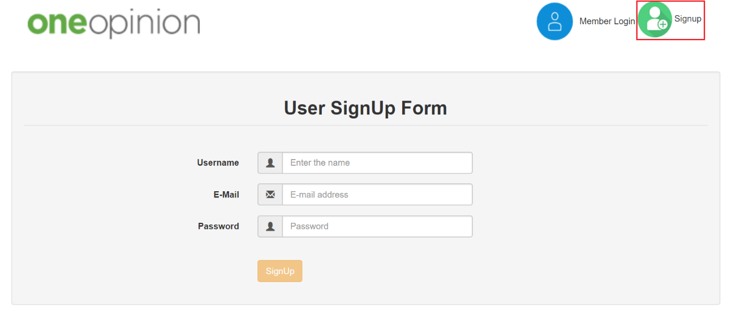

1. Now you can login into website using login page. You can see there are two options in the flowchart. The webpage provides two options to the user, whether he can be a normal user or ADMIN. Both have the different functionalities.

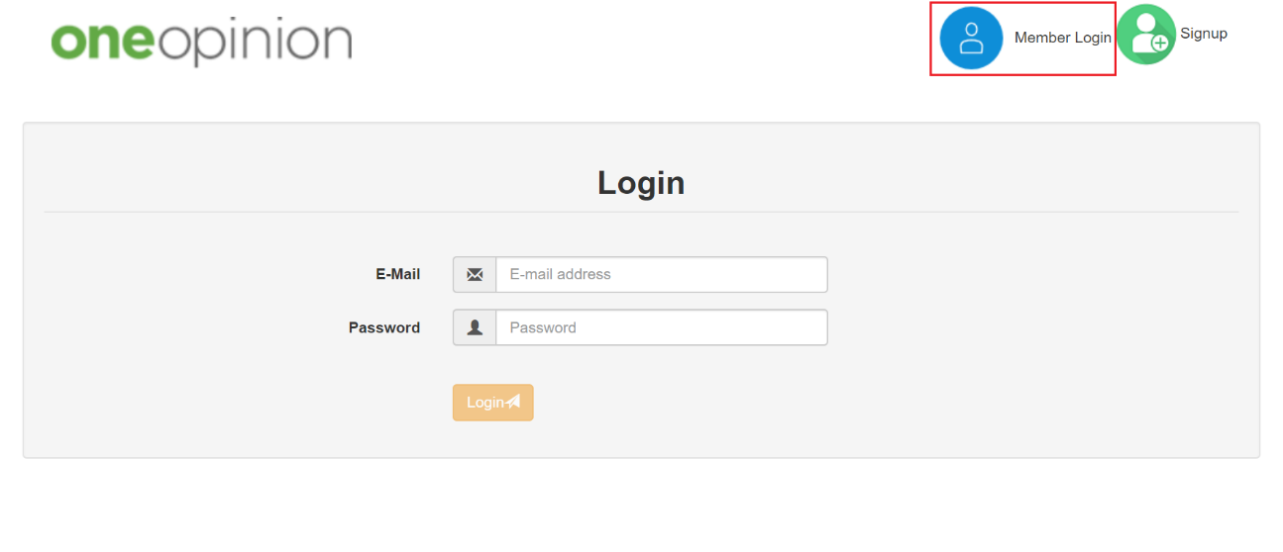

1. **ADMIN: -**
2. As an admin, we can use either “Add a new product” or “See Production Description” option.

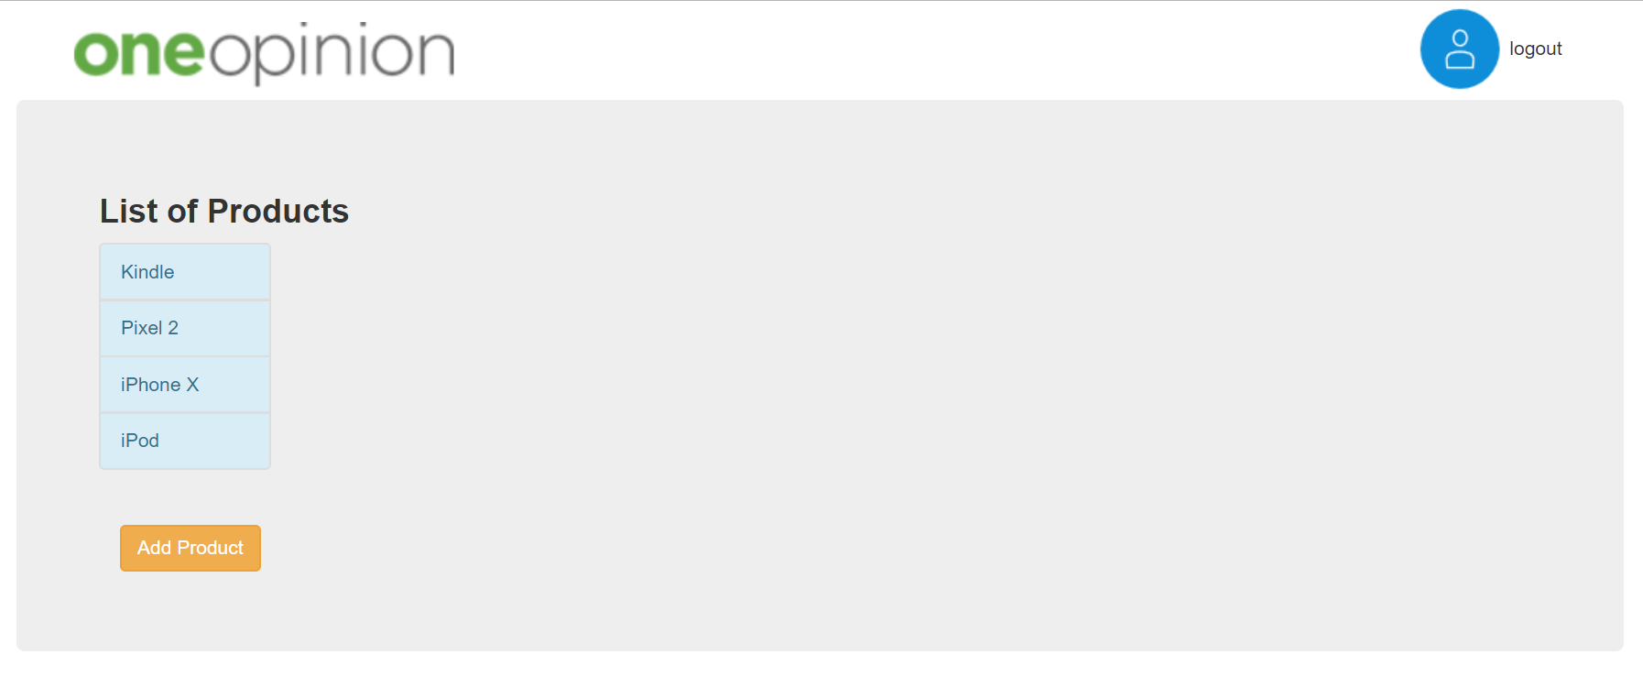

1. If we choose “Add a new product,” then we can fill the details of the new product.

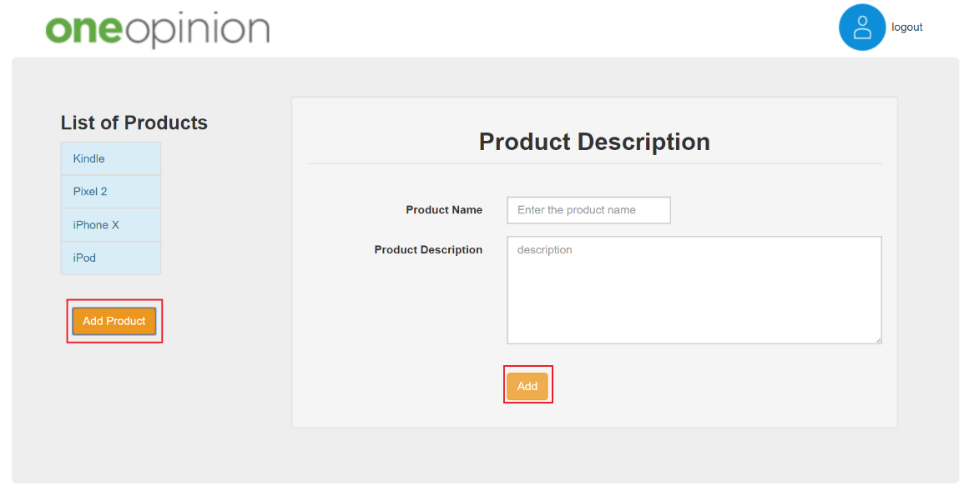

1. If we click on “See Production Description” then we have two options “Create a Survey” or “View Report.”



1. If the user clicks on “Create a Survey,” then he will get three options 🡪

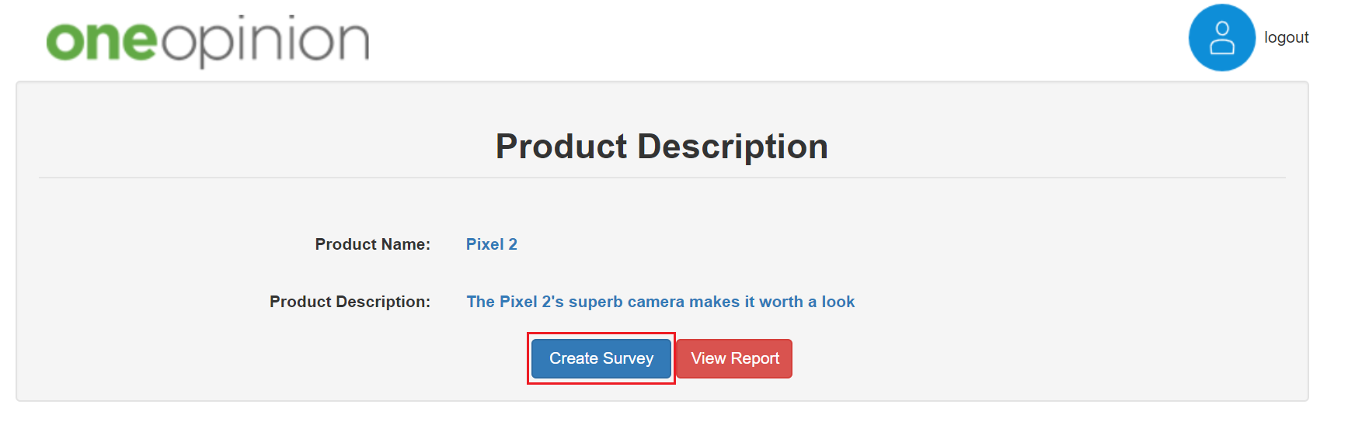

1. Add Questions: - When you choose this option then you will get options to create

questions for that survey.

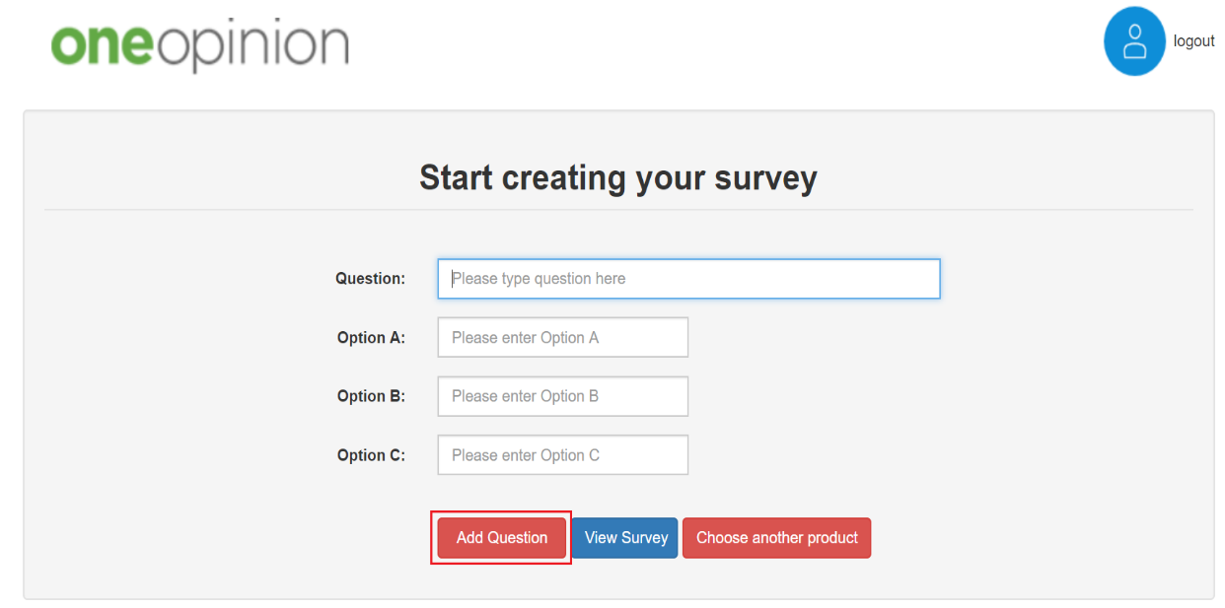

1. Choose another product: - If you want to change the product for a survey then you

can choose this option.

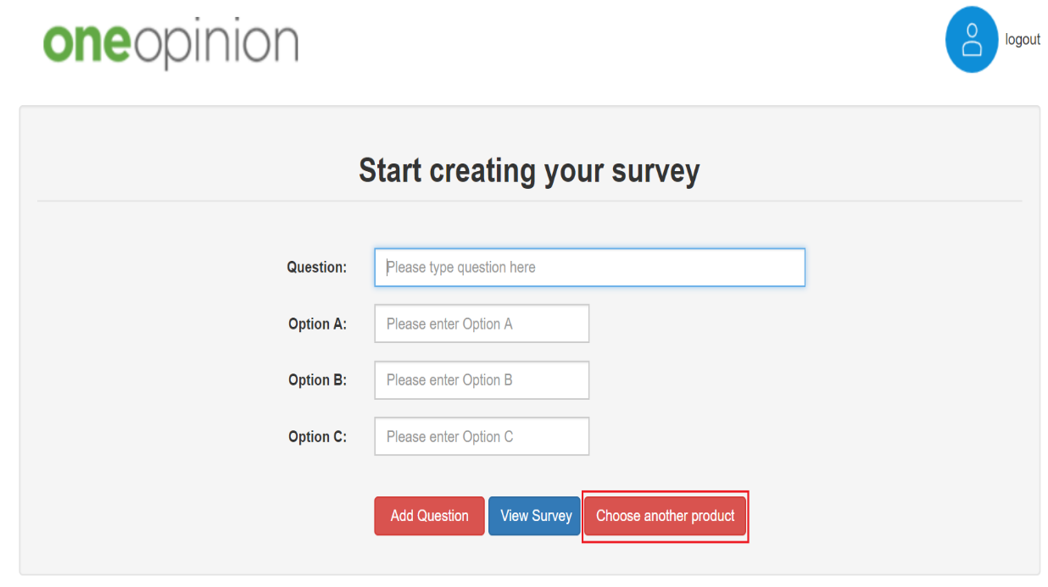

1. View Survey: - If an admin wants to view the existing survey then he/she can use this

option to see the survey.

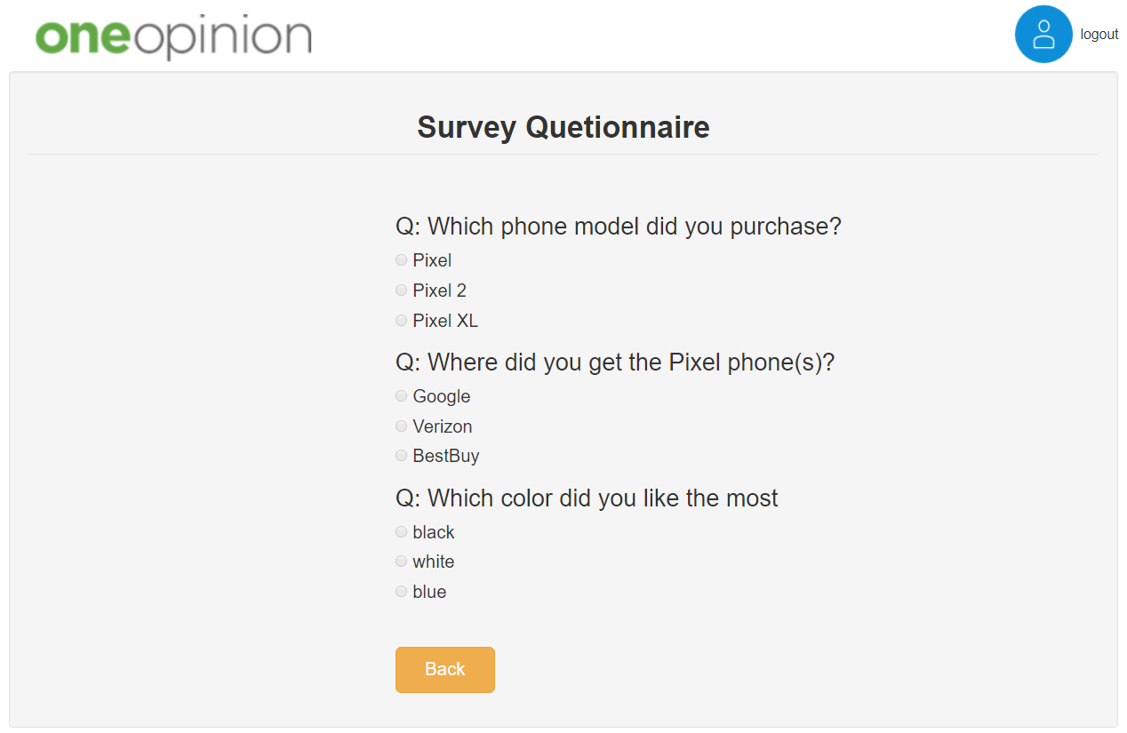

1. If Admin clicks on View Report, then he/she will get an option to render a graph.

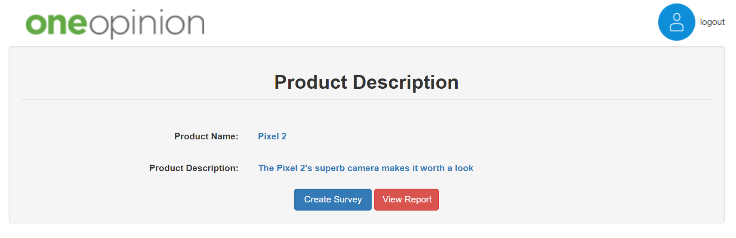

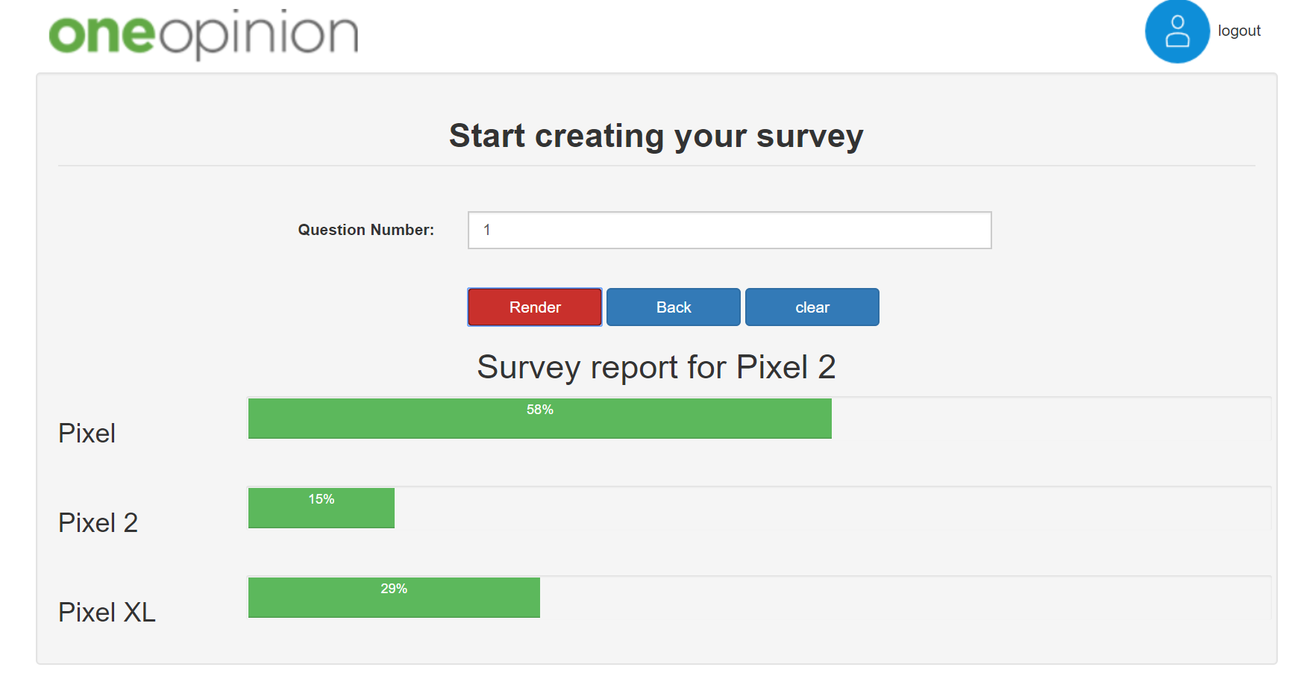

1. **USER: -** As a user, you will get the options in chronological order. As a user when you click on “See Product List” option, then you will see “Product description per specific product” option and here you can see Take the survey for existing report. After completion of the survey, the app will redirect to the EXIT option.

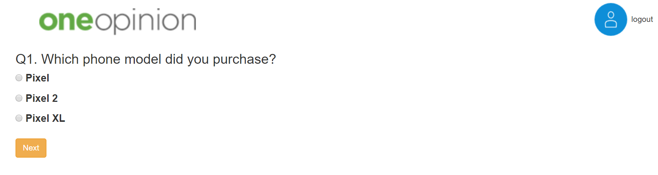

1. To Logout please click on logout and it will take you to main page.

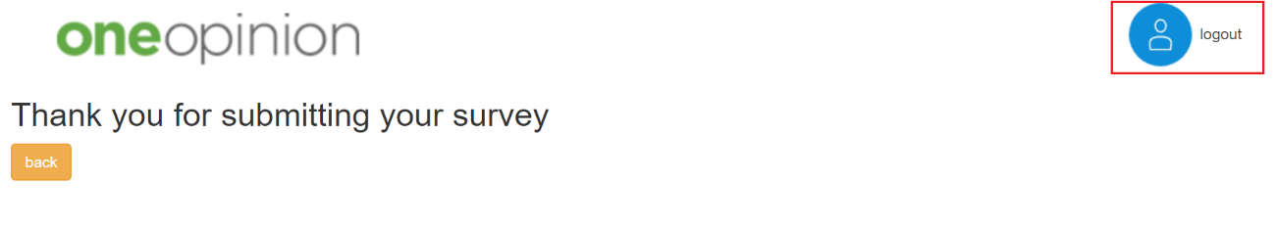

Flow Chart

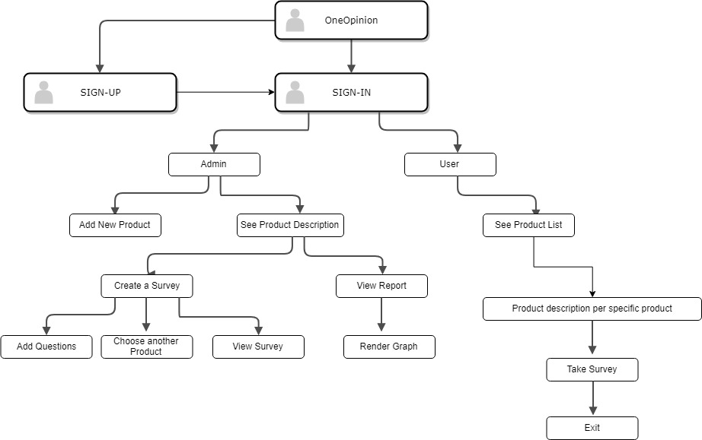

**Flow Chart of the One Opinion App**