Name: Swapnil Ghonge

Lab: ESD_LAB 2

Content: Report

**Things learnt in Lab 2**

Communication of microcontroller with RS-232

Learnt the interfacing for MAX-232 IC with 89C51RC2

Learnt the use of Logic analyzer with the NVRAM.

Learnt Detailed understanding of state and timing modes in Logic Port Software.

Learnt how to write interrupt program in assembly.

Learnt how to configure timer in interrupt mode..

Learnt how to use Flip software to program AT89C51RC2 using RS-232.

**Toughest things to do:**

Debugging the hardware for proper functioning

Interfacing LS374 with the 89C51RC2

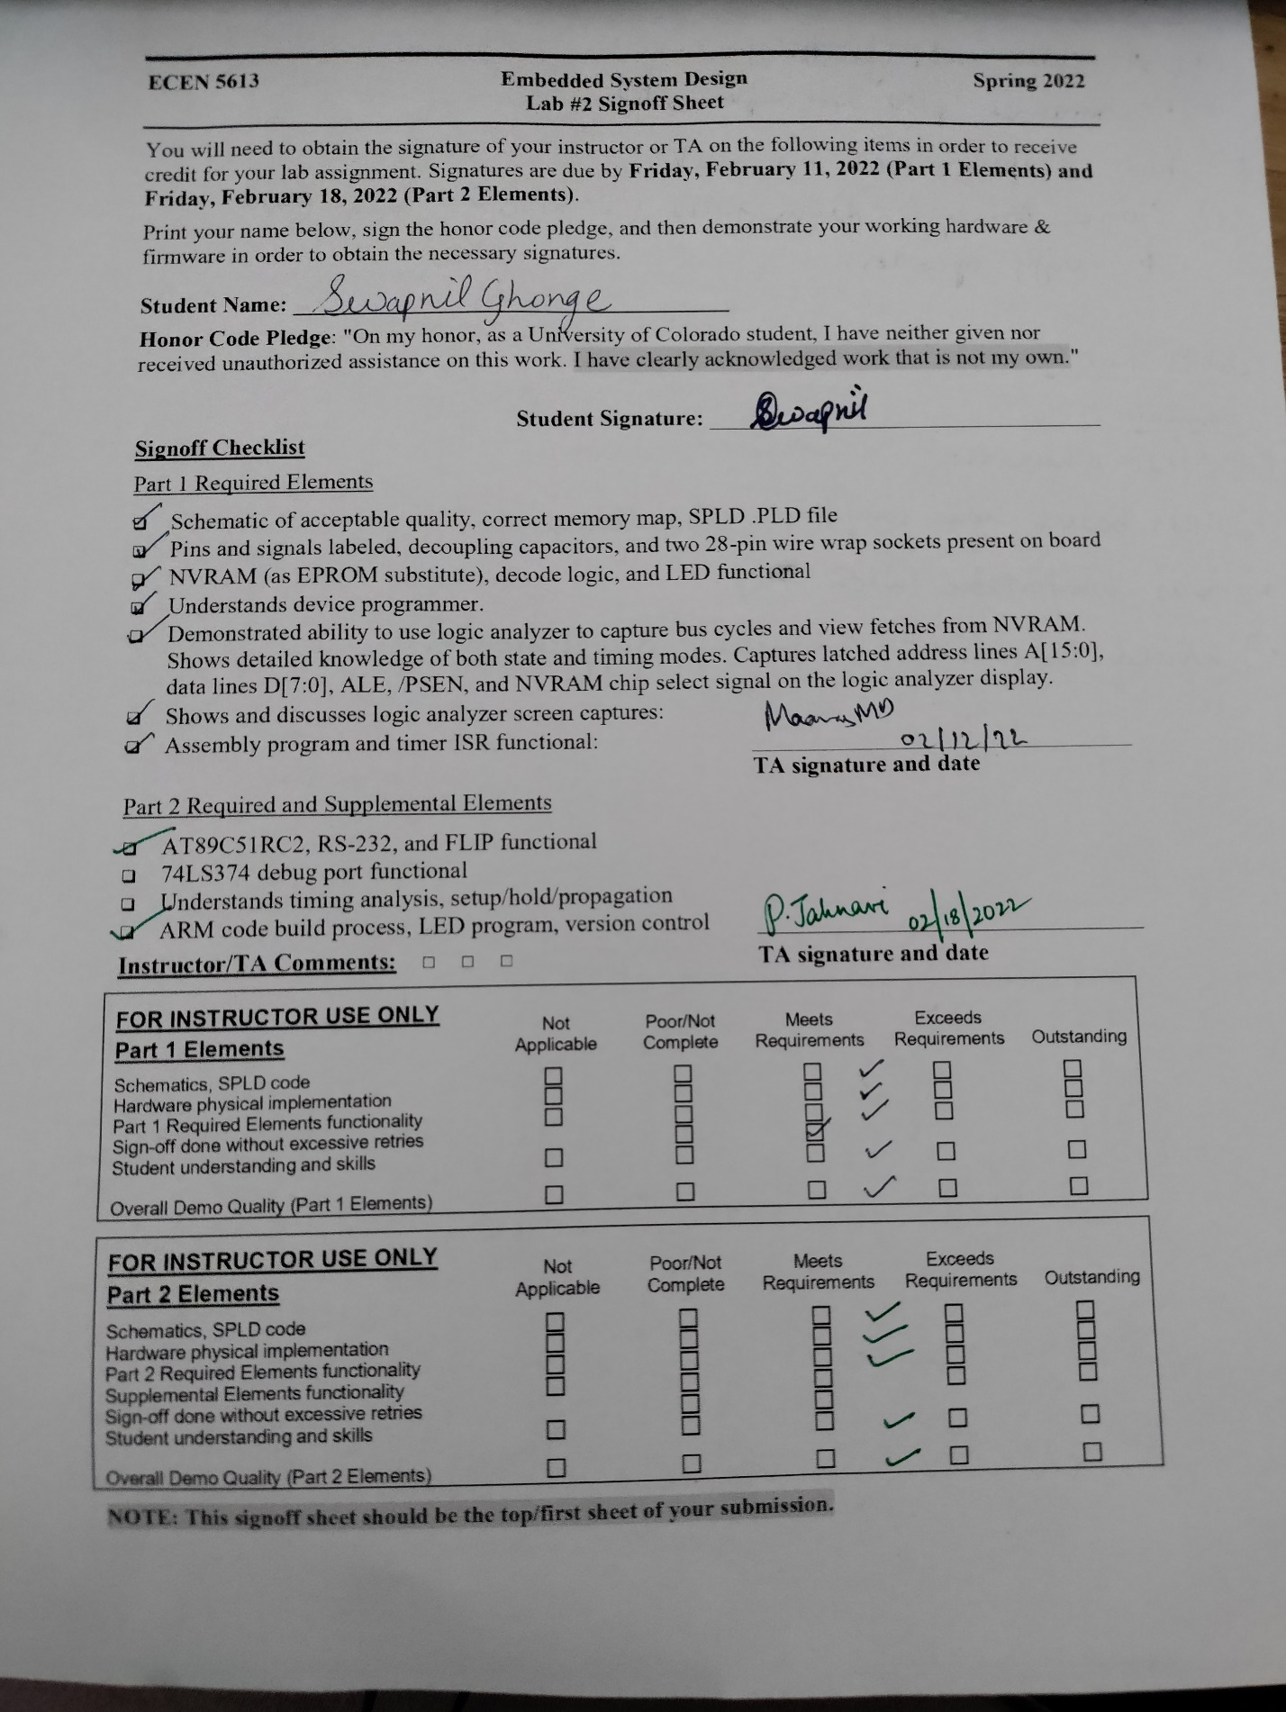

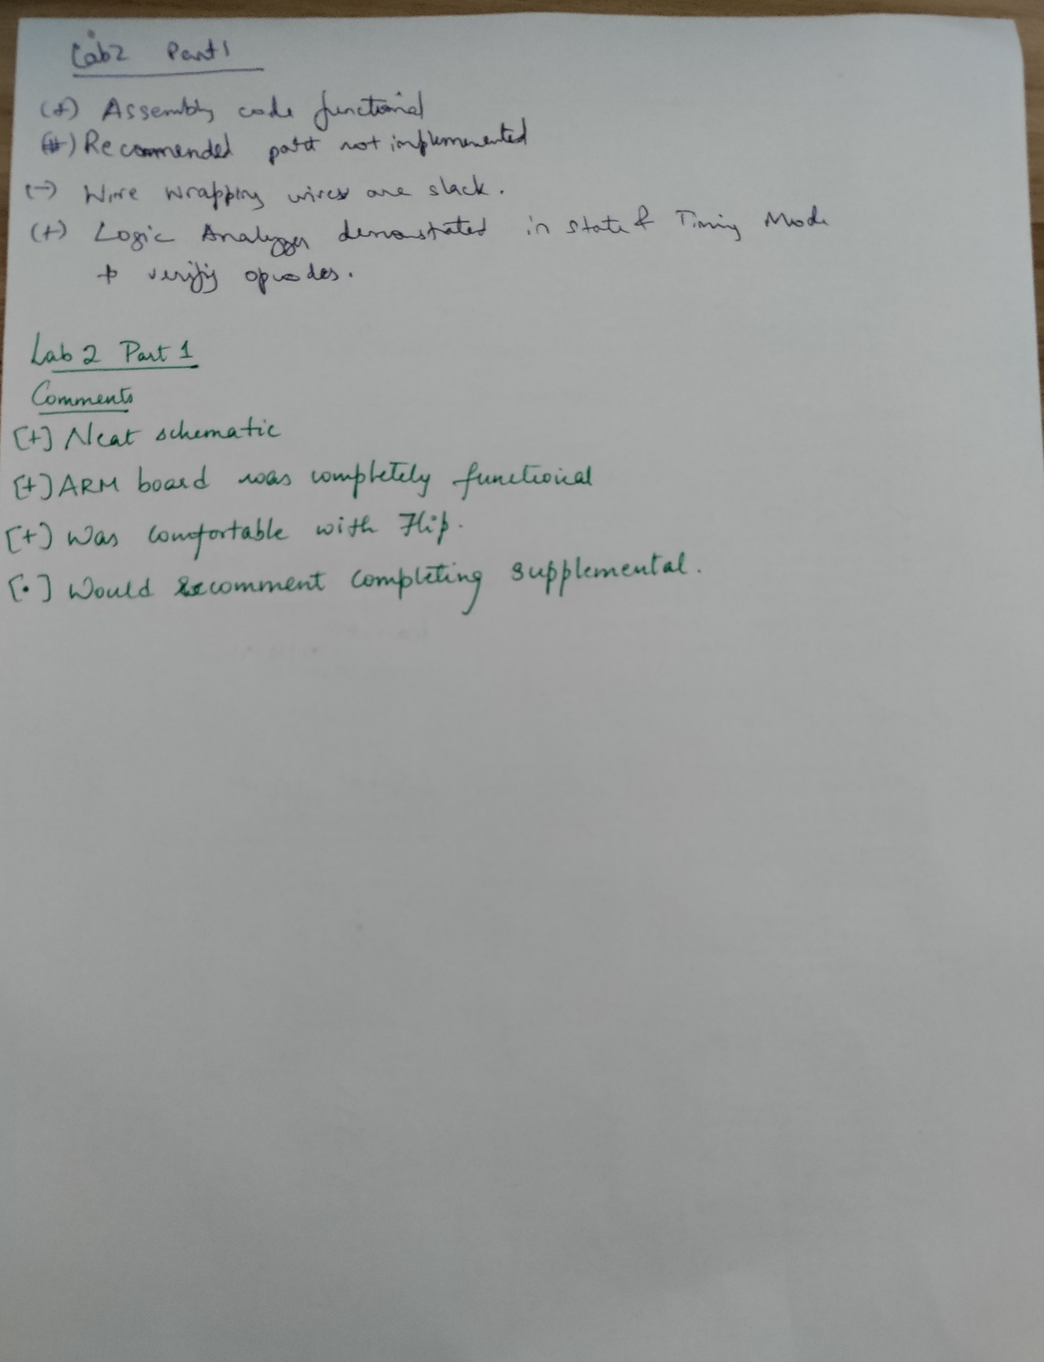

22. **Part 2 Required Element**

Questions

Answer:1 I used Windows Operating System and Keil uVision5 Software to develop 8051 code development.

Answer:2 A51 macro Assembler.

Answer:3 I used Code Composer Studio Version 11.1.0

Answer: 4 I did install Logic port to view timing analysis of data and address and Flip terminal to program my AT89C51RC2 IC.

Answer:5 I did faced problems to configure the Logic port software and connection of the Logic Analyzer. The toughest part to execute was the configuring LS374 latch.

Answer: 6 I think the lab is appropriate to learn the basic stuff about RS-232 communication and memory latch.

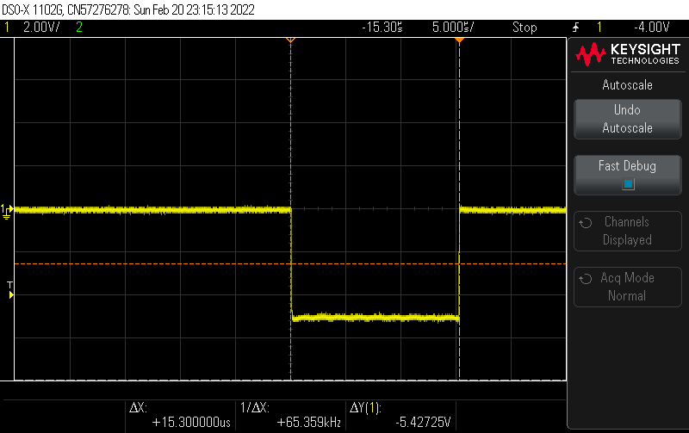

**Time Period of the oscillation**

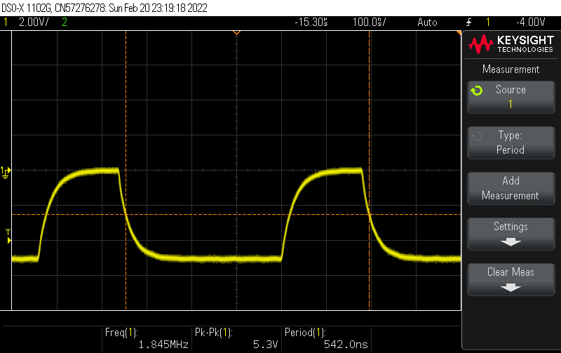

**Frequency at ALE signal**

**ISR Routine Cycles**

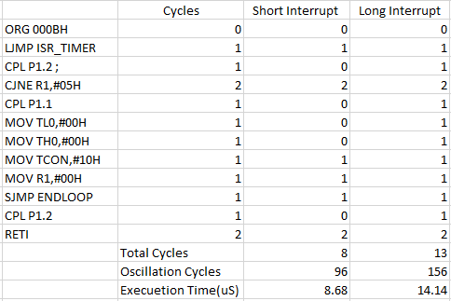

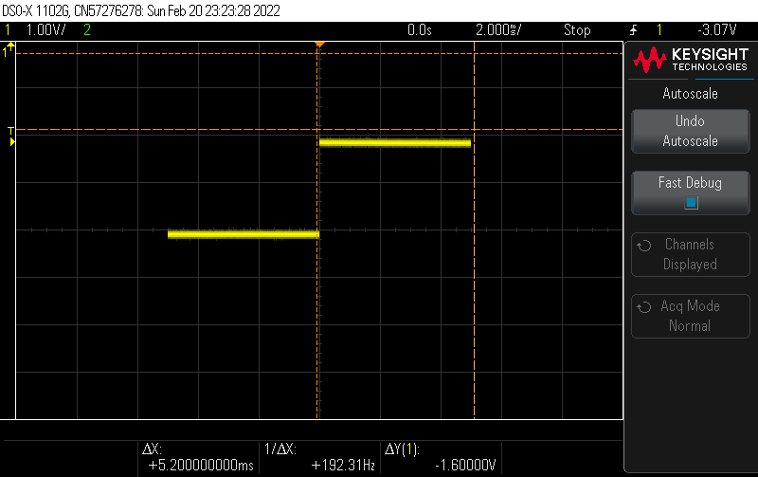

**Voltage level at P1.1 of AT89C51RC2**

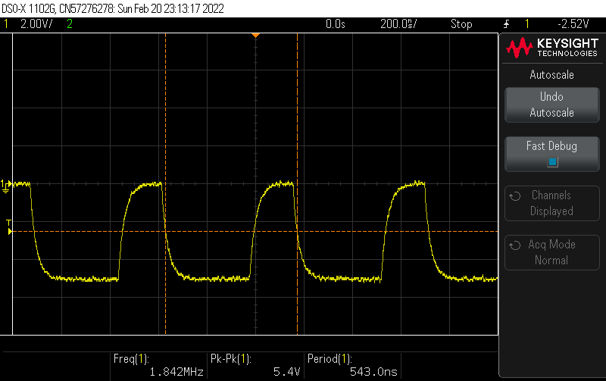

**Signal at EA of 89C51RC2**

**Timing Measurements on Logic Analyzer**

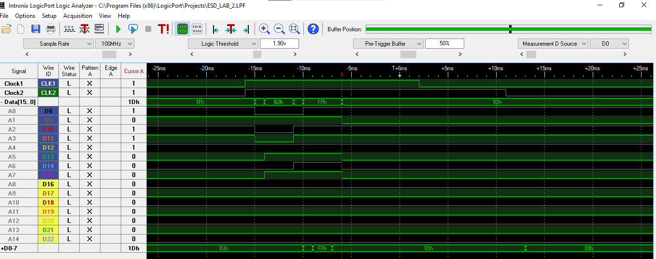

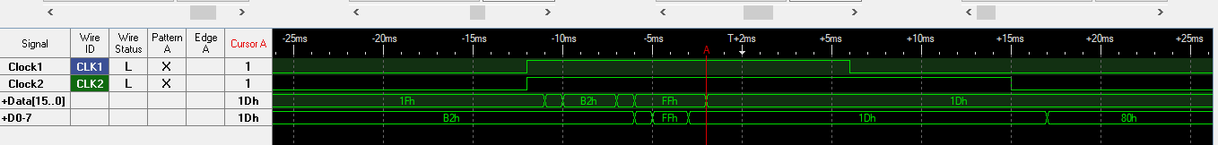

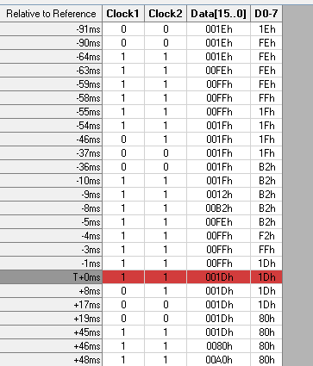

**Time Analysis of Logic Analyzer**

**Clock1: ALE**

**Clock2: PSEN**

**Screenshots of MSP432 Code**

**Toggling of LED’s and with Switch**

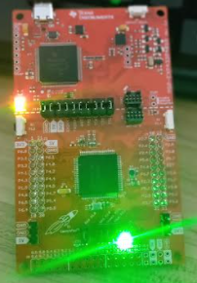

**Green LED during pop-up**

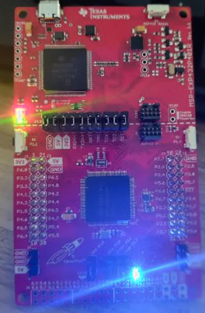

**Blue light is hold when switch is pressed.**