**ESD LAB-3 REPORT**

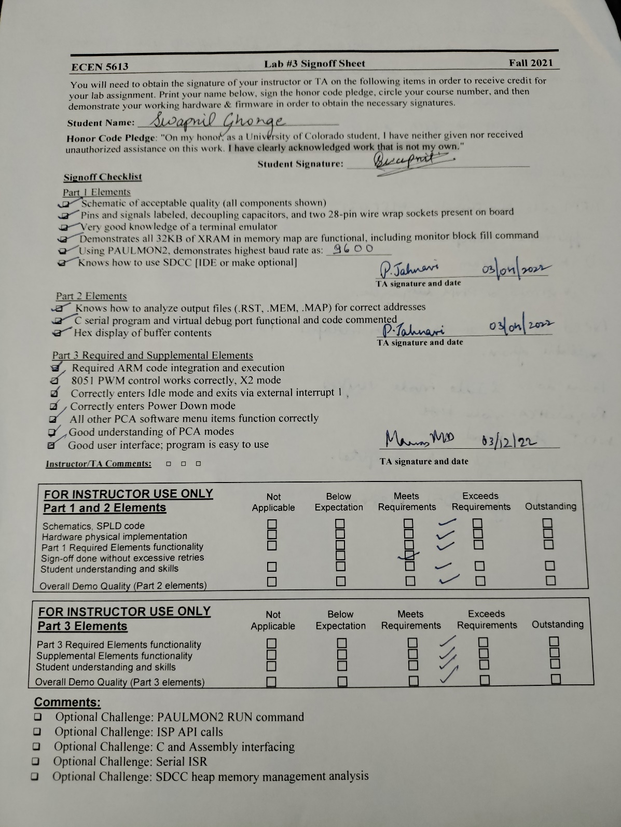

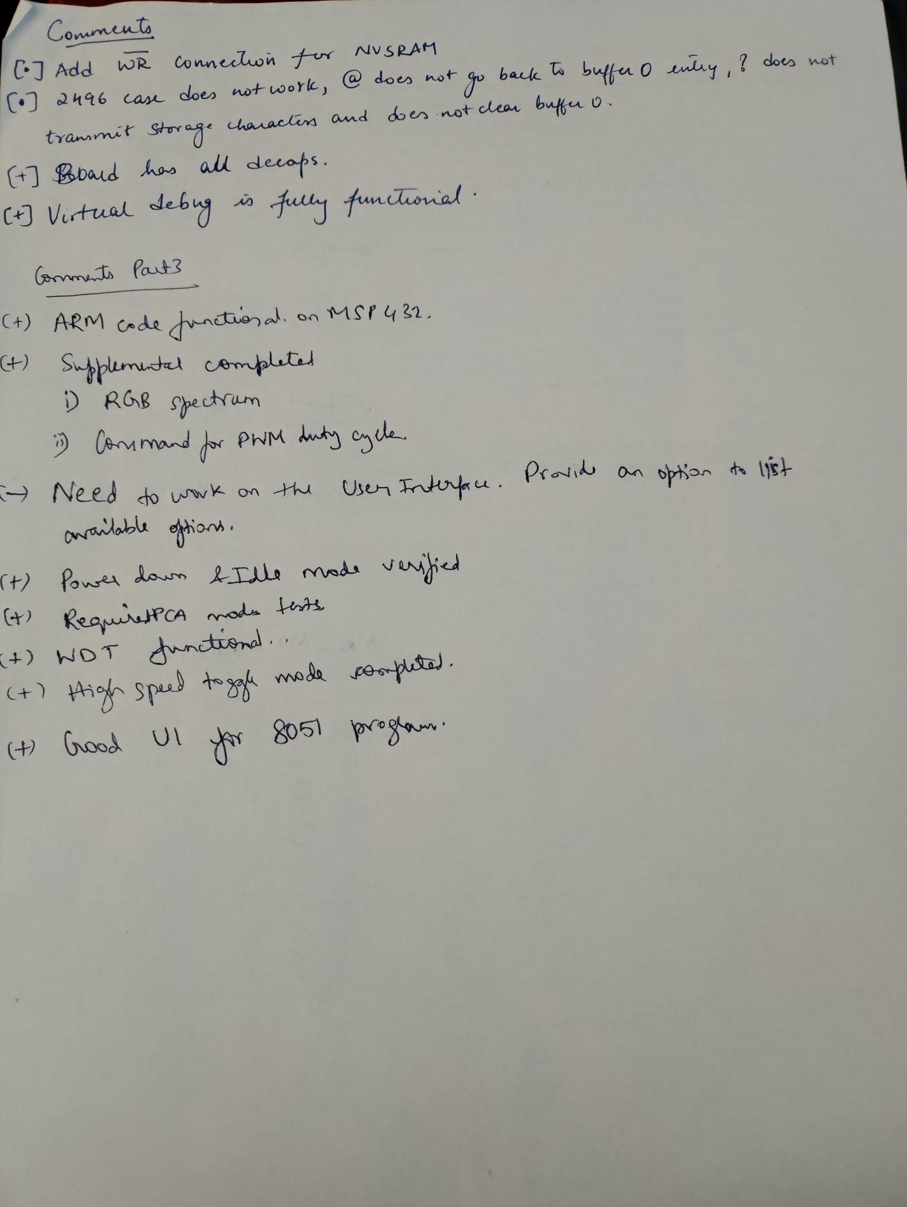

**Part-1 & 2**

Things Learnt:

Learnt how to use internal and external memory management.

Learnt how to use serial drivers for memory

Learnt how to change the values in memory location both for Internal XRAM and external XRAM.

Learnt how to use SDCC for for C compilers

Learnt how to change how to use baud rate on Tera Term.

Learnt how to efficiently use FLIP program to program AT89C51RC2.

Learnt how to allocate memory of Heap Size 5000 bytes using malloc function

Learnt how to use UART to which accepts command a function.

Learnt how to free a buffer.

Learnt how to change a buffer using +,-,@,? UART commands

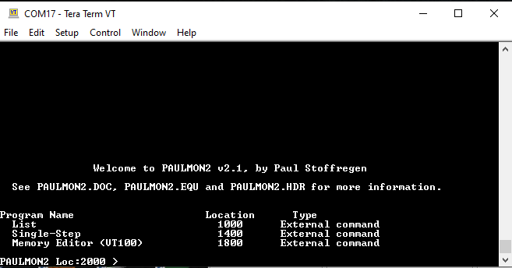

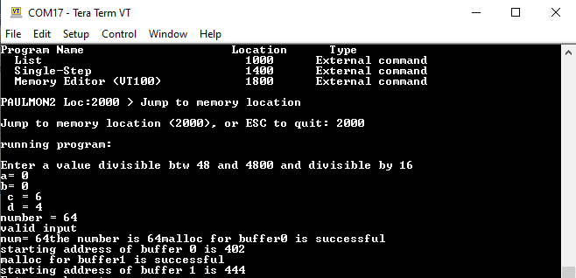

Allocating Buffer of size 64 bytes

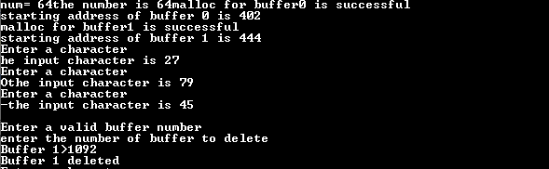

Buffer 1 is deleted by pressing ‘-‘

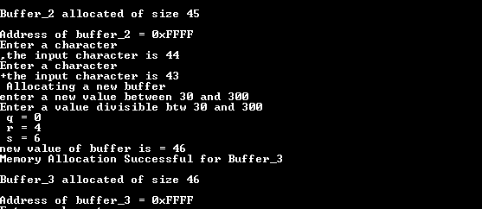

Adding additional buffer of 46 bytes by pressing ‘+’

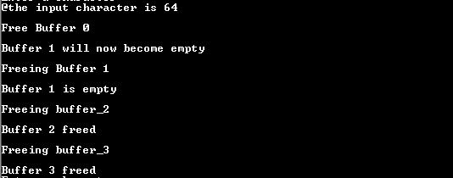

Freeing every buffer created



Buffer is full condition

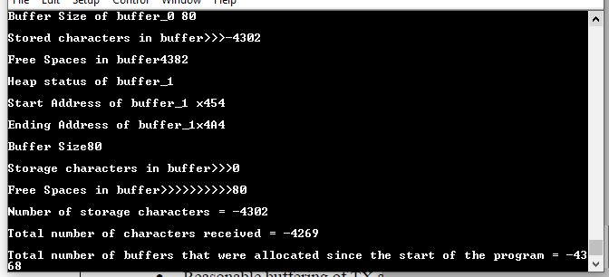

Details for buffer added by pressing ‘?’

**PART-3 Supplemental + Required**

1. **8051 Supplemental**

Things Learnt:

Learnt to configure Programmable Counter Array in 4 modes

Learnt how to set PWM flags

Learnt to stop PWM by setting flags

Learnt to set Maximum and minimum frequency at ALE, PSEN.

Learnt configure Power Down mode, Idle Mode by setting PCON flags

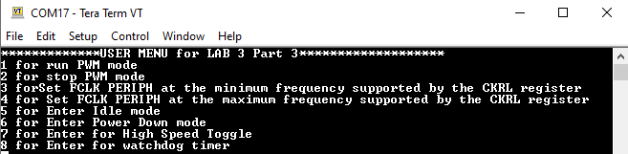

**User menu for Modules in PCA modes**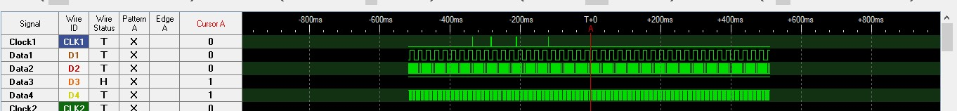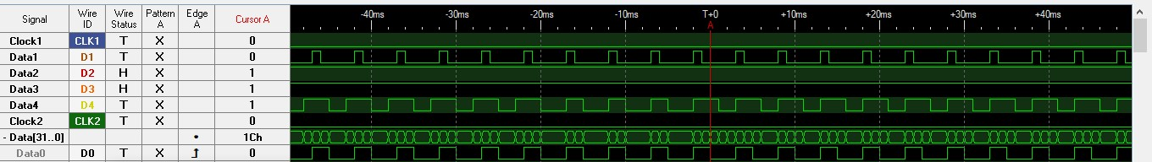

**High Speed Toggle**

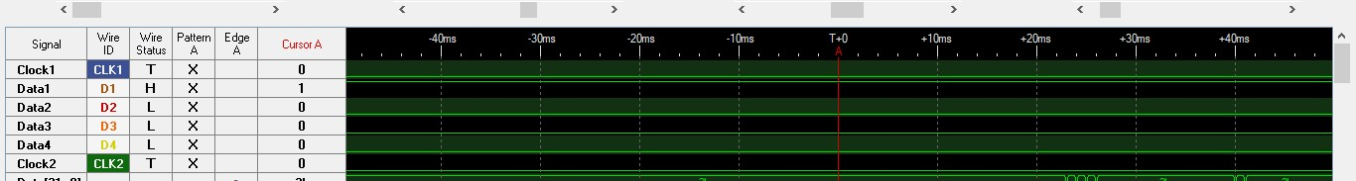

**Entering in Power Down Mode**

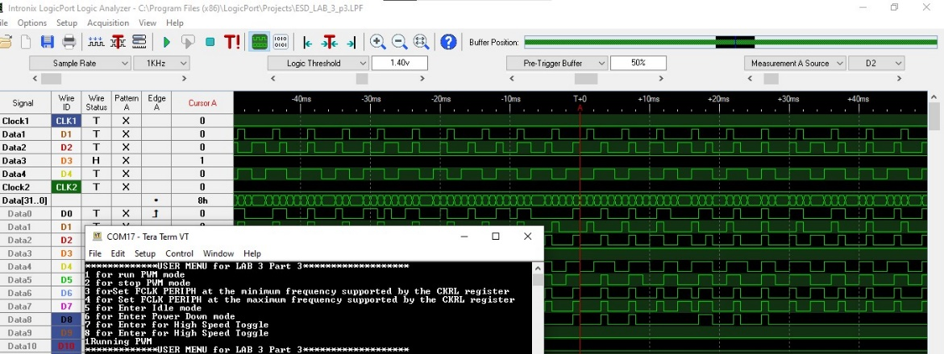

**Duty Cycle 25% at port D2**

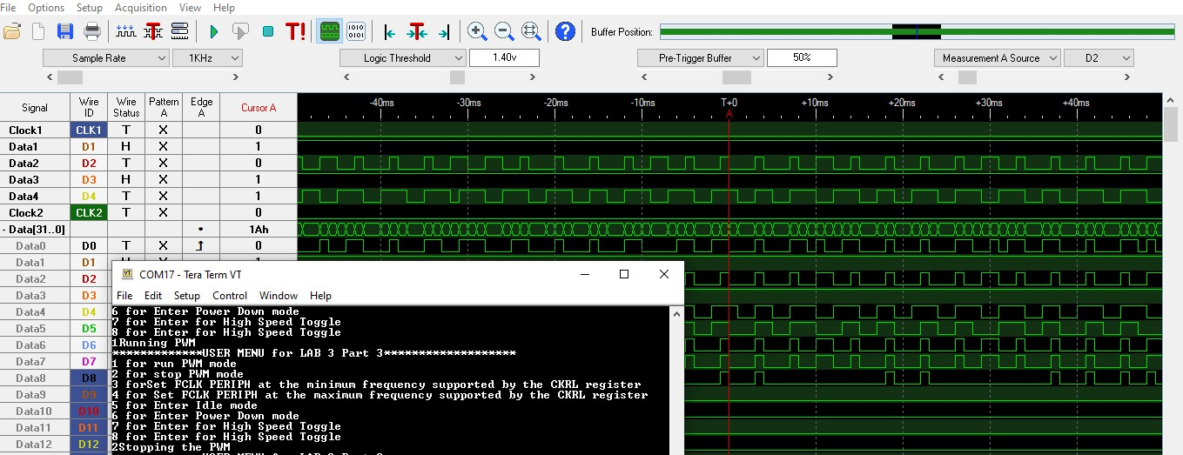

**Stopping PWM**

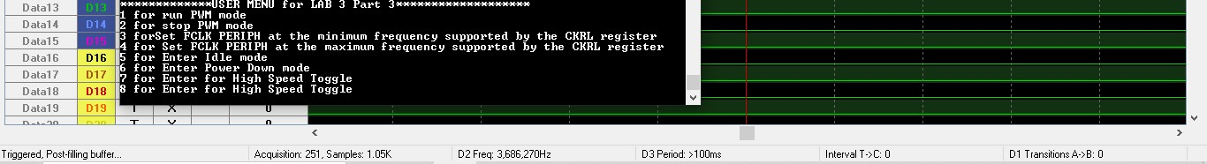

**Entering Maximum Frequency**

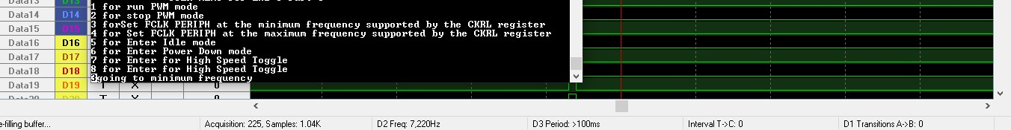

**Entering Minimum Frequency**

1. **MSP432 Required + Supplemental**

Learnt how to use ADC in temperature Flags

Learnt how to set PWM from examples.

Learnt how to Port mapping

Duty Cycle:

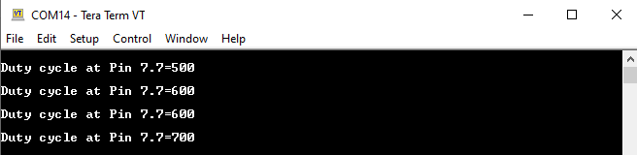

Temperature Values:

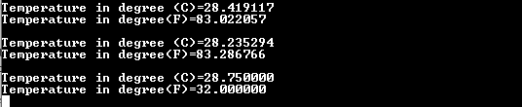

Period changing:

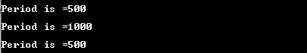

Spectrum:

