TESTING of Smart Health Monitoring System

TEST-1 Calibration of Acceleration

To calibrate the board, FRDM-KL25Z is kept on flat surface. The values of the calibration is printed on the Console.

Firstly the values of 50 values x, y, z are taken and average values are printed.

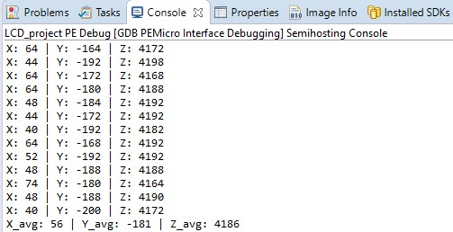

TEST-1 LCD Test

Following are messages are printed to test the display of the LCD.

Screen1:

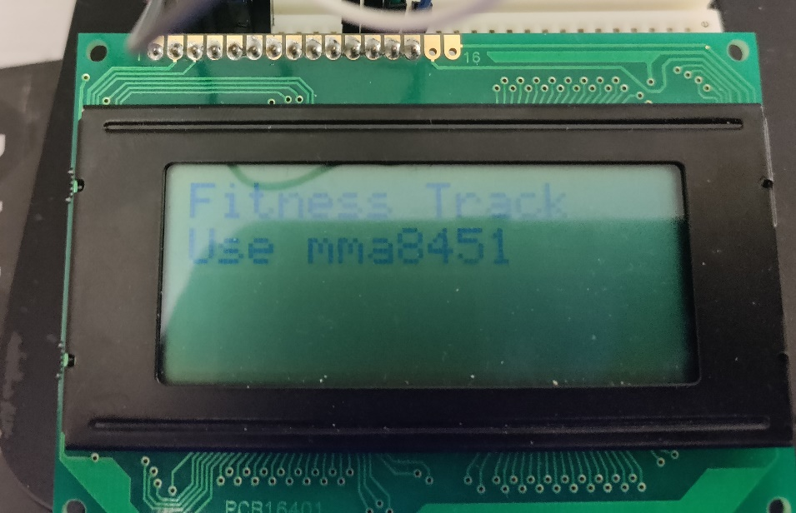

Screen:2

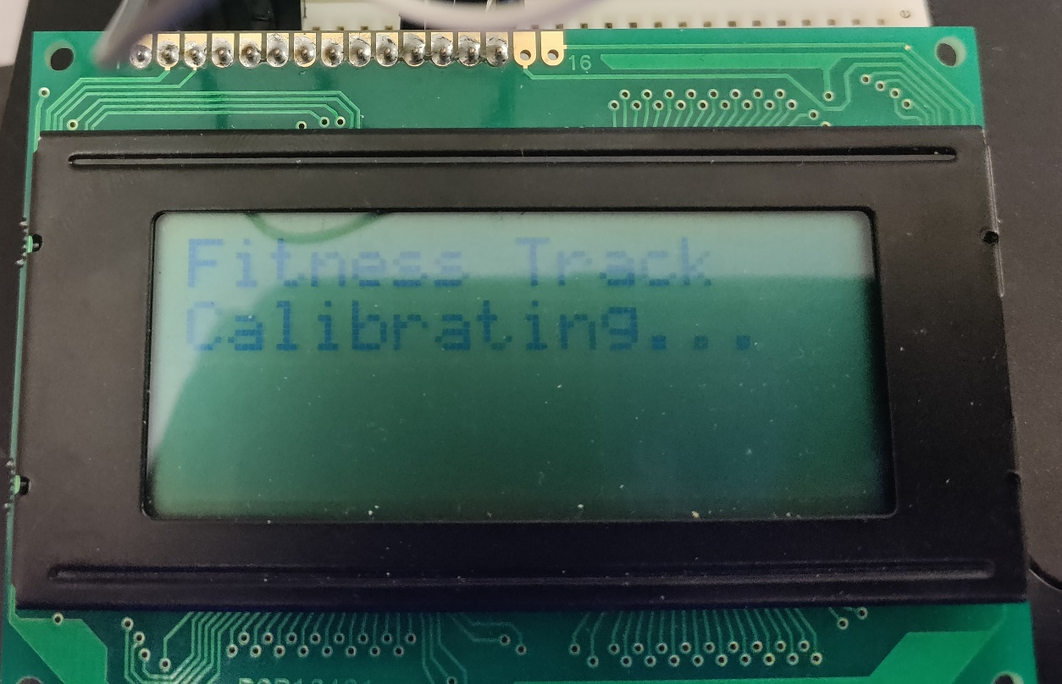

Screen:3

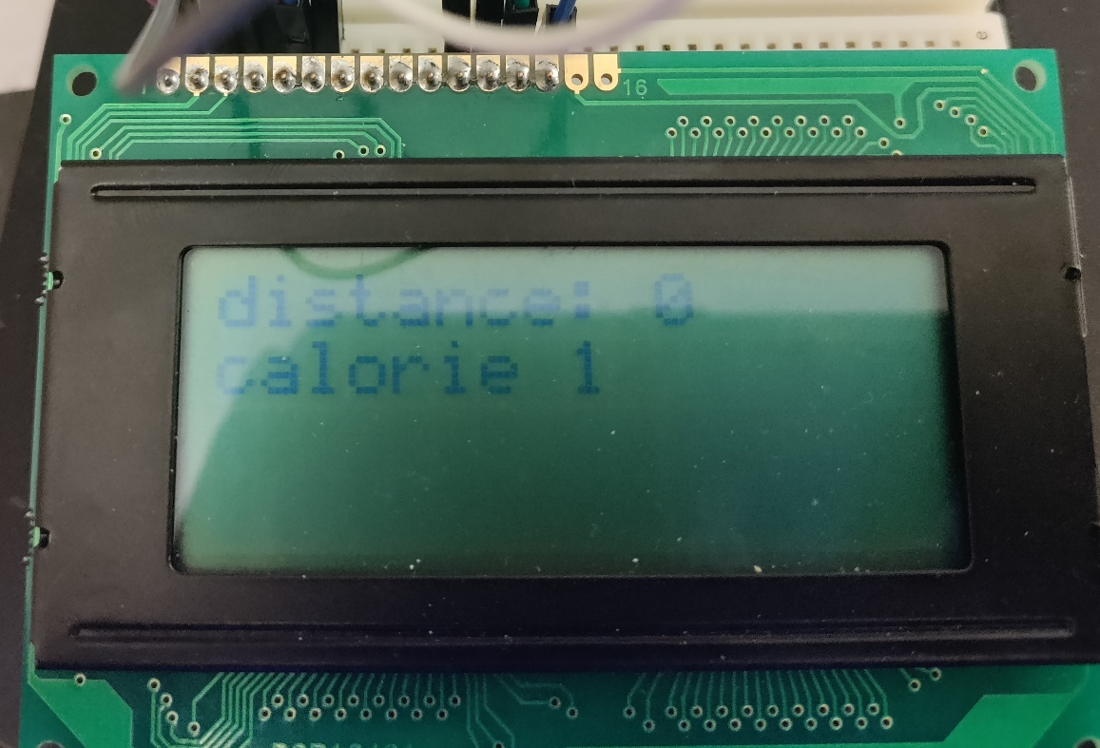

Distance Test:

As soon as the device is attached to the person whose fitness is to be tracked, whenever the acceleration value is greater then some threshold the distance is increased by a factor of 0.41( Data assumed for Standard Men and Women)

The calorie value increments by a factor of 0.5 for every 1meter distance.

