MICROPROJECT GROUP ACTIVITY
STAGE 2 — REPORT II / REVIEW II
Rubric alignment: Individual Contribution to Validation (implementation / analytics); Group Validation Outcome.
Text in square brackets marks items that only the group can supply or confirm (dates, screenshots, signatures, who did what). Replace each with actual work and delete the brackets. Results in Section 5 come from a command-line test driver built on the project's backend.c (see Appendix D); re-run them on the Windows build and attach the web-interface screenshots before submission.

A. Group and Project Information
Institute / Department: Mahavir Education Trust's Shah & Anchor Kutchhi Engineering College / Artificial Intelligence & Data Science
Programme / Branch / Class / Semester: Artificial Intelligence & Data Science / SY AIDS
Course / Subject and Course Code: Data Structures & Complexity Analysis
Academic Year: 2026–27
Microproject Title: Plagiarism Detection Engine using Binary Search Trees
Group Number: ______________
Faculty Mentor / Guide: Bhagyashree Patil
Date of Project Allocation: ____ / ____ / ________
Stage 1 Submission Date: ____ / ____ / ________
Stage 2 Submission Date: ____ / ____ / ________
Stage 3 Submission Date: ____ / ____ / ________

B. Group Members and Responsibilities
Sr. No. | Student Name | Roll No. | Assigned Role / Responsibility | Specific Deliverables
1 | Jaydeep H. Labor | 29 | Coordinator & Methodology Lead | Stage 1: problem statement, objectives, workflow. Stage 2: BST insertion and similarity-search code; BST, skewed-tree and timing tests (T3, T4, T10, T11)
2 | Swapnil Kesare | 24 | Research Lead (Data Structures) | Stage 1: Array and BST analysis, feasibility. Stage 2: file input, tokenising and text extraction; tests T1, T2
3 | Aditya Kharat | 27 | Literature Survey & Architecture Lead | Stage 1: background study, flowchart, BST insertion logic. Stage 2: report generation, scoring and verdict; tests T5–T9, T12

Each student must make a demonstrable contribution. Actual Stage 2 work is recorded in Section 3.

C. Overall Microproject Brief
Brief description of the project (150–250 words):
The microproject applies Data Structures and Complexity Analysis to automated plagiarism detection. A document (TXT, DOCX or PDF, or pasted text) is converted to text and tokenised into a sequential array of words and a sentence array. Common grammatical words are flagged as stopwords, and the remaining distinctive words are stored in a Binary Search Tree (BST) with their frequencies. Each of eight built-in reference sources is then compared with the document in two ways: every distinctive reference word is looked up in the BST, and a sliding window finds runs of three to ten identical consecutive words. The results are combined into an overall similarity percentage and a verdict from No Match to Very High Similarity, shown on a local web page together with the matching passages, the excluded common words and BST metrics (node count and height). The program is written in C and a small built-in HTTP server provides the interface. This replaces manual checking and brute-force comparison, which cost O(N × M), with indexed lookup that costs O(log N) per search in a reasonably balanced tree.
Domain / application area:
Data structures and text plagiarism detection.
Intended users / stakeholders:
Evaluators and faculty checking student submissions.
Main problem or need addressed:
Manual plagiarism checking and standard line-by-line text comparisons are extremely slow and inefficient when scanning large documents.
Expected deliverable:
A working software-based text comparison tool in C, with test results and screenshot evidence.
Tools / technologies used:
C (C11), GCC (MinGW-w64), VS Code, Windows, Git, miniz library (ZIP / zlib decompression).

STAGE 2 — REPORT II / REVIEW II

1. Reference to Stage 1 Plan
1.1 Restate the selected problem and objectives briefly:
Problem: manual plagiarism checking and line-by-line text comparison are extremely slow on large documents. Searching, inserting and evaluating text records need an organised data structure so that submissions can be compared quickly.
Stage 1 objectives and success criteria:
- O1 – Identify suitable data structures and design an appropriate algorithm (success: Arrays and BST implemented; CO5).
- O2 – Develop an efficient computational solution (success: a final percentage similarity score is output; CO6).
- O3 – Analyse time and space complexity (success: expected search / insertion time O(log N); CO4).

1.2 Which Stage 1 methodology steps have been completed?
All five planned steps now have working code: (1) file input, (2) preprocessing / tokenising with Arrays, (3) BST insertion, (4) similarity check by searching the BST, (5) report generation with a percentage score. Stage 1 itself covered the problem definition, the literature review (manual checking, linear array search, hash tables), the selection of Arrays and BST, the group meeting record (Week 2) and the plan.
1.3 What changes were made after the Stage 1 review, and why?
No faculty-required changes are recorded for Stage 1. The implementation differs from the Stage 1 plan in the following ways, and the group records them openly:
Stage 1 plan | What was implemented | Reason / note
Reference text supplied as a file and inserted into the BST | Eight reference sources are built into the program; the BST holds the unique distinctive words (with frequency) of the document being checked | Keeps the program self-contained, so one document can be checked without preparing a separate reference file
Text input only (plain text files) | TXT, DOCX and PDF upload, or pasted text, using miniz for ZIP / deflate | Evaluators receive documents in these formats
Out of scope: graphical or web interface | A local web interface served by a C HTTP server (Winsock) | Scope extension; easier to demonstrate
Similarity from matched tokens | Common-word (stopword) filtering added; exact-phrase and lexical scores combined | Unrelated documents share common words and would score falsely high
Algorithms: insertion, deletion, searching, sorting, traversals | Insertion, search, node count, height and free are implemented; deletion and traversals are not | Not yet implemented; to be implemented in Stage 3 or removed from the scope with the mentor's approval
Implementation language | C (C11), as stated in the Stage 1 template report (an earlier summary of Stage 1 mentioned Java) | Keep all documents consistent: C

1.4 Current status against the project timeline:
Stage 1 plan: Weeks 5–7 algorithm design and coding; Week 8 testing and debugging. Status: the prototype builds and runs with all five steps working; backend tests T1–T11 have been run (Section 5); web-interface test T12 and the screenshots are pending.

2. Implementation / Analytical Method
2.1 Describe what was built, simulated, modelled, observed or analysed:
A Plagiarism Detection Engine of about 2,300 lines of C, organised as follows:
- backend/backend.c – Token and Sentence Arrays, BST, stopword list, TXT / DOCX / PDF text extraction, reference corpus and the analysis routine backend_analyze().
- backend/miniz.c – ZIP and deflate decompression used for DOCX and PDF.
- frontend/frontend.c – native HTTP server on 127.0.0.1:8080 that serves the upload page and the report page.
- main.c, Makefile, build.bat – start-up and one-step Windows build.

2.2 Explain the architecture / design / algorithm / process in detail:
The flow follows the Stage 1 pattern Input → Data Processing → Data Structure → Operations → Output (Figure 1).
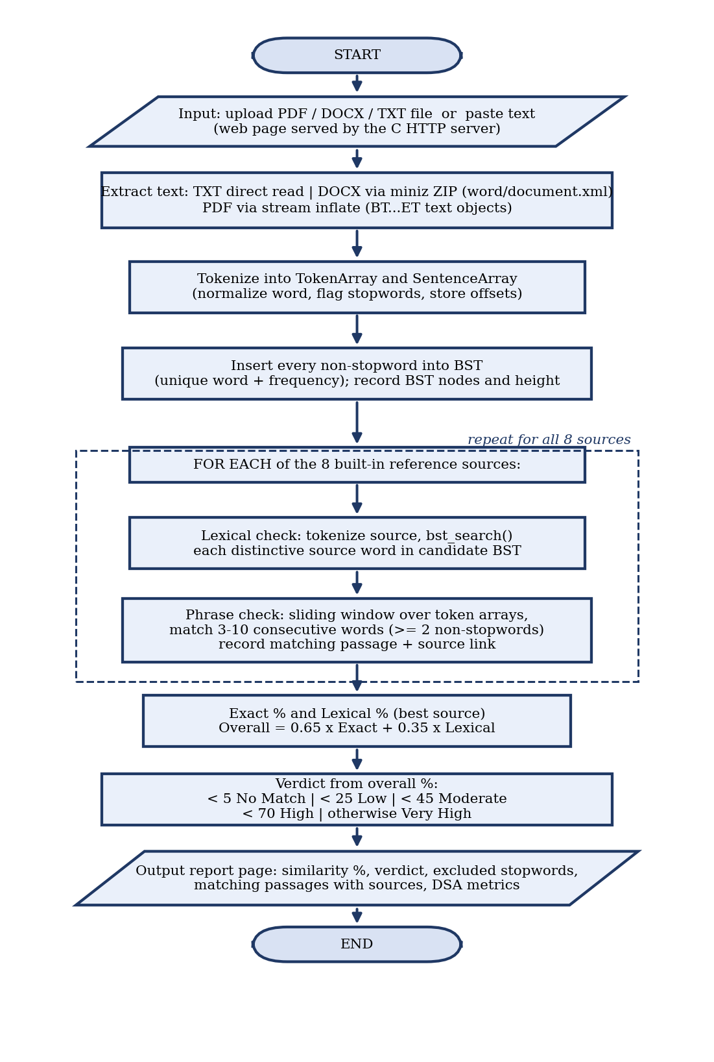
Figure 1: Flowchart of the implemented Plagiarism Detection Engine.
Data structures:
- TokenArray – resizable array of Token records (original word, normalised word, start / end character offset, sentence index, stopword flag). SentenceArray – resizable array of sentence spans.
- BSTNode – word (unique, normalised), frequency, left and right pointers. Duplicate words increase the frequency instead of adding a node.

Scoring:
- Exact similarity – the larger of (a) the share of the document's distinctive words that fall inside matched phrases and (b) the best per-source phrase-match ratio.
- Lexical similarity – the best per-source share of distinctive reference words that are found in the document's BST.
- Overall = 0.65 × exact + 0.35 × lexical when any phrase matches; if there is no phrase match and lexical ≥ 25%, overall = 0.5 × lexical; otherwise 0.
- Verdict: below 5 No Match; below 25 Low; below 45 Moderate; below 70 High; otherwise Very High Similarity.

Core BST operations (from backend.c):
BSTNode* bst_insert(BSTNode *root, const char *word); // lexicographic insert; frequency++ if present
const BSTNode* bst_search(const BSTNode *root, const char *word);
int bst_count_nodes(const BSTNode *root); // unique vocabulary size
int bst_height(const BSTNode *root); // depth, used to judge balance
void bst_free(BSTNode *root); // post-order deallocation

Complexity (V = distinct words in the document, T = document tokens, R = tokens in one reference source, L = characters):
Operation | Average / balanced | Worst case | Space
Tokenisation into arrays | O(L) | O(L) | O(L)
BST insert / search | O(log V) | O(V) (skewed tree) | O(V) tree; O(1) auxiliary
Lexical check, one source | O(R log V) | O(R × V) | O(1) extra
Phrase check, one source (sliding window on arrays, window ≤ 10) | O(T × R) | O(10 × T × R) | O(T) match mask
Baseline: linear array lookup | O(V) per lookup | O(V) per lookup | O(V)

The BST accelerates the vocabulary lookups; the phrase search compares the token arrays sequentially and does not use the BST.
2.3 Hardware, software, libraries, platforms, materials or datasets used:
Software: C11, GCC (MinGW-w64), miniz, Winsock2 and WinINet (Windows), VS Code, Git, a web browser. Build: build.bat or mingw32-make.
Hardware: Intel Core i3 or higher, 4 GB RAM, 500 MB storage (Stage 1 requirement).
Dataset: the eight built-in reference sources (Wikipedia: Data Structure; GeeksforGeeks: Binary Search Tree; Britannica: Plagiarism; and five further entries), plus the test inputs listed in Section 4.
2.4 Data collection, preparation and processing steps:
- Text extraction: TXT read directly; DOCX unzipped and the w:t text runs read from word/document.xml; PDF text objects read from decompressed streams.
- Normalisation: lower-case alphanumeric words; sentences split on . ! ? and line breaks.
- Stopword filter: about 170 common English words are kept for display but excluded from the BST and from phrase matching.

2.5 Procedure another student could follow to reproduce the work:
1. Install GCC (MinGW-w64) on Windows and open the plagiarism_detector folder.
2. Build: run build.bat (or mingw32-make).
3. Start: run plagiarism_detector.exe; the console prints "Server started successfully" and the address.
4. Open http://127.0.0.1:8080 in a browser.
5. Upload a PDF, DOCX or TXT file, or paste text, and read the similarity percentage, verdict and matches.

2.6 Safety, privacy, ethical, permission or data-handling considerations:
The server listens on the local loopback address only and documents are processed in memory on the user's machine. A URL-safety check (is_safe_public_url) and a web-page fetch function exist in the backend but the analysis routine does not call them, so no document or text is sent over the internet. The score shows overlap with the built-in sources and is not a final judgement of plagiarism; a human must review the matches.

3. Individual Contribution to Validation
Planned owners are taken from the Stage 1 methodology table (Section 8 of Stage 1).
Member name | Task completed | Method / tool used | Evidence ID / appendix | Finding / output
Jaydeep H. Labor | BST insertion and similarity search (bst_insert, bst_search, matching) | C, BST; test driver T3, T4, T10, T11 | Appendix D; Fig. A11 | BST gave correct counts and frequencies; sorted input made height equal N; at N = 16000 BST took 0.549 ms vs 99.336 ms for linear search
Swapnil Kesare | File input and tokenising into arrays; text extraction | C file I/O, arrays, miniz; tests T1, T2 | Appendix D; Fig. A3, A4 | TXT and DOCX text extracted correctly; tokens and stopword flags correct; PDF limited to simple PDFs
Aditya Kharat | Report generation, scoring and verdict; flowchart | C scoring logic; tests T5–T9, T12 | Fig. 1; Fig. A5–A9, A12 | Copy scored 100%, partial copy 66.53%, unrelated text 0%; empty and common-word-only input gave No Match

4. Test Plan / Analytical Validation Plan
Test ID | Feature / question tested | Input / scenario / dataset | Expected outcome / metric | Pass criterion
T1 | Document extraction | One TXT, one DOCX and one PDF file | Readable text returned for each | Text matches the file content
T2 | Tokenising and stopword flag | "Data, Structures; DATA structures! The tree." | 6 tokens: data structures data structures the tree; "the" flagged | Tokens and flag as expected
T3 | BST insertion | 10 insertions of 7 distinct words (apple ×3, mango ×2) | 7 nodes; frequencies 3 and 2; small height | Counts match hand count
T4 | BST search | One stored word, one absent word | Found / not found | Both correct
T5 | Verbatim copy of a reference passage | Full text of one reference source | Very High similarity | Overall ≥ 70%
T6 | Unrelated text | Cake recipe paragraph | No Match | Overall < 5%, no matches
T7 | Partial copy | First half of the T5 passage + two unrelated sentences | Between none and full similarity | 25% ≤ overall < 100%
T8 | Empty and common-words-only input | Empty string; a line of only stopwords | No Match, no crash | Verdict No Match
T9 | Common words do not inflate score | Sentence made mostly of common words, unrelated topic | No Match | Overall < 5%
T10 | Skewed vs random insertion | 100 and 1000 unique words, sorted vs shuffled order | Sorted tree height ≈ N; random height ≈ log N | Heights recorded
T11 | Performance vs baseline | BST vs linear lookup, N = 1000 … 16000, 2000 lookups | BST time grows far more slowly | Timing table recorded
T12 | Web interface end-to-end | Upload TXT / DOCX / PDF and paste text in the browser | Report page shows similarity, verdict, stopwords, matches, metrics | Report displayed for each input

4.1 Why are these tests / analyses appropriate for the objectives?
T2–T4 check the arrays and BST (O1). T5–T9 and T12 check that a correct percentage similarity score is produced (O2). T10–T11 test the complexity claims (O3).
4.2 What baseline, comparison or reference point is used, if any?
A linear array lookup (the approach rejected in Stage 1) is the baseline for T11. Hand-worked values are the reference for T2 and T3.
4.3 What limitations affect the reliability of the test or analysis?
Only exact words and phrases are matched, so paraphrasing is not detected. The reference set has only eight sources, so a document copied from anywhere else scores 0. The BST is not self-balancing. Timings come from one machine and one run. T1–T11 ran on a Linux build of backend.c; T12 needs the Windows web interface.

5. Implementation / Analysis Results
Observed values come from the test driver output in Appendix D.
Test ID / scenario | Expected result | Observed result / measured value | Pass / fail / interpretation | Evidence ID
T1 | Readable text for TXT, DOCX, PDF | TXT: 74 characters read correctly. DOCX: text extracted (82,363 characters from a test Word file). PDF: output was unreadable symbols for a PDF whose text uses embedded fonts | TXT and DOCX pass; PDF fail (limitation) | D1; Fig. A3, A4
T2 | 6 tokens, "the" flagged | 6 tokens, 2 sentences; "the" flagged as stopword | Pass | D1
T3 | 7 nodes, freq 3 and 2 | 7 nodes, height 3, frequency(apple) = 3, frequency(mango) = 2 | Pass | D1; Fig. A8
T4 | Found / not found | egg found; banana not found | Pass | D1
T5 | Overall ≥ 70% | Exact 100.00, lexical 100.00, overall 100.00; Very High Similarity; 18 matches | Pass | D1; Fig. A5
T6 | Overall < 5% | Overall 0.00; No Match; 0 matches | Pass | D1; Fig. A6
T7 | 25% ≤ overall < 100% | Exact 70.73, lexical 58.73, overall 66.53; High Similarity; 7 matches | Pass | D1; Fig. A7
T8 | No Match, no crash | Common words only: 15 words excluded, 0 distinct, 0%. Empty: 0 words, 0%. Both No Match | Pass | D1; Fig. A9
T9 | Overall < 5% | 20 words, 9 excluded, 5 distinct; overall 0.00; No Match | Pass | D1
T10 | Sorted height ≈ N; random ≈ log N | N = 100: sorted 100, random 16. N = 1000: sorted 1000, random 24 | Pass – confirms worst case | D1
T11 | BST time grows much more slowly | 2000 lookups: N = 1000 → 0.313 ms vs 6.020 ms; N = 16000 → 0.549 ms vs 99.336 ms (BST vs linear) | Pass | Fig. A11
T12 | Report displayed for each input | To be verified in the browser; screenshots in Fig. A2, A10, A12 | Pending | Fig. A2, A10, A12

5.1 Describe the most important result:
A verbatim copy of a reference passage scored 100% (Very High), unrelated text scored 0%, and a half-copied text scored 66.53% (High), so the score separates copied, partly copied and original text. In the timing test the BST lookup time rose from 0.313 ms to 0.549 ms while the linear lookup rose from 6.020 ms to 99.336 ms as N grew from 1000 to 16000.
5.2 Explain any result that differed from expectations:
(a) PDF extraction returned unreadable text for a PDF that uses embedded fonts, so PDF input works only for simple PDFs. (b) With sorted input the BST height equals N (100 and 1000), which is the O(N) worst case predicted in Stage 1; it was not removed by any balancing step. (c) The timing lookups were all misses (no hits), which is the longest path for the linear search.
5.3 Labelled screenshots, output, plots, calculations, code snippets or observation records:
Appendix A – web-interface screenshots (to be inserted) and the timing chart; Appendix B – code listings; Appendix D – test driver output.

6. Validation of the Proposed Methodology
Objective ID | Objective | Supporting evidence | Status
O1 | Identify data structures and design the algorithm | Fig. 1; Section 2.2; T2–T4 | Achieved: Arrays and BST implemented and used; deletion and traversals not implemented
O2 | Develop an efficient solution that outputs a similarity score | T5–T9, T11, T12 | Achieved for the eight built-in sources; T12 pending
O3 | Analyse time and space complexity; expected O(log N) | Section 2.2 table; T10, T11 | Partly achieved: O(log N) holds on random input; worst case O(N) shown; phrase search is O(T × R)

6.1 Which objectives are supported by the evidence collected?
O1 is supported by the working Arrays and BST (T2–T4). O2 is supported by T5–T9. O3 is supported by T10–T11 for BST search.
6.2 Which objectives are only partially achieved or not achieved?
O3 is partial because phrase matching compares token arrays sequentially and the BST is not balanced. The Stage 1 plan for deletion and traversals is not met.
6.3 Explain how results validate (or do not validate) the proposed method:
The results support using a BST for vocabulary lookup: lookup time stays almost flat as N grows, unlike linear search. They also confirm the risk named in Stage 1 (key uncertainty: performance with unbalanced inputs): sorted input degrades the tree to a list. The method is therefore valid for lookups on typical text but needs balancing to guarantee O(log N).
6.4 Evidence that supports each conclusion:
T10 and T11 (Appendix D, Fig. A11) for complexity; T5–T7 (Fig. A5–A7) for scoring.
6.5 Errors, failed tests or unexpected findings and how they were handled:
PDF extraction failure (T1) is recorded as a limitation.
6.6 Changes to design / methodology based on evidence:
Candidate changes: use a balanced BST, implement deletion and traversals, or revise the scope to match the code.

7. Problems Encountered and Team Decisions
Issue / obstacle | Effect on project | Options considered | Action taken and reason | Responsible member
Common words made unrelated texts look similar | False high scores | Plain word overlap; stopword filter | Stopword filter added; common words still shown but excluded from BST and phrases | Aditya Kharat
PDF extraction unreadable for embedded-font PDFs | PDF input unreliable | OCR / full PDF parser; limit to simple PDFs | Documented as limitation; TXT / DOCX or pasted text recommended | Swapnil Kesare
BST degrades on sorted input | Worst-case O(N) | AVL / red-black tree; accept risk | Measured in T10; balancing left for Stage 3 | Jaydeep H. Labor
Deletion and traversals planned but not coded | Stage 1 scope not fully met | Implement now; drop from scope | Deferred to Stage 3 | Jaydeep H. Labor
Project README says phrases of N ≥ 4 words; code uses 3 to 10 | Documentation mismatch | Change README or code | Update README to match code | Aditya Kharat

8. Stage 2 Evidence Checklist
☑ Working prototype / implementation / model / workflow, or documented case-study analysis
☑ Code, configuration, design drawings or analytical procedure where applicable
☑ Test cases / dataset description / calculations
☐ Actual results, screenshots, logs, plots or observation sheets (screenshots pending)
☐ Individual evidence for each member's validation contribution
☑ Comparison with expected results or baseline, where appropriate
☐ Updated references and record of methodology changes

9. Stage 2 Summary and Review
What has been validated so far?
Array tokenising, BST insert and search, stopword handling, the scoring on copied, partly copied, unrelated, empty and common-word-only inputs, and the BST-versus-linear lookup speed (T1–T11).
What remains unverified?
End-to-end behaviour of the web interface on Windows (T12); PDF files other than simple ones; large documents; documents copied from sources outside the eight built-in ones.
Priority improvements before final submission:
Use a balanced BST (for example AVL), implement deletion and traversals, add more reference sources, improve PDF extraction and correct the README.
Faculty feedback / required changes:
________________________________________________________________
Group response and action plan:
________________________________________________________________
Member name | Contribution confirmed (initial / signature)
Jaydeep H. Labor
Swapnil Kesare
Aditya Kharat

Group representative and date:
________________________________________________________________
Faculty mentor signature and date:
________________________________________________________________

References
- Reema Thareja, Data Structures Using C, Oxford University Press.
- Ellis Horowitz, Sartaj Sahni and Susan Anderson-Freed, Fundamentals of Data Structures.
- Thomas H. Cormen et al., Introduction to Algorithms.
- miniz – single-file ZIP / deflate library used in the project.

APPENDIX A — SCREENSHOTS OF THE MODEL
Insert one clear screenshot per figure from the running Windows build and keep the caption.
Insert screenshot here — Figure A1
Console after running plagiarism_detector.exe.
Figure A1: Build and start-up: console showing "Server started successfully" and the address
Insert screenshot here — Figure A2
Browser at http://127.0.0.1:8080.
Figure A2: Home page: upload box, Browse Files button and paste area
Insert screenshot here — Figure A3
Status banner with word count and extracted text.
Figure A3: T1 – TXT and DOCX upload: parsing status and extracted text
Insert screenshot here — Figure A4
Show the PDF used and what was extracted.
Figure A4: T1 – PDF upload result
Insert screenshot here — Figure A5
Paste a reference passage and show the report.
Figure A5: T5 – Verbatim copy: Very High Similarity report
Insert screenshot here — Figure A6
Pasted unrelated text and the report.
Figure A6: T6 – Unrelated text: No Match
Insert screenshot here — Figure A7
Half-copied text and the report.
Figure A7: T7 – Partial copy: similarity percentage, verdict and matching passages
Insert screenshot here — Figure A8
Lower part of the report page.
Figure A8: Excluded common words list and academic DSA metrics (BST nodes, height)
Insert screenshot here — Figure A9
Message shown for input with no distinctive words.
Figure A9: T8 – Empty / common-words-only input
Insert screenshot here — Figure A10
Text pasted, analysis run, report shown.
Figure A10: T12 – Pasted-text workflow
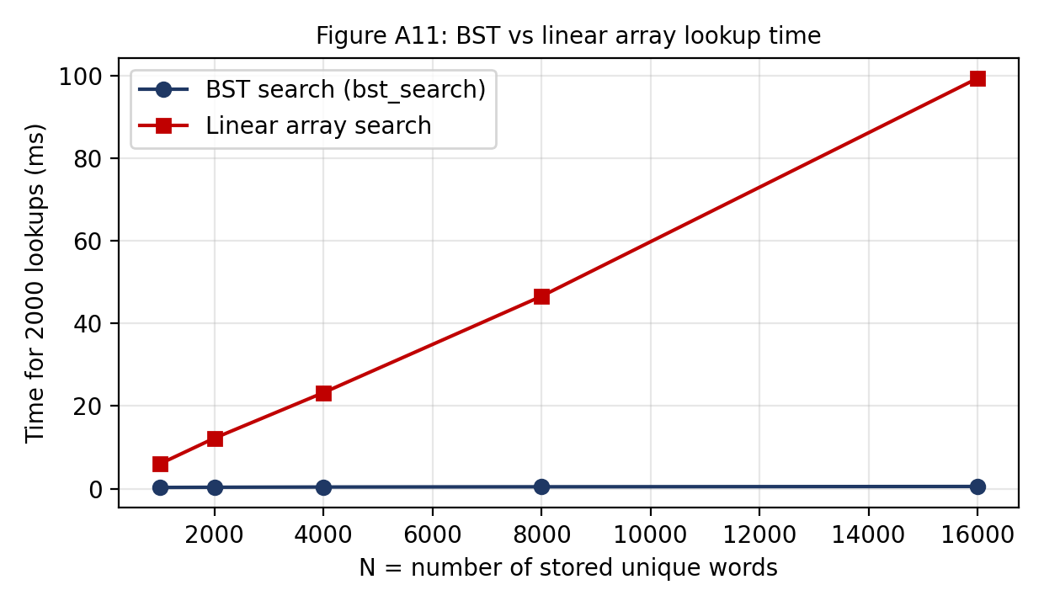
Figure A11: T11 – Lookup time for 2000 searches, BST vs linear array (measured with the test driver; lookups were misses).
Insert screenshot here — Figure A12
Matches section of the report.
Figure A12: Report page: matching passages with source titles and links

APPENDIX B — SOURCE CODE
Insert screenshot here — Listing B1
Paste code or screenshot.
Listing B1: backend.c: BST functions (bst_insert, bst_search, bst_height)
Insert screenshot here — Listing B2
Paste code or screenshot.
Listing B2: backend.c: tokenize_document and backend_analyze
APPENDIX C — SAMPLE INPUT FILES
Insert screenshot here — Figure C1
Screenshot or pasted contents.
Figure C1: Test inputs used (T5 passage, T6 recipe text, T7 half-copied text, TXT / DOCX / PDF files)

APPENDIX D — TEST DRIVER OUTPUT (T1–T11)
D1: output of a command-line test driver that includes the project's backend.c (same functions as the program) and miniz.c, compiled with GCC -O2 on Linux. The Windows-only calls _strdup, _stricmp and _strnicmp were mapped to POSIX equivalents; the Windows web front end was not part of this run. Re-run on the Windows build and attach your own output.
corpus sources=8
T2 tokens=6 sentences=2: data structures data structures the(stop) tree
T3 nodes=7 height=3 freq(apple)=3 freq(mango)=2
T4 search(egg)=found search(banana)=not found
T10 N=100 sorted_height=100 random_height=16
T10 N=1000 sorted_height=1000 random_height=24
T11 N=1000 M=2000 bst_ms=0.313 linear_ms=6.020 hits_bst=0 hits_linear=0
T11 N=2000 M=2000 bst_ms=0.359 linear_ms=12.233 hits_bst=0 hits_linear=0
T11 N=4000 M=2000 bst_ms=0.416 linear_ms=23.247 hits_bst=0 hits_linear=0
T11 N=8000 M=2000 bst_ms=0.472 linear_ms=46.581 hits_bst=0 hits_linear=0
T11 N=16000 M=2000 bst_ms=0.549 linear_ms=99.336 hits_bst=0 hits_linear=0
T5_copy words=95 distinct=39 bst_nodes=39 height=11 stop_excl=17 matches=18 exact=100.00 lex=100.0
0 overall=100.00 verdict=Very High Similarity
T6_unrelated words=29 distinct=19 bst_nodes=19 height=9 stop_excl=6 matches=0 exact=0.00 lex=0.00 overa
ll=0.00 verdict=No Match
T7_partial words=68 distinct=30 bst_nodes=30 height=10 stop_excl=14 matches=7 exact=70.73 lex=58.73 o
verall=66.53 verdict=High Similarity
T8_stopwords words=15 distinct=0 bst_nodes=0 height=0 stop_excl=15 matches=0 exact=0.00 lex=0.00 overal
l=0.00 verdict=No Match
T8_empty words=0 distinct=0 bst_nodes=0 height=0 stop_excl=0 matches=0 exact=0.00 lex=0.00 overall=
0.00 verdict=No Match
T9_function words=20 distinct=5 bst_nodes=5 height=5 stop_excl=9 matches=0 exact=0.00 lex=0.00 overall
=0.00 verdict=No Match
T1 /home/claude/s.txt -> ok len=74 err=
first: Binary search trees store words in order. A binary search tree is usef
T1 /home/claude/s.docx -> ok len=82363 err=
first: MICROPROJECT GROUP ACTIVITY STAGE 2 — REPORT II / REVIEW II Rubric a
T1 /home/claude/s.pdf -> ok len=11469 err=
first: ?,g({0=_#g2Y)('wcV_rhX?/<6yX=<m"-$PXEk$nJYZ_;DKKK)'NA#w$R9LRj+2%ob?JnJ

