highligted

**TC - MFR Journals Automation**

Enterprise Application Group

**Functional Design Document**

Version 0.1 Author: Shrinath Hajra

Apr 7, 2017Prepared for: **Thomas Cook**



|  |  |
| --- | --- |
| **Document ID:** | 0.1 |
| **Document Name:** | TC - MFR Journals Automation |
| **Publication Date:** |  |
| **Prepared By:** | Shrinath Hajra |

|  |  |  |  |  |  |
| --- | --- | --- | --- | --- | --- |
| **Version** | **Date** | **Page No** | **Change Mode**  **(A/M/D)** | **Brief description of change** | **Prepared/ Revised by** |
| 0.1 | April 7, 2017 | All | A | First Draft | Shrinath Hajra |

**A – Added, M – Modified, D – Deleted**

**Table of Contents**

Part-1: Introduction 4

Purpose of the document 4

Scope of the document 4

Project Overview 5

Part-2: Functional Requirement 6

GUI Screen Prototype 6

Part-3: Reports 12

Part-4: Non-Functional Requirements 12

Part-5: Out of Scope Points 12

Appendix A: Glossary 12

Acronyms 12

Project Terminology 13

Appendix B: Any needed appendices. 13

Part-7: Approval Signature Page 14

Part-1: Introduction

Confidential & Proprietary © WNS Global Services 2008

Purpose of the document

The purpose of this document is to detail the functional design approach for “MFR Journals Automation**”**. It is expected the following groups of people will use this document:

* Client Sponsor and stakeholders from operation group of Supervisors from processes within WNS will be expected to agree the requirements as stated within this document will meet their need.
* Solution Architects and Developers will be expected to agree to be able to deliver the requirements as stated within this document.
* SQA team will base their test strategy and test cases on this document.

Scope of the document

The scope of the document includes;

1. Implementation of VBA Macro.
2. Implementation of email scanning.
3. Implementation of duplicate attachment checking.
4. Implementation of JE approval requirement checking.
5. Implementation of MFR JE file error checking.
6. Implementation of JE allocation to agents.

**Limitations of Current Process**

JE file approval checking and error correction needs to be done manually.

Project Overview

This project has been conceptualized to develop a VBA Macro. Current process includes manual work where repetitive tasks such as checking email for new MFR JE file, sending approval email if required, doing lots of checks and preparing the JE file is done. This manual and repetitive work is time consuming and is error-prone due human intervention.

**Objectives**

Following are major objectives of this project:

1. Scanning the emails in pre-defined JE outlook folder.
2. Checking for duplicate attachment.
3. Checking if the approval is required for input JE.
4. Checking if there are any error in input JE.
5. Allocating the JE to agent.

**Features**

The following are the major features of the project;

1. Implementation of VBA Macro.
2. Implementation of email scanning.
3. Implementation of duplicate attachment checking.
4. Implementation of JE approval requirement checking.
5. Implementation of MFR JE file error checking.
6. Implementation of JE allocation to agents.

Part-2: Functional Requirement

GUI Screen Prototype

1. **Login**

Supervisor will login to Application using Access Code.

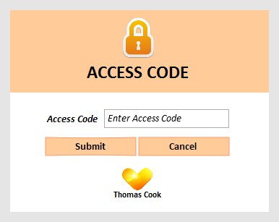

|  |  |  |  |  |
| --- | --- | --- | --- | --- |
| Field | Description | Mandatory (Y/N) | Control Type | Length |
| Access Code | Login Access Code | Y | Textbox | 10 |

**Business Rules**

1. If access code is blank, the Application should show error message for missing Access Code.
2. Access code should be masked.
3. On click of “Submit” button Application should validate if correct Access code is entered. If itis incorrect then Application will show message “Incorrect Access Code” however login form should be still visible to Supervisor
4. Multiple attempts for login are allowed.
5. On successful login, “Main Form” should be shown.
6. On click of “Cancel” button, the form should exit.
7. **Main Form:**

Supervisor can perform Email scanning, JE Allocation, Viewing Errors and Logs on this form.

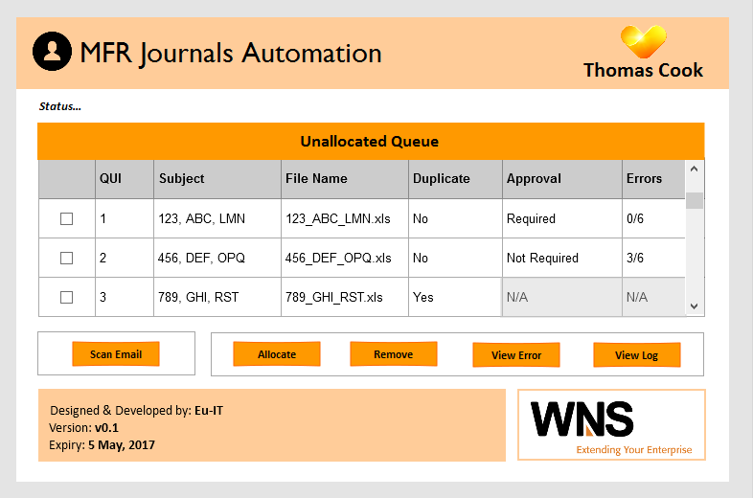

|  |  |  |  |  |
| --- | --- | --- | --- | --- |
| Field | Description | Mandatory (Y/N) | Control Type | Length |
| Queue | Queue for showing all the emails allocated today. | Y | DataGridView |  |

**Business Rules**

1. After successful login, MFR Journals Automation “Main Form” should be shown.
2. Queue should show all the unallocated scanned emails.
3. Initially, the queue should be empty and after each successful scanning, the scanned emails information should be added to the queue.
4. Only single row can be selected at a time to Allocate, Clear, View Error or Log.
5. When the queue is empty, only “Scan Email” button should be enabled while all the other buttons, “Allocate”, “Remove”, “View Error”, “View Log” should be disabled.
6. On click of “Scan Email” button, the Application should scan for any new email in dedicated MFR JE outlook folder and check for approval and errors in the file.
7. After scanning the emails, details such as email Subject line, Attached file name, Whether the attachment is duplicate, whether the approval is required from ledger owner and the number of errors, if any in the JE file, should be populated into Queue
8. On click on “Allocate” button, Allocation window should be shown. Supervisor can allocate the emails from this window to any agent.
9. On click of “Remove” button, selected row should get remove from the table as well as database.
10. On click of “View Error” button, Error window should be shown that will list all the errors found for selected email from queue.
11. If there are no error for selected email in queue, a message should be shown as “No errors found”
12. On click of “View Log” button, Log window should be shown with option to filters the logs and extract the report.
13. If any of the email has duplicated attachment, which should be indicated in “Duplicate” column as Yes/No in the queue, Application should not check for approval and errors. In this case, the respective “Approval” and “Error” columns will be grayed out to be N/A.
14. “Status…” label should be updated in real-time to show status of current task being executing/has executed.
15. **JE Allocation Form:**

Supervisor can allocate JE to Agents on this form.

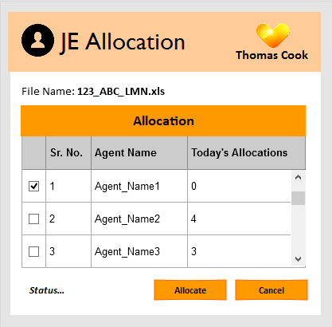

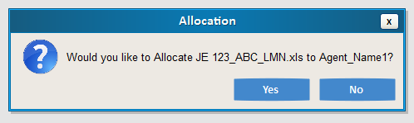

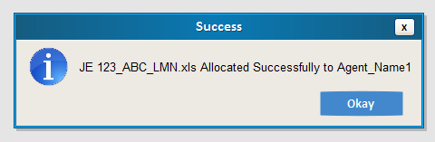

|  |  |  |  |  |
| --- | --- | --- | --- | --- |
| Field | Description | Mandatory (Y/N) | Control Type | Length |
| Allocation | Queue for showing all Agent Names and today’s Allocation Count | Y | DataGridView |  |

**Business Rules**

1. On load:
2. The form should show table of all the Agent names along with number of JE’s allocated to them today.
3. Name of file name for which “Allocate” button is clicked on “Main Form” should be visible on this form.
4. Multiselect option should not be available in DataGridView.
5. On click of “Allocate” button, a confirmation MessageBox should be shown to confirm the selected file name and Agent name for allocation.
6. On click of “Yes” button on “Allocate” MessageBox:
7. JE should be allocated to respective Agent. This includes, the email being saved in Agent’s shared drive as well as his/her outlook folder.
8. If there is approval required for the JE file and/or if any error is found, a text file should be saved in Agent’s shared drive which should have the body of email that needs to be sent for JE Approval and Error correction.
9. Updates should be saved in the Database.
10. “Success” MessageBox should be shown.
11. On click of “No” button on “Allocate” MessageBox, JE should not be allocated to any Agent and the “Main Form” should be shown.
12. On Click of “Ok” on “Success” MessageBox, “Main Form” should be shown with updated Queue.
13. On click on “Cancel” button, Current window should be closed, JE should not be allocated to any Agent and “Main Form” should be shown.
14. “Status…” label should be updated in real-time to show status of current task being executing/has executed.
15. **Error Form:**

Supervisor can view list of errors for the current selected file name in “Main Form”.

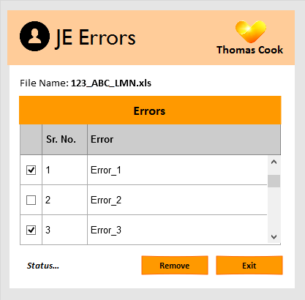

|  |  |  |  |  |
| --- | --- | --- | --- | --- |
| Field | Description | Mandatory (Y/N) | Control Type | Length |
| Error | Queue for showing all the errors found in current selected file. | Y | DataGridView |  |

**Business Rules**

1. On load:
   1. The file name should be shown which was selected on “Main Form”.
   2. Error DataGridView should show all the associated errors for selected file name.
2. Error DataGridView will have Multiselect checkboxes.
3. On click of “Remove” button, the selected error(s) should be removed from the DataGridView.
4. On click of “Exit” button, the “Error” form should be closed and “Main Form”  
    should be shown.
5. “Status…” label should be updated in real-time to show status of current task being executing/has executed.

**5. Error Log:**

This form will allow Supervisor to view allocation log. Log report can also be extracted into Excel format here.

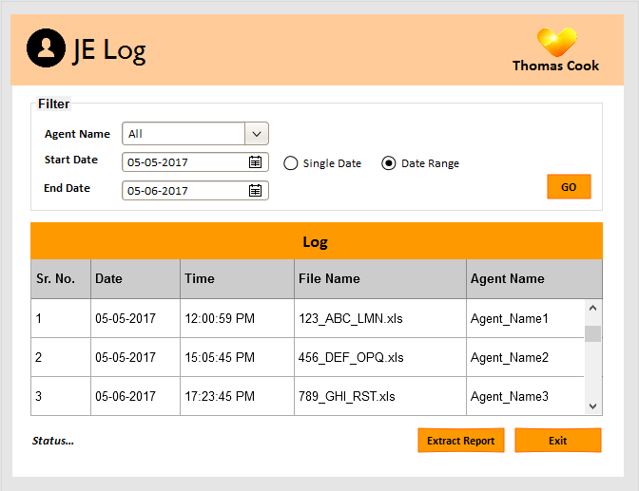

|  |  |  |  |  |
| --- | --- | --- | --- | --- |
| Field | Description | Mandatory (Y/N) | Control Type | Length |
| Agent Name | List of Agent Names | Y | Combo Box | 20 |
| Start Date | Date Picker | Y | Date Picker |  |
| End Date | Date Picker | N if “Single Date” is Selected  Y if “Date Range” is Selected | Date Picker |  |
| Single Date / Date Range | Whether to fetch data using single date or between two dates | Y | Radio Button |  |

**Business Rules**

1. On load:
   1. “Agent Name” should select “All” by default.
   2. “Single Date” radio button should be checked and “Start Date” should show today’s date.
   3. “End Date” Date Picker should be disabled.
   4. Log table should be empty.
2. When “Single Date” radio button is selected, only “Start Date” Date Picker should be should be shown and “End Date” Date Picker should be disabled.
3. When “Date Range” radio button is selected, both, “Start Date” and “End Date” Date Picker should be enable.
4. On Click of “Go” button, the Log table should be populated from Database for the selected filter options.
5. On Click of “Extract Report” button, data from Log table should be extracted into Excel file for reporting.
6. On Click of “Exit” button, form should close and “Main Form” should be shown.
7. “Status…” label should be updated in real-time to show status of current task being executing/has executed.

Part-3:Reports

Log table data from Log window will be extracted into Excel file.

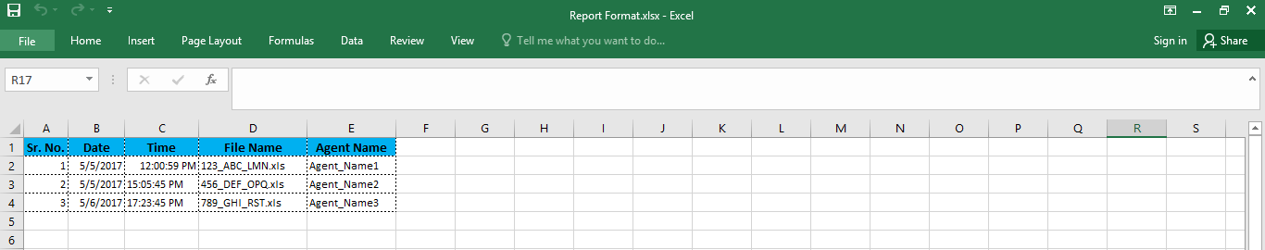

Part-4: Non-Functional Requirements

Part-5: Out of Scope Points

Following points are not considered in this phase of application

1. Application will not Interact with any client system.
2. Filtration of MFR related emails will be done manually.
3. Approval checking.
4. Application/Tool will not read any error correction emails. Error needs to be manually corrected as per the email instruction received from respective ledger owners.

Appendix A: Glossary

Acronyms

NA

Project Terminology

NA

Appendix B: Any needed appendices.

NA

Part-7: Approval Signature Page

Deliverable Name: Chetan Wagh

Version Number: 0.1

Project Name: Month End Close Tracker

I agree that this document represents my best understanding of the information presented within this Deliverable for this project today. Future changes in this baseline document can be made through the project’s defined change process. I realize that approved changes might require us to renegotiate the costs, resource and schedule commitments for this project.

|  |  |  |  |
| --- | --- | --- | --- |
| **Name** | **Title** | **Signature/Electronic Vote/Email** | **Date** |
| <Approver Name> | <Approver Title> | <Approver Signature> | <Date Signed/Reviewed /Emailed> |
|  |  |  |  |
|  |  |  |  |
|  |  |  |  |
|  |  |  |  |
|  |  |  |  |
|  |  |  |  |