**Introduction**

The aim of this exercise is to produce an Excel VBA application that allows a user to view and modify data in a database. The exercise will be judged on the quality of the code, as well as the end-result. An Object Oriented approach is preferred, although not mandatory. Code that is reusable, readable, flexible and modular code will be marked higher. The exercise is not expected to take more than three hours in total.

**Instructions**

There is a Microsoft Access database called "CaseStudy.mdb" in included in the zip file. The database contains four tables as shown in the diagram below.

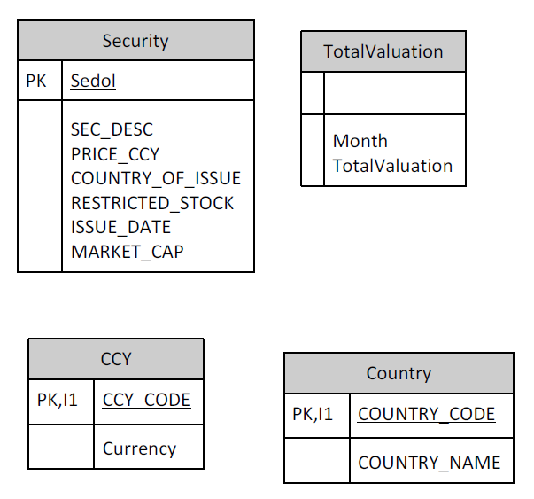

In the file “Application.xlsm” create an EXCEL VBA form that will allow users to browse, update, add and delete records in the Security table in the Access DB

There is a procedure in the module mdlDBConnect that will create a database connection for you

Constraints

SEDOLs are always 7 characters long and include leading zeros, eg 0001234

The SEDOLs in the database are stored as numbers, so are losing their leading zeros

The form should correct this and show them full-length

It does not need to try to correct this in the database, just display them correctly

All data entry should be validated

Consider that the application may be deployed to multiple environments where directory paths will not be the same.