Hi Nutan,

PFA Timesheet macro along with output mail generated from the tool.

**Functionalities:-**

I have generalizing Timesheet macro for Meteor ODC( Currently developing for London Process) which we can use for other activities in our ODC to track Daily/Monthly count of breaks, total Time required to complete particular process or for any similar purpose.

As shown below, In Mapping Sheet mention Process names in a particular activity, its sub activities in Process Activities, Mention Column width for formatting purpose and in the last column i.e. Column Formats mention the data format.

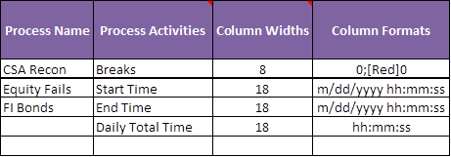

We can start the template design from any row in “Monthly sheet”, just need to change the row variable mentioned in ”Holidays” sheet.

|  |  |
| --- | --- |
| **Template  Creation** |  |
| **Row start** | **8** |

Tool also takes into account MLP holidays, just mention it in the template of “Mapping” sheet, so that tool will automatically working days according to that.

|  |  |
| --- | --- |
| **Holiday Date** | **Holiday Name** |
| 5/1/2018 | Labour Day |

**Time Zone Independent:-** This Tool always considers the Start/End time in EST format even though system date may be in different time zone.

**Main Monthly Sheet(Data Entry) :-** Every month you need to click once on the Calendar icon and change the date to select the desired month so that tool will generate the new template accordingly (considering MLP Holidays as well). After that select Process Name and enter breaks for it and click on Start/End the activity. After all the data is filled for the entire month then click on “Generate Summary” button. This will create Summary template along with chart sheet for Total breaks distribution as shown below.

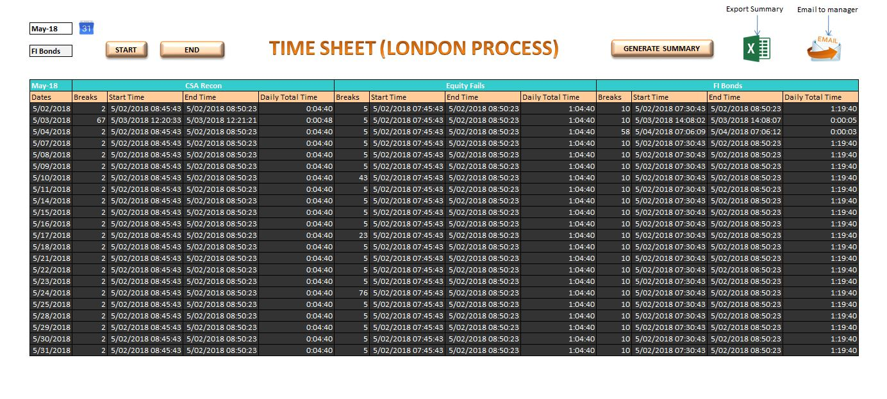

**Final Summary output**

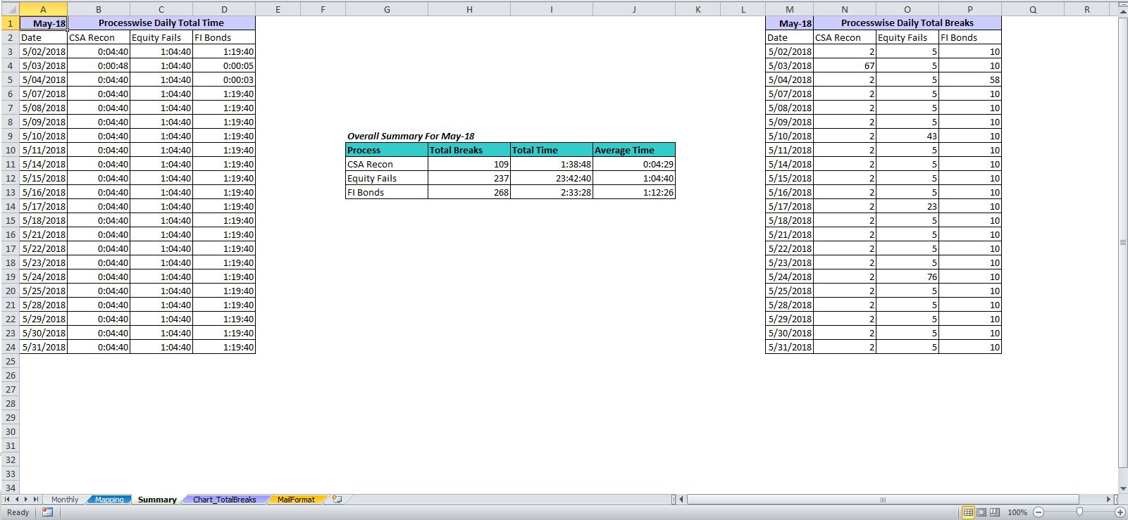

**Chart sheet for Total Breaks Distribution**

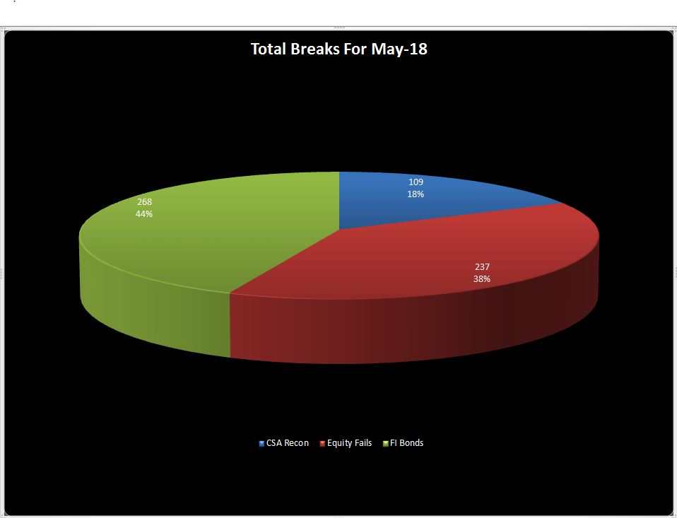

Thanks,

Swapnil

**________________________________________________**

Swapnil Sunil Kulkarni | +91 20 6698 2472 **|**[swapnil.kulkarni@mlp.com](mailto: swapnil.kulkarni@mlp.com)