


Prepayment Automation Tool

User Manual

Version 1.0 Author: - Swapnil Kulkarni
Date: - 6 Oct 2017 Prepared For: - Sompo Canopius

Document Id: | 1.0
Document Name: | Prepayment Automation Tool
Publication Date: | 6th October 2017
Latest Revision Date: | NA
Prepared By: | Swapnil Kulkarni

Version | Date | Change Mode  (C/A/M/D) | Brief description of change | Prepared/ Revised by
1.0 | Oct 06, 2017 | C | Initial Draft | Swapnil Kulkarni

C – Created, A – Added, M – Modified, D – Deleted
Table of Contents
Part-I: Introduction 4
Project Overview 4
Purpose of the document 4
Scope of the document 4
Part-II: ACCESSING SYSTEM 4
Part-III: Tool Functionalities 5
A) New User Registration 5
B) Data Uploading Techniques 9
1) Excel Upload Facility 9
Validations: - Please refer following table for input validation in the excel dump file. 10
Above table is also mentioned in the dump file in “Input Validations” sheet. 10
2) Prepayment Entry Form 11
1. Sub Section 11
Part-IV: Annexure 12
Approval Signature Page 13

Part-I: Introduction
Confidential & Proprietary © WNS Global Services 2008
Project Overview
- Prepayments are amounts paid for by the business in advance of the goods or services been received for a future period.
- Therefore, prepaid expense must be not be shown as expense in the accounting period in which it is paid but instead it must be presented as such in the subsequent accounting periods in which the services in respect of the prepaid expense have been performed.
- At the end of an invoice specified period. The Prepaid expense account balance should be zero.
- The prepayment process applies where we have paid for services with Net Value £5000.00+.
Purpose of the document
The purpose of this document is to capture business requirements
Scope of the document
This document explains the functionality of the system in details under -
- Input Form with validations / direct excel upload facility.
- O/P prepare prepayment schedule (Consolidated).
- Prepare Yearly Report for Prepayment Schedule.
- Prepare Reconciliation Template and report.
- Totaling in consolidated report and year wise report should be BU and Currency wise as we are currently directly doing totaling.

Part-II: ACCESSING SYSTEM
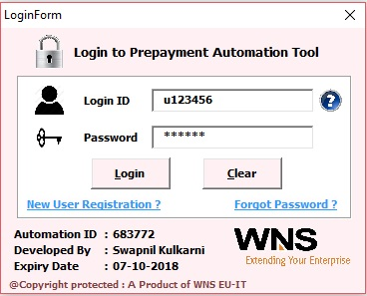
GUI

Username: <Employee ID>
Password: ******* (as your convenience Max 30, preferable length: 5-12)
Business Rule
- Username/Password should not kept blank.
- If you close this window then the tool will close automatically.
- Once username and password has been entered then click on “Login” button to get access into the tool and if you have made any mistake while typing username/ password then click on “Clear” button.

Part-III: Tool Functionalities
- New User Registration
Click on New User Registration link in the login form then the following form will pop up.
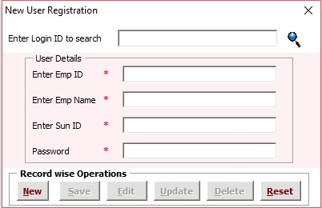

Activities:
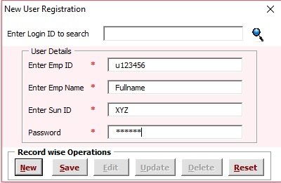
- New Record: - For any new record click on New Button then the cursor will go Enter employee ID textbox to enter the data. Fill up the information in each textbox and then click on Save Button to save the information related to that particular Employee. (As shown below)

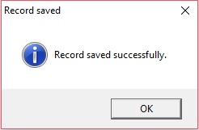

- Search Record:- Now if you want to search and update any details for an employee then type the employee Id in Enter Login ID to search textbox as shown below
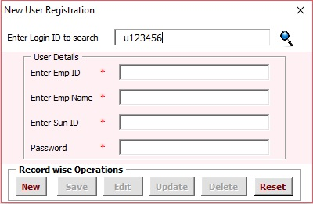


Now Click on Search button then employee details will be displayed.
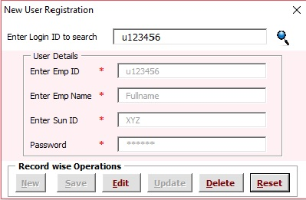

- Update Record: - Now search the record you want to search for e.g. U123456. Follow the steps mentioned in the above activity (Searching Record). Now click on “Edit” Button and change any details for e.g. Full Name.
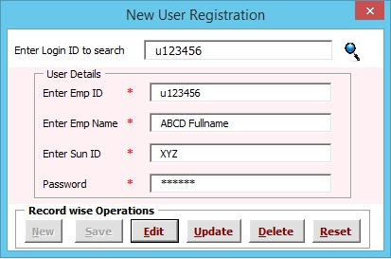
Now click on “Update” button and then record will be updated successfully.
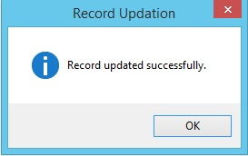
- Record Deletion: - Now search the Record as mentioned in activity 2 for e.g. u123456.

Now Click on “Delete” button then following Message Box will be displayed.
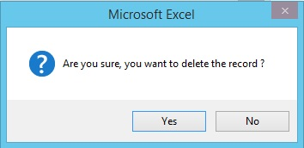
Now click on Yes to delete the record of selected employee.
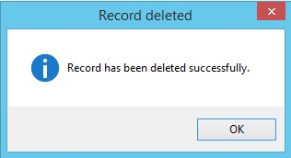

- Reset: - For every successful activity from 1, 3, 4 the form will be reset to its normal state. Now suppose you still want to reset the details then you can anytime click on Reset button.

- Data Uploading Techniques
There are two ways from which you can enter the record(s) into the database.
- Excel Upload Facility
- Prepayment Entry Form
- Excel Upload Facility
Go to Add-ins→Prepayment Tool→Excel Upload Facility.
Then the following form will pop up.
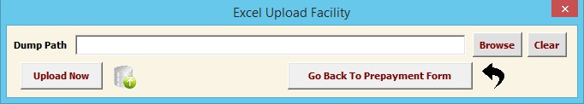

Business Rules/ Steps: -
  - Dump Path should not kept blank.
  - First click on Browse button and select the excel file from the exact directory where it is located for e.g. Prepayment Schedule Format-DXM.xlsx.
  - Once dump path has been entered then click on “Upload Now” button to the data in the database. If all the data is uploaded successfully then “Success” will be printed in each row of column R of Prepayment Schedule Format-DXM.xlsx otherwise “Failed : <Reason>” will be printed in each row of column R of Prepayment Schedule Format-DXM.xlsx.
  - If you have made any mistake while browsing the correct file then click on “Clear” button to erase the path and then again click on “Browse” button.
  - Following are 2 the screenshot to show the upload of unique data and duplicate data.
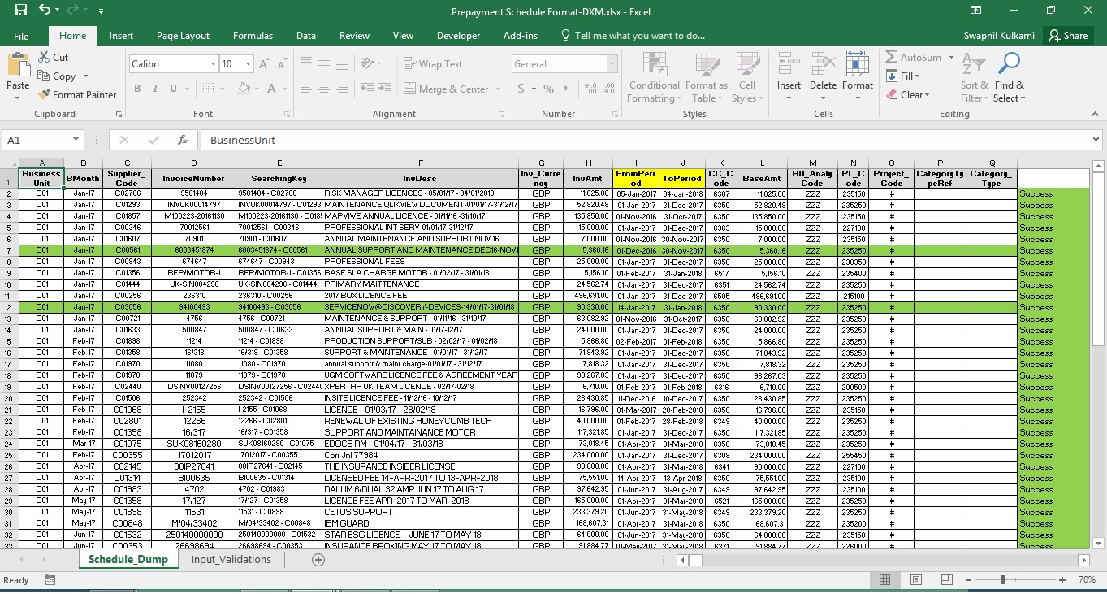

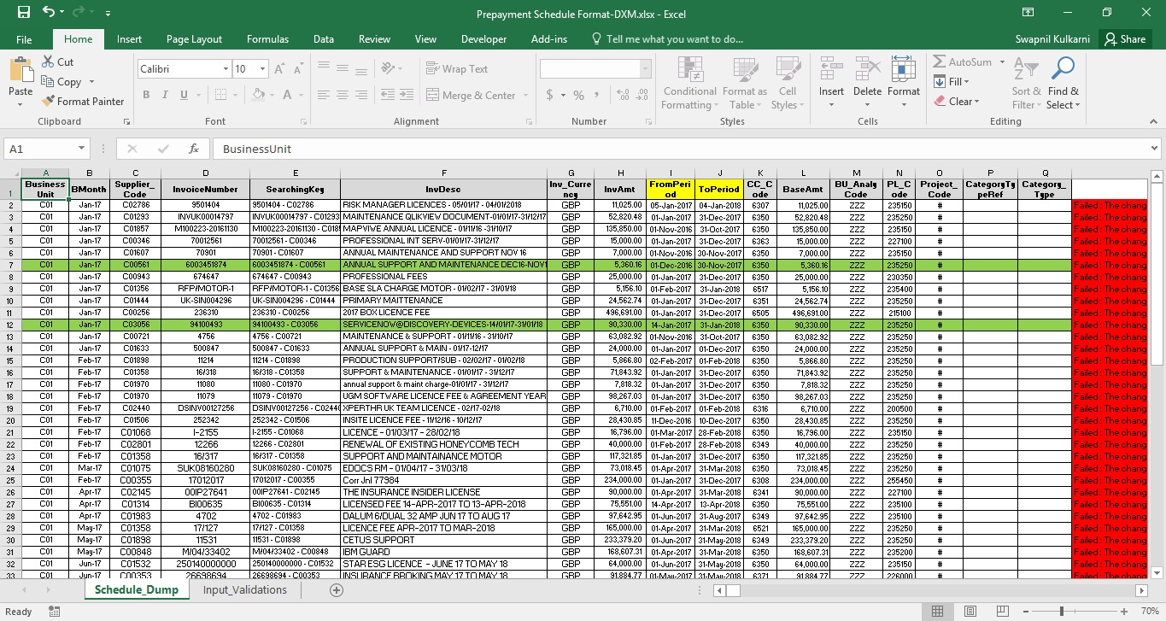

Val

Validations: - Please refer following table for input validation in the excel dump file.
Column Name | DB Description | Format Example
BusinessUnit | Short Text, max field size:= 3 | C01
BMonth | Date | Aug-17
Supplier_Code | Short Text, max field size:= 6 Single quotes not allowed | C01358
InvoiceNumber | Short Text, max field size:= 50 | 17/127
SearchingKey | Short Text , max filed size : = 65 | 17/127 - C01358
InvDesc | Short Text, max field size:= 150, Single quotes not allowed | LICENCE FEE APR-2017 TO MAR-2018
Inv_Currency | Short Text, max field size:= 3 | GBP
InvAmt | Double, upto 15 digit | 165000.10
FromPeriod | Date | dd/MMM/YYYY
ToPeriod | Date | dd/MMM/YYYY
CC_Code | Integer, Range:= -32767 to 32768, 4 DIGIT | 6521
BaseAmt | Double,upto 15 digit | 165000.10
BU_AnalyCode | Short Text, max field size:= 3 | ZZZ
PL_Code | Long Integer, 6 Digit | 235250
Project_Code | Short Text, max field size:= 50
CategoryTypeRef | Short Text, max field size:= 50
Category_Type | Short Text, max field size:= 50
Above table is also mentioned in the dump file in “Input Validations” sheet.

- Prepayment Entry Form
Go To→Add-Ins→Prepayment Tool→Prepayment Entry Form, and then following form will pop up.
There are total 7 dropdown out of which 3 of them i.e. Supplier Code, Cost Centre Code and P & L Code are having their Names textbox disabled as they are loaded from the Masters DB.
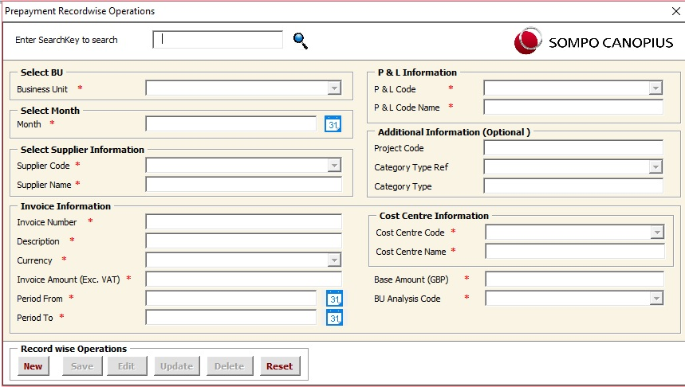

Record wise Operations: -
- New Record Entry: - To enter any new record into the database please click on “New” button then the form contents will be enabled. Validations will be same as above mentioned for the dump file. For any wrong entry of a particular field the tool will point out the validation rule and display the error message and the cursor will be pointing to that particular field as shown below. Here in the base amount field we have entered a text entry so the tool will highlight the error when we click on “Save” Button.
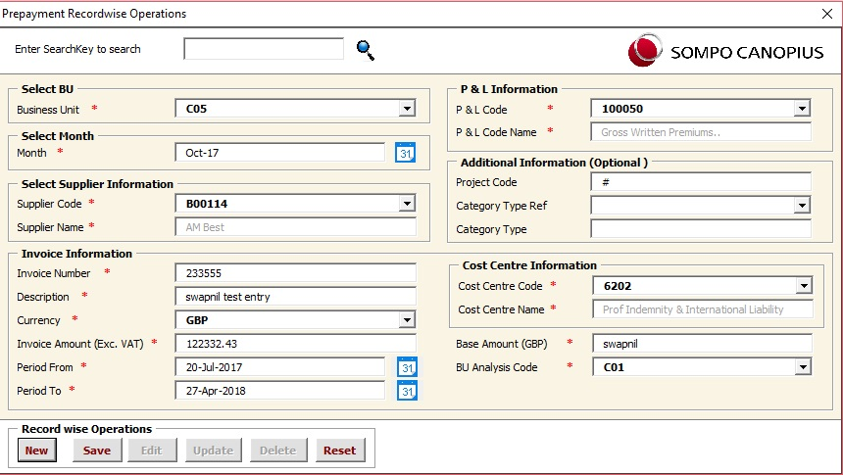

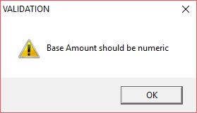

Now Change the entry of field Base Amount to numeric and then click on “Save”.
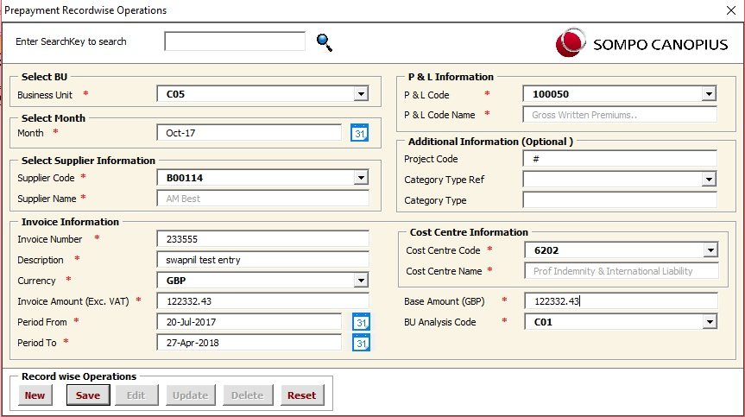

- Updating Record: - Suppose you extract the report either consolidated or Yearly report, then you realize that there is some mistakes in one of those entries then you can copy the “Searching Key” of that record and paste it into search Box.
For example 233555 - B00114 is the Searching Key of the record we want to edit. Type it in the search box and click on search logo then its information will be displayed. but it will be in disabled form. To enable it and edit any information please click on “Edit” button.
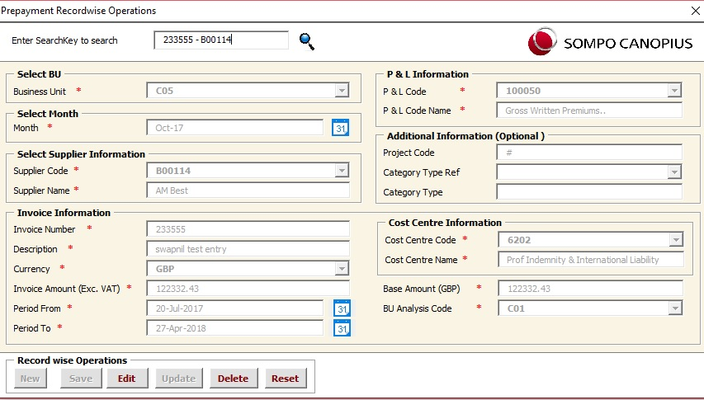

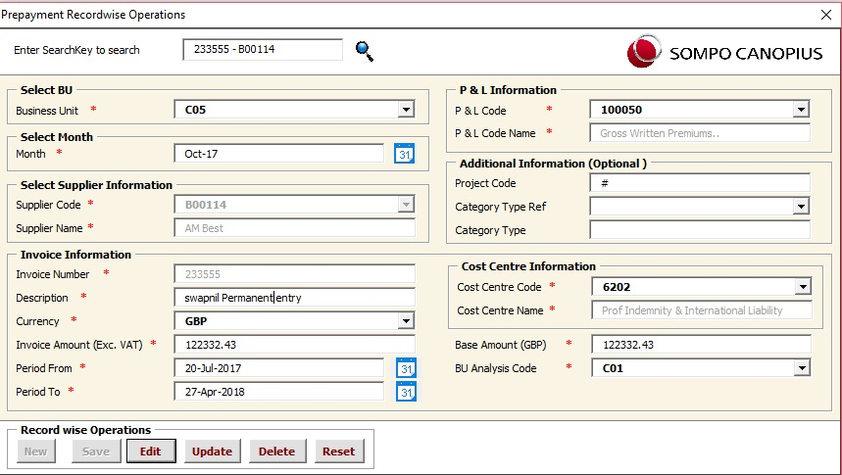
Above information is in disabled form. To enable it and edit any information please click on “Edit” button. Then “Update” button will get enabled and update your piece of information and click on update button in the record to update the record successfully as show below in the following screenshots.

Go to Add-ins Tab and select Prepayment Tool→Prepayment Entry Form.
GUI

- Sub Section
If any sub section then describe the sub section in details, provide some business logic and validations

Actor:-

- Admin
- Agent

Business Rule

Mention any business rule or validations which will help user while doing transactions

Navigation: - Path →

GUI

Part-IV: Annexure

Approval Signature Page
Deliverable Name: _____________________________________________
Version Number: _____________________________________________
Project Name: _____________________________________________

I agree that this document represents my best understanding of the information presented within this Deliverable for this project today. Future changes in this baseline document can be made through the project’s defined change process. I realize that approved changes might require us to renegotiate the costs, resource and schedule commitments for this project.

Name | Title | Signature / Electronic Vote / Email | Date
Name of the Employee | Designation | <Approver Signature> | <Date Signed/Reviewed /Emailed>
Name of the Employee | Designation | <Approver Signature> | <Date Signed/Reviewed /Emailed>

