# Task 1

Open ​​<https://www.facebook.com/>

Capture the below text and verify text contains the below text

Facebook helps you connect and share with the people in your life

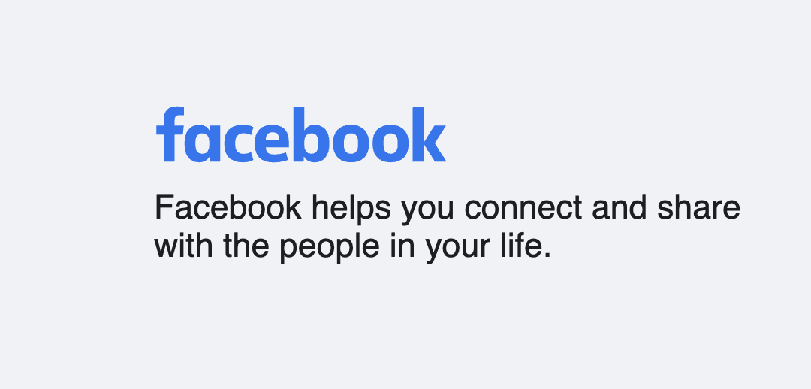

ANS:

package base;

import java.util.concurrent.TimeUnit;

import org.openqa.selenium.By;

import org.openqa.selenium.WebDriver;

import org.openqa.selenium.WebElement;

import org.openqa.selenium.chrome.ChromeDriver;

import org.openqa.selenium.edge.EdgeDriver;

import org.openqa.selenium.firefox.FirefoxDriver;

import org.testng.Assert;

public class Assignment8 {

static WebDriver driver;

public static void main(String[] args) {

// TODO Auto-generated method stub

//Launching the browser

driver=new ChromeDriver();

driver.manage().window().maximize();

//Pass the URL

driver.get("https://www.facebook.com/");

driver.manage().timeouts().implicitlyWait(10,TimeUnit.SECONDS);

String AcualText=driver.findElement(By.xpath("//h2[text()='Facebook helps you connect and share with the people in your life.']")).getText();

System.out.println("The Actual Text is::" +" "+AcualText);

String ExpectedText="Facebook helps you connect and share with the people in your life.";

Assert.assertEquals(AcualText, ExpectedText,"Both the text are Matching");

/*

Another Method to verify

*/

if (AcualText.contains("Facebook helps you connect and share with the people in your life.")) {

System.out.println("Expected Message is displayed as a Facebook helps you connect and share with the people in your life.");

}

else {

System.out.println("Expected string is not matched");

}

driver.close();

}

}

# Task2

Open ​​<https://www.facebook.com/>

Capture all link text available in the footer section and verify Create Page Link is present or not. If yes then click on it.

ANS:

package base;

import java.util.List;

import java.util.concurrent.TimeUnit;

import org.openqa.selenium.By;

import org.openqa.selenium.WebDriver;

import org.openqa.selenium.WebElement;

import org.openqa.selenium.chrome.ChromeDriver;

import org.openqa.selenium.edge.EdgeDriver;

import org.openqa.selenium.firefox.FirefoxDriver;

import org.testng.Assert;

public class Assignment8 {

static WebDriver driver;

public static void main(String[] args) {

// TODO Auto-generated method stub

//Launching the browser

driver=new ChromeDriver();

driver.manage().window().maximize();

//Pass the URL

driver.get("https://www.facebook.com/");

driver.manage().timeouts().implicitlyWait(10,TimeUnit.SECONDS);

//Get list of web-elements with tagName - a

List<WebElement> Alllinks = driver.findElements(By.tagName("a"));

//Traversing through the list and printing its text along with link address

for(WebElement el:Alllinks)

{

System.out.println(el.getText()+" = "+el.getAttribute("href"));

String alllnktext=el.getText();

if (alllnktext.contains("Create a Page"))

{

driver.findElement(By.xpath("//a[text()='Create a Page']")).click();

System.out.println("The Create PAge link found and Clicked on successfully");

String CreatePgURL=driver.getCurrentUrl();

Assert.assertEquals(CreatePgURL, "https://www.facebook.com/pages/create/?ref_type=registration_form");

}

else

{

System.out.println("The Create Page link not found");

}

}

driver.close();

}

}

# Task 3

Note- Please use only xpath in this scenario

Open <https://www.facebook.com/>

Click on Create new account

Fill in all details and click on the Signup button

ANS:

package base;

import java.util.List;

import java.util.concurrent.TimeUnit;

import org.openqa.selenium.By;

import org.openqa.selenium.WebDriver;

import org.openqa.selenium.WebElement;

import org.openqa.selenium.chrome.ChromeDriver;

import org.openqa.selenium.edge.EdgeDriver;

import org.openqa.selenium.firefox.FirefoxDriver;

import org.openqa.selenium.support.ui.Select;

import org.testng.Assert;

public class Assignment8 {

static WebDriver driver;

public static void main(String[] args) {

// TODO Auto-generated method stub

//Launching the browser

driver=new ChromeDriver();

driver.manage().window().maximize();

//Pass the URL

driver.get("https://www.facebook.com/");

driver.manage().timeouts().implicitlyWait(10,TimeUnit.SECONDS);

//Create new account Option

driver.findElement(By.xpath("//a[text()='Create new account']")).click();

//USername

driver.findElement(By.xpath("//div[@id='reg_form_box']/child::div//input[@placeholder='First name']")).sendKeys("Mukesh");

//Surname

driver.findElement(By.xpath("//div[@id='reg_form_box']/child::div//input[@name='lastname']")).sendKeys("Russia");

//Email address

driver.findElement(By.xpath("//div[@id='reg_form_box']/child::div//input[@name='reg_email__']")).sendKeys("Putin@yopmail.com");

//New PAssword

driver.findElement(By.xpath("//div[@id='reg_form_box']/child::div//input[@name='reg_passwd__']")).sendKeys("Putin@123");

//Birth Day

Select BirthDay=new Select(driver.findElement(By.xpath("//span[@data-name='birthday_wrapper']/child::span/child::select[@id='day']")));

BirthDay.selectByValue("3");

//Birth Month

Select BirthMonth=new Select(driver.findElement(By.xpath("//span[@data-name='birthday_wrapper']/child::span/child::select[@id='month']")));

BirthMonth.selectByVisibleText("May");

//Birth Year

Select BirthYear=new Select(driver.findElement(By.xpath("//span[@data-name='birthday_wrapper']/child::span/child::select[@id='year']")));

BirthYear.selectByValue("2003");

//Email address- Confirmation

driver.findElement(By.xpath("//div[@id='reg_form_box']/child::div//input[@name='reg_email_confirmation__']")).sendKeys("Putin@yopmail.com");

//Gender-Male

driver.findElement(By.xpath("//label[text()='Male']")).click();

//SignUp Button

driver.findElement(By.xpath("(//button[text()='Sign Up'])[1]")).click();

driver.close();

}

}

# Task 4

Perform same steps which you did in task 3 but replace all xpath with css Selectors.

package base;

import java.util.List;

import java.util.concurrent.TimeUnit;

import org.openqa.selenium.By;

import org.openqa.selenium.WebDriver;

import org.openqa.selenium.WebElement;

import org.openqa.selenium.chrome.ChromeDriver;

import org.openqa.selenium.edge.EdgeDriver;

import org.openqa.selenium.firefox.FirefoxDriver;

import org.openqa.selenium.support.ui.Select;

import org.testng.Assert;

public class Assignment8 {

static WebDriver driver;

public static void main(String[] args) {

// TODO Auto-generated method stub

//Launching the browser

driver=new ChromeDriver();

driver.manage().window().maximize();

//Pass the URL

driver.get("https://www.facebook.com/");

driver.manage().timeouts().implicitlyWait(10,TimeUnit.SECONDS);

//Create new account Option

driver.findElement(By.cssSelector("a[data-testid=open-registration-form-button]")).click();

//USername

driver.findElement(By.cssSelector("input[name=firstname]")).sendKeys("Mukeshji");

//Surname

driver.findElement(By.cssSelector("input[name=lastname]")).sendKeys("Russia");

//Email address

driver.findElement(By.cssSelector("input[name=reg_email__]")).sendKeys("Putin14@yopmail.com");

//New PAssword

driver.findElement(By.cssSelector("input[data-type=password]")).sendKeys("Putin@123");

//Birth Day

Select BirthDay=new Select(driver.findElement(By.cssSelector("#day")));

BirthDay.selectByValue("3");

//Birth Month

Select BirthMonth=new Select(driver.findElement(By.cssSelector("#month")));

BirthMonth.selectByVisibleText("May");

//Birth Year

Select BirthYear=new Select(driver.findElement(By.cssSelector("#year")));

BirthYear.selectByValue("2003");

//Email address- Confirmation

driver.findElement(By.cssSelector("input[name=reg_email_confirmation__]")).sendKeys("Putin14@yopmail.com");

//Gender-Female

driver.findElement(By.cssSelector("label[class=_58mt]")).click();

//SignUp Button

driver.findElement(By.cssSelector("button[name=websubmit]")).click();

driver.close();

}

}