

Functional Safety Concept Lane Assistance

**Document Version: [Version]**

**Template Version 1.0, Released on 2017-06-21**



# 

# Document history

|  |  |  |  |
| --- | --- | --- | --- |
| Date | Version | Editor | Description |
| 05/22/2018 | 1.0 | Swapnil More | First Draft |
|  |  |  |  |
|  |  |  |  |
|  |  |  |  |
|  |  |  |  |

# Table of Contents

Document history

Table of Contents

Purpose of the Functional Safety Concept

Inputs to the Functional Safety Analysis

Safety goals from the Hazard Analysis and Risk Assessment

Preliminary Architecture

Description of architecture elements

Functional Safety Concept

Functional Safety Analysis

Functional Safety Requirements

Refinement of the System Architecture

Allocation of Functional Safety Requirements to Architecture Elements

Warning and Degradation Concept

# Purpose of the Functional Safety Concept

The purpose of the functional safety concept is to look at the item from a high-level perspective, refine the safety goals from hazard analysis and risk assessment as functional safety requirements, allocate safety requirements to the relevant parts of the system diagram; and discuss the verification, validation i.e. how to prove that the system actually meets the requirements.

# Inputs to the Functional Safety Concept

## Safety goals from the Hazard Analysis and Risk Assessment

|  |  |
| --- | --- |
| **ID** | **Safety Goal** |
| Safety_Goal_01 | The oscillating torque to the steering wheel from the lane keeping assistance shall be limited. |
| Safety_Goal_02 | The Lane Keeping Assistance function shall be time limited, and additional steering torque shall end after a given time interval, so the driver cannot misuse the system for autonomous driving. |
| Safety_Goal_03 | The Assistance provided by the Lane Keeping System shall be limited. |
| Safety_Goal_04 | The Lane Keeping Assistance function shall be deactivated when the camera sensor stops working. |

## 

## Preliminary Architecture

The lane assistance item preliminary architecture:

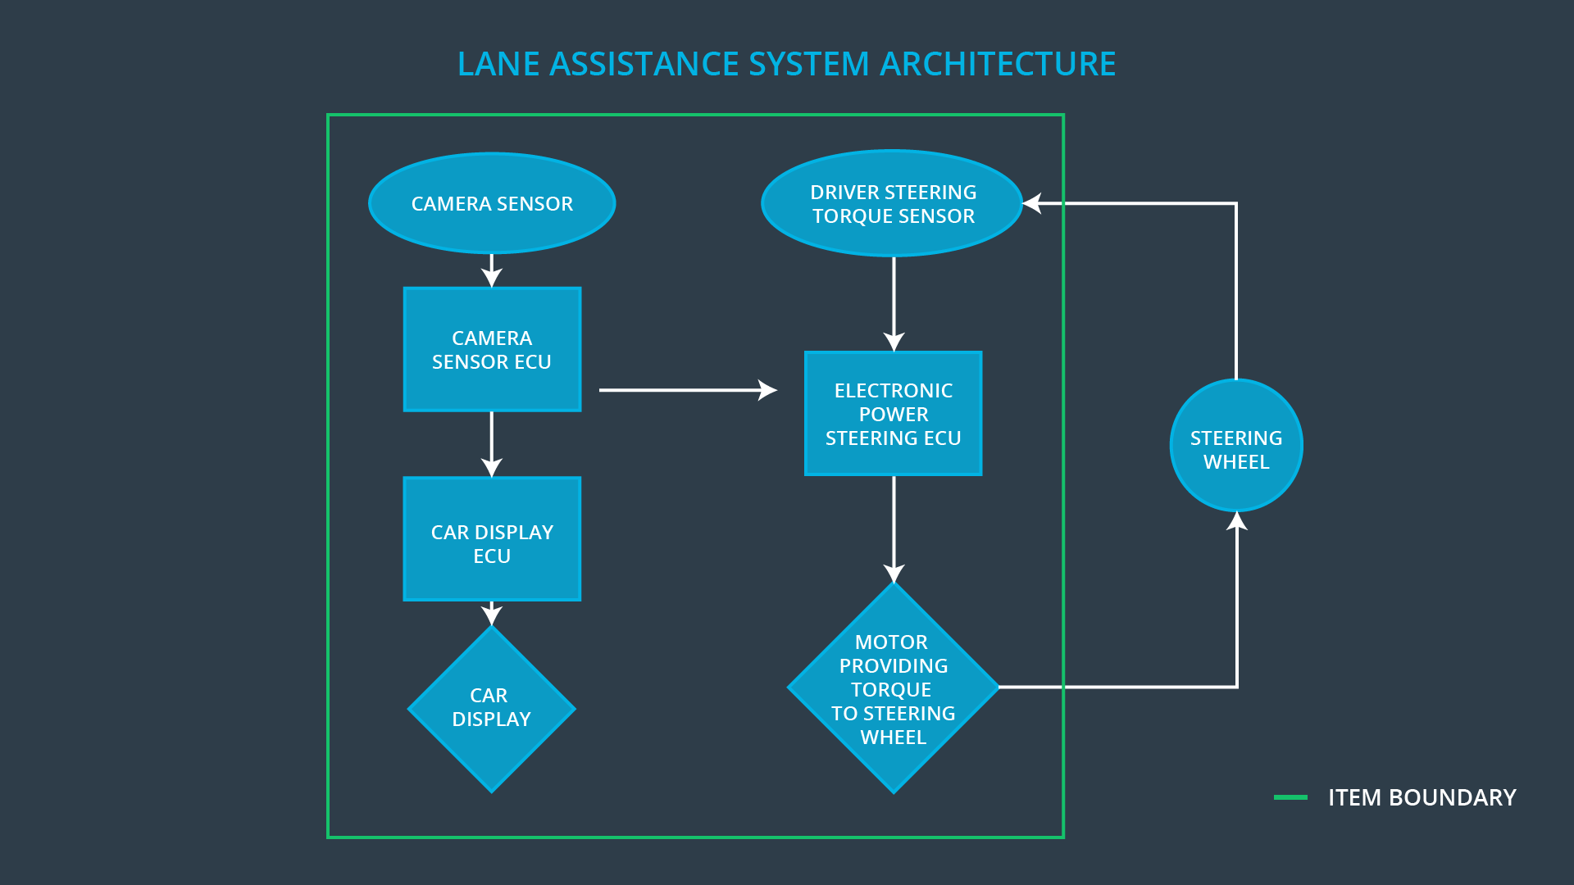

### Description of architecture elements

|  |  |
| --- | --- |
| **Element** | **Description** |
| Camera Sensor | Capture images and send them to the Camera Sensor ECU |
| Camera Sensor ECU | Process images to detect lane lines, calculate the vehicles position with respect to the lane lines and send information to the EPS ECU |
| Car Display | Display the Lane Departure Warning and status of the Lane Assistance System |
| Car Display ECU | Control the car display based on inputs from the camera sensor ECU |
| Driver Steering Torque Sensor | Measure Steering Wheel Torque |
| Electronic Power Steering ECU | Calculate the assistance torque, motor torque based on inputs from the camera sensor ECU |
| Motor | Generate torque requested by the EPS ECU |

# Functional Safety Concept

The functional safety concept consists of:

* Functional safety analysis
* Functional safety requirements
* Functional safety architecture
* Warning and degradation concept

## Functional Safety Analysis

|  |  |  |  |
| --- | --- | --- | --- |
| **Malfunction ID** | **Main Function of the Item Related to Safety Goal Violations** | **Guidewords (NO, WRONG, EARLY, LATE, MORE, LESS)** | **Resulting Malfunction** |
| Malfunction_01 | Lane Departure Warning (LDW) function shall apply an oscillating steering torque to provide the driver a haptic feedback | MORE | The Lane  Departure Warning  function applies an  oscillating torque  with very high  torque amplitude  (above limit) |
| Malfunction_02 | Lane Departure Warning (LDW) function shall apply an oscillating steering torque to provide the driver a haptic feedback | MORE | The Lane  Departure Warning  function applies an  oscillating torque  with very high  torque frequency  (above limit) |
| Malfunction_03 | Lane Keeping Assistance (LKA) function shall apply the steering torque when active to stay in ego lane | WRONG | The Lane Keeping  Assistance function  is not limited in time  duration which lead  to misuse as an autonomous driving  function. |
| Malfunction_04 | Lane Keeping Assistance (LKA) function shall apply the steering torque when active to stay in ego lane | MORE | The Lane Keeping Assistance applies a torque with very high torque amplitude (above limit) |
| Malfunction_05 | Lane Departure Warning (LDW) function shall apply an oscillating steering torque to provide the driver with haptic feedback | WRONG | The Lane  Departure Warning  start acting  randomly when the  camera sensor is  not working. |

## Functional Safety Requirements

Lane Departure Warning (LDW) Requirements:

|  |  |  |  |  |
| --- | --- | --- | --- | --- |
| **ID** | **Functional Safety Requirement** | **ASIL** | **Fault Tolerant Time Interval** | **Safe State** |
| Functional  Safety  Requirement  01-01 | The Lane Departure Warning item shall  ensure that the lane departure  oscillating torque amplitude is below  Max_Torque_Amplitude. | C | 50 ms | Vibration torque  amplitude  below  Max_Torque_A  mplitude. |
| Functional  Safety  Requirement  01-02 | The Lane Departure Warning item shall  ensure that the lane departure  oscillating torque frequency is below  Max_Torque_Frequency. | C | 50 ms | Vibration  frequency is  below  Max_Torque_Fr  equency. |
| Functional  Safety  Requirement  01-03 | The Lane Departure Warning function  shall be deactivated when the camera sensor stops working. | C | 50 ms | Camera sensor status is active. |

Lane Departure Warning (LDW) Verification and Validation Acceptance Criteria:

|  |  |  |
| --- | --- | --- |
| **ID** | **Validation Acceptance**  **Criteria and Method** | **Verification Acceptance**  **Criteria and Method** |
| Functional  Safety  Requirement  01-01 | Validate Max_Torque_Amplitude  chosen is high enough to be  detected by a driver while low  enough not to cause loss of steering | Verify the system does turn off if  the Lane Departure Warning  exceeded Max_Torque_Amplitude. |
| Functional  Safety  Requirement  01-02 | Validate Max_Torque_Frequency  chosen is adequate to be detected  by the driver and not cause the loss  of steering. | Verify the system does turn off if  the Lane Departure Warning  exceeded Max_Torque_Frequency. |
| Functional  Safety  Requirement  01-03 | Validate Lane Departure Warning is  off when the camera sensor is not  working. | Verify the Lane Departure Warning  is never on when the camera  sensor is not working. |

Lane Keeping Assistance (LKA) Requirements:

|  |  |  |  |  |
| --- | --- | --- | --- | --- |
| **ID** | **Functional Safety Requirement** | **ASIL** | **Fault Tolerant Time Interval** | **Safe State** |
| Functional  Safety  Requirement  02-01 | The Lane Keeping Assistance item shall ensure that the time duration for steering assistance is below Max_Assist_Time | B | 500 ms | Assistance time is below Max_Assist_Time |
| Functional  Safety  Requirement  02-02 | The Lane Keeping Assistance item shall  ensure that the lane assist torque amplitude is below  Max_Assist_Amplitude. | C | 50 ms | Assistance torque amplitude is below Max_Assist_Torque |

Lane Keeping Assistance (LKA) Verification and Validation Acceptance Criteria:

|  |  |  |
| --- | --- | --- |
| **ID** | **Validation Acceptance**  **Criteria and Method** | **Verification Acceptance**  **Criteria and Method** |
| Functional  Safety  Requirement  02-01 | Validate Max_Assist_Time  chosen is adequate to provide required assistance but not long enough for the driver to misuse the system | Verify the system does turn off if  the Lane Keeping Assistance  exceeded Max_Assist_Time |
| Functional  Safety  Requirement  02-02 | Validate Max_Assist_Amplitude  chosen is adequate to provide required assistance and not cause the loss of steering | Verify the system does turn off if  the Lane Keeping Assistance  exceeded Max_Assist_Amplitude |

## Refinement of the System Architecture

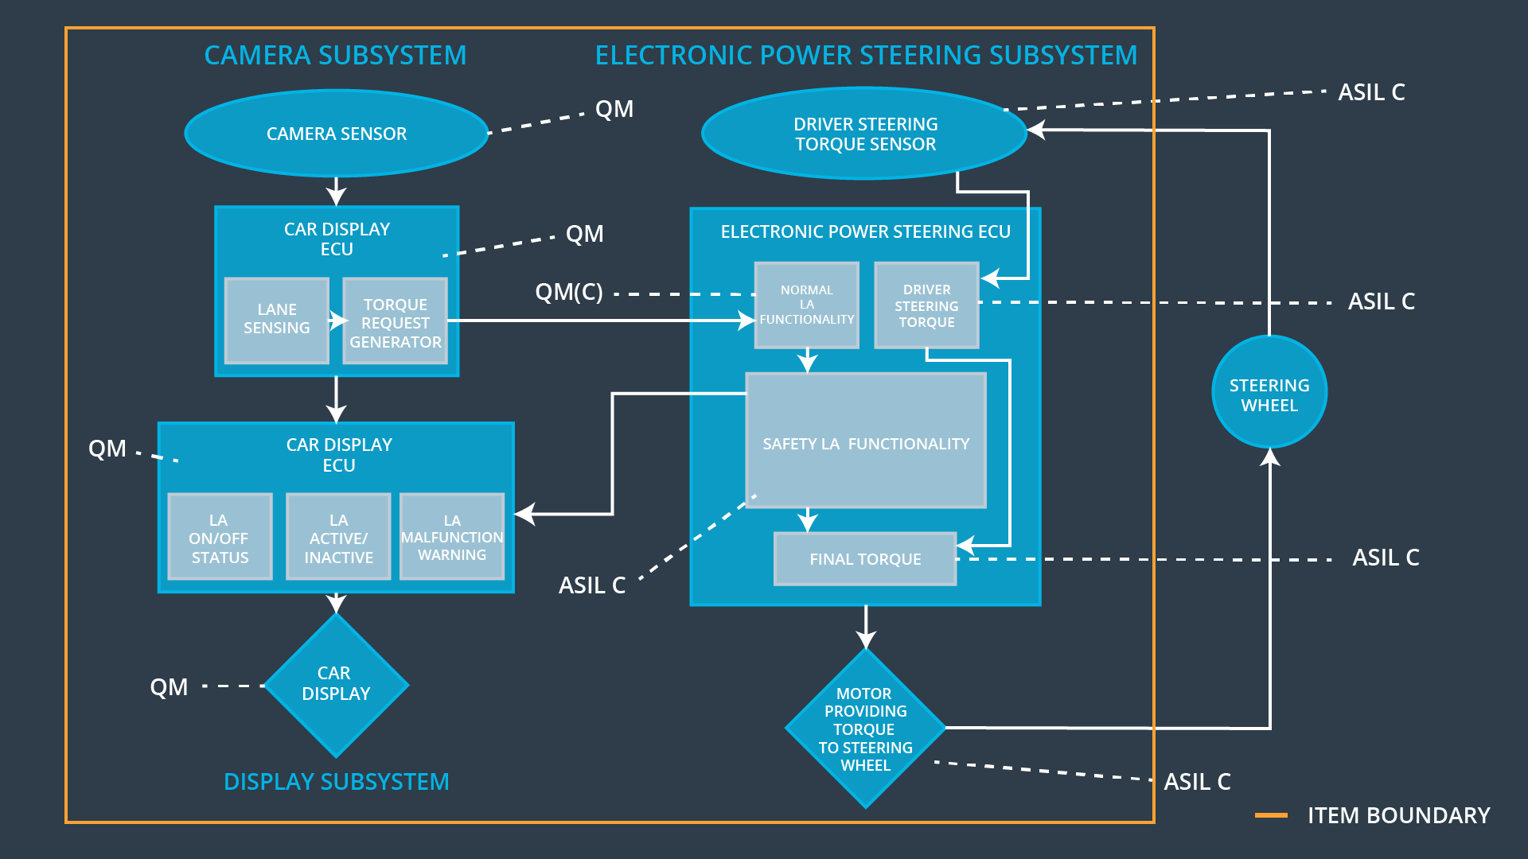

## Allocation of Functional Safety Requirements to Architecture Elements

|  |  |  |  |  |
| --- | --- | --- | --- | --- |
| **ID** | **Functional Safety Requirement** | **Electronic Power Steering ECU** | **Camera ECU** | **Car Display ECU** |
| Functional  Safety  Requirement  01-01 | The Electronic Power Steering ECU shall ensure that the lane departure oscillating torque amplitude is below Max_Torque_Amplitude. | **X** |  |  |
| Functional  Safety  Requirement  01-02 | The Electronic Power Steering ECU shall ensure that the lane departure oscillating torque frequency is below  Max_Torque_Frequency. | **X** |  |  |
| Functional  Safety  Requirement  01-03 | The Electronic Power Steering ECU shall deactivate the Lane Departure Warning function when the camera sensor stops working. | **X** |  |  |
| Functional  Safety  Requirement  02-01 | The Electronic Power Steering ECU shall ensure that the time duration for steering assistance is below Max_Assist_Time | **X** |  |  |
| Functional  Safety  Requirement  02-02 | The Electronic Power Steering ECU shall ensure that the lane assist torque amplitude is below Max_Assist_Amplitude. | **X** |  |  |

## Warning and Degradation Concept

|  |  |  |  |  |
| --- | --- | --- | --- | --- |
| **ID** | **Degradation Mode** | **Trigger for Degradation Mode** | **Safe State invoked?** | **Driver Warning** |
| WDC-01 | Turn off Lane  Departure  Warning  functionality | Malfunction_01,  Malfunction_02,  Malfunction_05 | Yes | Lane  Departure  Warning  Malfunction  Warning on  Car Display |
| WDC-02 | Turn off Lane  Keeping  Assistance  functionality | Malfunction_03,  Malfunction_04 | Yes | Lane Keeping  Assistance  Malfunction  Warning on  Car Display |