**Day 5: Understanding Core Concepts – JDK vs JRE vs JVM & POP vs OOP**

**1️. POP vs OOP**

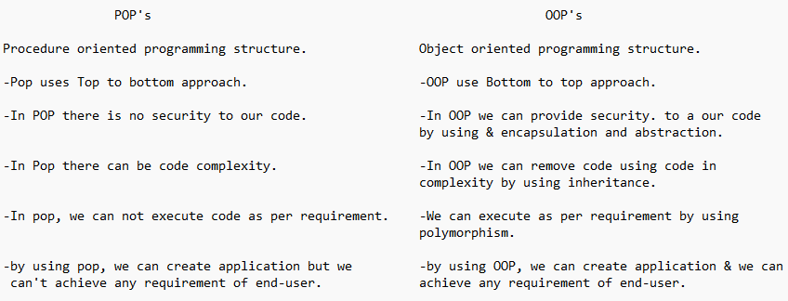

**2️. JDK vs JRE vs JVM**

**JDK vs JRE vs JVM.**

**JDK (Java Development kit)**

- JDK contains Development tools

- developments tools contains keywords, JRE, libraries, java commands.

- JDK is responsible to build Java application

**JRE (Java Runtime Environment)**

- Java is responsible to execute java application

- JRE is set of java libraries.

**JVM (Java virtual machine)**

- JVM is a virtual machine is not available physically

- JVM is a set of classes & interfaces which is actual responsible to execute java application.

