<https://www.youtube.com/playlist?list=PLR0uCBk15bq9DNfKBvhTyleC5p4b0AyTY>

* Difference between React and Angular

<https://www.guru99.com/react-vs-angular-key-difference.html>

* AngularJS is a (javascript) structural framework for developing dynamic web apps, whereas React is a JavaScript library that allows you to build UI components.
* Angular JS is based on MVC (Model View Controller) whereas (Angular is based on Real DOM) React is based on Virtual DOM(Document Object Model).
* Angular is based on Typescript and React is based on JavaScript.
* AngularJS doesn’t allows adding JavaScript library to the source code while React allows adding JavaScript library to the source code.
* AngularJS provides testing and debugging for a complete project with a single tool whereas React requires a set of tools to perform different types of testing.
* Angular JS was released in 2010 by Google whereas React JS was released in 2013 and maintained by Facebook.
* Current version: Angular - 14, React JS - 18.
* Angular is complete solution itself while React JS can be packaged with other programming libraries.
* Companies using: Angular - Wepay, Beam, Mesh etc. React JS - Facebook, Instagram, Netflix, etc.
* Template: Angular - HTML + Typescript. React JS - JSX(Javascript XML) + (ES5/ES6).
* Angular: Two-way data binding (but supports one-way data binding with “[ ]”). React: One-way data binding (but supports two-way data binding with ReactLink).

(Both used for single page web apps, free and open source)

(Angular JS, React JS uses Javascript, while angular uses typescript).

React.js

1. React.js introduction and Prerequisite

* React Native to develop apps for cross platform like android and ios.
* Wappalyzer: Extension to see technologies used in website.
* Single page website: flipkart – don’t need to reload. Multi page website: NASA – need to reload.
* React

<https://reactjs.org/>

* Create React App

npx create-react-app my-app

cd my-app

npm start

eslint- config error

Had the same problem with the name case. When creating the project, had named it "React2", but VS ignored my case and named the project's folder "react2" (lowercase) instead. The solution was to:

1. Close Visual Studio.
2. Rename the folder. That is, make the case match the project name. (From a git-bash shell: mv react2 React2 to fix the name case.)
3. Open Visual Studio, and try again.
   1. React Movie Website Using Props

* If you want to use javascript in JSX you need to add {}
* Use of map function

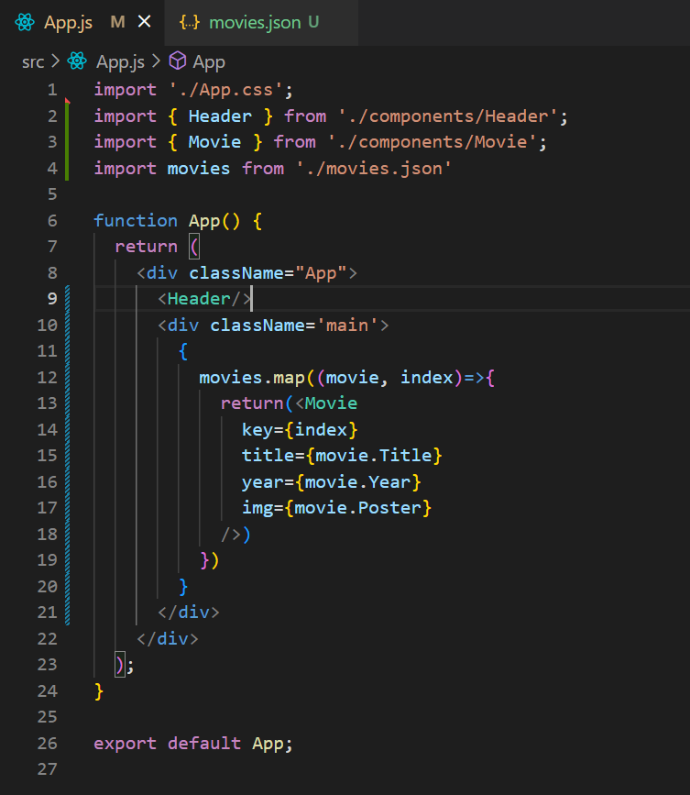

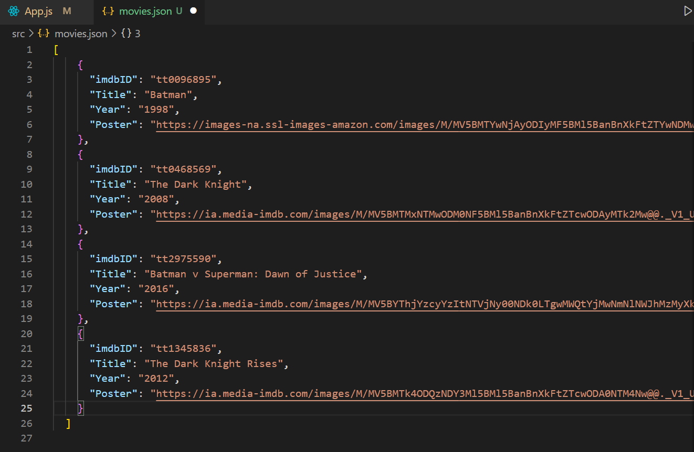

* 1. React-Developer-Tools, Ternary Operator, If-Else in JSX
* React-Developer-Tools: Extension to see components in website.

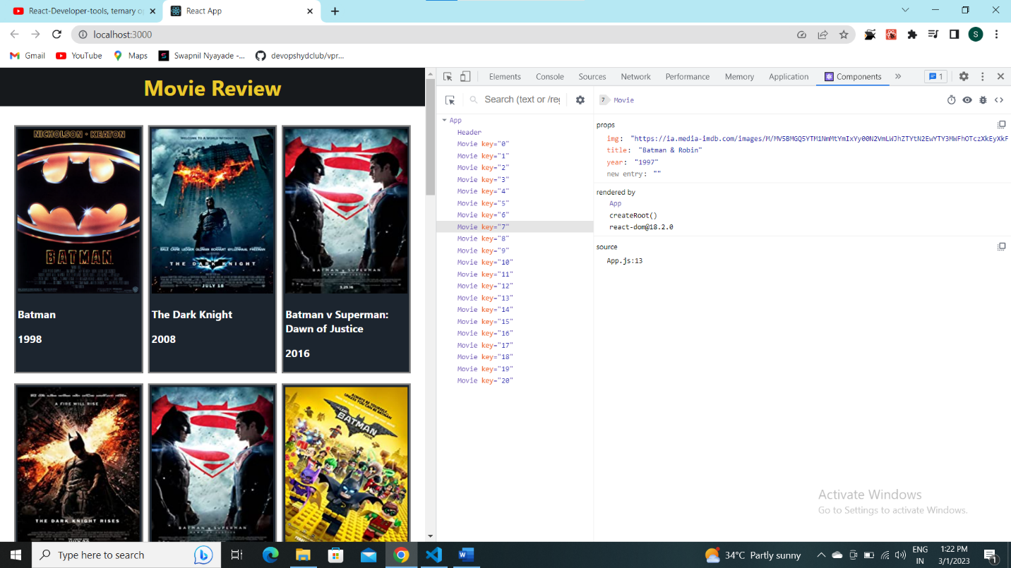

* Ternary operator in JSX

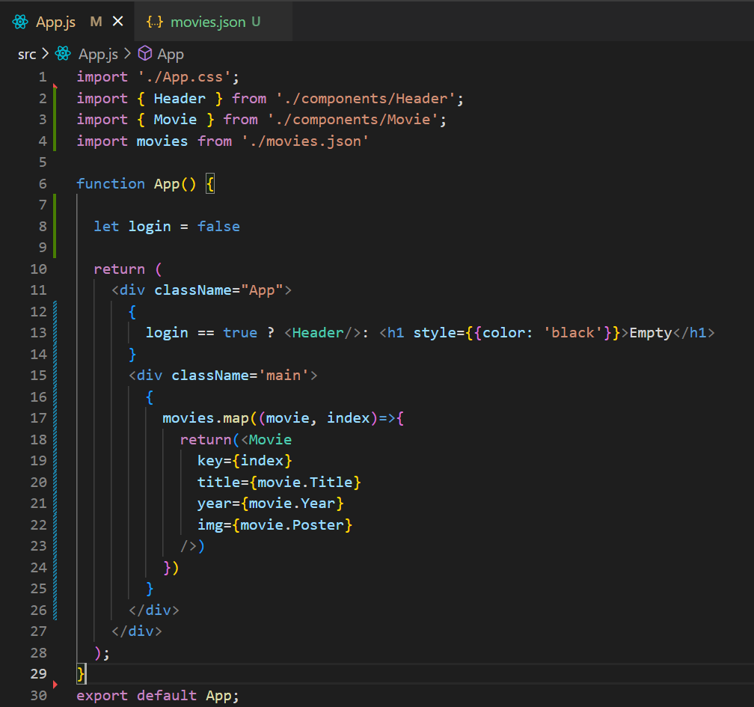

* If Else in JSX

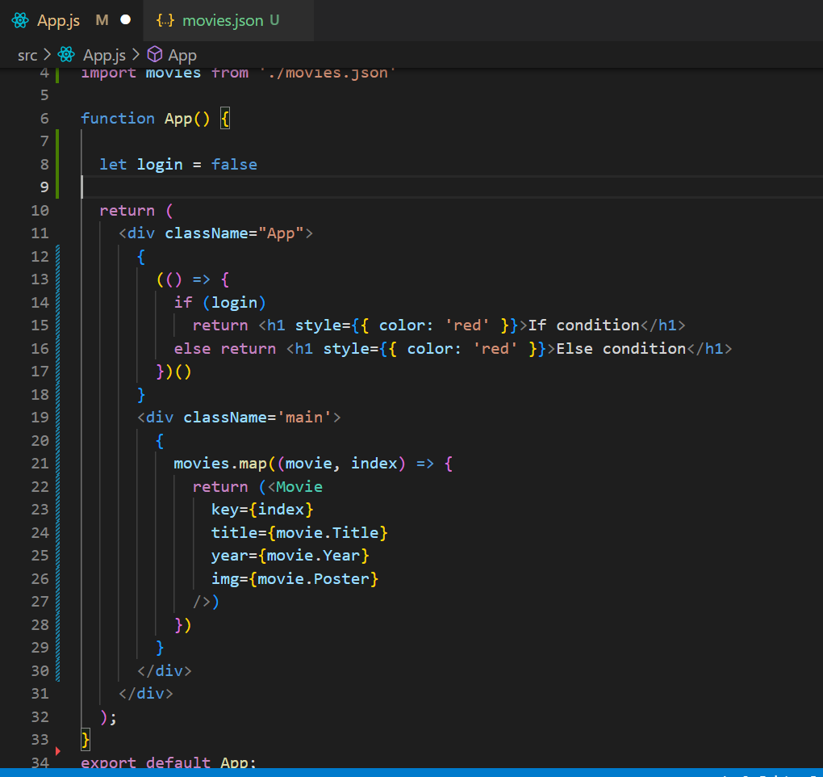

* Object destructuring in javascript

