There the five types of inheritance as below

1. Single inheritance
2. Multilevel inheritance
3. Hierarchical inheritance
4. Multiple inheritance
5. Hybrid inheritance
6. **Simple or Single inheritance**

In this only one super class and only one sub class called as single.

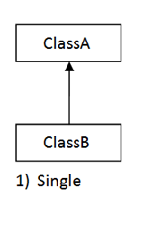

**package** com.inheritance;

**public** **class** Insurance {

**void** getInsuranceDetails() {

System.***out***.println("this is insurance details..");

}

}

**package** com.inheritance;

**public** **class** HealthInsurance **extends** Insurance {

**void** getHealthInsuranceDetails() {

System.***out***.println("this is health insurance details.");

}

}

**package** com.inheritance;

**public** **class** TestMain {

**public** **static** **void** main(String[] args) {

HealthInsurance healthInsurance = **new** HealthInsurance();

healthInsurance.getInsuranceDetails();

healthInsurance.getHealthInsuranceDetails();

}

}

Output

this is insurance details..

this is health insurance details.

1. **Multilevel inheritance**

It has only one base class and multiple derived class called as multilevel. Or it refers to the concept of one class extending (Or inherits) more than one base class.

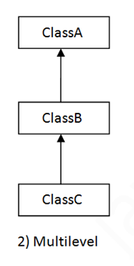

**package** com.inheritance;

**public** **class** Account {

**void** getAccountDetails() {

System.***out***.println("this is account details..");

}

}

**package** com.inheritance;

**public** **class** CurrentAccount **extends** Account {

**void** getCurrentAccountDetails() {

System.***out***.println("this is current account details");

}

}

**package** com.inheritance;

**public** **class** SavingAccount **extends** CurrentAccount {

**void** getSavingAccountDetails() {

System.***out***.println("this is saving account details");

}

}

**package** com.inheritance;

**public** **class** TestMain {

**public** **static** **void** main(String[] args) {

SavingAccount savingAccount = **new** SavingAccount();

savingAccount.getAccountDetails();

savingAccount.getCurrentAccountDetails();

savingAccount.getSavingAccountDetails();

}

}

Output

this is account details..

this is current account details

this is saving account details

1. **Hierarchical inheritance**

One class is inherited by many sub classes called as.

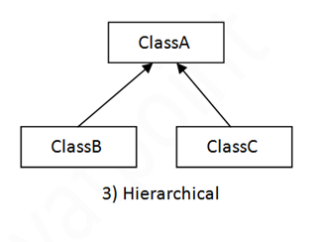

**package** com.inheritance;

**public** **class** Loan {

**void** getLoanDetails() {

System.***out***.println("this is loan details");

}

}

**package** com.inheritance;

**public** **class** HomeLoan **extends** Loan {

**void** getHomeLoanDetails() {

System.***out***.println("this is home loan details..");

}

}

**package** com.inheritance;

**public** **class** PersonalLoan **extends** Loan {

**void** getPersonalLoanDetails() {

System.***out***.println("this is personal loan details");

}

}

**package** com.inheritance;

**public** **class** CarLoan **extends** Loan {

**void** getCarLoanDetails() {

System.***out***.println("this is car loan details.");

}

}

**package** com.inheritance;

**public** **class** TestMain {

**public** **static** **void** main(String[] args) {

HomeLoan homeLoan = **new** HomeLoan();

CarLoan carLoan = **new** CarLoan();

PersonalLoan personalLoan = **new** PersonalLoan();

homeLoan.getHomeLoanDetails();

carLoan.getCarLoanDetails();

personalLoan.getPersonalLoanDetails();

}

}

Output

this is home loan details..

this is car loan details.

this is personal loan details

1. **Multiple inheritance**

One class has many super classes called as multiple inheritance.

Why multiple inheritance not supported in java in case of classes?

Class base has test () method and class derived has also test () method. Class test extends Base, Derived, which test method It will called, so it create the ambiguity so that’s why multiple inheritance does not supports in java.

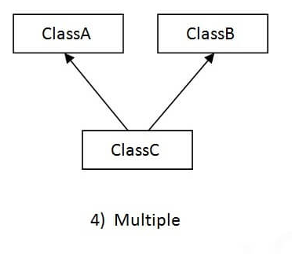

**package** com.multiple.inheritance;

**public** **class** A {

**void** m1() {

}

}

**package** com.multiple.inheritance;

**public** **class** B {

**void** m1() {

}

}

**package** com.multiple.inheritance;

**class** C **extends** A,B {

**public** **static** **void** main(String[] args) {

C c= **new** C();

c.m1();

}

}

Note- it will get the compile time error.

1. **Hybrid inheritance**

It is the combination of single and multiple inheritance. So it is not allowed in java.

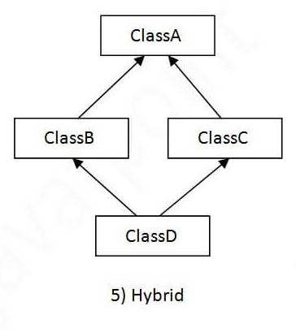

**Aggregation (Has Relationship)**

If class has entity reference, it is known as Aggregation. It represents Has-A relationship.

Example-

**package** com.test;

**public** **class** Employee {

**private** **int** id;

**private** String firstName;

**private** String lastName;

**private** String mobileNumber;

**private** Address address;

**public** **int** getId() {

**return** id;

}

**public** **void** setId(**int** id) {

**this**.id = id;

}

**public** String getFirstName() {

**return** firstName;

}

**public** **void** setFirstName(String firstName) {

**this**.firstName = firstName;

}

**public** String getLastName() {

**return** lastName;

}

**public** **void** setLastName(String lastName) {

**this**.lastName = lastName;

}

**public** String getMobileNumber() {

**return** mobileNumber;

}

**public** **void** setMobileNumber(String mobileNumber) {

**this**.mobileNumber = mobileNumber;

}

**public** Address getAddress() {

**return** address;

}

**public** **void** setAddress(Address address) {

**this**.address = address;

}

// getter and setter

}

**package** com.test;

**public** **class** Address {

**private** String streetNo;

**private** String city;

**private** String state;

**private** String country;

**public** String getStreetNo() {

**return** streetNo;

}

**public** **void** setStreetNo(String streetNo) {

**this**.streetNo = streetNo;

}

**public** String getCity() {

**return** city;

}

**public** **void** setCity(String city) {

**this**.city = city;

}

**public** String getState() {

**return** state;

}

**public** **void** setState(String state) {

**this**.state = state;

}

**public** String getCountry() {

**return** country;

}

**public** **void** setCountry(String country) {

**this**.country = country;

}

}

**package** com.test;

**import** java.util.Scanner;

**public** **class** Test {

**public** **void** getUserDetails() {

Scanner scanner = **new** Scanner(System.***in***);

System.***out***.println("Enter employee id>>");

**int** id = scanner.nextInt();

System.***out***.println("Enter employee first name>>");

String firstName = scanner.next();

System.***out***.println("Enter employee last name>>");

String lastName = scanner.next();

System.***out***.println("Enter employee mobile number>>");

String mobileNumber = scanner.next();

System.***out***.println("Enter street no>>");

String streetNo = scanner.next();

System.***out***.println("Enter city>>");

String city = scanner.next();

System.***out***.println("Enter state>>");

String state = scanner.next();

System.***out***.println("Enter country>>");

String country = scanner.next();

// set the value into employee object here

Employee employee = **new** Employee();

employee.setId(id);

employee.setFirstName(firstName);

employee.setLastName(lastName);

employee.setMobileNumber(mobileNumber);

// set value into address object here

Address address = **new** Address();

address.setStreetNo(streetNo);

address.setCity(city);

address.setState(state);

address.setCountry(country);

//set address object into employee object

employee.setAddress(address);

// get the value from employee object here

System.***out***.println("Employee ID>>" + employee.getId());

System.***out***.println("Employee First Name>>" + employee.getFirstName());

System.***out***.println("Employee Last Name>>" + employee.getLastName());

System.***out***.println("Employee Mobile Number>>" + employee.getMobileNumber());

System.***out***.println("Employee Street No>>" + employee.getAddress().getStreetNo());

System.***out***.println("Employee City>>" + employee.getAddress().getCity());

System.***out***.println("Employee State>>" + employee.getAddress().getState());

System.***out***.println("Employee Country>>" + employee.getAddress().getCountry());

}

**public** **static** **void** main(String[] args) {

Test test = **new** Test();

test.getUserDetails();

}

}

Output

Enter employee id>>

10

Enter employee first name>>

Ajay

Enter employee last name>>

pawar

Enter employee mobile number>>

8595958575

Enter street no>>

3

Enter city>>

pune

Enter state>>

maharashtra

Enter country>>

india

Employee ID>>10

Employee First Name>>Ajay

Employee Last Name>>pawar

Employee Mobile Number>>8595958575

Employee Street No>>3

Employee City>>pune

Employee State>>maharashtra

Employee Country>>india