**Kmap Solver**

Kmap is technique use in Digital logic to minimize given expression.

Here 3 variable Kmap code is present. Where we can give input the min. term and at output we will get all the expression of prime implements.

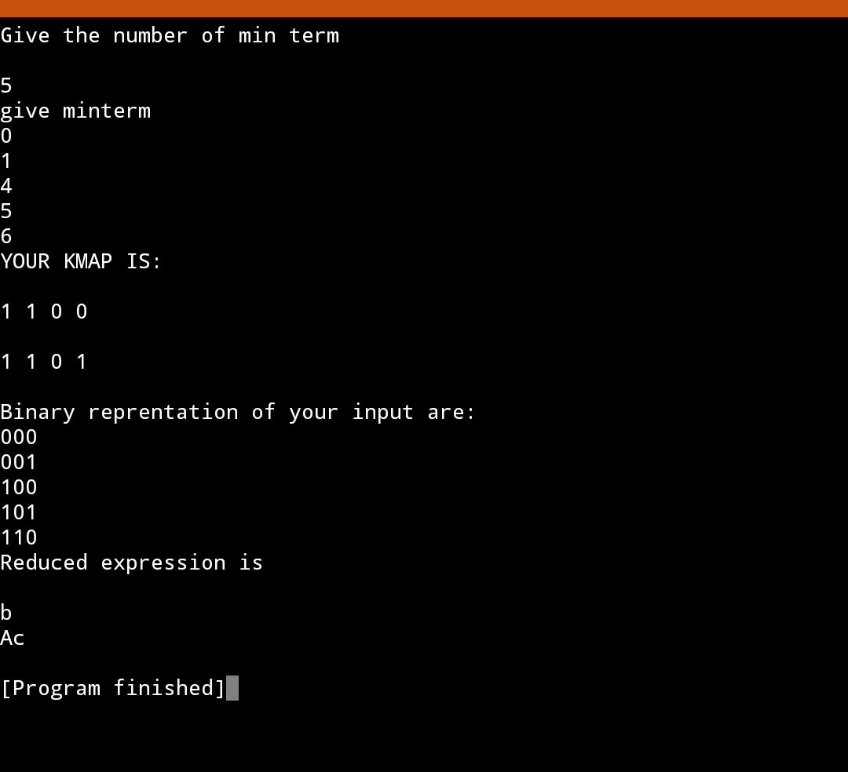

Note: Here only prime implements are given , not essential prime implements.