This project takes input from HTML file , pass to servlet , and servlet passes request-response back to JSP page , which generate Resume

**IMPORTANT:**

Registration page: <https://www.roseindia.net/html/how-to-create-student-registration-form-with-html-code.shtml>

CV page: http://www.thomashardy.me.uk/free-responsive-html-css3-cv-template

This are free html templetes I have used, I made all requirement changes according to our project, All Thanks to both sites.

Input

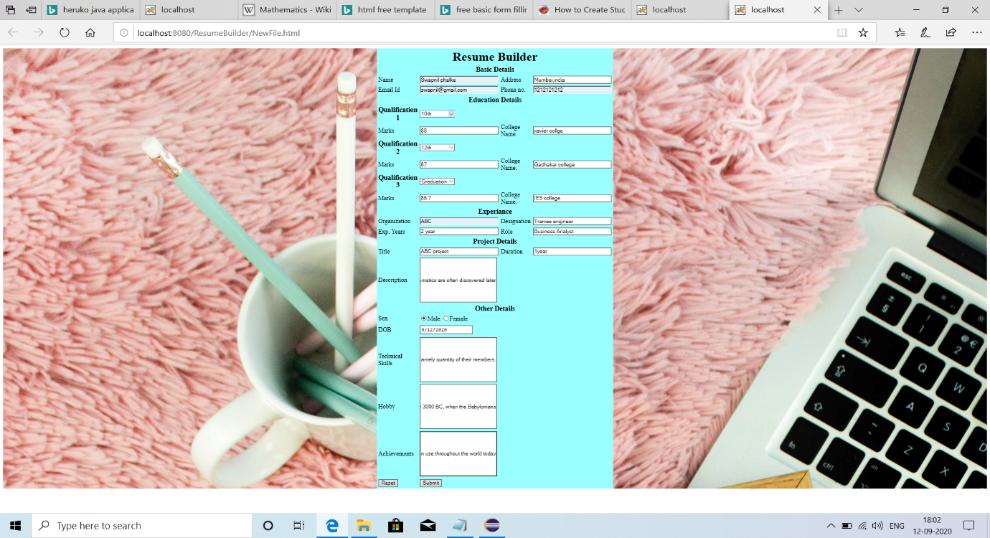

Output

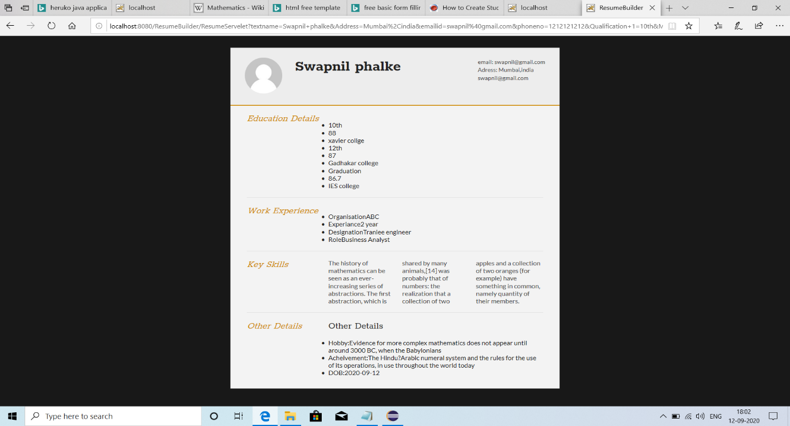

What more needs to be done:

Validation

Changes in JSP so that if dropdown is null, it will not print anything

Image import