

MATHS CHALLENGE

Hi I am Swapnil Rane. Thanks for purchasing the asset.

For any query fell free to contact me

:- [madfireongames@gmail.com](mailto:madfireongames@gmail.com)

Scene Order

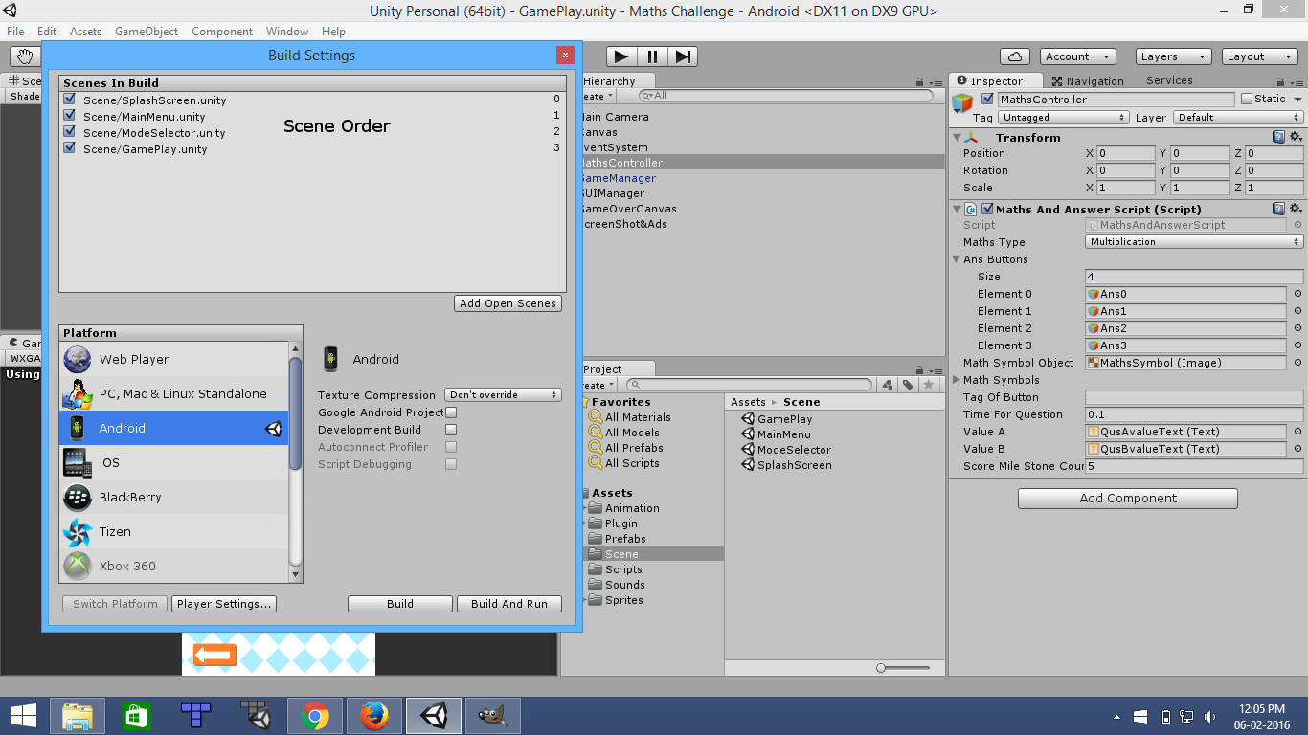

The order of scenes must be similar to the image. SplashScreen is not is the asset , its not the important part .

Share Screen

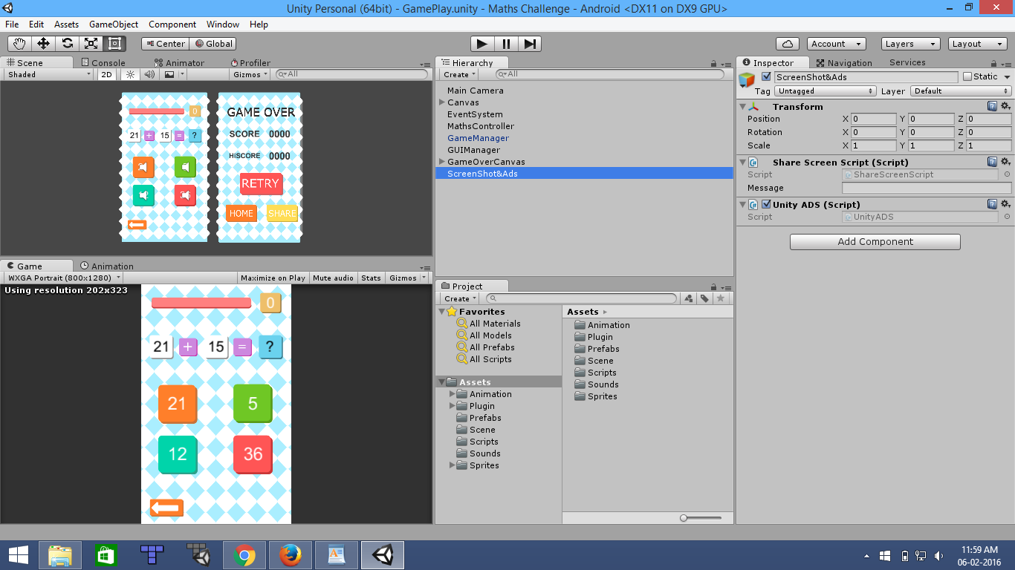

In the GamePlay scene create the new game object and name it ShareScreen and attach the ShareScreenScript which is in script folder to that object.

Maths And Question Manager

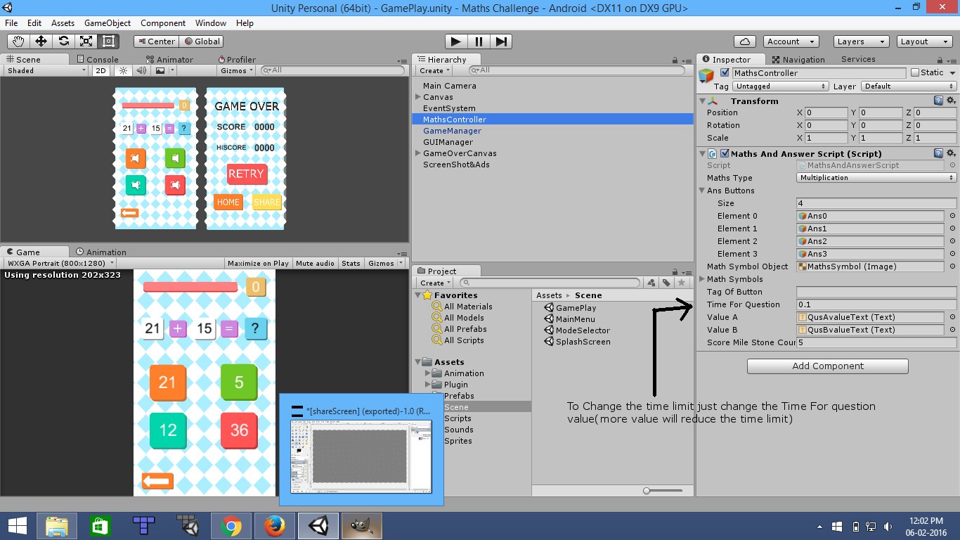

MathsManager game object controls the question , values assigned to the ans button , timer , milestone etc.

Scripts

All the scripts are commented , each and every line is explaned , if you have any problem feel free to contact me at [madfireongames@gmail.com](mailto:madfireongames@gmail.com). If you want any update to be done like adding Ads , implementing separate FB and Twitter button contact me.

Thank You For Purchasing The Asset