Rage Ride

Thank you for buying my asset , if you have any problem contact me at madfireongames@gmail.com.

Scripts
- CameraFollow: This make camera to follow player.
- SimpleCameraShake: This make camera shake when player dies.
- Juice: This controls the juice functions.
- Meteor: This controls the meteor movement.
- ObjectSpawner: This spawns the meteor and juice randomly in the game.
- PlayerCOntroller: This controls the movement and other functions of player.
- SpawnFollower: This make the spawner to follow the player.
- MeteorSpawnerMenu: This spawn meteor in the main menu.
- GameController: This controls the entire game , it also save and load data on device.
- InGameGui: This controls the in game gui.
- MainMenuManager: This controls the main menu gui.
- ObjectPooling: This spawn the required object in the scene and reuses them as per requirement.
- CreateScrollList: This script decide how many player buttons to create , there cost , description , ship image etc.
- SampleButton: This script is attached to the sampleButton prefabs which are created when game start. It controls the behaviour of button.
- ShipSelector: This controls the small menu in main menu where we select the ship.
- GooglePlayServices: This controls the playe services like leaderboard and achievements.
- PlayerSpawner: This decide which player to spawn depending on which player is selected in main menu.
- AdManager: This controls the unity ads and Admob.

GameController

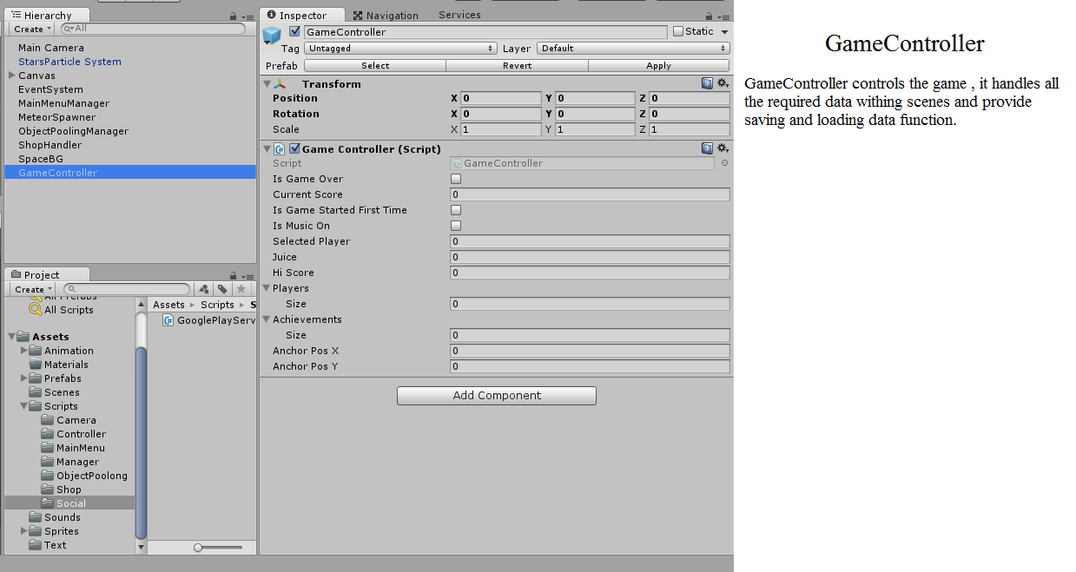

GooglePlayService

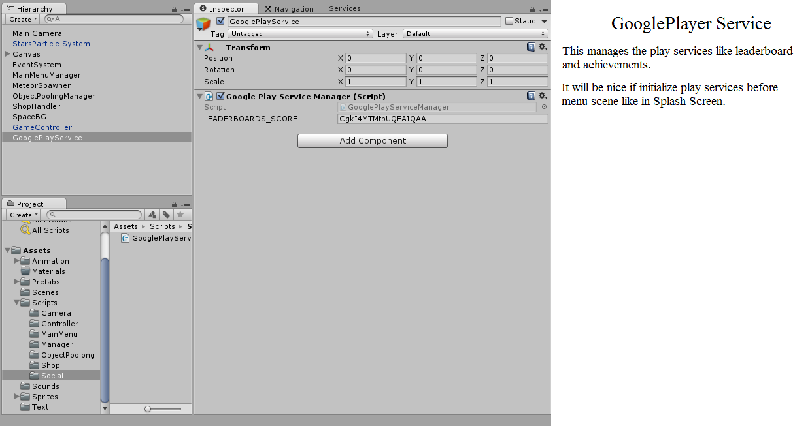

InGameGUI

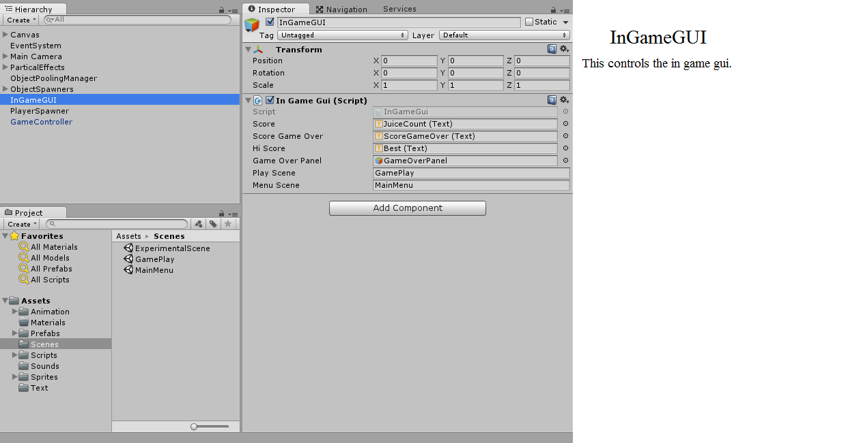
MainMenuManager

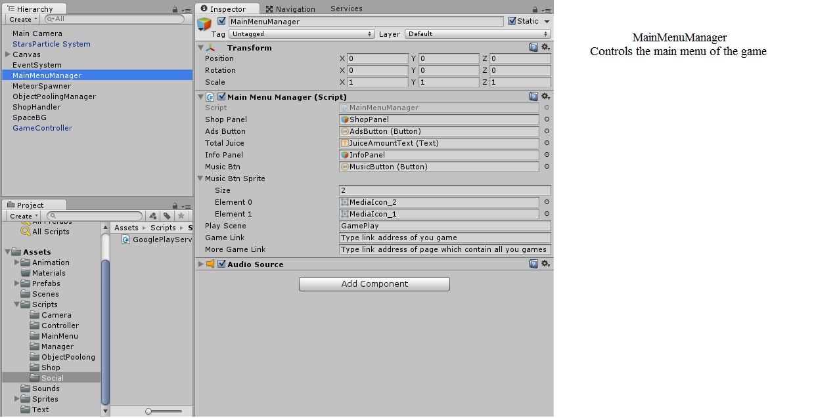

ObjectPooling

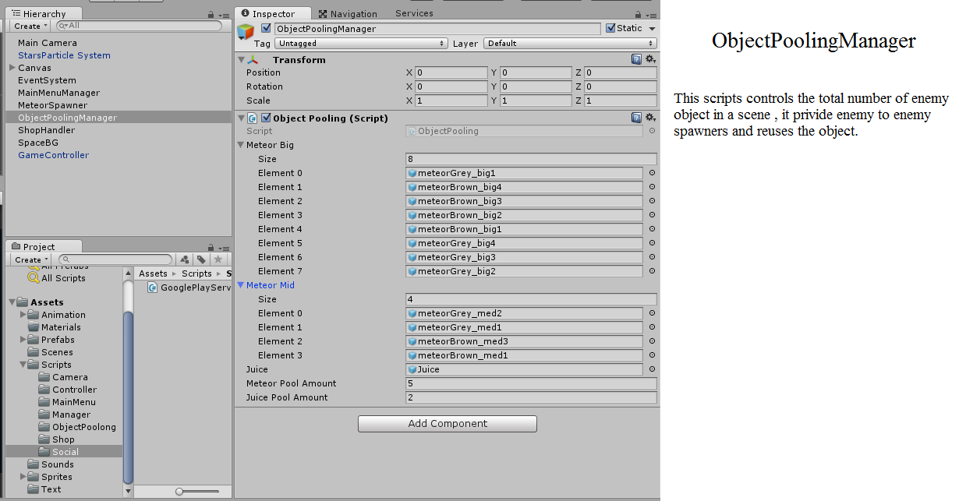

ObjectSpawner

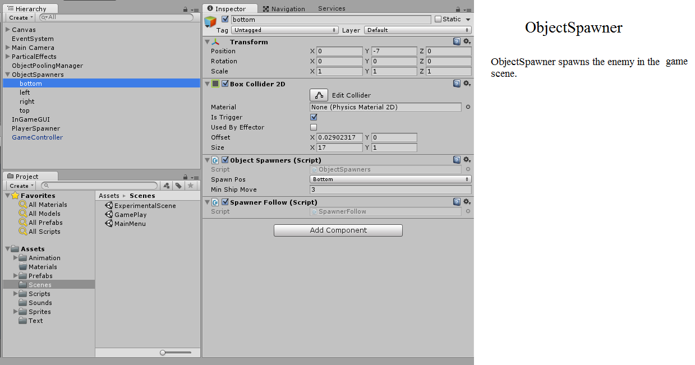

PlayerSpawner

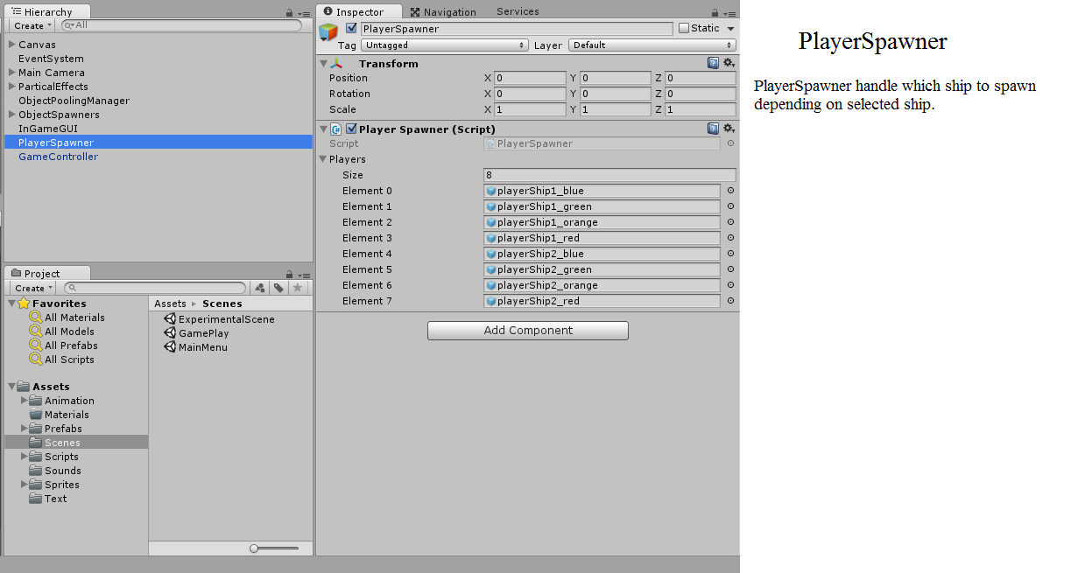
ShopHandler

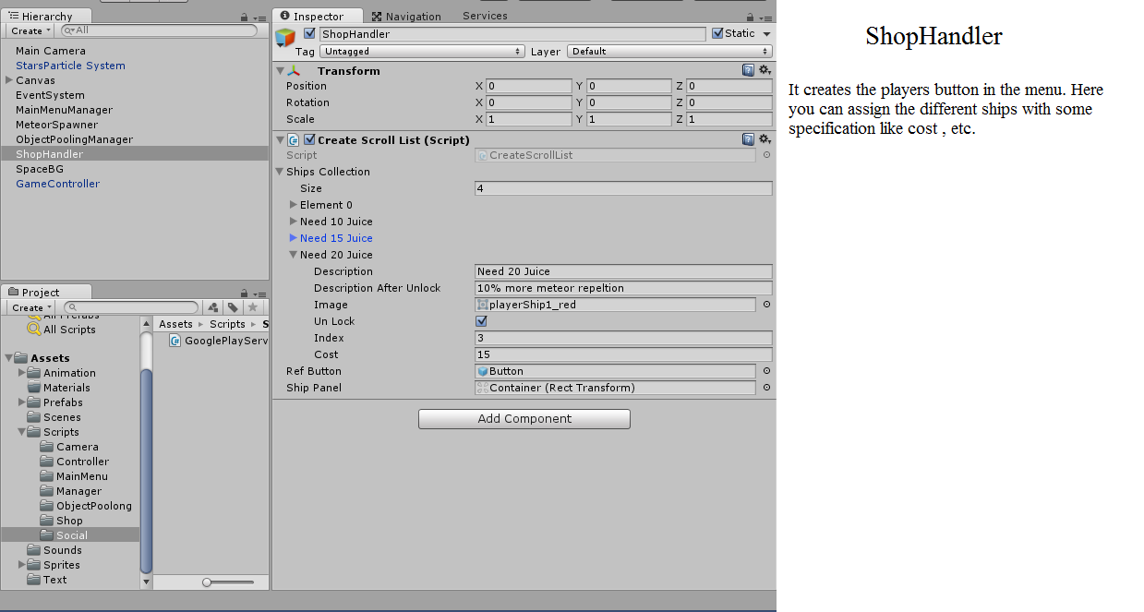

Thanks again for purchasing the asset , need help contact me at madfireongames@gamil.com.

