
Thank you for purchasing my asset , if you have any problem contact me at madfireongames@gmail.com.

Scripts
1. AdManager – This script controls the UnityAds and Admob Ads.
2. GameManager – This script controls the working of game play scene like scoring , game play menu , controlling questions etc.
3. GooglePlayInGame – This controls the google play service like leaderboard.
4. MenuManager – This controls the main menu of game.
5. Question – This provide the basic structure for the question and answer.
6. QuestionContainer – This script extract the data from xml file and provide it to game manager.
7. questions.xml – This is the file where all the questions and answer data is store. To change game question just change the data of this file.

AdsManager
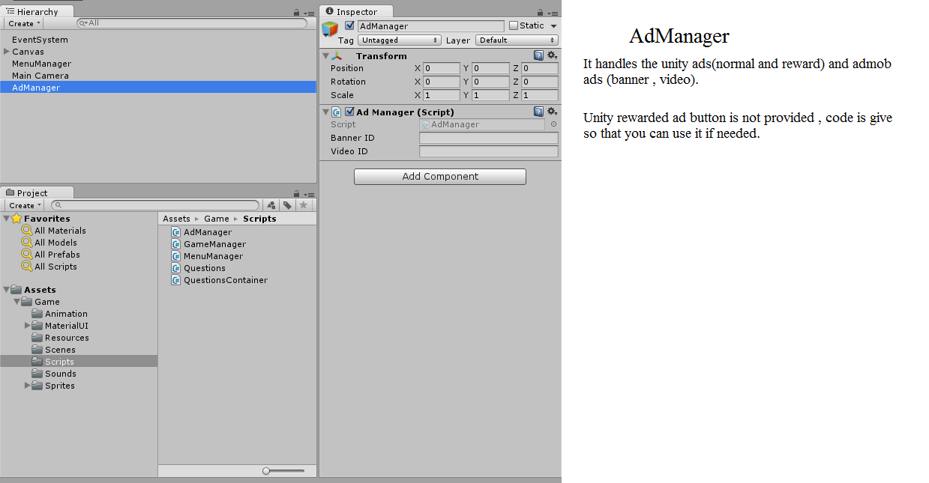
To use ads you need to import unityAds and Admob
sdk. And same for google play services.

GameManager
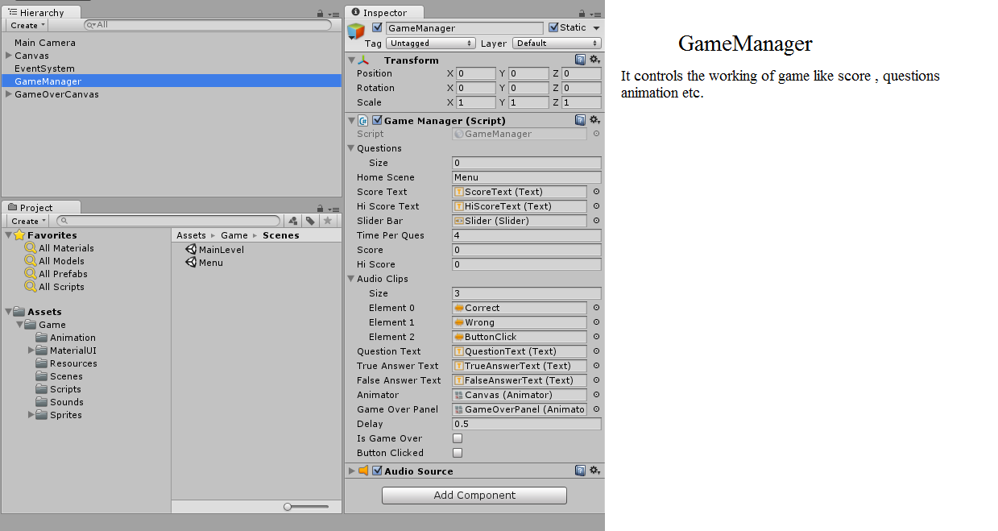

MenuManager
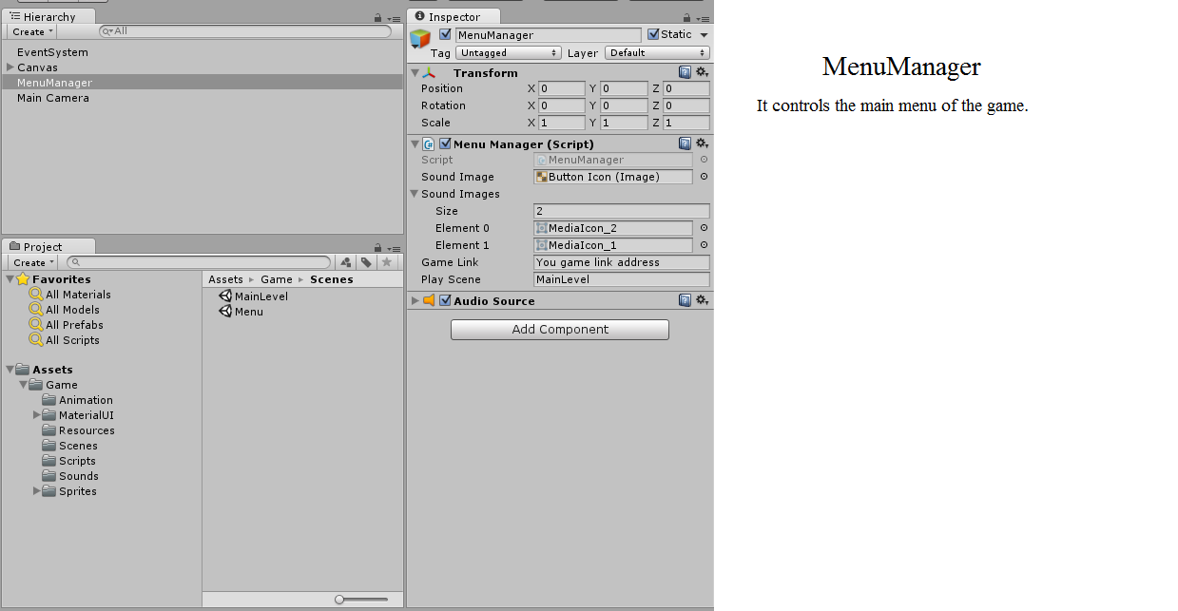

Thank again you for purchasing my asset , if you have any problem contact me at madfireongames@gmail.com.

