NAARIKSHA - A WOMEN SAFETY APP using Scream Detection

*Prof. Dr. Nilesh Patil\**,*Marwin Shroff, Shubh Panchal*, *Swapnil Shah*, and *Vanshita Jain*

***Abstract-* The women safety app is a mobile application designed to enhance the safety of women by detecting screams and alerting authorities or emergency contacts in the event of an attack or emergency situation. The app utilizes advanced scream detection technology to analyze audio signals in real-time and determine if a scream has been detected. Once a scream is detected, the app will send an alert to emergency contacts or authorities, along with the location of the user, allowing for swift action to be taken. The app also includes other safety features such as location tracking, live audio and video recording, and the ability to connect with emergency services directly from the app. This app is a powerful tool for promoting women's safety and preventing violence against women in our communities.**

***Keywords***: Employee; Scream detection, ANN, CNN, GPS, APIs

I. Introduction

The safety of women is a pressing issue in today's society, with women facing various forms of violence and harassment on a daily basis. To address this issue, a women safety app has been developed which aims to enhance women's safety by utilizing advanced technology. This mobile application has the capability to detect screams and alert authorities or emergency contacts in the event of an attack or emergency situation. The app also provides other safety features, such as location tracking, live audio and video recording, and the ability to connect with emergency services directly from the app. With the help of this app, women can feel more secure and confident while going about their daily routines. This app is a powerful tool for promoting women's safety and preventing violence against women, and is an important step towards building a safer and more secure community for women.

*1.1. Need of the Project*

The need for this project arises from the unfortunate reality that women face a significant risk of violence and harassment in various situations. This includes walking alone at night, using public transportation, traveling to unfamiliar places, and more. Traditional methods of ensuring safety, such as carrying pepper spray or alarms, are not always effective in emergency situations. Therefore, there is a need for a technological solution that can enhance women's safety and security.

The proposed women safety app, which uses scream detection, has the potential to detect emergency situations and immediately notify relevant authorities, making it a valuable tool for ensuring women's safety. The use of machine learning algorithms such as SVM can improve the accuracy of the app in detecting distress screams. Additionally, the app can incorporate geofencing algorithms to track a user's location and send alerts to emergency contacts in case of any abnormal activity. Integration with Google Maps API can also help users navigate to safe locations and avoid potential danger zones.

Overall, the women safety app has the potential to provide a sense of security for women, especially in high-risk situations. It can serve as a tool to deter potential attackers and provide quick response in emergency situations. Therefore, the need for this project is paramount to ensure the safety and well-being of women.

*1.2. Drawbacks in the existing technologies*

The drawbacks in existing technologies are:

1. Lack of quick response helpline: In most existing technologies, there is no provision for a quick response helpline that can immediately help women in emergency situations.

2. Outdated technologies: Many of the existing applications for women's safety are based on outdated technologies that haven't been updated for a long time. As a result, they are often incompatible with modern devices and poor in quality.

3. Location information required: Most existing technologies require the user to provide information about their current location and other details to the operator. This can be time-consuming and may not be possible in some emergency situations.

4. Sound sensor threshold: The sound sensors used in some existing technologies have a threshold value of 2540dB, which can easily be reached in noisy environments such as heavy traffic areas. This can lead to false alarms and reduce the effectiveness of the technology.

5. Lack of loud alarm: Some existing technologies do not provide a loud alarm feature in case of emergency, which can make it difficult for people in the vicinity to be alerted.

6. Preconfigured voice detection: Some existing technologies rely on preconfigured voice detection, which judges the voice based on a pre-set pitch. However, in emergency situations, if the pitch of the voice does not match the pre-set pitch, the

scream detection feature may not work.

The limitations of existing technologies for women's safety highlight the need for a more modern and effective solution that can overcome these shortcomings. The development of a women's safety app with scream detection technology can help address some of these issues and provide a more reliable and efficient means of ensuring women's safety.

*1.3. Applications of the product*

The applications of this application includes:

1. Smart Scream detection which automatically eliminates other noise and only detects scream.

2. Loud alarm with AI detection

3. Geofencing to mark safe boundaries on the app.

4. A map which marks all nearby police stations and other amenities through the user’s live location.management.

5. Live Tracking: The app can use GPS to track the user’s real-time location, which can help friends and family members to monitor the user's movements and take necessary actions in case of an emergency.

6. One-click Emergency Services: The app can have a one-click emergency services feature, which can instantly connect the user with the nearest police station, ambulance, or hospital in case of an emergency.

7. Fake Call Feature: This feature can allow users to trigger a fake call to their phone in case they feel unsafe, which can help them to create a distraction or an excuse to leave the situation.

8. Offline Access: The app can provide offline access to critical features like scream detection and emergency services, which can be useful in areas with poor network connectivity.

9. Customized Notifications: The app can send customized notifications to the user, depending on their location and the time of day. For instance, the app can send a notification when the user is walking alone in a dark alley, reminding them to stay alert.

10. Community-driven: The app can be designed as a community-driven platform, where users can share their experiences, report incidents, and provide support to each other.

11. Wearable Integration: The app can integrate with wearable devices like smartwatches or fitness bands, which can trigger an alarm or notify emergency services in case of an unusual activity or distress signal.

12. Language Translation: The app can support multiple languages, which can be useful for non-native speakers or tourists who may find it difficult to communicate in the local language during an emergency.

By incorporating these features and leveraging the latest technologies like AI and geofencing, a women safety app can provide a holistic and efficient solution to address the safety concerns of women in various situations.

*1.4. Novelty*

The women safety app is a novel solution that addresses the critical need for promoting women's safety and reducing instances of violence against women. The app is designed to offer advanced technology-based features, including scream detection, location tracking, live audio and video recording, and emergency alert systems, making it a comprehensive safety tool for women. The app's most significant novelty is its smart scream detection feature, which uses machine learning and speech recognition technology to identify and distinguish screams from other sounds accurately. This feature enables the app to detect and respond to dangerous situations promptly, automatically sending alerts to emergency contacts or authorities. This ability can potentially save lives and prevent harm to women. Another innovative feature of the app is its geofencing capability, which marks safe boundaries on the app, allowing women to navigate and stay within safe areas. This feature is particularly helpful for women who travel alone, providing them with a real-time map of their location, nearby police stations, and other essential amenities. The app also offers a loud alarm with AI detection, which can be activated manually or triggered automatically in case of an emergency. The alarm can attract attention and alert people nearby, potentially deterring the perpetrator and allowing the victim to escape.

Additionally, the app includes live audio and video recording features, which can provide crucial evidence in the event of an assault or harassment. The recordings can be used as evidence in court, supporting victims in seeking justice. Overall, the women safety app's novelty lies in its innovative use of advanced technologies, including machine learning, speech recognition, and GPS tracking, to create a comprehensive safety tool for women. The app's ability to detect screams accurately, track locations, and offer real-time emergency alerts can potentially save lives and prevent harm, making it a valuable tool in promoting women's safety.

*1.5. Scope of the project*

The scope of the women safety app project is to develop a robust and user-friendly application that will help ensure women's safety in different situations. The project will involve extensive research on the latest technologies and trends related to women's safety and the development of algorithms for scream detection and speech recognition. The app will provide a range of features, including location tracking, real-time audio and video recording, and an emergency alert system. The project will also involve collaboration with relevant stakeholders, including women's safety organizations, law enforcement agencies, and government bodies. Feedback from these stakeholders will be used to ensure that the app meets the needs of the target audience globally. The project will be developed using agile methodology, with regular testing and feedback to ensure that the app meets the highest quality standards. The app will be designed to work seamlessly across different platforms, including iOS and Android, and will be optimized for different screen sizes. In addition, the project will incorporate robust data security measures to ensure that users' personal information is kept secure and confidential. The app will be compliant with relevant data protection regulations, and user data will be stored securely using encryption technologies. Overall, the scope of the women safety app project is to develop a comprehensive safety solution that utilizes the latest technology to help ensure women's safety and well-being.

*2. Related Work*

2.1 "*Scream and gunshot detection and localization for audio-surveillance systems*" by *Tagliasacchi, M., Gerosa, L., Valenzise, G., Antonacci, F., and Sarti, A*. was published in the proceedings of the 2007 IEEE Conference on Advanced Video and Signal Based Surveillance [1]. *Tagliasacchi et al.* presented a method for detecting and localizing screams and gunshots in audio surveillance systems. They utilized a support vector machine (SVM) as a classification algorithm to distinguish audio signals as either containing screams or gunshots or not [2]. Additionally, the authors employed a time-difference-of-arrival (TDOA) algorithm to estimate the location of the sound source [3]. The proposed method was evaluated on a dataset comprising real-world audio signals, and the results demonstrated a high degree of accuracy in detecting and localizing screams and gunshots [4]. The authors suggested that their method could have significant applications in various domains, including crime prevention and emergency response [5].

2.2 "*Distress Screaming vs Joyful Screaming: An Experimental Analysis on Both the High Pitch Acoustic Signals to Trace Differences and Similarities*" by D. Handa and R. Vig was published in the proceedings of the 2020 Indo-Taiwan 2nd International Conference on Computing, Analytics and Networks [1]. *D.Handa et al.* conducted an experimental analysis to investigate the differences and similarities between distress screaming and joyful screaming based on their high pitch acoustic signals. They collected audio samples of screams from both distressing and joyful contexts and analyzed their frequency content and intensity using Fourier transforms and Mel-frequency cepstral coefficients (MFCC)[2]. The results showed that distress screams had higher pitch and intensity compared to joyful screams. The authors suggest that their findings could be used to improve the accuracy of scream detection systems for various applications, such as women's safety apps and acoustic surveillance systems[3].

2.3 "*Robust unsupervised detection of human screams in noisy acoustic environments*" by *M. K. Nandwana et al.* was published in the proceedings of the 2015 IEEE International Conference on Acoustics, Speech and Signal Processing (ICASSP). The authors presented a method for unsupervised detection of human screams in noisy acoustic environments, where labeled training data is not available. They used a combination of spectral features and non-negative matrix factorization (NMF) to separate the scream signals from background noise[1]. The proposed method was evaluated on a dataset of real-world audio recordings, and the results showed that it outperformed state-of-the-art methods in terms of accuracy and false alarm rate[2]. The authors suggest that their method could be useful in various applications, such as emergency response and surveillance systems, where detecting human screams is critical for providing timely assistance[3].

2.4 "*Environmental Sniffing: Noise Knowledge Estimation for Robust Speech Systems*" by *Akbacak and Hansen et al.* discusses a novel approach for improving speech recognition systems in noisy environments[1]. The authors propose a technique called "environmental sniffing", which involves estimating the noise characteristics of the environment in which the speech is being captured, and using this information to enhance the speech signal[2]. The paper presents a detailed description of the environmental sniffing technique, which involves capturing a small amount of background noise and using this to estimate the noise power spectral density (PSD) of the environment. The authors then use this information to apply spectral subtraction to the speech signal, effectively removing the noise component[3]. To evaluate the effectiveness of the proposed technique, the authors conduct experiments on a speech recognition system in various noisy environments. The results show that the environmental sniffing technique significantly improves the speech recognition accuracy in all tested environments[4]. Overall, the paper presents a novel approach for improving speech recognition in noisy environments, which can have significant implications for various applications, including hands-free communication systems, hearing aids, and voice-controlled devices. The technique proposed in the paper is a promising step towards achieving robust speech recognition in real-world environments[5].

2.5 "*Two-Stage Supervised Learning-Based Method to Detect Screams and Cries in Urban Environments*" by *A. Sharma and S. Kaul et al.* proposes a two-stage machine learning-based method to detect screams and cries in urban environments. The method is designed to address the challenges of noisy environments and overlapping sounds, which can make it difficult to accurately detect screams and cries. In the first stage, the authors use a supervised learning algorithm to train a classifier that distinguishes between screams and non-screams[1]. The authors use a dataset of labeled audio samples to train the classifier, which includes features such as pitch, energy, and zero-crossing rate[2]. The authors also perform feature selection to identify the most important features for scream detection. In the second stage, the authors use a spectral clustering algorithm to segment the audio into regions with similar acoustic properties[3]. The authors then apply the classifier to each segment to detect screams and cries. The authors use a threshold to determine whether a segment contains a scream or not, based on the output probabilities of the classifier[4]. The authors evaluate their method on a dataset of urban audio recordings containing screams and cries. The results show that their method outperforms several baseline methods, including a simple threshold-based method and a method that uses spectral features alone[5].

*3. Implementation*

*3.1 Design*

*3.1.1 Dashboard*

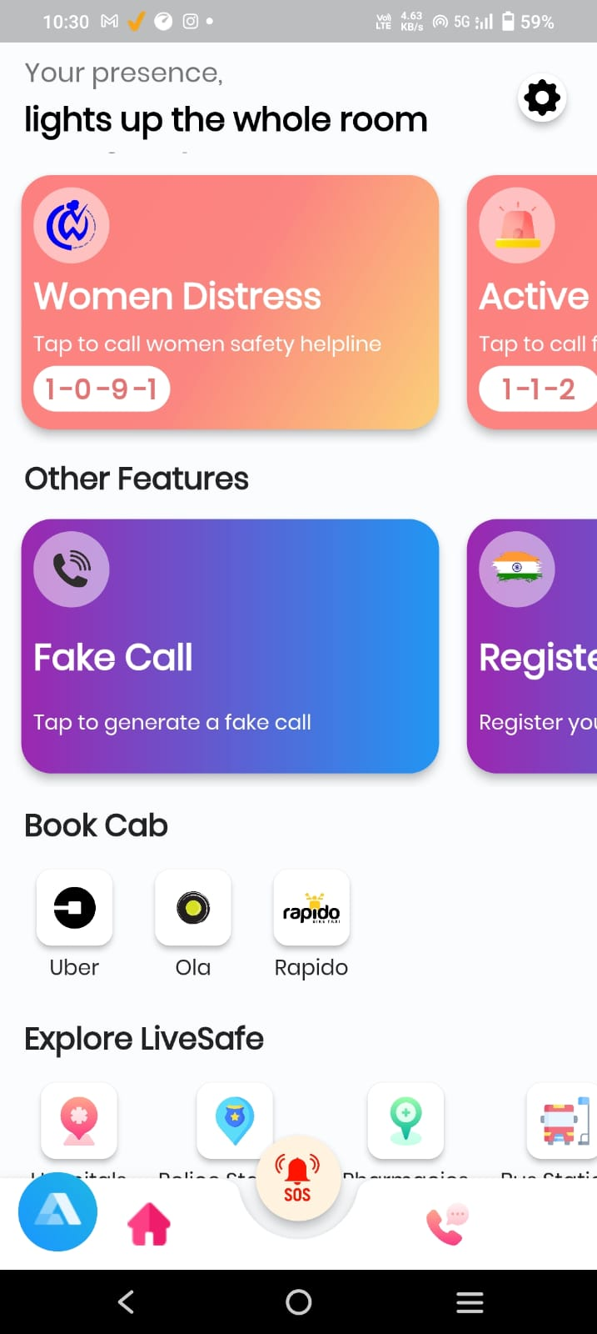

The dashboard of the women safety app is designed to provide a comprehensive and user-friendly interface for ensuring the safety and well-being of women. It features various key functionalities aimed at empowering women and offering them immediate assistance in times of distress.

The women distress feature allows users to quickly send distress signals, alerting emergency contacts and authorities about their location and situation. The fake call functionality provides a discreet way for women to escape potentially unsafe situations by simulating incoming calls.

Additionally, the integration of popular ride-hailing services like Uber, Ola, and Rapido enables women to conveniently book rides and ensure secure transportation. This feature ensures that women can travel safely and have access to trusted transport options at their fingertips.

Furthermore, the app's Explore feature provides real-time information about safe zones, nearby police stations, hospitals, and other essential services. This empowers women to make informed decisions and navigate their surroundings confidently.

Overall, the women safety app's dashboard offers a seamless user experience, combining essential safety features like distress signals, fake calls, and trusted ride-hailing services, while also providing valuable information to enhance personal safety and well-being.

*3.1.2 Scream Detection*

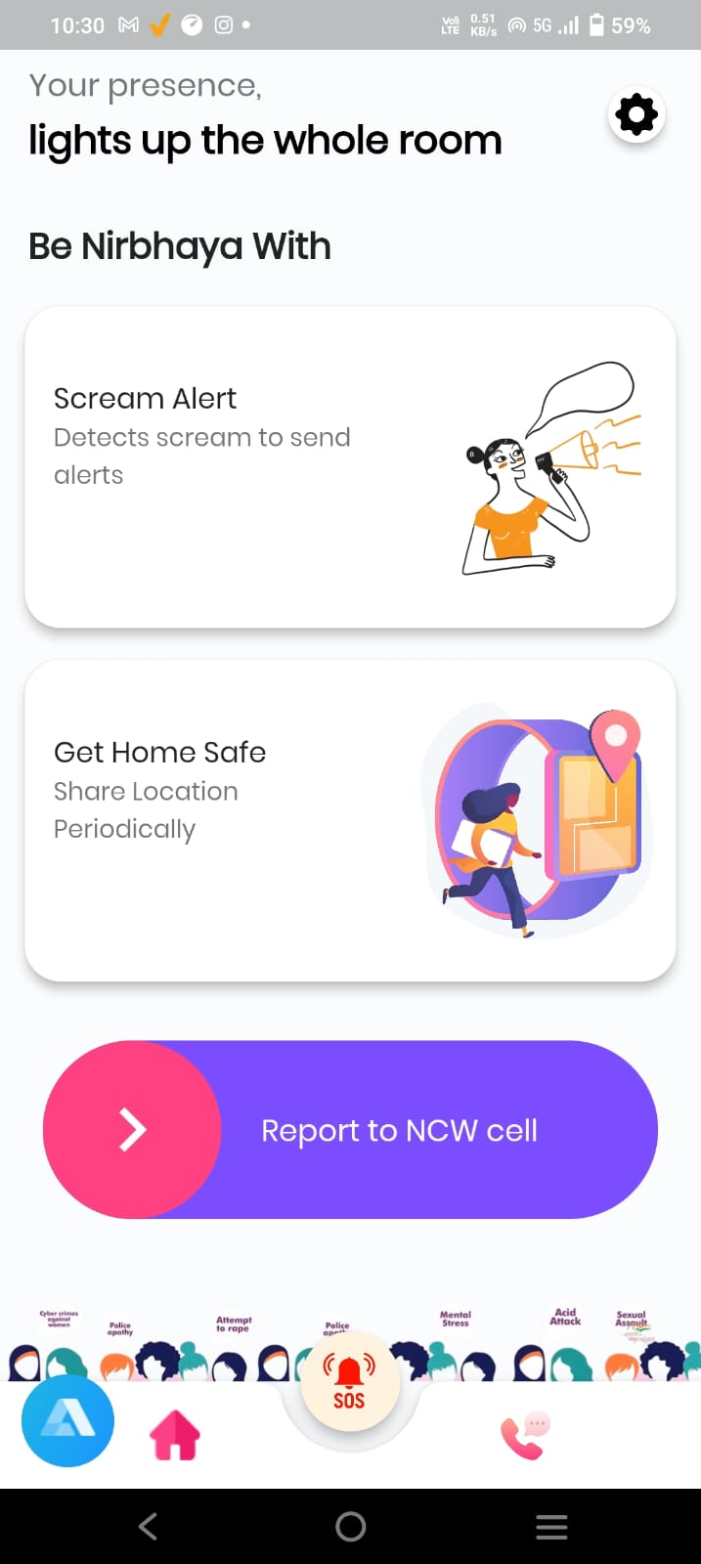

The women safety app incorporates a scream detection button, which serves as a crucial tool in times of danger. When activated, this feature utilizes advanced audio analysis to detect distress screams or loud noises, triggering immediate alerts to emergency contacts and authorities. It provides an additional layer of security, ensuring swift response and assistance during critical situations.

Furthermore, the app includes a "share live location" feature that enables women to share their real-time location with trusted contacts. This feature acts as a virtual safety net, allowing friends, family, or authorities to monitor the user's whereabouts and respond promptly if necessary.

Additionally, the app offers a call redirect feature to the National Commission for Women (NCW) cell. This functionality ensures that in case of emergency, users can directly connect with the NCW helpline for immediate support and guidance. It streamlines the process of reaching out to authorities specialized in women's safety concerns.

These features collectively enhance the safety and security of women, providing them with immediate assistance through scream detection, real-time location sharing, and a direct connection to relevant authorities through call redirection to the NCW cell.

*3.1.3 Danger Siren*

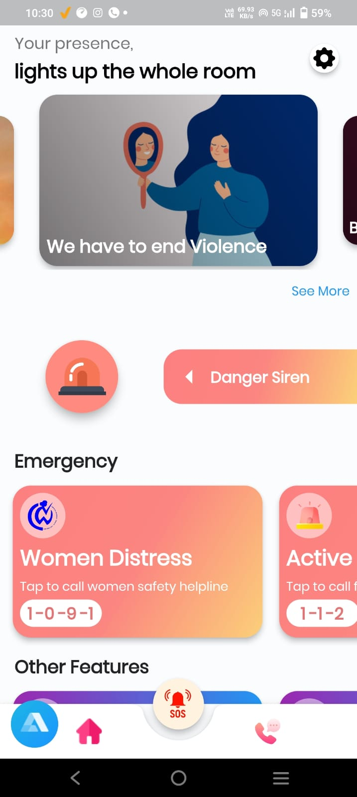

The women safety app incorporates a danger siren feature that serves as a powerful deterrent and alarm system. When activated, the danger siren emits a loud and attention-grabbing sound, alerting nearby individuals and potentially scaring off potential threats. This feature aims to draw immediate attention to the user's situation and attract help from people in the vicinity. It serves as an effective tool for creating awareness and potentially diffusing dangerous situations, providing an added layer of security for women using the app.

*3.1.4 SOS Contacts*

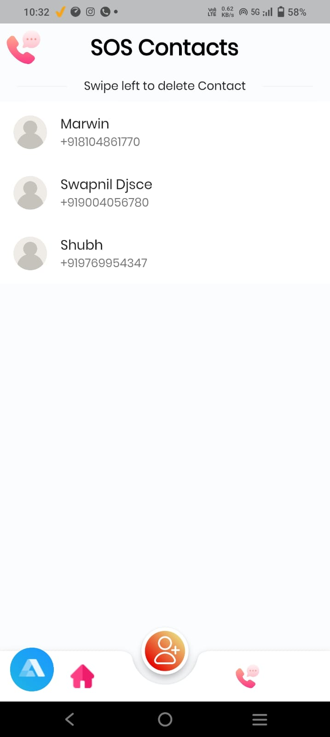

The SOS Contacts feature in the women safety app allows users to create a list of trusted contacts who can be quickly alerted in case of an emergency. With just a single tap on the SOS button, the app sends an immediate distress signal to the pre-selected contacts, providing them with the user's location and relevant information. This feature ensures that help can be mobilized swiftly, allowing friends, family, or emergency services to respond promptly and provide assistance when needed. It offers peace of mind and a sense of security, knowing that a support network is readily available at the user's fingertips.

*3.1.5 Safe Shake feature*

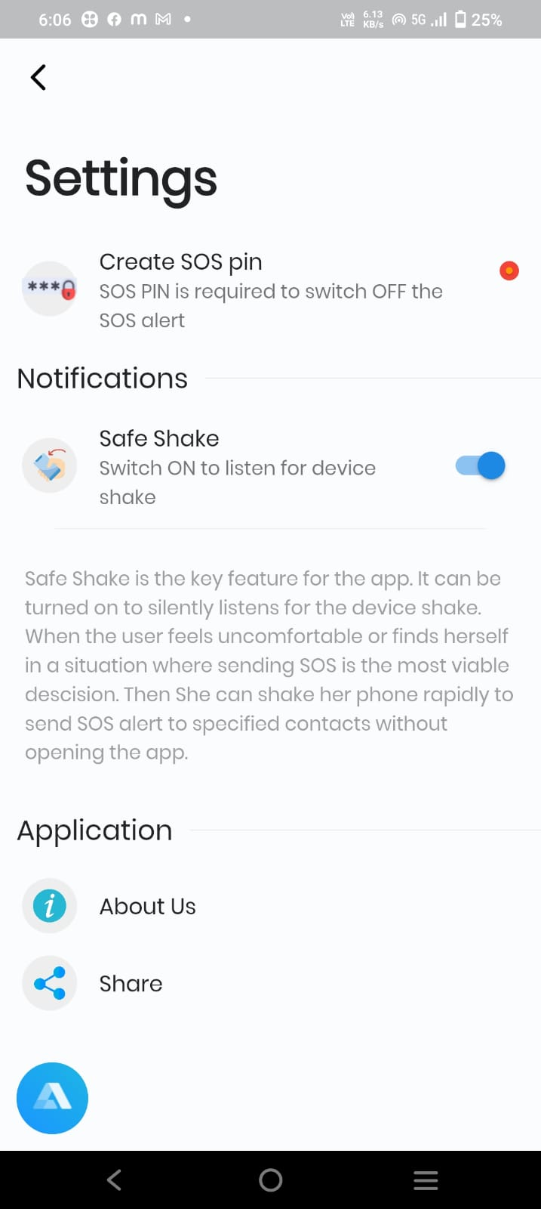

The safe shake feature in the women safety app offers a discreet and intuitive way to signal for help. By shaking their device vigorously, users can trigger an alert that notifies their emergency contacts about their distress situation. This feature is designed to be easily activated even in high-stress or dangerous situations, where traditional methods of communication may be difficult or risky. The safe shake feature provides an additional layer of safety, empowering women to quickly and silently seek assistance when faced with potential threats or emergencies.

*3.2 Algorithms*

In the case of scream detection, the SVM algorithm can be trained on a dataset of audio signals containing both screams and non-screams. The SVM algorithm will learn to separate the two classes by finding the hyperplane that maximizes the margin between the two classes. The SVM algorithm works by mapping the input audio signal into a higher-dimensional feature space, where the two classes can be separated by a hyperplane. The algorithm then finds the hyperplane that maximizes the margin between the two classes. The hyperplane is defined by the weight vector 'w' and bias 'b', which are learned during the training process. The SVM algorithm is trained by solving the following optimization problem:

Minimize:

1/2 ||w||^2 + C∑ξi

Subject to:

yi(w.T xi + b) ≥ 1 - ξi

ξi ≥ 0

Where:

w is the weight vector

b is the bias

xi is the input feature vector

yi is the corresponding class label (+1 for screams and -1 for non-screams)

ξi is the slack variable, which allows for some misclassification in the training data

C is the regularization parameter, which controls the trade-off between maximizing the margin and minimizing the classification error.

The accuracy obtained is 0.9655172413793104. The Scream is detected.

During the testing phase, the SVM algorithm takes the input audio signal, maps it into the feature space, and then classifies it as a scream or non-scream, based on which side of the hyperplane the signal falls.

SVM is used for scream detection in a women safety app by training the algorithm on a dataset of audio signals containing both screams and non-screams. The SVM algorithm finds the hyperplane that maximizes the margin between the two classes, allowing it to accurately classify new audio signals as screams or non-screams.

One of the commonly used geofencing algorithms we have used is the Circle Geofencing Algorithm. This algorithm involves creating a virtual circle around a given location, with a specified radius. The algorithm then continuously checks the user's current location against the virtual circle, and triggers an event if the user enters or exits the circle. The circle geofencing algorithm can be implemented using the Haversine formula, which calculates the distance between two points on the surface of the earth. The Haversine formula takes into account the curvature of the earth and provides a more accurate calculation of the distance between two points.

This geofencing algorithm can be used to track locations in a women safety app. The app can create virtual boundaries around safe areas, such as home or work, and trigger an event if the user enters or exits these areas. Additionally, the app can create virtual boundaries around potentially unsafe areas, such as dark alleys or deserted streets, and provide warnings or alerts to the user to exercise caution. By using geofencing algorithms, the app can provide real-time location tracking and ensure that the user is aware of their surroundings at all times.

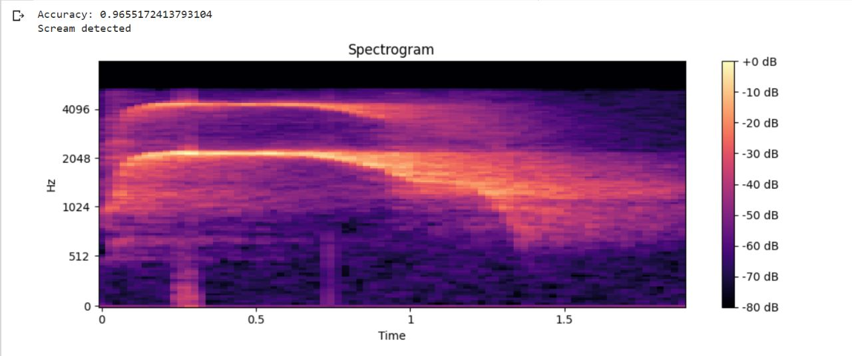

*3.3 Use Cases*

There are 7 major use cases as follows:

1. Emergency Assistance: One of the primary use cases of a women's safety app is to provide emergency assistance in case of any danger or threat. The app can send alerts or notifications to the user's emergency contacts or to nearby emergency services.

2. Real-Time Location Tracking: Using GPS technology, the app can track the user's location in real-time, allowing friends and family to monitor the user's movements and ensure their safety.

3. Scream Detection: The app can use advanced machine learning algorithms to detect screams and other distress signals, and immediately trigger an alert or call for assistance.

4. Geofencing: The app can use geofencing algorithms to create virtual boundaries around safe and unsafe areas, and provide notifications or alerts when the user enters or exits these areas.

5. Self-Defense Training: The app can provide users with self-defense training and techniques to help them defend themselves in case of an attack. This can include video tutorials, tips, and techniques to escape from dangerous situations.

6. Safety Tips and Resources: The app can provide users with safety tips and resources, such as helpline numbers, emergency contacts, and information about women's safety laws and regulations.

7. Safe Route Planning: The app can suggest safe and secure routes for the user to take, based on factors such as crime rates, street lighting, and traffic. This can help users avoid potentially dangerous areas and reach their destination safely.

In addition to these use cases, a women's safety app can also include features such as a loud alarm, a panic button, a discreet mode, and a virtual escort. These features can provide additional layers of security and peace of mind to the user, and ensure their safety in potentially dangerous situations. Overall, a women's safety app can be an effective tool to promote women's safety and prevent violence against women.

3.4 Modules Implemented

The women safety app consists of several modules designed to provide users with a comprehensive safety solution. These modules are as follows:

1. Scream Detection: This module uses machine learning algorithms to detect screams and other distress signals, which can then trigger an emergency alert or call for assistance.

2. Location Tracking: This module uses GPS technology to track the user's location in real-time, allowing friends and family to monitor the user's movements and ensure their safety.

3. Emergency Assistance: This module allows users to quickly notify emergency services and their contacts in case of an emergency. The app can also provide the user's location to these contacts to enable quick response times.

4. Geofencing: This module uses geofencing algorithms to create virtual boundaries around safe and unsafe areas, and provides notifications or alerts when the user enters or exits these areas.

5. Self-Defense Training: This module provides users with self-defense training and techniques to help them defend themselves in case of an attack.

6. Safety Tips and Resources: This module provides users with safety tips and resources, such as helpline numbers, emergency contacts, and information about women's safety laws and regulations.

7. Safe Route Planning: This module suggests safe and secure routes for the user to take, based on factors such as crime rates, street lighting, and traffic.

Each module is designed to work seamlessly with the others, providing users with a complete safety solution that can adapt to their specific needs and circumstances. The app's advanced technology, including speech recognition and machine learning, allows for accurate and efficient detection of distress signals, while its intuitive interface and integration with emergency services ensure that users can quickly and easily access the help they need in case of an emergency. The app's focus on providing users with practical tools and resources, such as self-defense training and safety tips, also promotes a sense of empowerment and control, allowing users to take an active role in their own safety and well-being.

*4. Limitations*

1.Dependence on technology: Women safety apps rely heavily on technology, such as GPS and machine learning algorithms, which may not always be accurate or reliable.

2. False alarms: Women safety apps may generate false alarms, which can reduce the credibility of the app and cause unnecessary panic.

3. Lack of awareness and adoption: Women safety apps may not be widely adopted or used, particularly by women who are not tech-savvy or who do not have access to smartphones.

4. Privacy concerns: Women safety apps may collect sensitive information, such as location data, which raises privacy concerns and requires strict data protection measures.

5. Limited reach: Women safety apps may only be available in certain countries or regions, limiting their reach and effectiveness.

6. Limited functionality: Women safety apps may have limited functionality, such as only providing basic features like location tracking and emergency alerts, without providing more advanced features like self-defense training or safe route planning.

7. Limited response time: Women safety apps may not be able to provide immediate assistance in case of an emergency, especially if the user is in a remote or low network coverage area.

It's important to recognize these limitations when using women safety apps and to use them as a complementary tool to other safety measures, such as self-defense training, situational awareness, and community support. Additionally, developers of women safety apps should work to address these limitations through continuous improvement and innovation.

*5. Conclusion*

In conclusion, the development of women safety apps has been a step forward in addressing the issue of violence against women. These apps have the potential to provide an additional layer of safety and security for women in potentially dangerous situations. The use of advanced technology, such as GPS and machine learning algorithms, has allowed for the development of features such as real-time location tracking, scream detection, and emergency alerts, which can help women quickly call for help and notify their contacts and authorities in case of an emergency.

However, there are limitations and challenges that need to be addressed. These include false alarms, dependence on technology, lack of awareness and adoption, and privacy concerns. Developers and stakeholders need to work together to overcome these challenges and create apps that are reliable, user-friendly, and privacy-conscious.

Moreover, women safety apps are not a complete solution to the issue of violence against women. They should be viewed as a tool that can complement and support other measures to address the root causes of gender-based violence, such as education, awareness-raising, and policy changes. It is also essential to ensure that women from marginalized and vulnerable communities are not left behind and have access to these safety tools.

Overall, women safety apps have the potential to make a positive impact on women's safety and security. However, their effectiveness will depend on the collaboration and efforts of all stakeholders involved in their development, implementation, and promotion.

*6. Lessons Learnt*

Lessons learned while creating a women safety app include the importance of user-centered design, the integration of multiple technologies, data privacy, ongoing improvement and refinement, and a collaborative approach. By taking these lessons into account, developers and stakeholders can create a women safety app that is effective, useful, and promotes the safety and security of women.

1. User-centered design: It's important to prioritize the needs and preferences of the end-users (i.e., women) when designing the app. Conducting user research and usability testing can help ensure the app is intuitive, user-friendly, and effective.

2. Security and privacy: As the app deals with sensitive information and emergency situations, it's important to ensure the highest levels of security and privacy are maintained throughout the development process.

3. Integration of multiple technologies: Creating a women safety app may involve integrating various technologies, such as scream detection, geofencing, GPS tracking, and emergency contacts. It's important to carefully consider how these technologies can work together to provide the best user experience.

4. Collaboration with stakeholders: Collaborating with various stakeholders, such as law enforcement, emergency response teams, and women's advocacy groups, can help ensure the app is effective and addresses the needs of the community.

5. Ongoing monitoring and evaluation: Once the app is launched, it's important to continue monitoring and evaluating its effectiveness, collecting user feedback, and making improvements as needed. This can help ensure the app continues to meet the evolving needs of women and remains a valuable tool for promoting women's safety.

APPENDIX

• Background Study

The background study on women safety app involves analyzing the existing apps, their features, and limitations, and understanding user feedback to inform the development of a new app.

Source: https://www.legalserviceindia.com/legal/article-7599-safety-of-women-in-india.html

• Advancements in Attendance System History Of Time And Attendance The advancements in women safety app include the use of machine learning algorithms, such as SVM and CNN, for scream detection, and incorporating geofencing and emergency contact features.

Source:https://www.researchgate.net/publication/299404936_Women_safety_device_and_application-FEMME

• Flutter is a mobile app development framework created by Google that allows for the creation of high-performance, visually appealing, and natively compiled apps for both Android and iOS platforms using a single codebase. It uses the Dart programming language and provides a wide range of customizable widgets and tools for building beautiful, responsive, and scalable apps.

• Google Maps API is a powerful tool for developers to integrate Google Maps into their web applications or mobile apps. It provides an easy-to-use interface for accessing a variety of features, such as interactive maps, satellite imagery, geocoding, and location-based services. Developers can use the API to customize maps and location-based information, create directions and search functions, and integrate with other Google services. One of the key benefits of using Google Maps API is the ability to display customized maps on your website or app. With the API, developers can create custom markers, overlays, and information windows to display location-based information. They can also customize the map style, including colors, labels, and map elements to match the look and feel of their brand or application. Another benefit of using Google Maps API is the ability to create directions and search functions. Developers can use the API to provide turn-by-turn directions to a location or provide search results based on a user's location. The API also includes traffic data, which can be used to display real-time traffic conditions and estimate travel times. The Google Maps API also provides geocoding and reverse geocoding services, allowing developers to convert addresses into latitude and longitude coordinates or vice versa. This functionality can be useful for location-based applications, such as delivery services or ride-sharing apps. Furthermore, Google Maps API can integrate with other Google services, such as Places API and Street View. The Places API allows developers to provide detailed information about specific locations, such as ratings, reviews, and photos, while Street View allows users to explore locations through 360-degree panoramic views. In addition to the core features, Google Maps API also offers a range of tools and resources to help developers build and optimize their applications. The API includes extensive documentation, sample code, and support resources, as well as a range of pricing options depending on the usage and scale of the application. However, there are some limitations to using Google Maps API. One major limitation is the cost, as developers are charged based on the number of requests made to the API. Additionally, the API is subject to usage limits, which can impact the performance and functionality of the application if exceeded. Moreover, the API may have limitations in some regions, such as restrictions on the use of satellite imagery or street view data.

Acknowledgment

The authors would like to express their sincere gratitude to Dwarkadas J. Sanghvi College of Engineering, Mumbai, India for providing a proper platform and useful resources which were of great help throughout the research.

Contributions

| Term | Deinition | Contribution |
| --- | --- | --- |
| Conceptualisation | Idea and Formulation of project | Marwin Shroff |
| Methodology | Deciding the workflow of the project | Swapnil Shah and Shubh Panchal |
| Research | • Field survey  • Literature Survey | Shubh Panchal  Marwin Shroff |
| Resources | Provision of reference material | Swapnil Shah |
| Design | App Design using Figma | Marwin Shroff |
| Software | • App Development  • ML Development  • Integration of APIs | Swapnil Shah  Shubh Panchal  Marwin Shroff |
| Visualisation | Preparation and creation of Presentation of the work | Swapnil Shah, Vanshita Jain and Shubh Panchal |
| Writing - Original draft | Preparation, creation and presentation of published work, specifically writing the initial draft | Marwin Shroff |
| Writing - Review and editing | Preparation, creation and presentation of published work, specifically the critical review and editing | Marwin Shroff and Shubh Panchal |
| Supervision | Oversight and leadership responsibility for activity planning and execution | Swapnil Shah and Vanshita Jain |
| Project  Administration | Management and coordination responsibility for research activity planning and execution | Prof. Dr. Nilesh Patil |

References

• IEEE - M. Tagliasacchi, L. Gerosa, G. Valenzise, F. Antonacci and A. Sarti, "*Scream and gunshot detection and localization for audio-surveillance systems*," in 2007 IEEE Conference on Advanced Video and Signal Based Surveillance, AVSS 2007, London, 2007 pp. 21-26.

• IEEE - D. Handa and R. Vig, "*Distress Screaming vs Joyful Screaming: An Experimental Analysis on Both the High Pitch Acoustic Signals to Trace Differences and Similarities*," 2020 Indo – Taiwan 2nd International Conference on Computing, Analytics and Networks (Indo-Taiwan ICAN), 2020, pp. 190-193,doi: 10.1109/Indo-TaiwanICAN48429.2020.9181340.

• IEEE - M. K. Nandwana, A. Ziaei and J. H. L. Hansen, "*Robust unsupervised detection of human screams in noisy acoustic environments,*" 2015 IEEE International Conference on Acoustics, Speech and Signal Processing (ICASSP), 2015, pp. 161-165, doi: 10.1109/ICASSP.2015.7177952.

• IEEE - M. Z. Zaheer, J. Y. Kim, H. -G. Kim and S. Y. Na, "*A Preliminary Study on Deep-Learning Based Screaming Sound Detection,*" 2015 5th International Conference on IT Convergence and Security (ICITCS), 2015, pp. 1-4, doi: 10.1109/ICITCS.2015.7292925.

• A. Sharma and S. Kaul, "*Two-Stage Supervised Learning-Based Method to Detect Screams and Cries in Urban Environments,*" in IEEE/ACM Transactions on Audio, Speech, and Language Processing, vol. 24, no. 2, pp. 290-299, Feb. 2016, doi:

•Mathur,Yash”*Human_Scream_Detection_using_ml_and_deep_learning.*”Human_Scream_Detection_using_ml_and_deep_learning. Retrieved May 21, 2022.

• "*Human screams occupy a privileged niche in the communication soundscape*", Current Biology, vol. 25, no. 15, pp. 2051-6, 2015."CASSANDRA: audio-video sensor fusion for aggression detection," 2007

• IEEE Conference on Advanced Video and Signal Based Surveillance, 2007

• Akbacak and J. H. L. Hansen, "*Environmental Sniffing: Noise Knowledge Estimation for Robust Speech Systems*," in IEEE Transactions on Audio, Speech, and Language Processing, vol. 15, no. 2, pp. 465-477, Feb.2007, doi: 10.1109/TASL.2006.881694.

• Bengio, A. Courville and P. Vincent, "*Representation Learning: A Review and New Perspectives,*" in IEEE Transactions on Pattern Analysis and Machine Intelligence, vol. 35, no. 8, pp. 1798-1828, Aug. 2013,

• “*Guided Subband Filter for Acoustic Event Detection in Noisy Environments Using Wavelet Packets,*" in IEEE/ACM Transactions on Audio, Speech, and Language Processing, vol. 23, no. 2, pp. 361-372, Feb. 2015

• Weimin Huang, Tuan Kiang Chiew, Haizhou Li, Tian Shiang Kok and Jit Biswas, "*Scream detection for home applications,*" 2010 5th IEEE Conference on Industrial Electronics and Applications, Taichung, Taiwan, 2010, pp. 2115-2120, doi: 10.1109/ICIEA.2010.5515397.

• Saeed, Fairuz & Bashit, Abdullah Al & Vishu, Viswanathan & Valles, Damian. (2021). “*An Initial Machine Learning-Based Victim’s Scream Detection Analysis for Burning Sites.* Applied Sciences”. 11. 8425. 10.3390/app11188425.

• Shankhdhar, Ashutosh & Rachit, & Kumar, Vinay & Mathur, Yash. (2021). “*Human Scream Detection Through Three-Stage Supervised Learning and Deep Learning. “*10.1007/978-981-16-1395-1_28.