**“MYTracks”**

**project undertaken**

AT

**CS INFOTECH**

2451, sec-22c, chandigarh

In the partial fulfillment of the requirement

for the degree of

**acknowledgement**

apart from the efforts of me, the success of my project depends largely on the encouragement and guidelines of many others. I take this opportunity to express my gratitude to the people who have been instrumental in the successful completion of this project.

I would like to show my greatest appreciation to my project in-charge, Mrs. Shalini Sharma. I can’t say thank you enough for the tremendous support and help. I feel motivated and encouraged every time I attend her meeting. Without her encouragement and guidance this project work would not have materialized.

I’m highly grateful to Mr. Chhotu. Sharma, chief instructor at CS InfoTech, for his thorough guidance right from day 1 till the end of training. He actually laid the ground for conceptual understanding of technologies used in project.

**Table of contents**

|  |  |  |
| --- | --- | --- |
| **s. no.** | **topic** | **page no.** |
| 1 | Company Profile | 4-6 |
|  | (i) About Company Philosophy | 4 |
|  | (ii) Management | 5 |
| 2 | Introduction | 7-20 |
|  | (i) Statement about the problem- Existing system | 8 |
|  | (ii) Objectives of Project | 9 |
|  | (iii) Working Environment | 10-15 |
| 3 | System Design | 21 |
|  | (iii) Database Files | 24 |
|  | (v) Screen Shots | 27-30 |
| 4 | Conclusion | 31 |

**COMPANY PROFILE**

**CS Group**

CS Group founded by Mr. Chhotu Sharma is an amalgam of CS Infotech and CS Soft Solutions Pvt. Ltd. CS Soft Solutions is a complete IT solutions providing company with huge clientele all over the world. CS Infotech is a pioneer institution which is engaged in providing computer education in Microsoft Technologies, to students as well as professional executives.

**CS InfoTech**

CS Infotech is a pioneer institution engaged in providing computer education to numerous students every year. The company provides comprehensive learning environment to individuals and is also engaged in honing the technical skills of the professional executives to help them achieve excellence in their working fields. Students are also provided with opportunity to handle live projects during industrial training. The motive behind providing industrial training is to facilitate students with live projects and to keep them abreast of the latest technologies used in market. The institution takes immense pride in having empowered thousands of students across the entire region in all these years. CS Infotech has a good record of getting students placed in reputed firms.

**CS Soft Solutions Pvt. Ltd.**

CS Soft Solutions is a complete IT solutions providing company based in Mohali. CS Soft Solutions was created to achieve the goal of providing its clients state-of-art web development services comparable with best in the world. The services provided by CS Soft Solutions Pvt. Ltd. are

* Web Development
* Web Designing
* Online Marketing
* Mobile Application Development

CS Soft Solutions Pvt. Ltd. was conceptualized in October 2009 by Mr. Chhotu Sharma and Mrs. Shalini Sharma. The goal was to build a company that worked on solid principals, to develop world class IT products and provide a congenial environment and adequately encouraging work culture for all the team members at CS Soft Solutions Pvt. Ltd. Consequently, there is a huge clientele from all across the world.

One of the methods of paying back to the industry that has been adopted by the CS Group is to recruit students from CS Infotech into CS Soft Solutions Pvt. Ltd. on the basis of their performance and ability to perform in the industry.

**Founders**

Mr. Chhotu Sharma is the founder of the CS Group. He is a Microsoft Certified Software Developer and has been training IT professionals in different Microsoft Technologies since last 12 years. He is recognized as “The Guru of Microsoft Technologies”. His students have been picked up by Fortune 500 companies including Microsoft, Accenture, TCS, Infosys and others. In the year 2009, he established CS Soft Solutions Pvt. Ltd, a company offering complete IT services in multifarious IT applications. He has been instrumental in shaping the goals and evolving values of CS Soft Solutions Pvt. Ltd. His strong penchant for excellence at professional as well as personal front, backed by a sincere and an honest approach towards life are the basic reasons for the success of the ventures he has launched and actively developed. These qualities of sincerity and honesty easily percolate among students, ensuring their success in future lives too.

Mrs. Shalini Sharma is Director of CS Soft Solutions Pvt. Ltd. and an adept teacher at CS Infotech. She is an embodiment optimism and bears a sharp analytical acumen coupled with excellent People Management skills. She has trained thousands of students during last decade. She has expertise in a wide array of languages and she meticulously imparts technical training to her wards with endeavour to make them fully equipped in dealing with various requirements of the IT industry, in their careers.

**Introduction**

**Project Title:** MyTracks

**Project Leader:** Mrs. Shalini Sharma

**Project Duration:** 6 Weeks

**Project category:** Web Based Application

The project named **MyTracks** is developed using PHP. This project has been developed in partial fulfillment of Requirements

MyTracks is a music site where real people do the choosing of tunes. Mytracks is the best place for people who care about music to make and discover refreshingly human playlists. Members pick at least eight songs from their own collections, upload them and share them as handcrafted mixes that seem like a happy throwback from the cassette era. You can find mixes created by your friends or simply follow other members who share your tastes. Internet radio created by people,not algorithms. Choose a theme or genre below to start discovering new music.

**Statement about the Problem-existing system**

In basic system, people who want to have the information about the latest albums or movies which provide best entertainment had to visit music shops or refer to television for seeking the information regarding date of release etc. One has to physically move to music shops to check all details about the albums or movies available and then only they can decide and purchase those products. Moreover, most of the work involved in the process has to be done manually which is very time consuming and cumbersome and also, it reduces the efficiency, accuracy and speed of retrieval of data. It is not that no effort has been made towards this end. An attempt to get the complete working automated failed as the system could not be integrated into a functional whole. I felt this shortcoming becoming glaringly evident.

**Objectives of Project**

After thoroughly analyzing the existing system the following objectives have been set:

* Providing user friendly interface
* Keeping project records online
* To get all the information about the songs online
* Easy access of data
* Easy maintenance
* Maintaining data consistency
* Providing better performance
* Increasing the efficiency through automation
* Adequate validation checks for data entry
* Facility to update the data time to time
* Adequate security of the database

**WORKING ENVIRONMENT**

**Front-End**

**PHP**

PHP is a server-side scripting language designed for web development but also used as a general-purpose programming language. PHP is now installed on more than 244 million websites and 2.1 million web servers. Originally created by Rasmus Lerdorf in 1995, the reference implementation of PHP is now produced by The PHP Group. While PHP originally stood for Personal Home Page, it now stands for PHP: Hypertext Preprocessor, a recursive acronym.

PHP code is interpreted by a web server with a PHP processor module which generates the resulting web page: PHP commands can be embedded directly into an HTML source document rather than calling an external file to process data. It has also evolved to include a command-line interface capability and can be used in standalone graphical applications.

PHP is free software released under the PHP License, which is incompatible with the GNU General Public License (GPL) due to restrictions on the usage of the term PHP.

PHP can be deployed on most web servers and also as a standalone shell on almost every operating system and platform, free of charge.

**Back-End**

**MySql**

MySQL is the world's most popular open source database software, with over 100 million copies of its software downloaded or distributed throughout its history. With its superior speed, reliability, and ease of use, MySQL has become the preferred choice for Web, Web 2.0, SaaS, ISV, Telecom companies and forward-thinking corporate IT Managers because it eliminates the major problems associated with downtime, maintenance and administration for modern, online applications.

Many of the world's largest and fastest-growing organizations use MySQL to save time and money powering their high-volume Web sites, critical business systems, and packaged software — including industry leaders such as Yahoo!, Alcatel-Lucent, Google, Nokia, YouTube, Wikipedia, and Booking.com.

The flagship MySQL offering is MySQL Enterprise, a comprehensive set of production-tested software, proactive monitoring tools, and premium support services available in an affordable annual subscription.

MySQL is a key part of WAMP (Windows, Apache, MySQL, PHP / Perl / Python), the fast-growing open source enterprise software stack. More and more companies are using LAMP as an alternative to expensive proprietary software stacks because of its lower cost and freedom from platform lock-in.

MySQL was originally founded and developed in Sweden by two Swedes and a Finn: David Axmark, Allan Larsson and Michael "Monty" Widenius, who had worked together since the 1980's

**Software Requirement Specification**

## Scope:

## This document shall provide the requirement specification for the “MyTracks” as per the scope defined.

# Users:

## This site can be used by 2 types of users:

# The users who are interested in searching, playing and creating playlists.

# The administrator of the system who will be responsible for the updates to be made as per the requirement like adding, updating, deleting an album in the database.

# Assumptions:

# The alerts will not be provided by the site, the user has to visit it to get the information.

# Requirements:

# Functional Requirements:

# The portal will search for the details of the playlists as per details entered by user.

# If the user is an admin, he has to login.

# Admin can add, modify or delete records related to various tracks.

# The user can search , play and create songs.

# The concept of Master Pages and Content Pages is used.

# Non-functional Requirements:

## Portability:

## The system will be designed to be portable across popular Windows OS.

## Extensibility:

## The system should be extensible to add further information and users for more expansion.

## Re-Usability:

## The system’s code could be reused to add further new features if need to be added in future.

## Reliability and Availability:

## System shall be able to deliver the required in reliable manner.

## Software Upgradeability:

## System is to be developed in phases, so it shall be easily upgradeable to include the new items in the database.

## User Interface Requirements:

**6.1 Log in screen:**

Admin has to first log in to the site.

**6.2 Home page:**

Homepage allows user to search playlists**.**

**6.3 Panels:**

Website is divided into 3 panels for Home page of different users:

* User panel
* Admin panel

**6.3.1** **User panel:**

Users can browse through playlists. They can get information about playlists, view and play songs online.

**6.3.2 Admin panel:**

Administrator can update any information such as addition, modification and deletion of tracks.

**Processing Requirements**

In this step we analyzed the processing capabilities of the system on which the proposed system would be developed and the specification is divided into two categories namely:

1. **Hardware Specifications**

**Processor**

Minimum: 600 megahertz (MHz) Pentium processor

Recommended: 1 gig hertz (GHz) Pentium processor

**RAM**

Minimum: 192 megabytes (MB)

Recommended: 256 MB

**Hard Disk**

2 GB of available space required on installation drive

1 GB of available space required on system drive

**Display**

Minimum: 800 x 600 256 colors

Recommended: 1024 x 768 High Color - 16-bit

# Technologies to be used

* PHP is being used for developing the web pages.
* MYSQL is being used for managing the database at server side.

1. **OS required** Microsoft Windows XP / higher version of Windows OS required.

**SYSTEM DESIGN**

System design is the process of developing specifications for a candidate system that meet the criteria established in the system analysis. The plan of the project provides a review of the different modules in which the project is divided. The modules are designed and tested individually and then merged together to form an integrated project. The different tables being used are:

|  |
| --- |
| **Tables** |
| * + 1. tbcat     2. tbtrk     3. tbusr     4. tbplylst     5. tbplylstdet |

Table Database

The various roles through which the data flows used in the project are:

1. **Administrator**
2. **User**

Database Files

|  |  |  |
| --- | --- | --- |
| Sr. No. | Table Name | Description |
| 1. | Tbcat | Information about song Categories |
| 2. | Tbtrk | Information about the Tracks |
| 3. | Tbusr | Information about users . |
| 4. | Tbplylst | Detail about playlists created by users. |
| 5. | Tbplylstdet | Tracks added in playlists. |

Relations in the database for Mytracks

# The following are the relations we have designed to manage the database. Here we have followed a convention of having the table names with tb as a prefix, and the remaining name of the table represent the description of the data inside that table.

**Database**

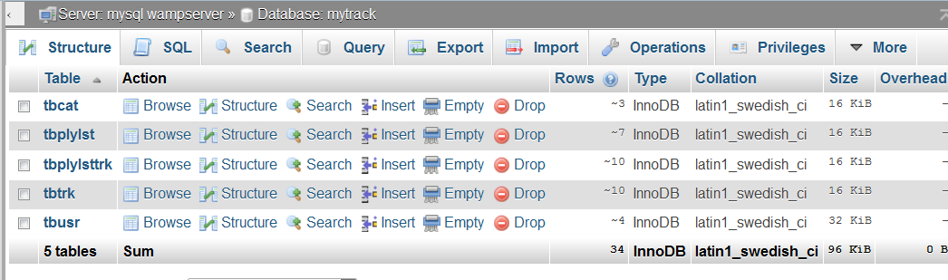

**tbcat**

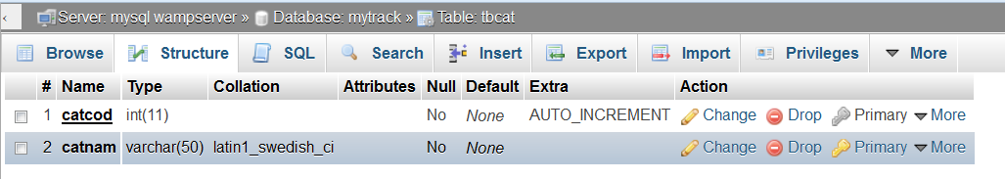

**tbplylst**

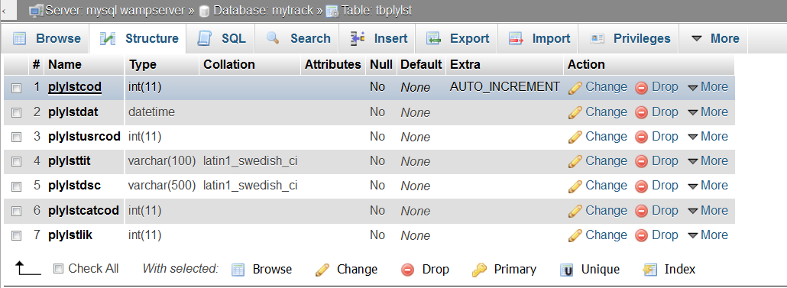

**tbplylsttrk**

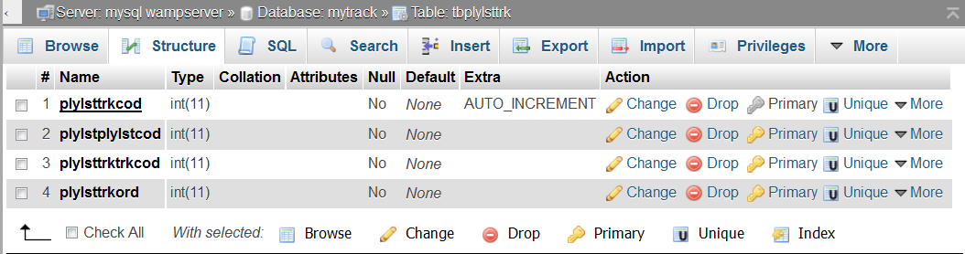

**tbtrk**

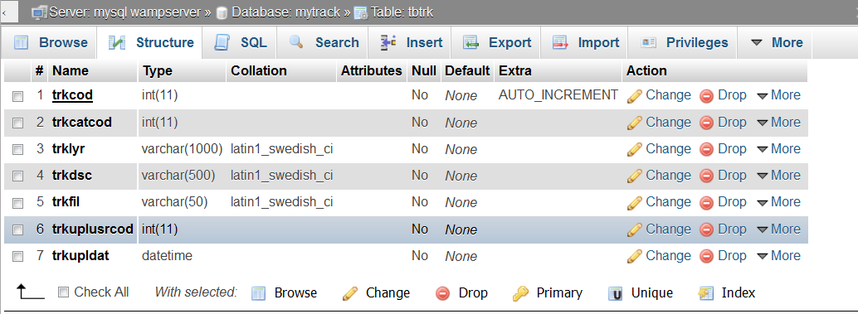

**tbusr**

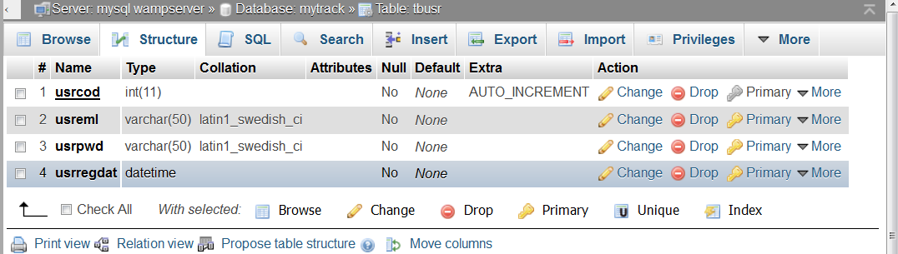

**Storeprocedur**

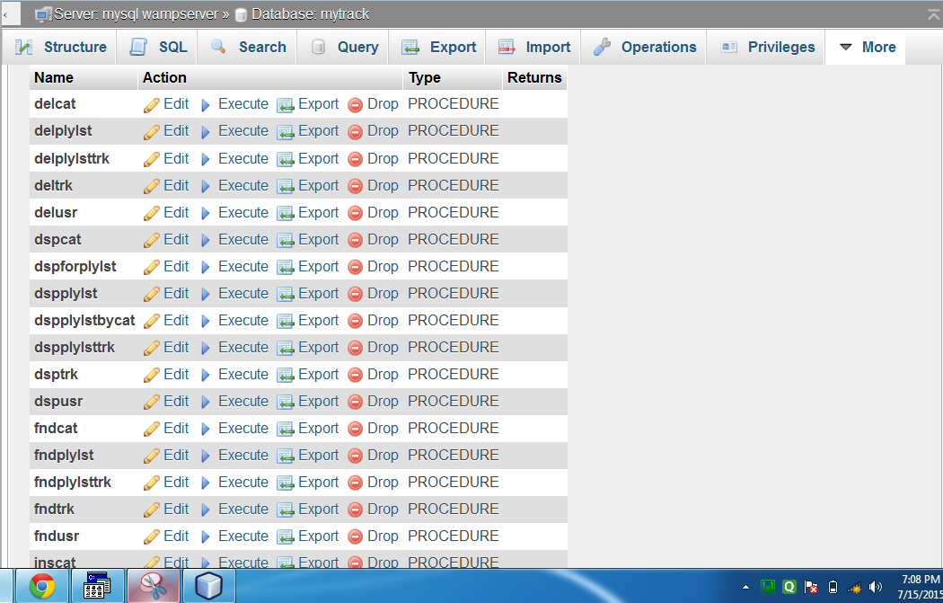

**Screen shots**

**Flow of Application in Terms of Screen Shots**

Since it is a web application, thus there is no pre-defined flow in terms of screen shots that user will come across. They will depend on users’ actions/links he clicks.

**Screen shots of admin folder:-**

**Category page:-**

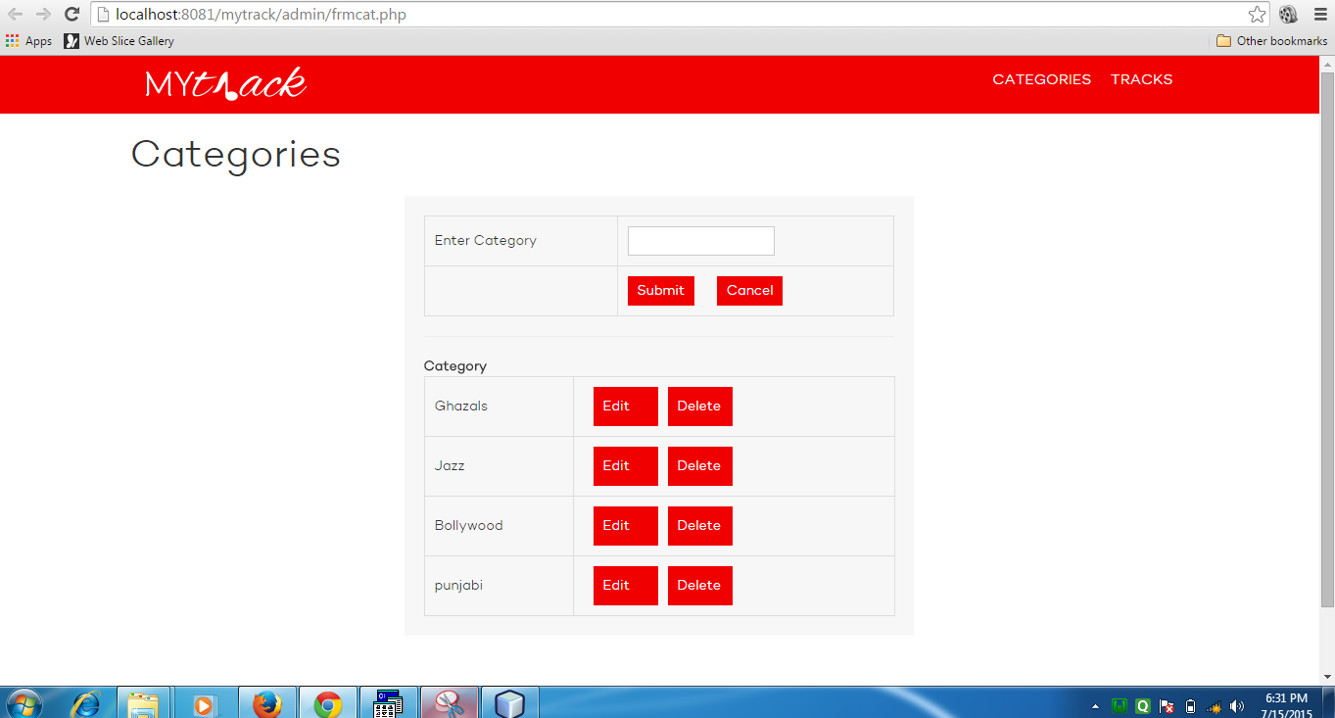

**Track page admin can search track by category**

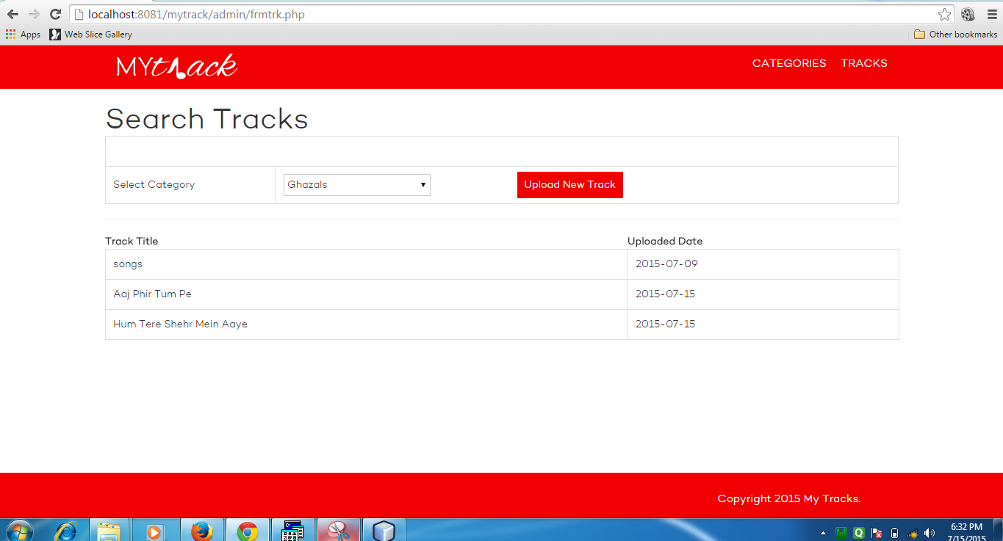

**Upload track**

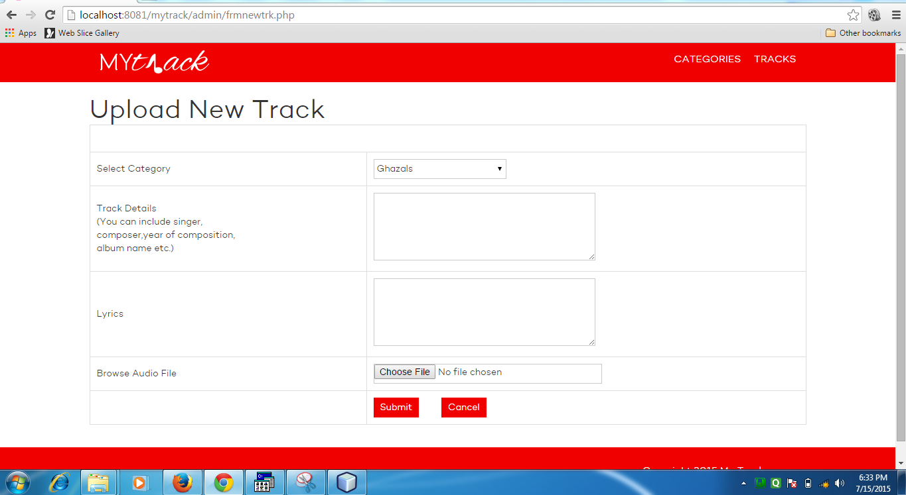

**Index page**

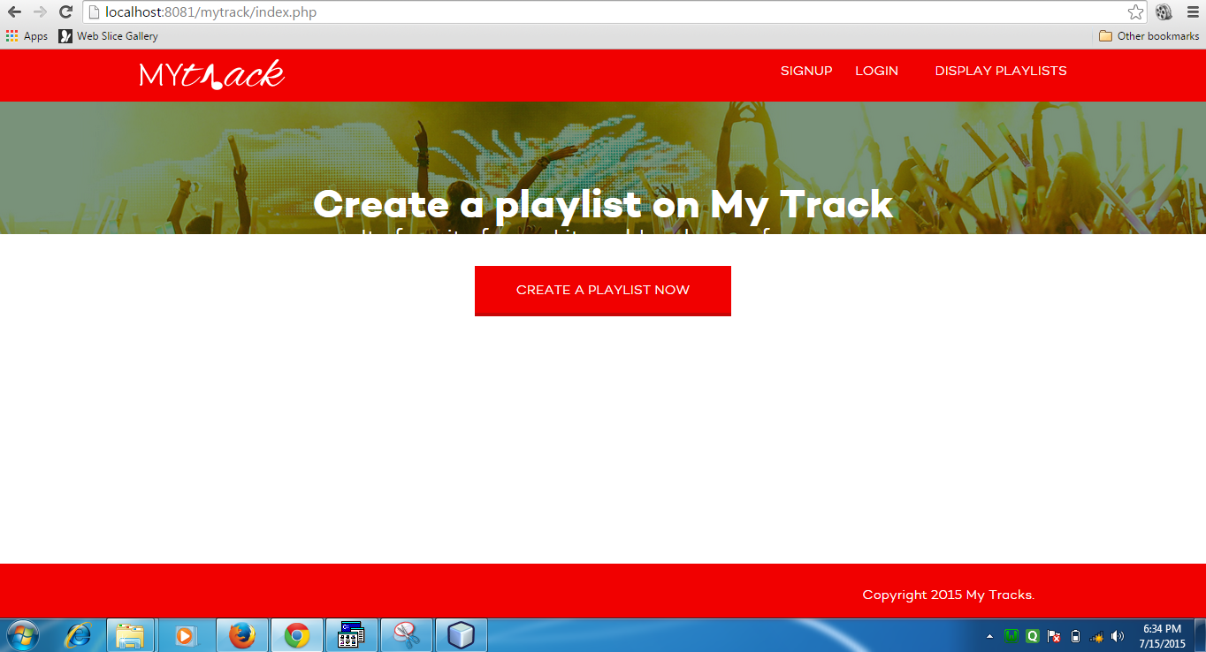

**Signup page**

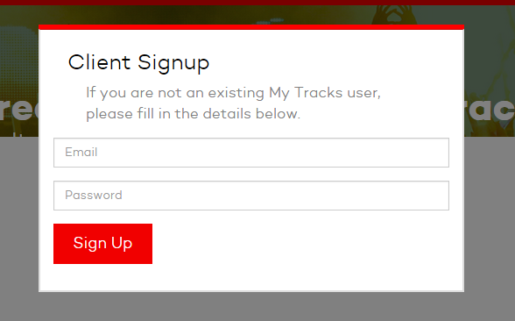

**Login page**

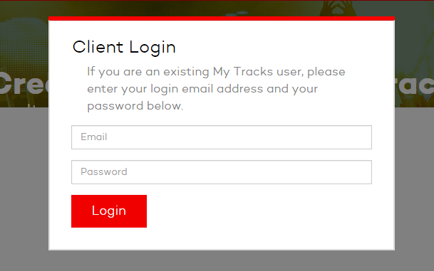

**Creat play list**

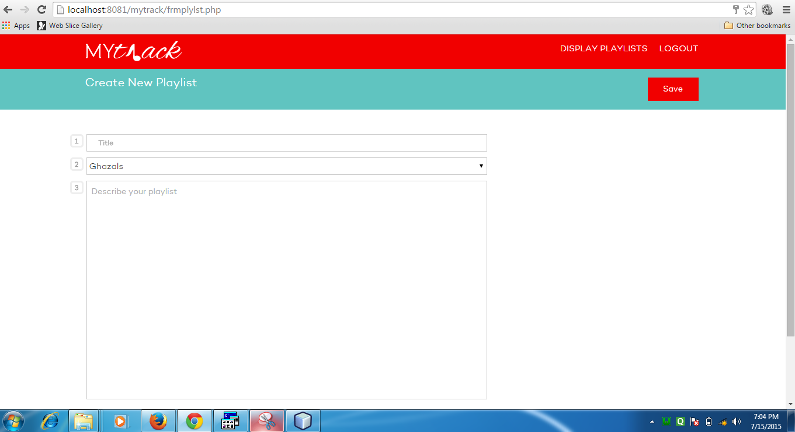

**Play list page**

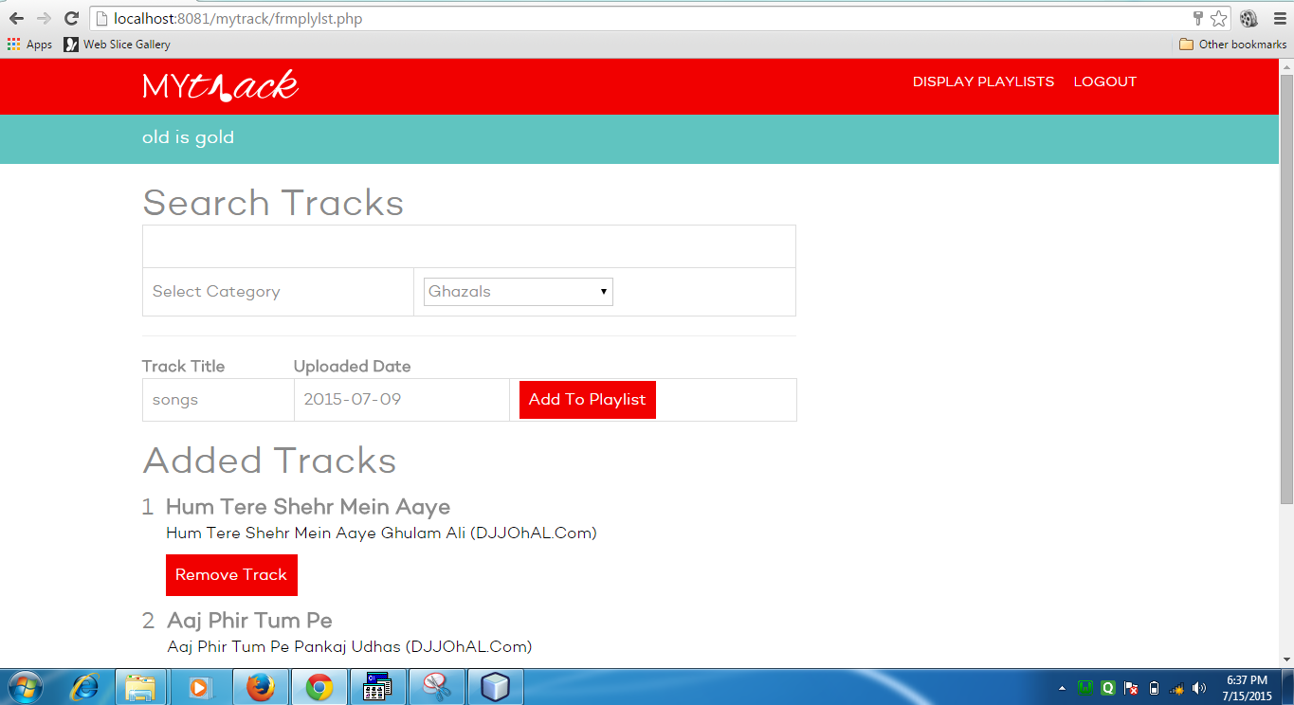

**Display play list**

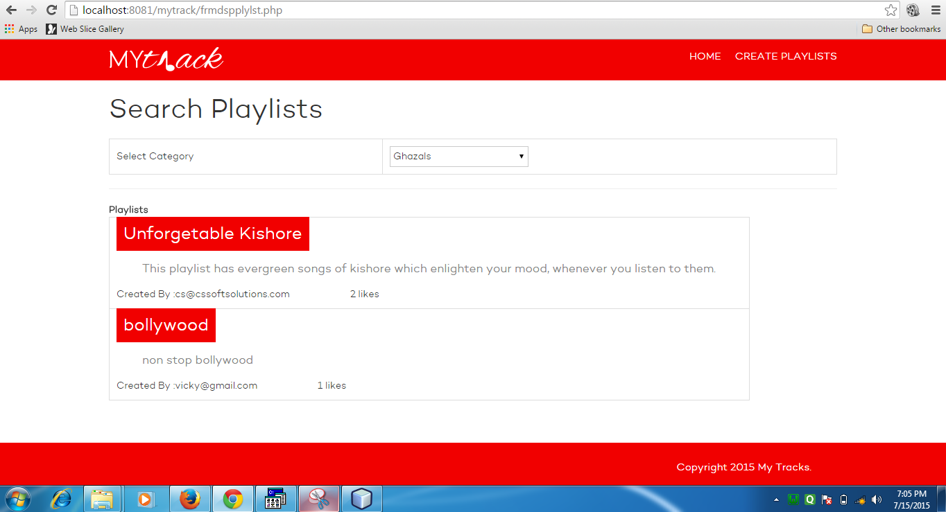

**Form play list detail page**

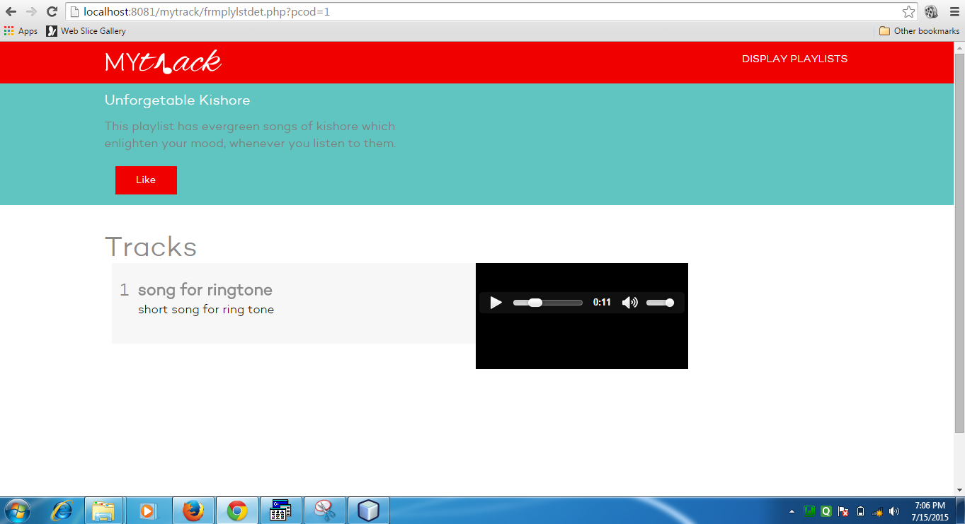

**CONCLUSION**

The system has been developed for the given condition and is found working effectively. The developed system is flexible and changes can be made easily whenever required. Using the facilities and functionalities of PHP, the software has been developed in a neat and simple manner, thereby reducing the operator’s work.

The speed and accuracy are maintained in proper way. The user-friendly nature of this software developed in PHP is very easy to work with both the higher management as well as other users with little knowledge of computer. The results obtained were fully satisfactory from the user point of view.

The system was verified with valid as well as invalid data in each manner. The system is run with an insight into the necessary modifications that may be required in the future. Hence the system can be maintained successfully.