1. Download VM Virtualbox from
https://www.virtualbox.org/wiki/Downloads

2. Download the ubuntu iso file from (Ubuntu 18.04.2 LTS)
https://ubuntu.com/download/desktop

3. Create a new ubuntu environment in the VM Virtualbox by adding the iso file in the settings of that new instance.
New->Enter your machine name->Memory size 8192-Virtual hard Disk size 25.65GB --- To create a new instance
Settings->Storage->Controller IDE->Select the Ubuntu iso file ----To attach the Ubuntu file to your instance

4. Download java (java-8-openjdk-amd64) from terminal through
sudo apt update
sudo apt install openjdk-8-jdk
java -version (openjdk version "1.8.0_212")
Version 8 as it is compatible with both Hbase and spark.

5. Download kafka from terminal through
wget http://www-us.apache.org/dist/kafka/2.2.1/kafka_2.12-2.2.1.tgz
tar xzf kafka_2.12-2.2.1.tgz

6. Download Spark (spark-2.4.3-bin-hadoop2.7.tgz) from
https://spark.apache.org/downloads.html
tar xzf spark-2.4.3-bin-hadoop2.7.tgz

7. Download Hbase (hbase-1.4.10-bin.tar.gz) from
http://www.eu.apache.org/dist/hbase/
tar xvzf hbase-1.4.10-bin.tar.gz

8. Configure hbase:
8.1 Change @rem set HBASE_MANAGES_ZK = true in env.cmd
8.2 set JAVA_HOME in env.sh
export JAVA_HOME=path
8.3 Uncomment and change in env.sh
export HBASE_MANAGES_ZK = true
8.4 change the hbase-site.xml to
<configuration>
<property>
<name>hbase.rootdir</name>
<value>file://path_to_hbase</value>
</property>
<property>
<name>hbase.zookeeper.property.dataDir</name>
<value>path_to_zookeeper</value>
</property>
<property>
<name>hbase.unsafe.stream.capability.enforce</name>
<value>false</value>
<description>
Controls whether HBase will check for stream capabilities (hflush/hsync). Disable this if you intend to run on LocalFileSystem, denoted by a rootdir with the 'file://' scheme, but be mindful of the NOTE below.

WARNING: Setting this to false blinds you to potential data loss and inconsistent system state in the event of process and/or node failures. If HBase is complaining of an inability to use hsync or hflush it's most
likely not a false positive.
</description>
</property>
</configuration>

The path to hbase and zookeeper will appear on tmp file only after we start hbase and create a table or similar commands.

9. Set JAVA_HOME and HBASE_HOME from terminal through
Sudo nano /etc/profile
export JAVA_HOME = path_to_java
Sudo nano ~/.bashrc
export HBASE_HOME = path_to_hbase

10. Download eclipse and import the projects and build them to create the SNAPSHOTS.
HbaseTableTrigger
HbaseClientManipulation
SparkConsumer

11. First we need to start the hbase as we will be using the hbase's inbuilt zookeeper to run both hbase and kafka. After starting hbase enter into the hbase shell.
./bin/start-hbase.sh
./bin/hbase shell
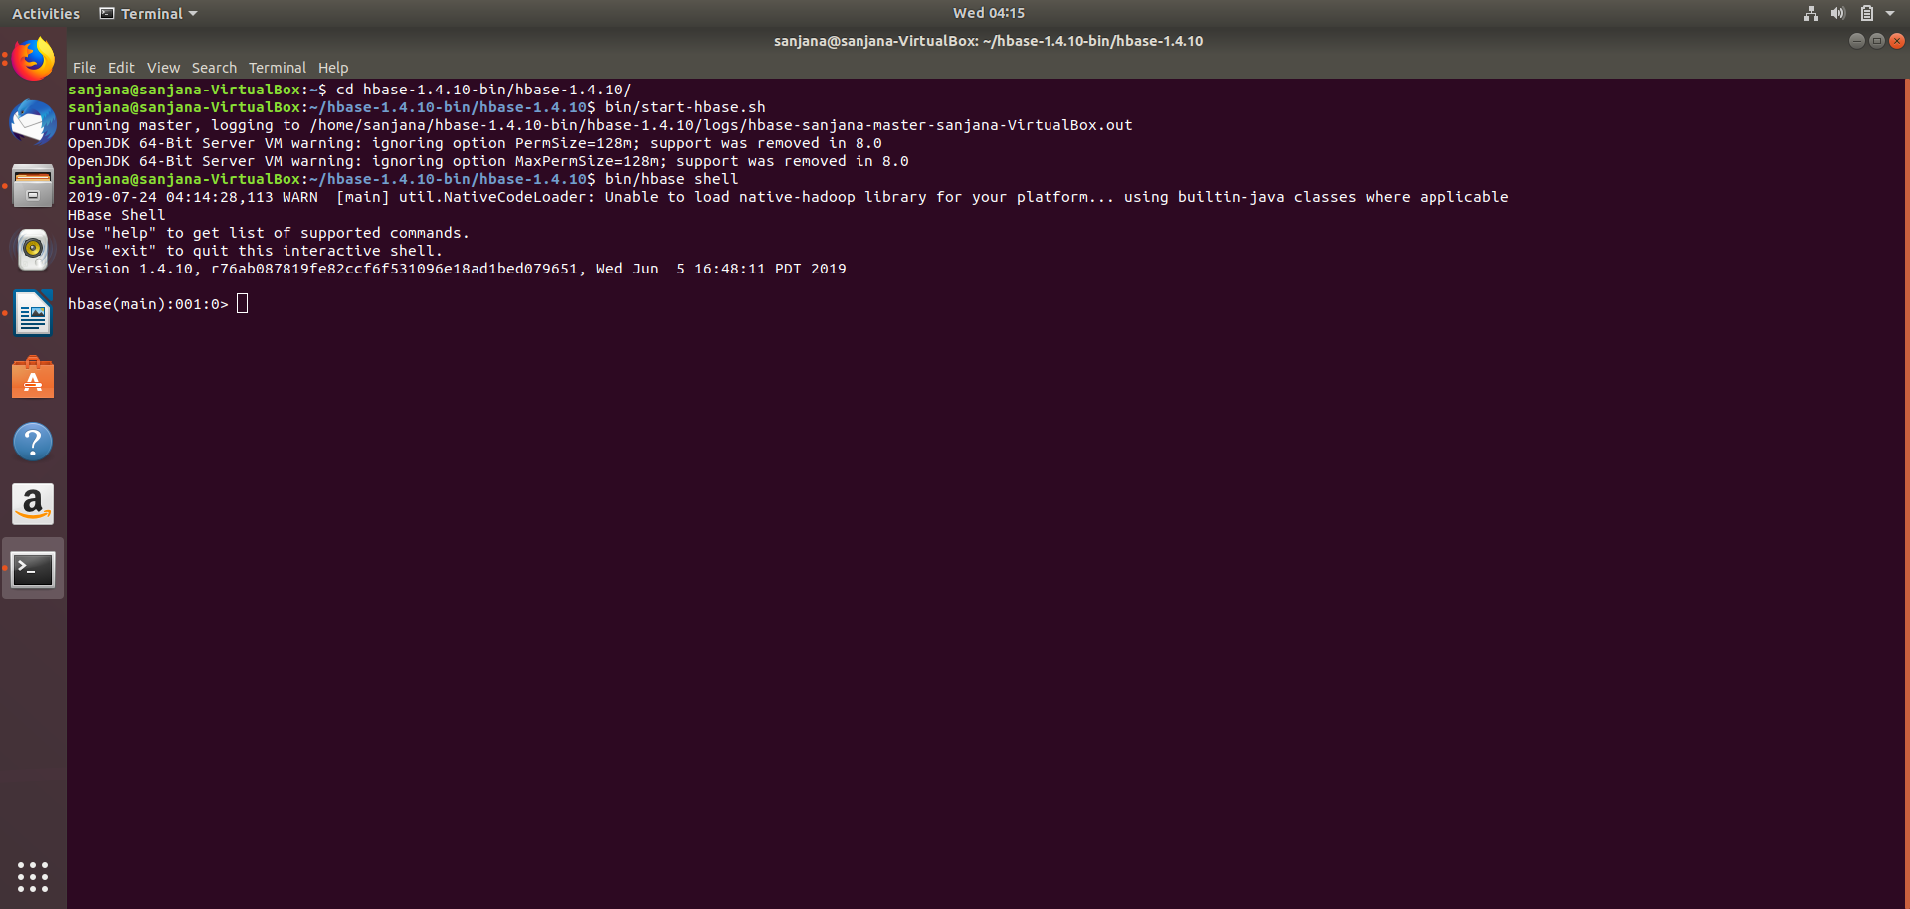

12. Create a table in hbase with the structure:
table name - claims
column families - personal_info, professional_info
columns - patient_name, cover_from, cover_to, reason, amount, health_plan, payer

Create 'claims', 'personal_info','professional_info'

13. After the creation of the table, disable the table and attach the Coprocessors jar file that was created with all the dependencies.
disable 'claims'
alter 'claims', METHOD => 'table_att', 'Coprocessor'=>'location_of_the_jar_with_all_the_dependencies|package_name.class_name|'

If the coprocessor file is changed and built then the new coprocessor jar should be attached to the patients table. We will have to disable the table and then unwind the previous jar and attach the new one.
alter 'claims', METHOD => 'table_att_unset', NAME=>'coprocessor$1'

14. Enable the table and describe it to find the attached jar.
enable 'claims'
Describe 'claims'

15. After starting hbase and entering into the hbase shell open a new terminal and start the kafka sever.
bin/kafka-server-start.sh config/server.properties

16. Open a new terminal to open the kafka topic to check if the json string is being pushed into the topic.
bin/kafka-console-consumer.sh --bootstrap-server localhost:9092 --topic ClaimsTopic --from-beginning

17. Start the spark consumption in a new terminal using the command
bin/spark-submit --class package_name.class_name --master local[2] ./target/name-SNAPSHOT-jar-with-dependencies.jar

18. Run the hbase client code to push the data into the hbase table and consumption in spark terminal.

