HR Attrition Analysis Report
Prepared using Python (Pandas, NumPy, Matplotlib, Seaborn, Scikit-learn)
Objective: Identify key drivers of employee attrition and recommend actionable strategies

1. Introduction
This report presents a comprehensive analysis of employee attrition using exploratory data analysis (EDA), feature engineering, statistical testing, and machine learning techniques. The goal is to understand patterns of employee turnover and identify key factors influencing attrition.

2. Data Understanding & EDA
Initial analysis included distribution analysis, correlation analysis, and categorical breakdowns.
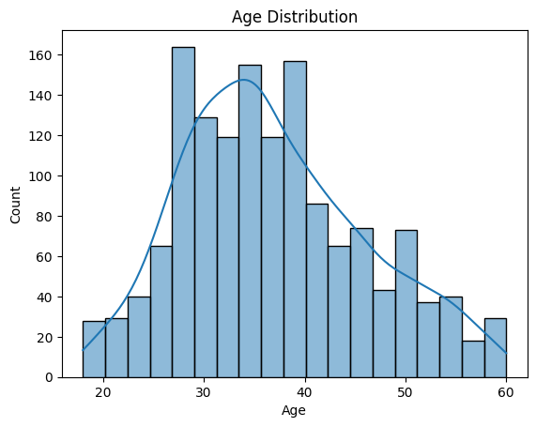
Age Distribution
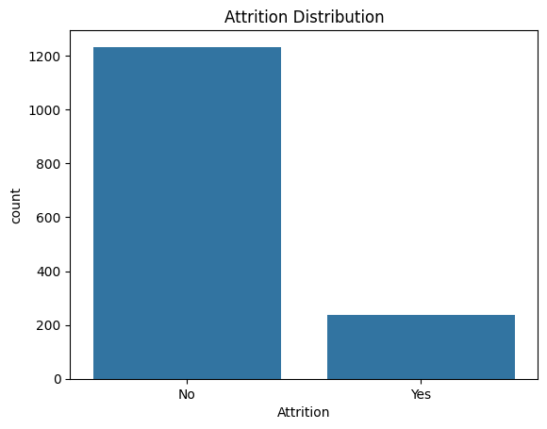
Attrition Distribution
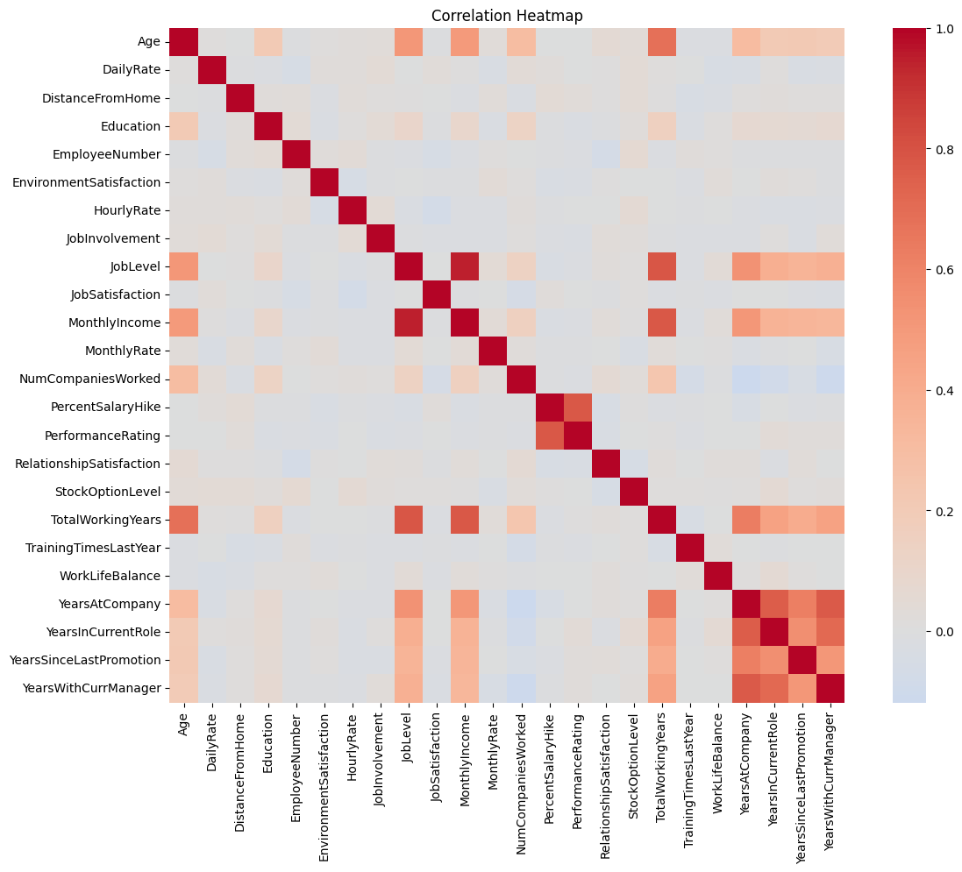
Correlation Heatmap
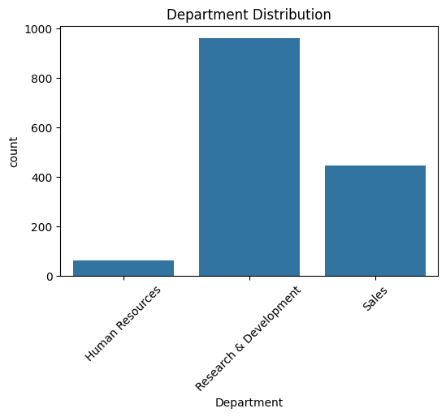
Department Distribution
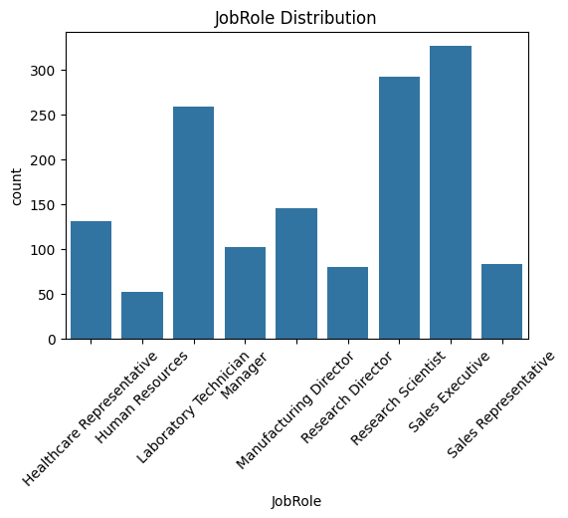
Job Role Distribution
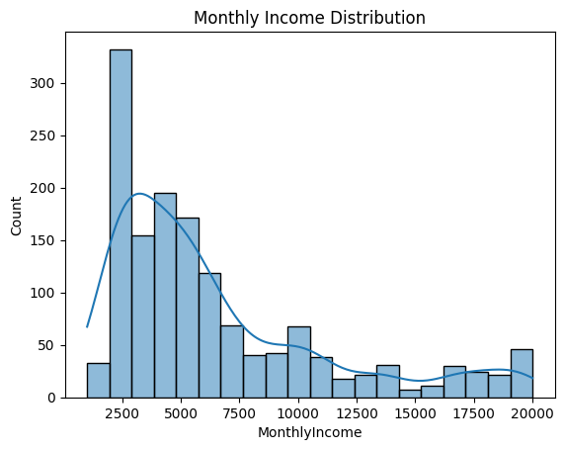
Monthly Income Distribution
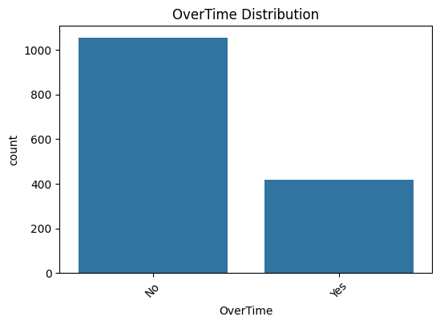
Overtime Distribution

3. Key Findings from EDA
• Attrition rate is approximately 16%.
• Workforce is concentrated in Research & Development.
• Majority employees fall in age group 25–40.
• Income distribution is right-skewed.
• Overtime and travel frequency impact attrition significantly.

4. Statistical Analysis Insights
Chi-square and t-tests indicate that overtime, income, satisfaction, and tenure are statistically significant drivers.
Effect size analysis shows income and satisfaction have strong influence on attrition.

5. Machine Learning Insights
Logistic Regression and Random Forest models identified top drivers:
• Overtime (strongest)
• Satisfaction Score
• Monthly Income
• Age and Experience

6. Business Insights
• Overtime increases attrition risk significantly.
• Low income employees are most likely to leave.
• Early tenure employees are high-risk.
• Attrition is multi-factor driven.

7. Recommendations
• Optimize compensation structure.
• Reduce overtime workload.
• Improve onboarding experience.
• Implement predictive risk monitoring.

8. Conclusion
Attrition is predictable and can be reduced using targeted interventions. A data-driven HR strategy will significantly improve retention and workforce stability.

